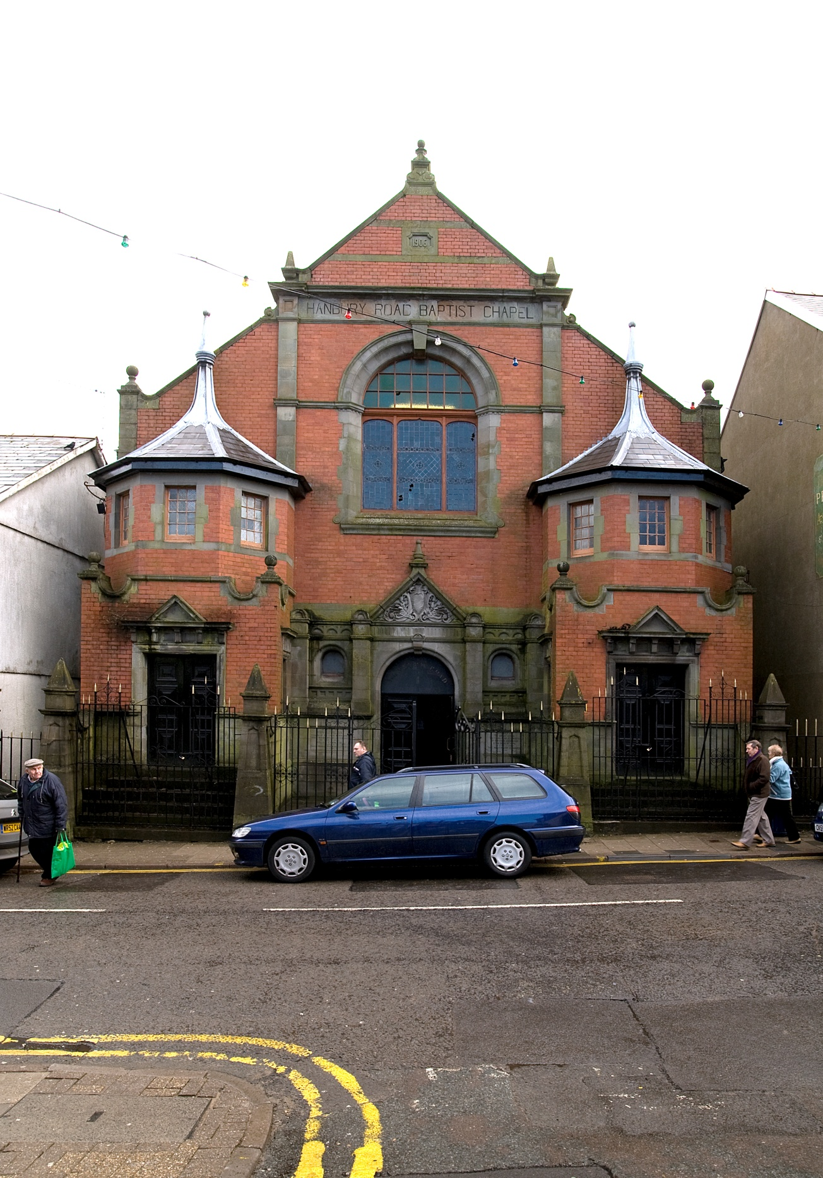

- Front elevation. Red-brick with Forest of Dean stone dressings. Gable-fronted with projecting stair turrets. The inscription above the central window reads: HANBURY ROAD BAPTIST CHAPEL.
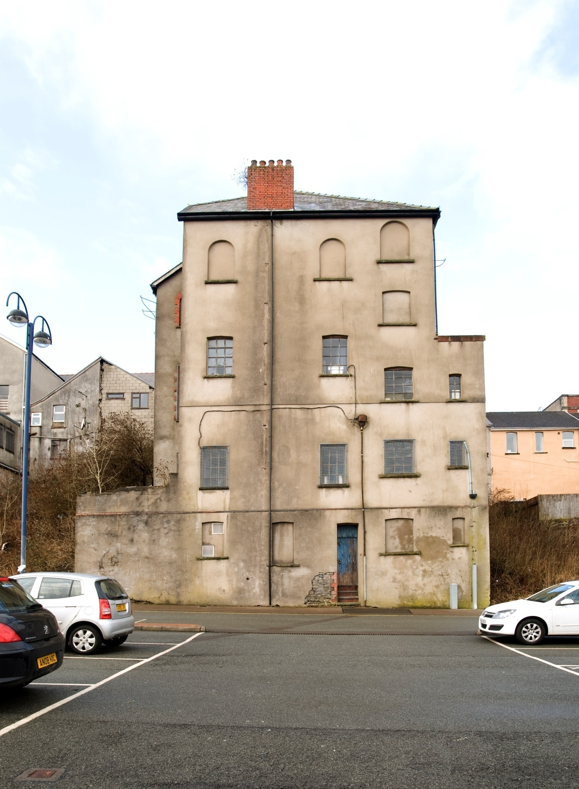
- Rear elevation: three storeys over basement.

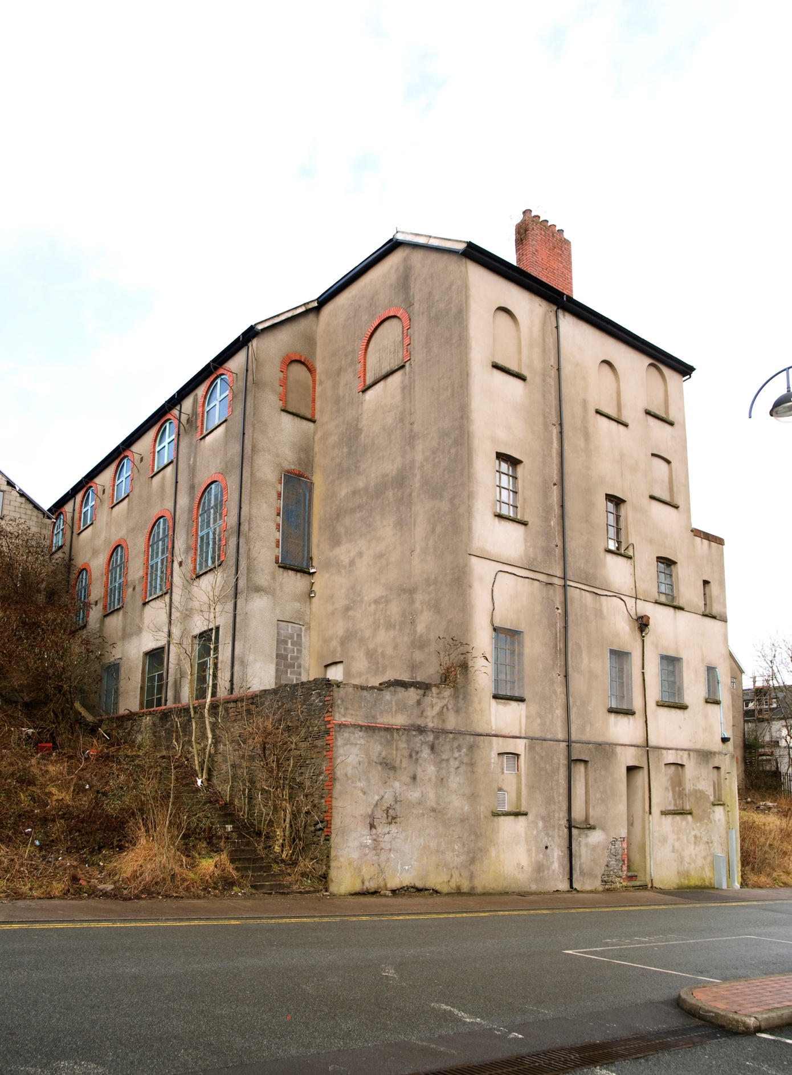
- Side elevation showing the sloping site.

F 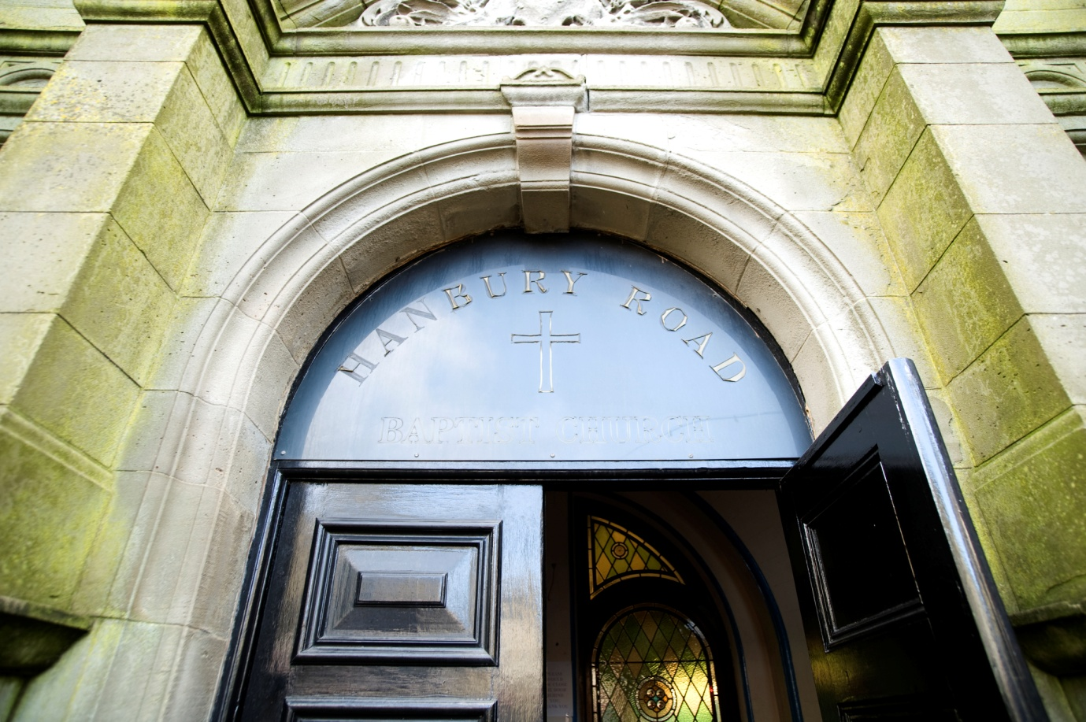
- Detail of central doorway with inscription ‘HANBURY ROAD’.

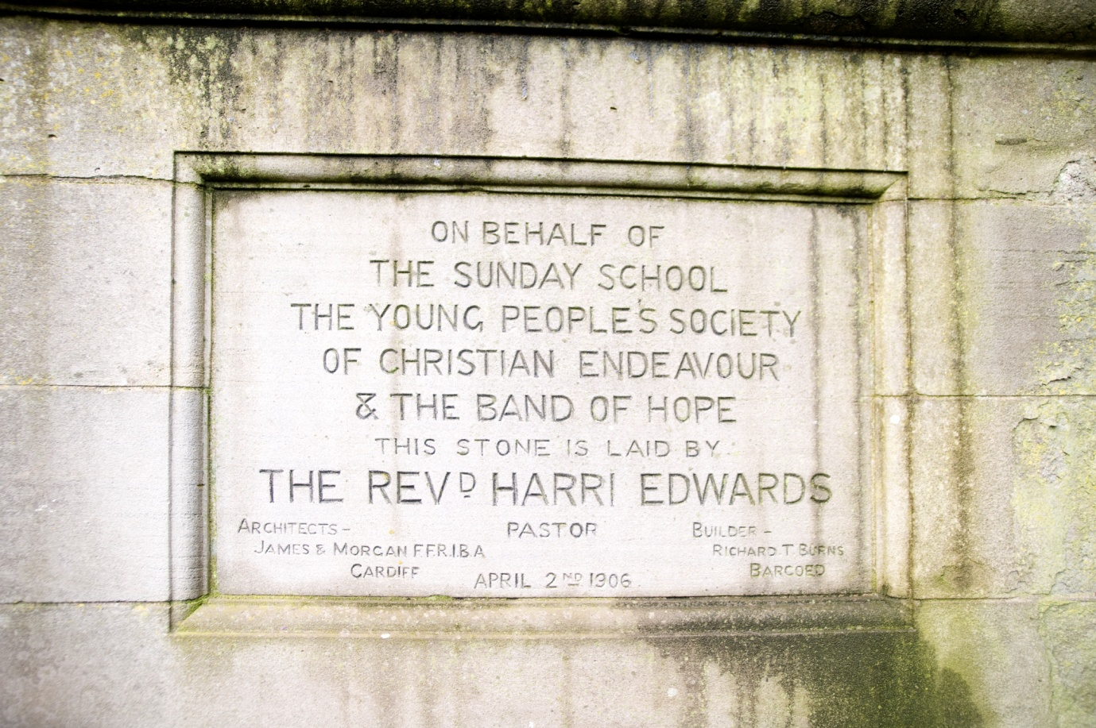
- Foundation Stone laid by Rev. Harri Edwards on 2nd April 1906.

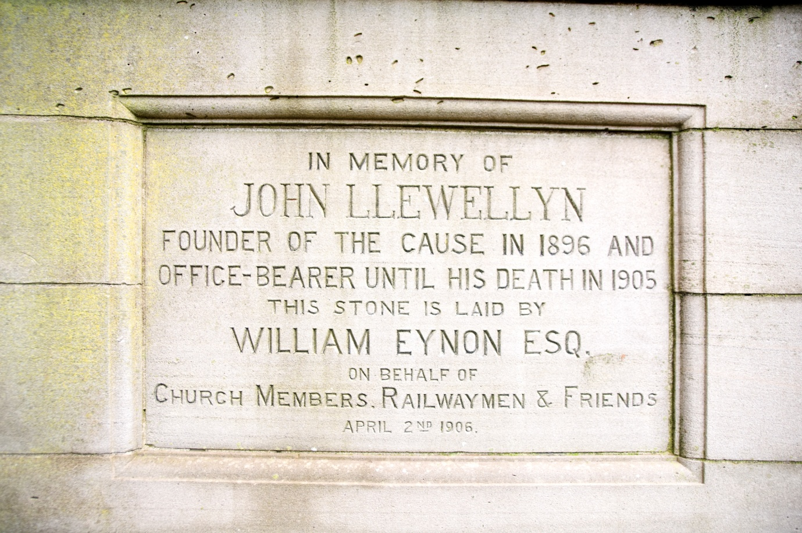
- Foundation Stone laid by William Eynon, Esq., on 2nd April 1906.
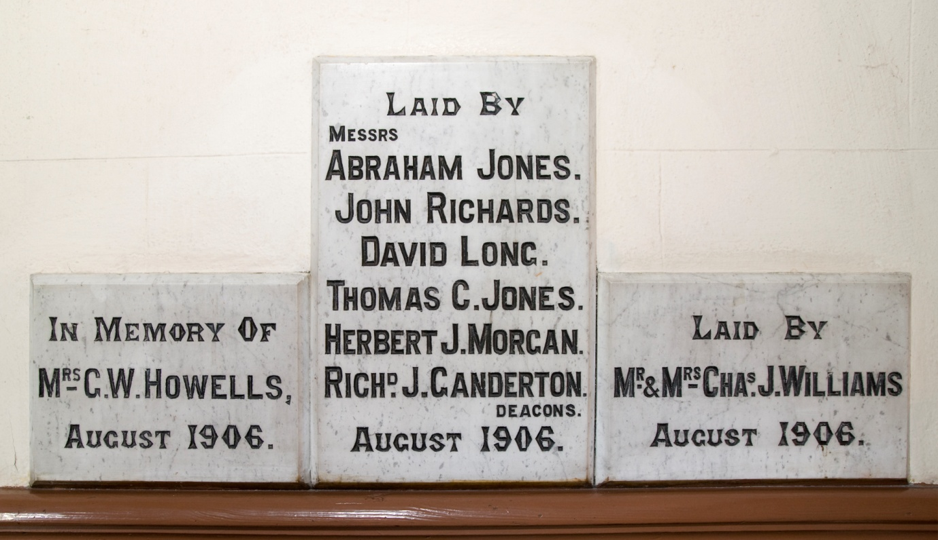

- Completion stone laid by the Deacons, August 1906.

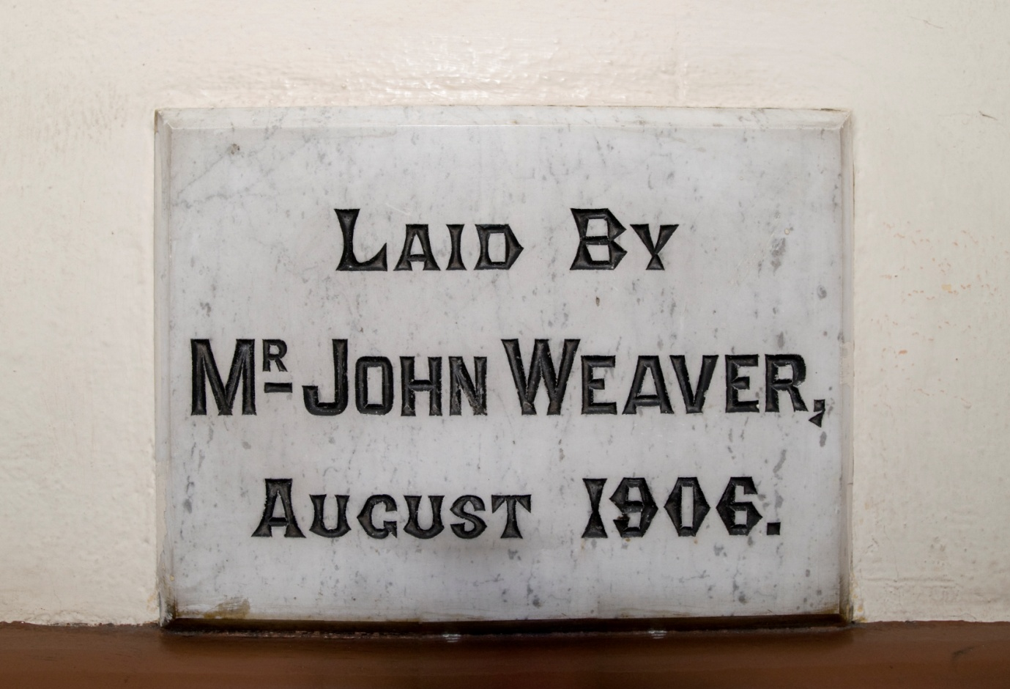
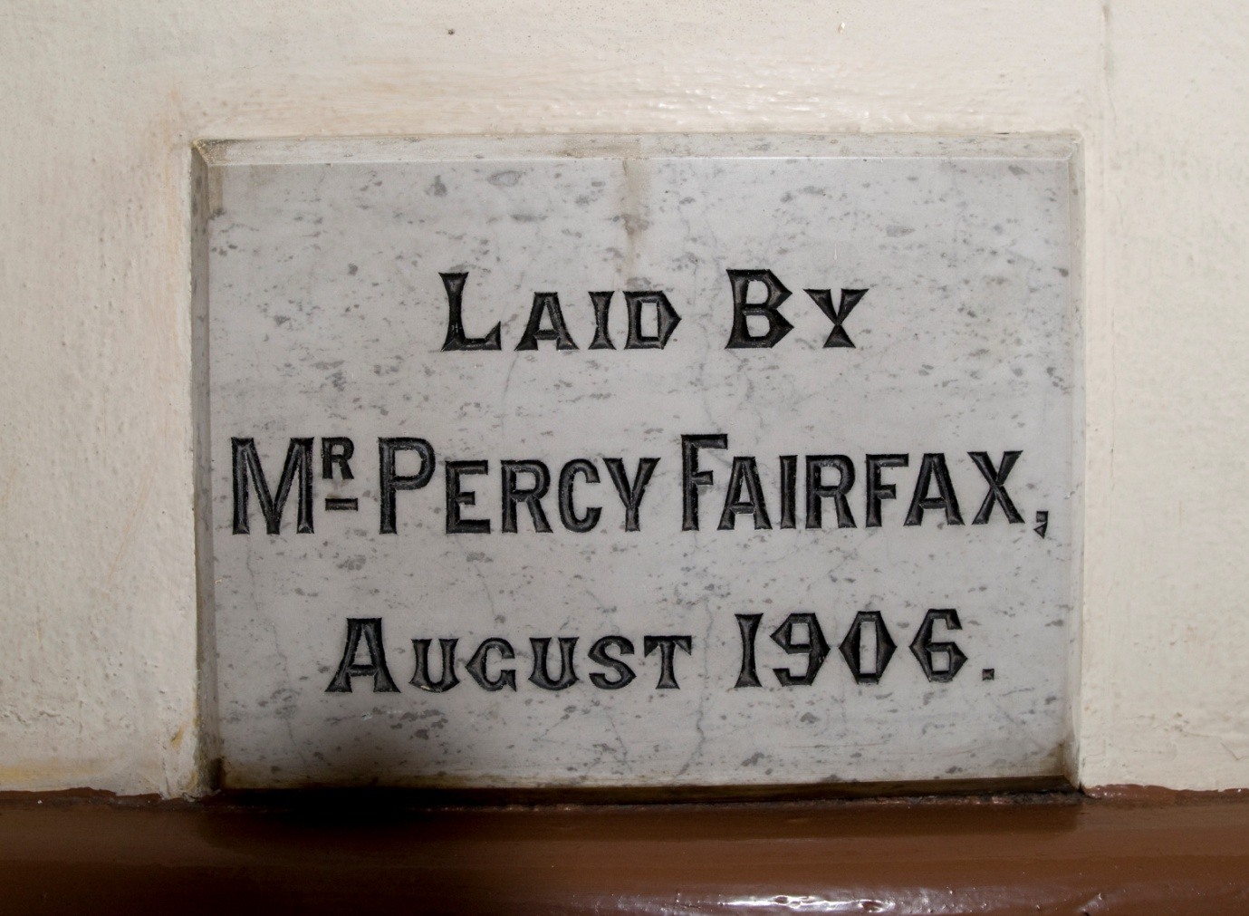
- Completion stones laid by Mr John Weaver and Mr Percy Fairfax, August 1906.
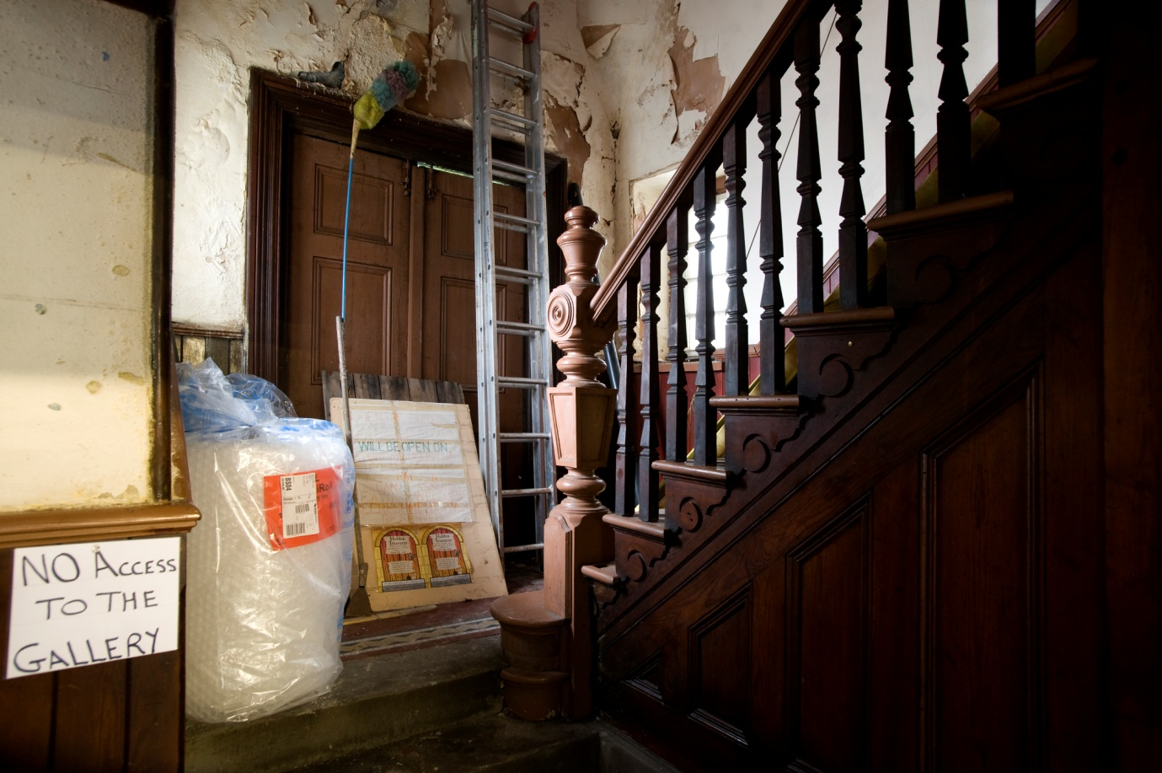
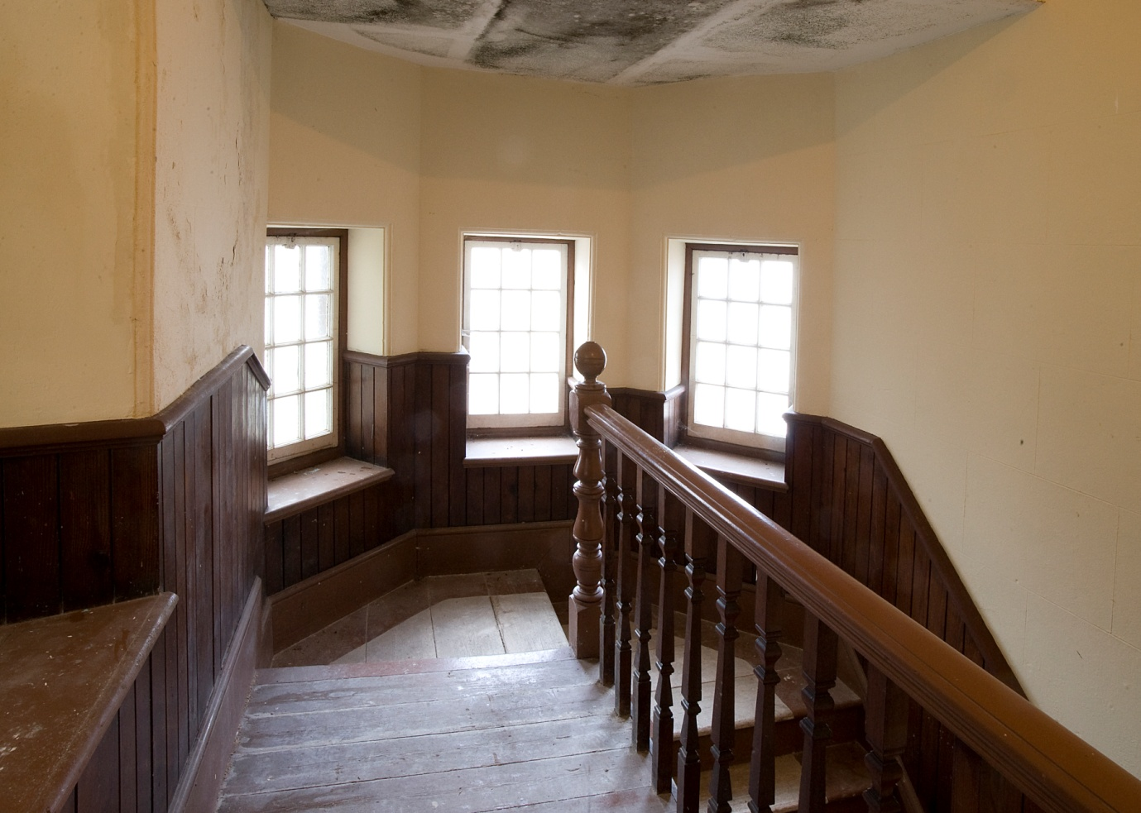
- Stair turret: lower and upper stair to the gallery.

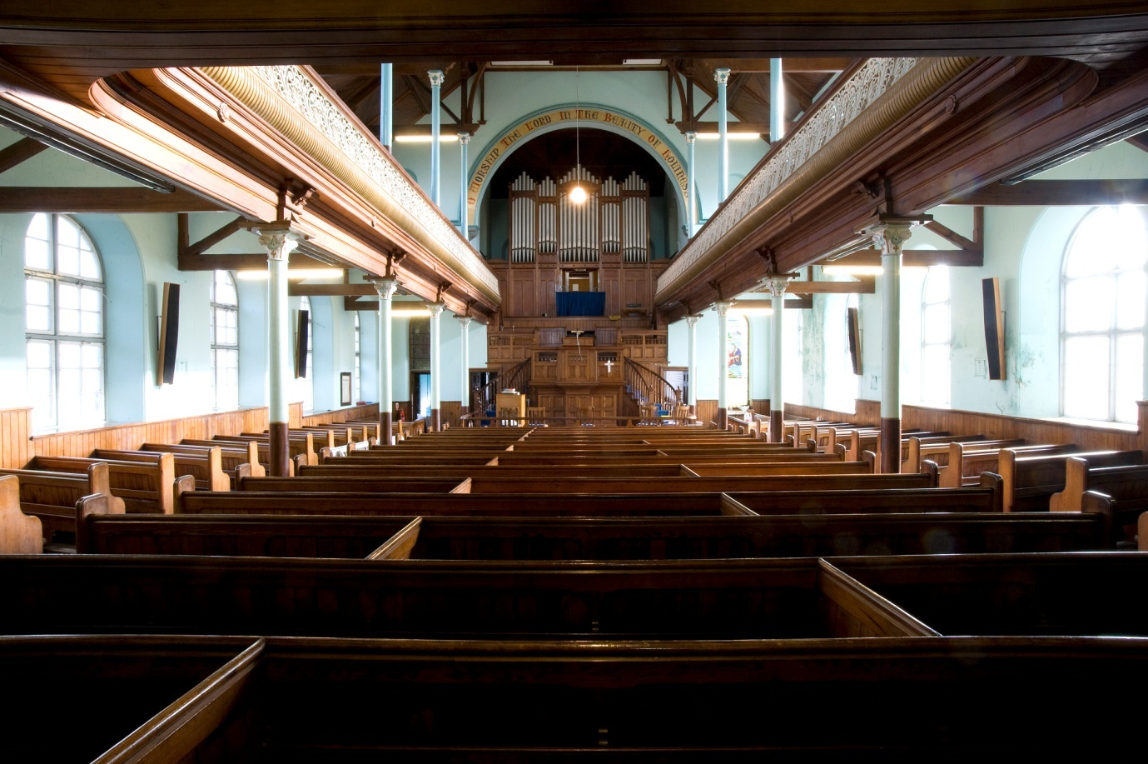
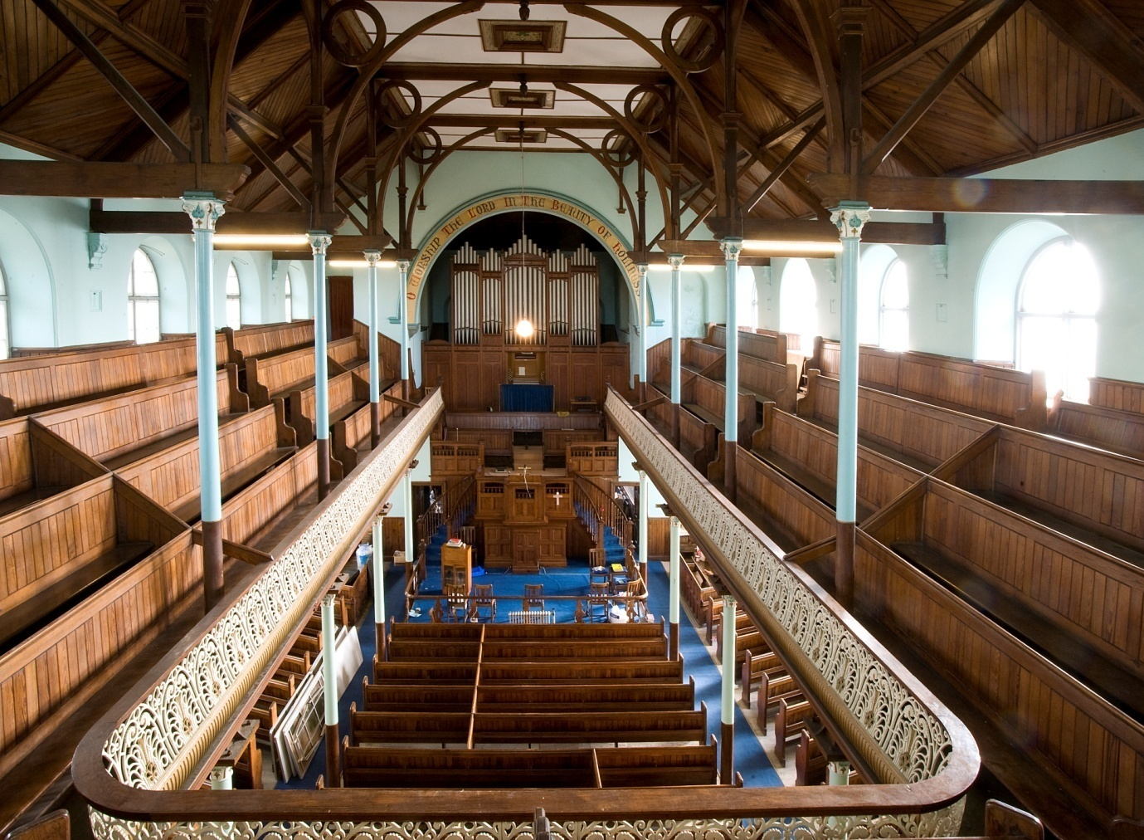
- Interior looking towards the sedd fawr.

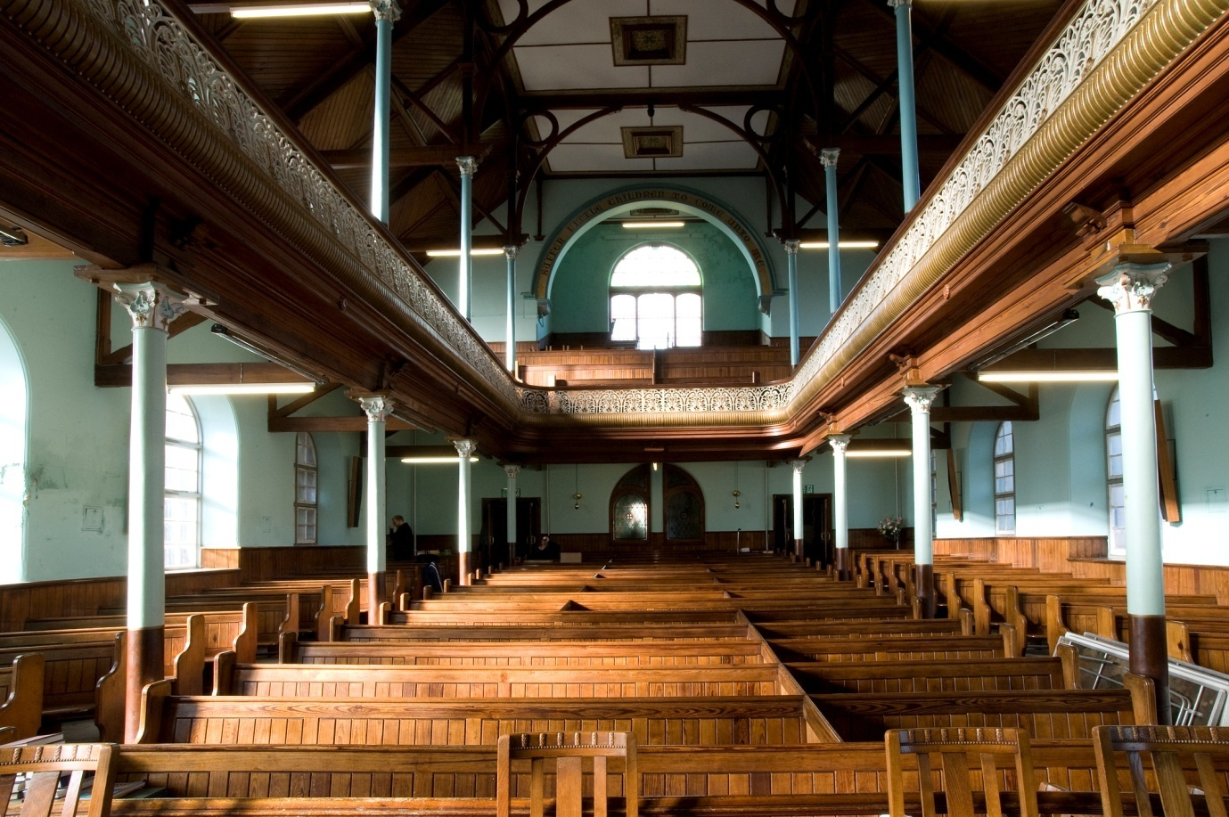
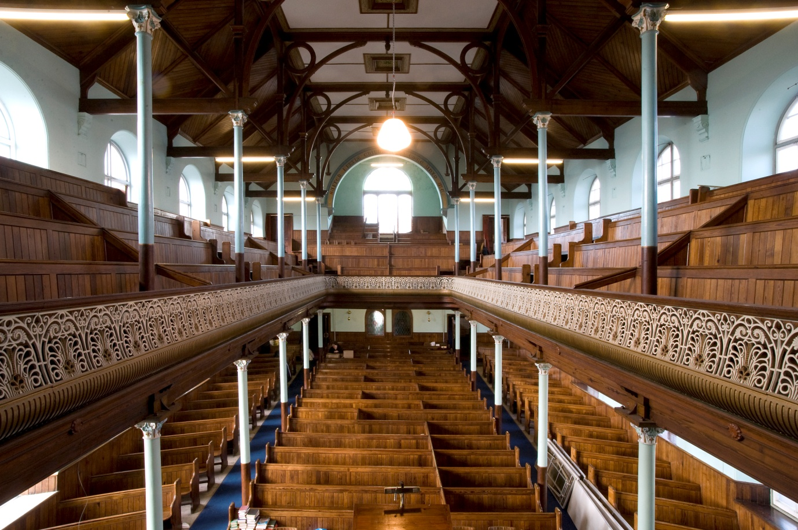
- Interior looking from the sedd fawr.

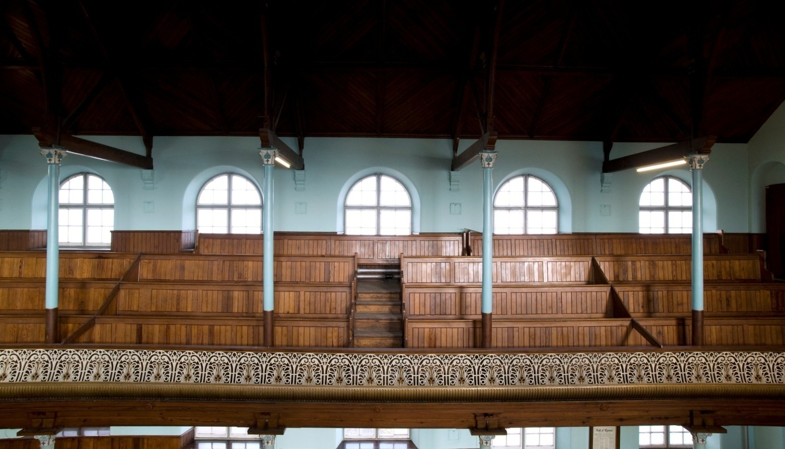
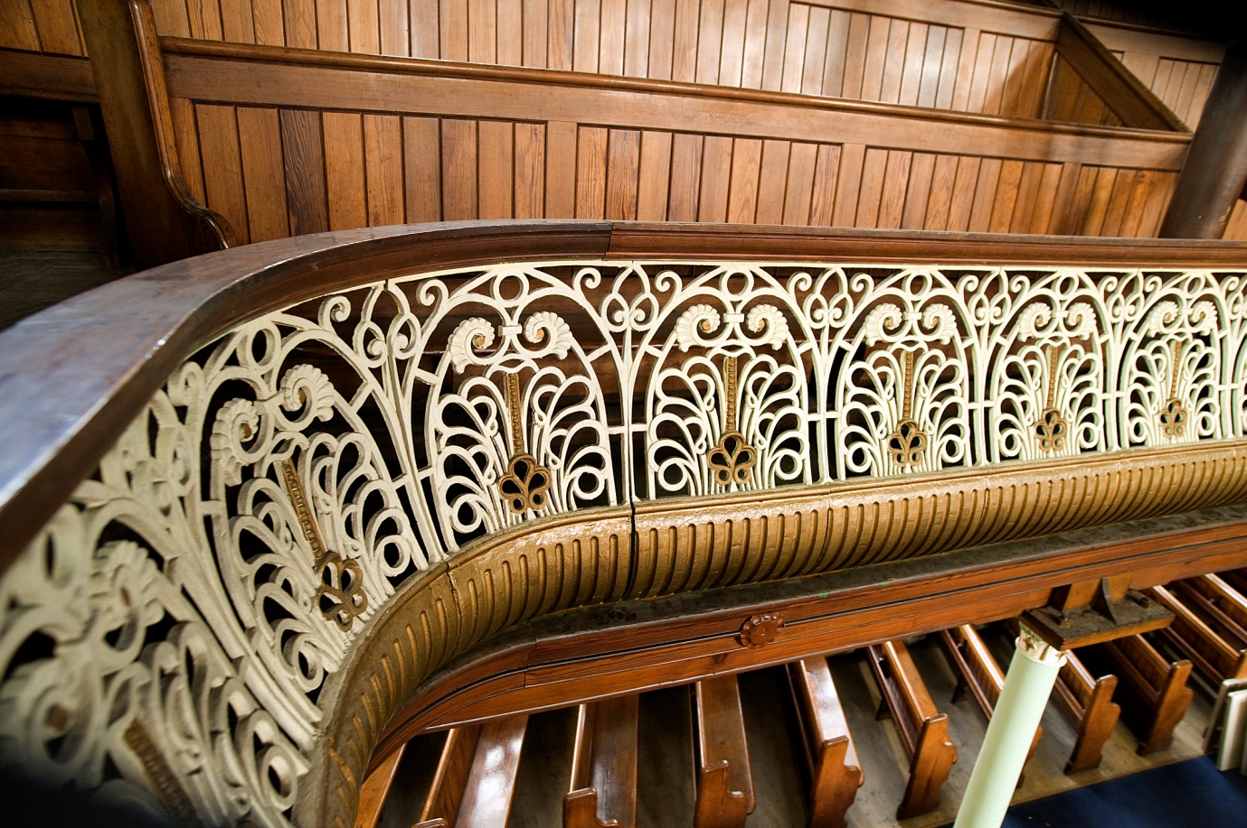
- Gallery details.

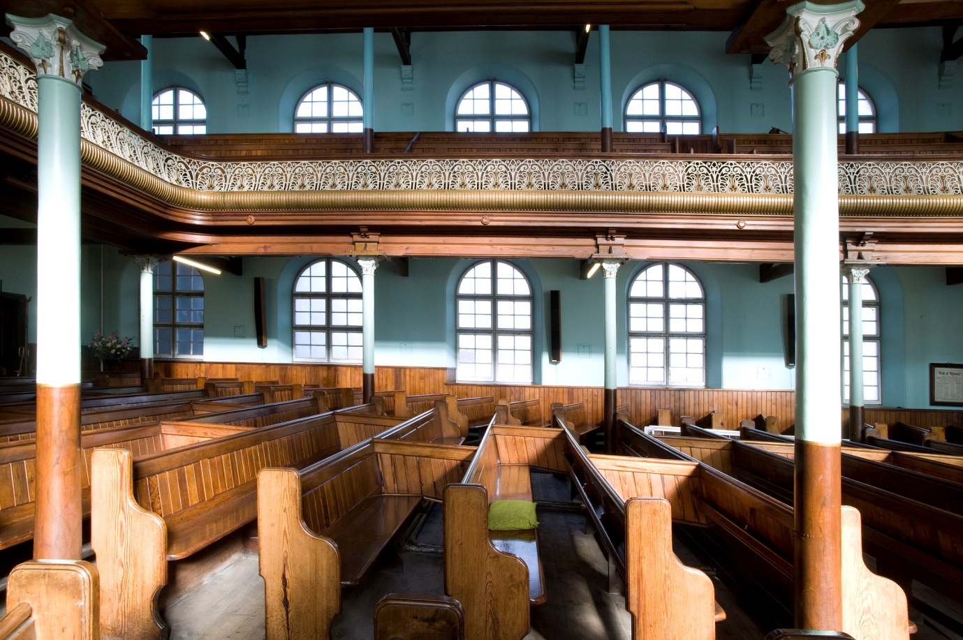
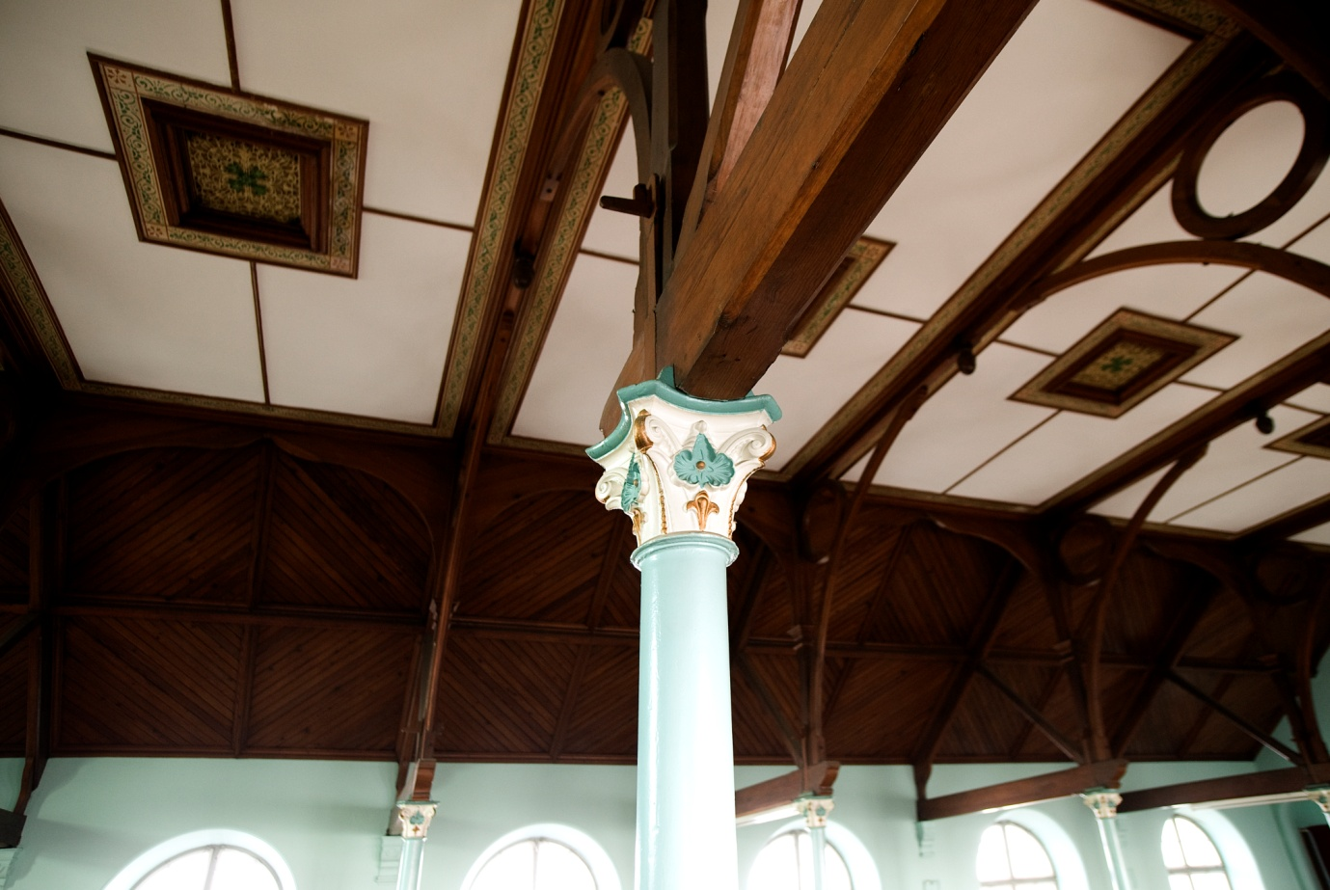
- Gallery and details of cast-iron columns.

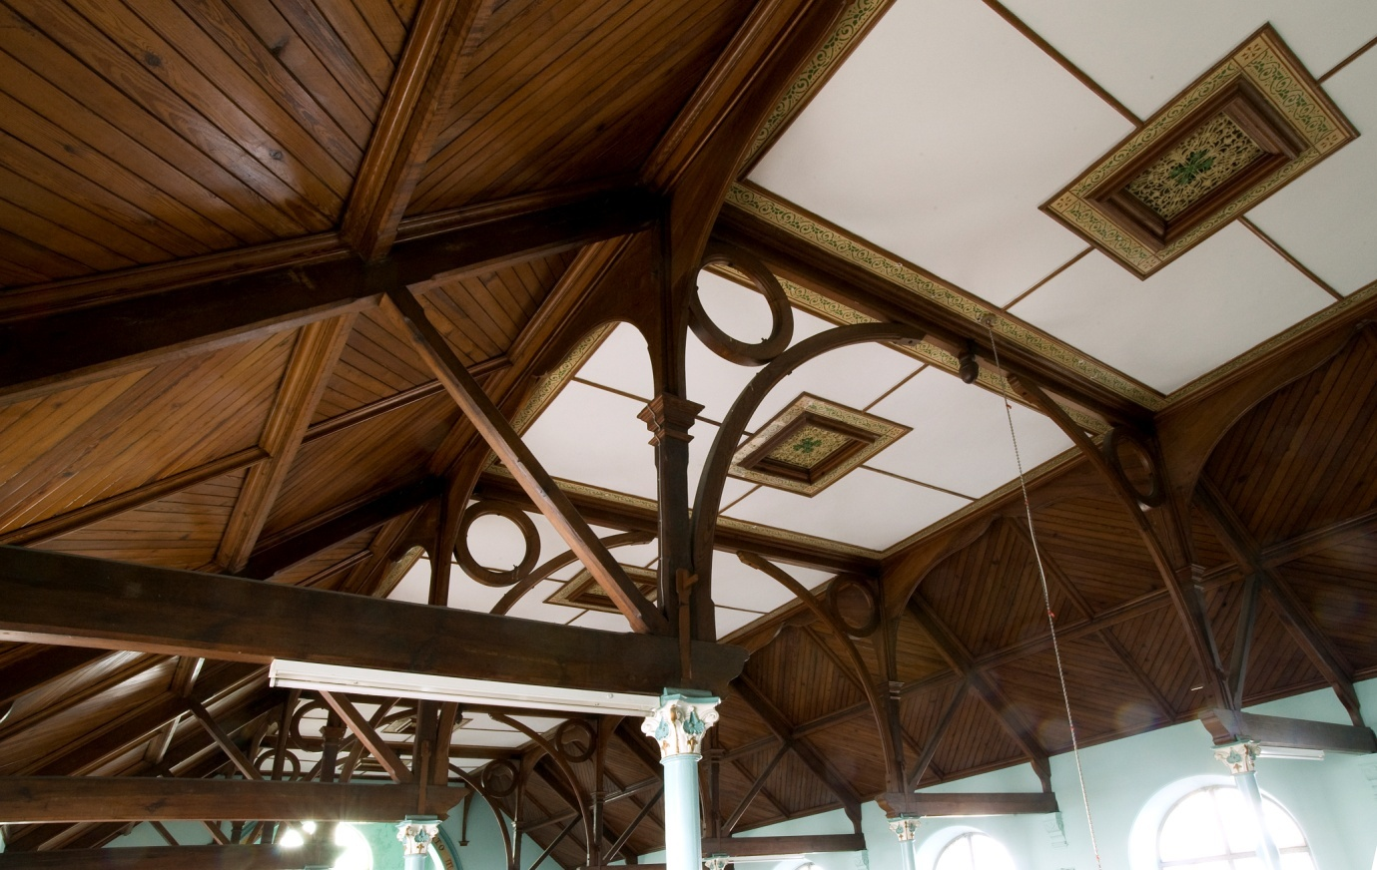

- Roof detail showing (1) the ornate trusses; (2) lozenge pattern ceiling boarded; (3) painted and stencilled ventilators.

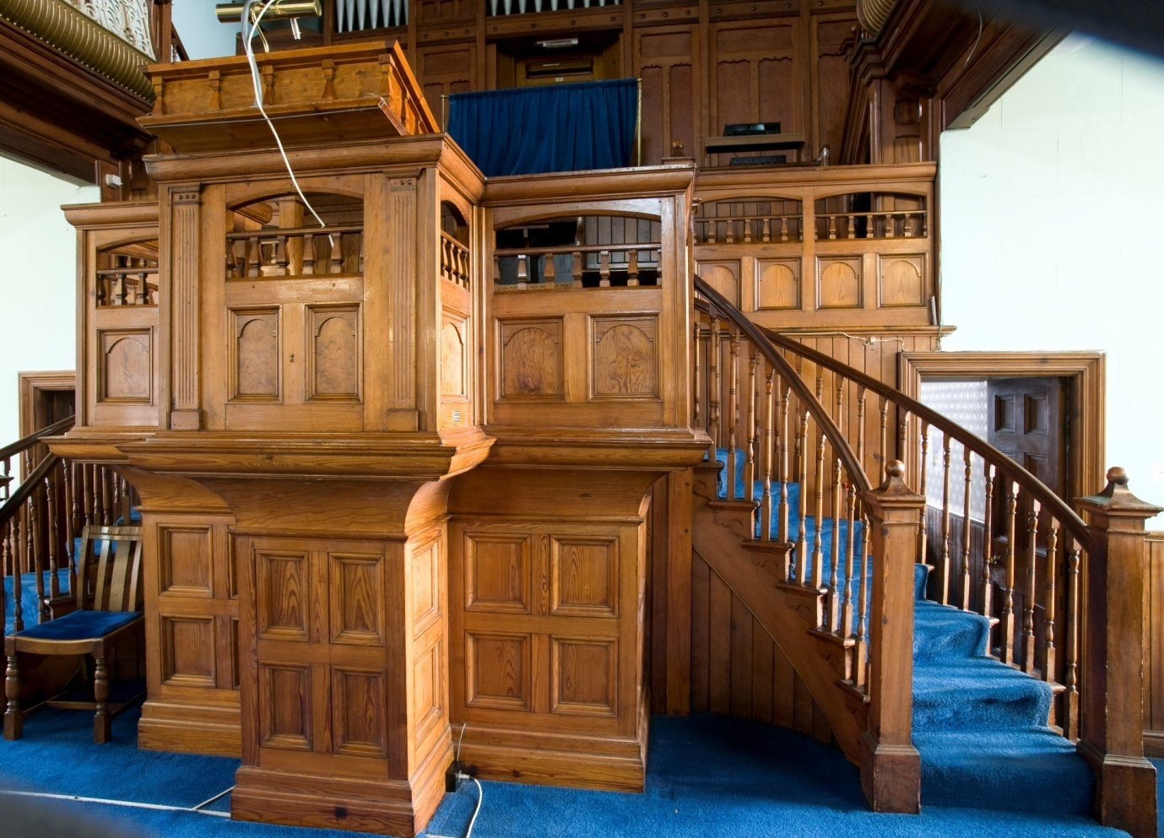
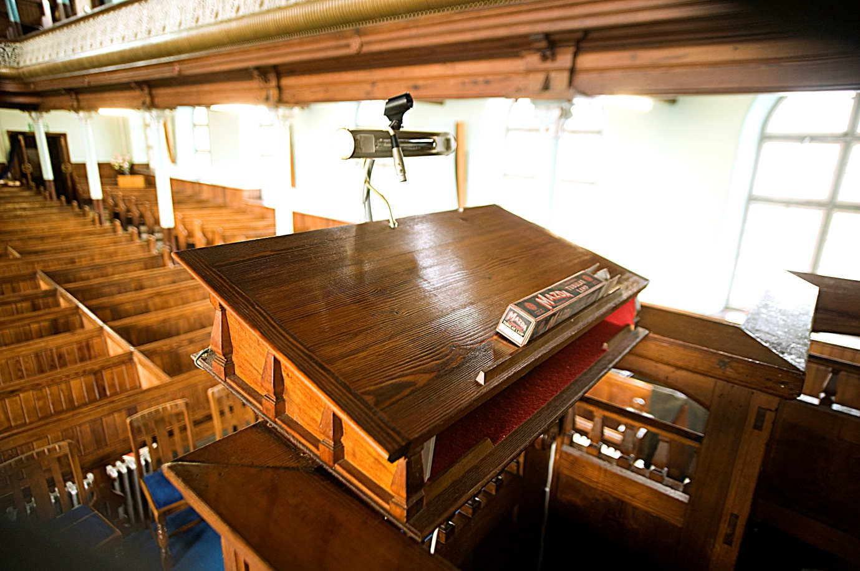
- The pulpit and set fawr.
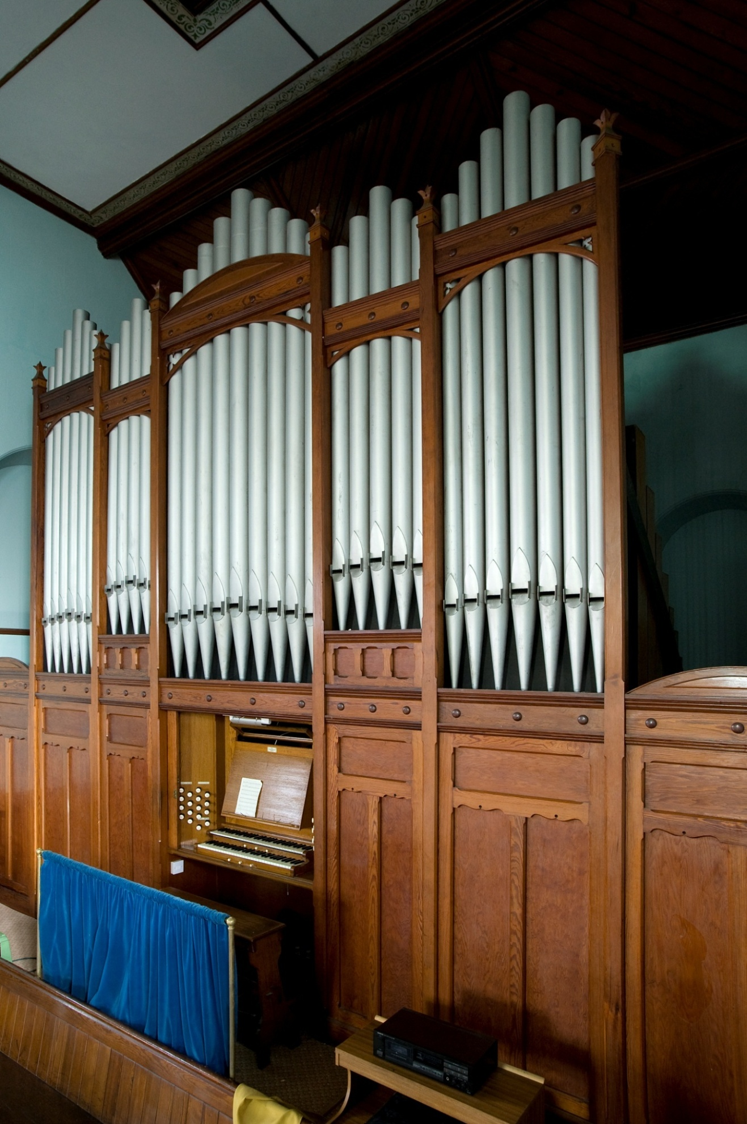
- Organ installed in 1933.
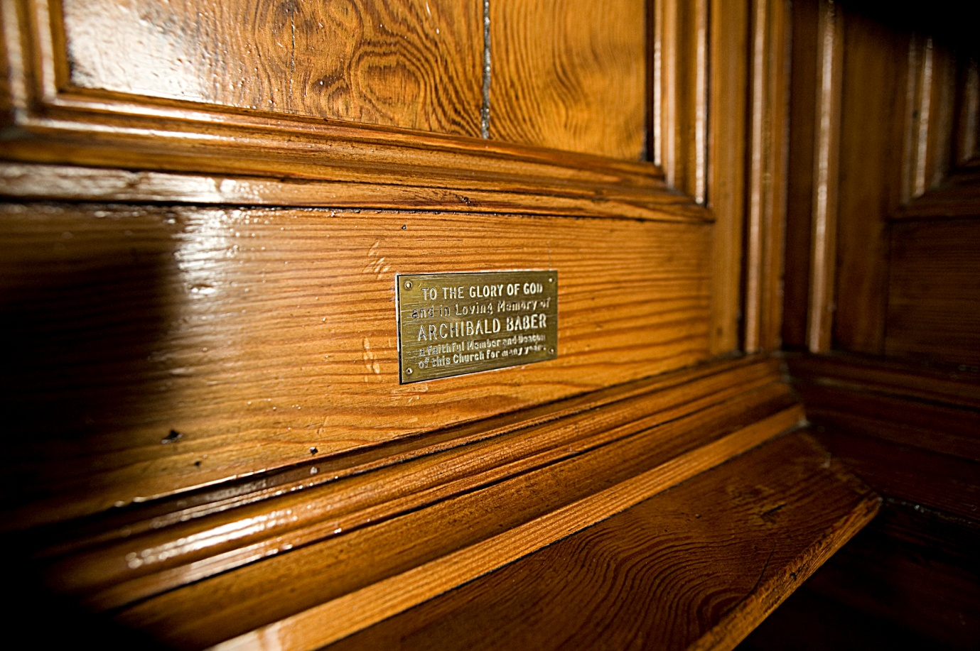

- Dedication plaque.

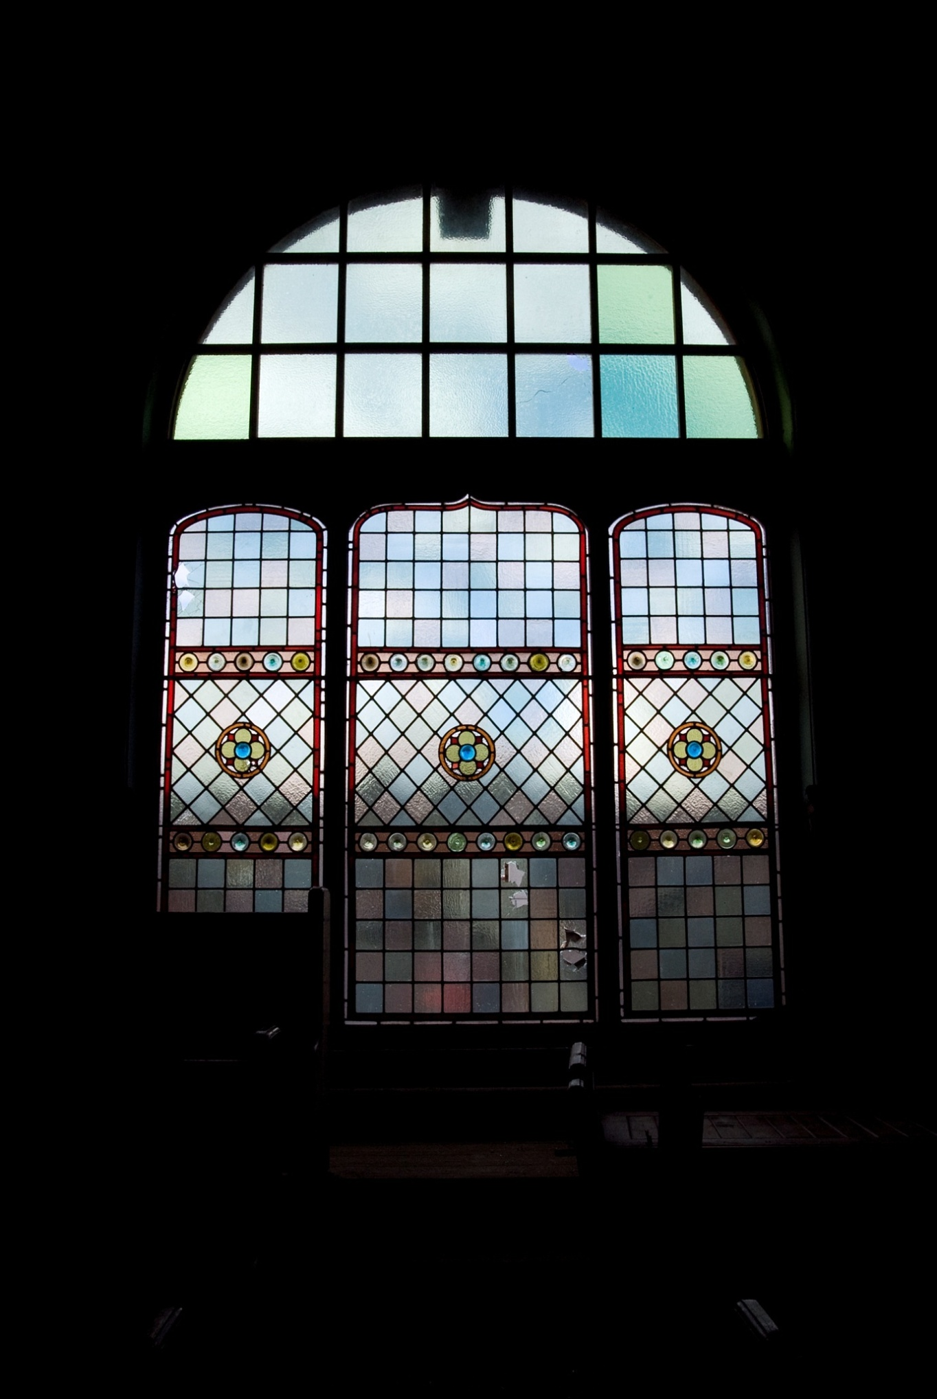
- Gallery window.
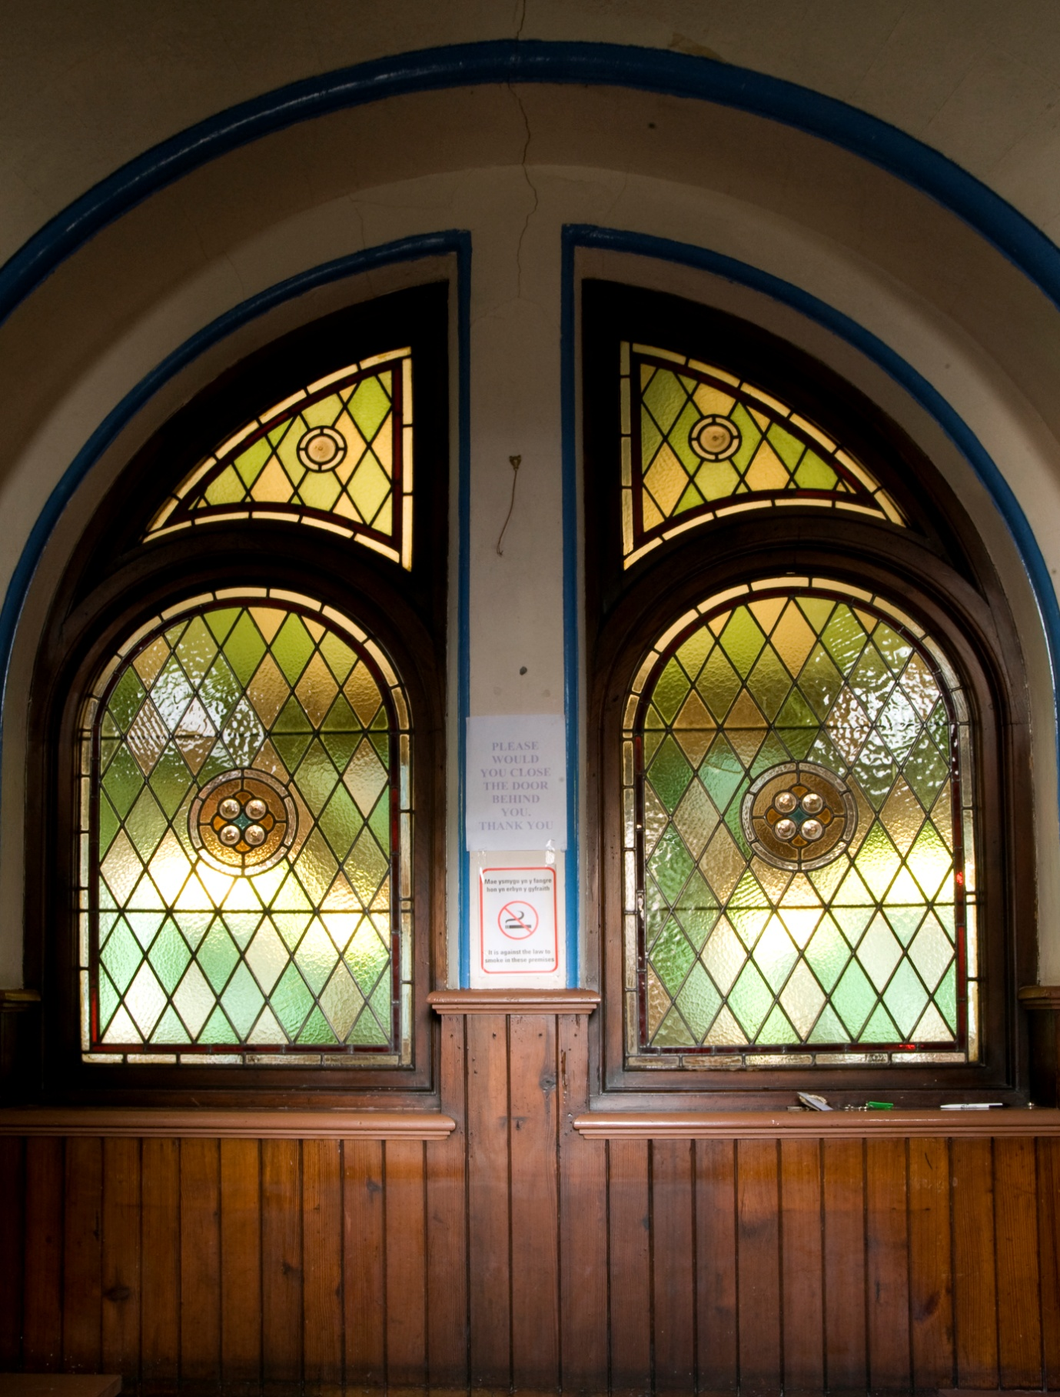
- Lobby window.

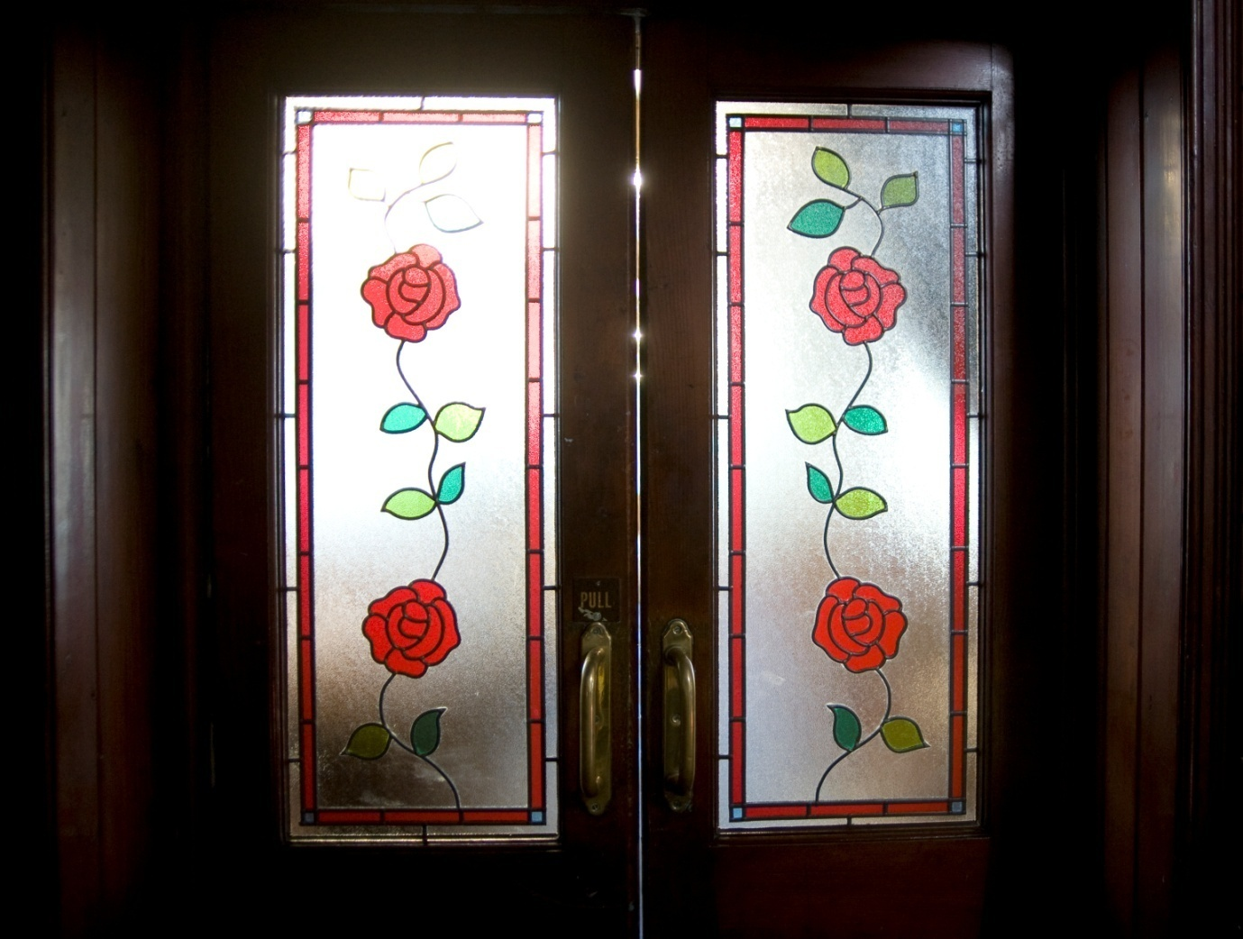
- Doors into the chapel with rose motif.

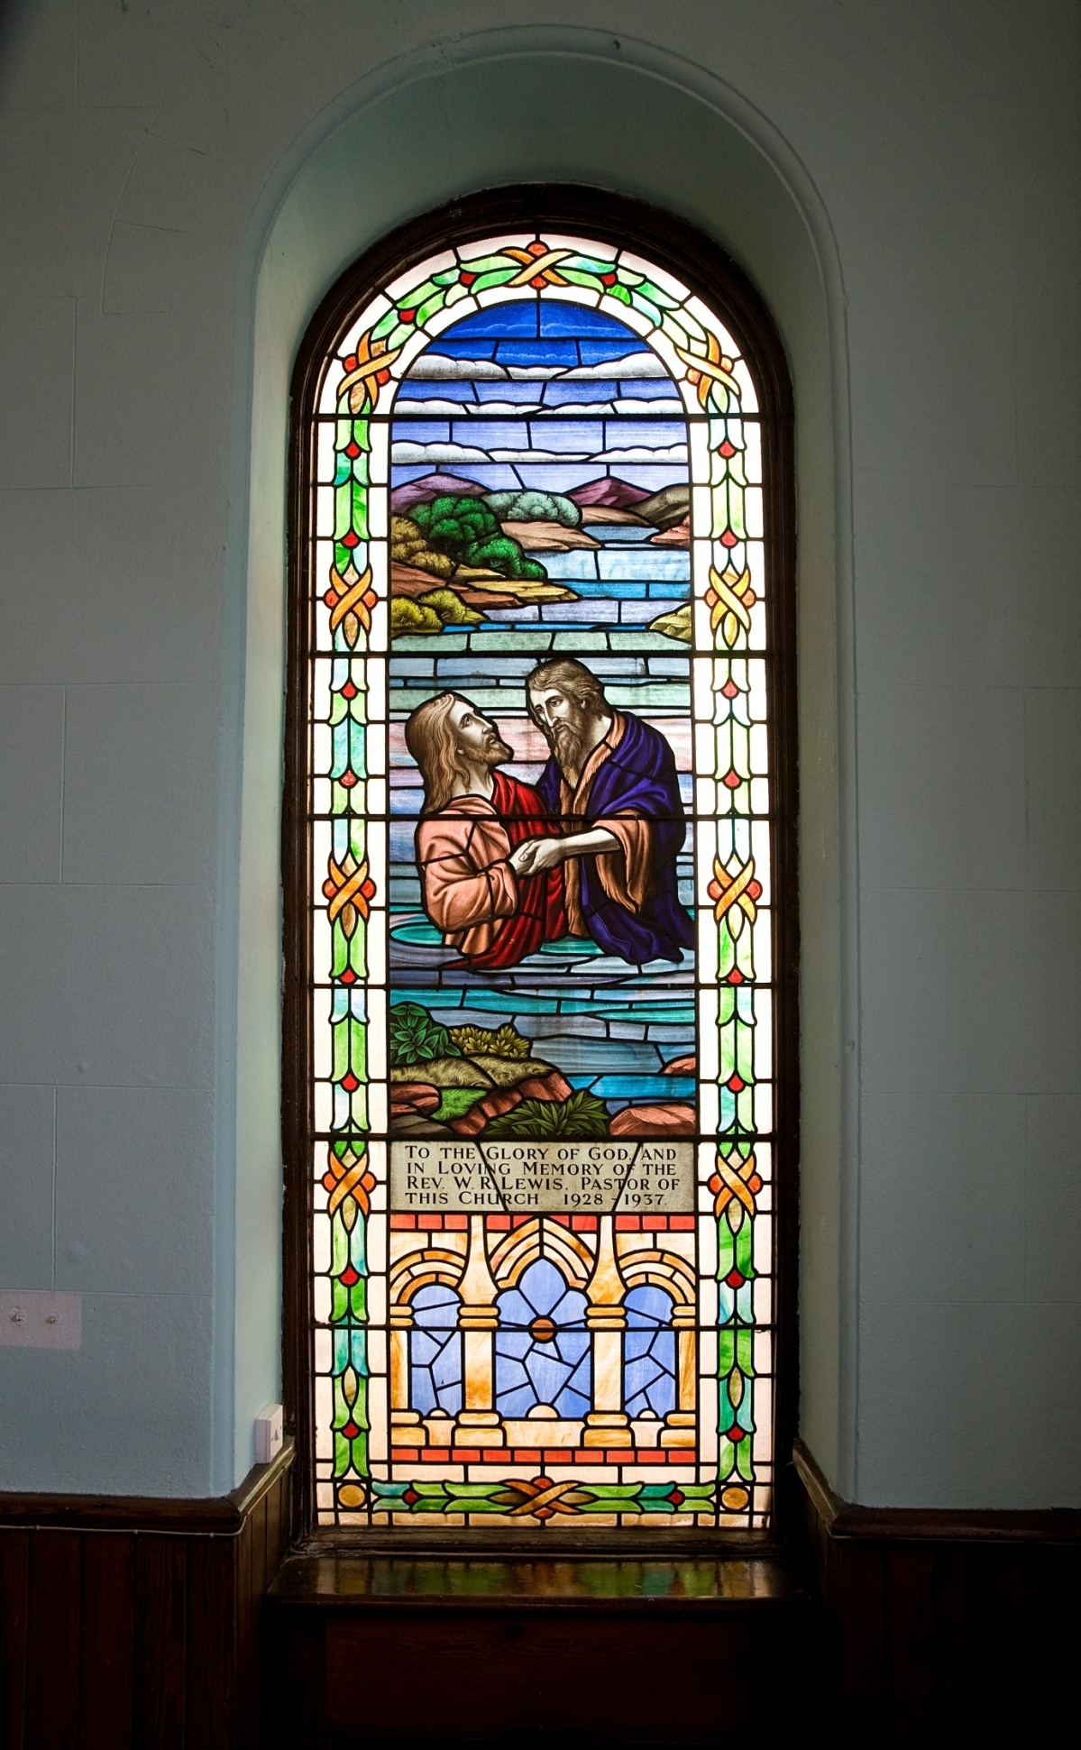
- Memorial window flanking organ installed in 1938.
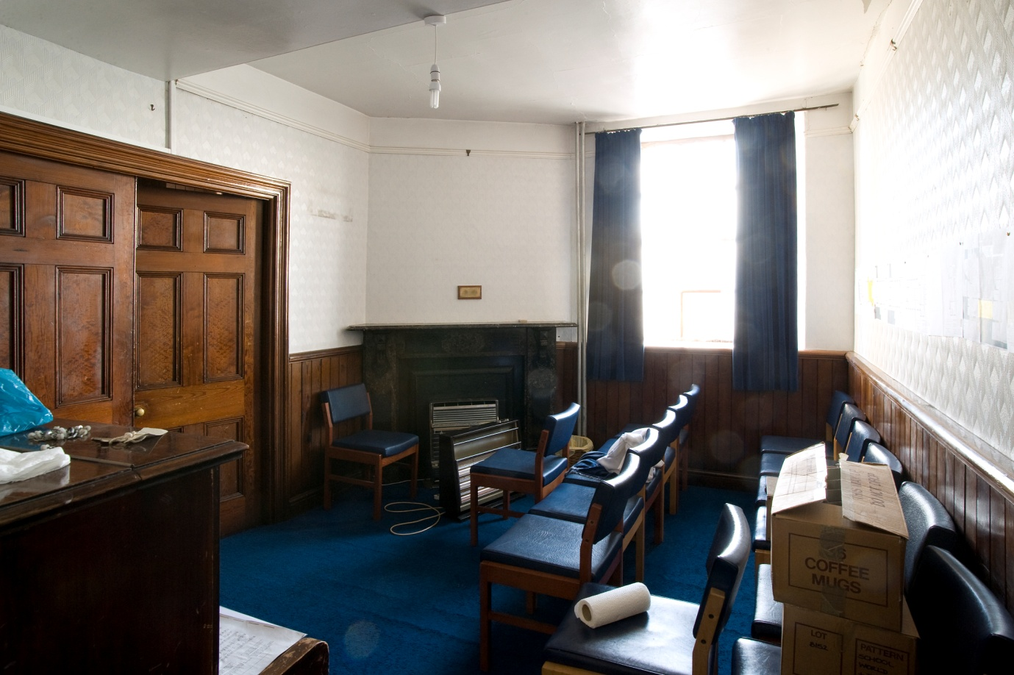

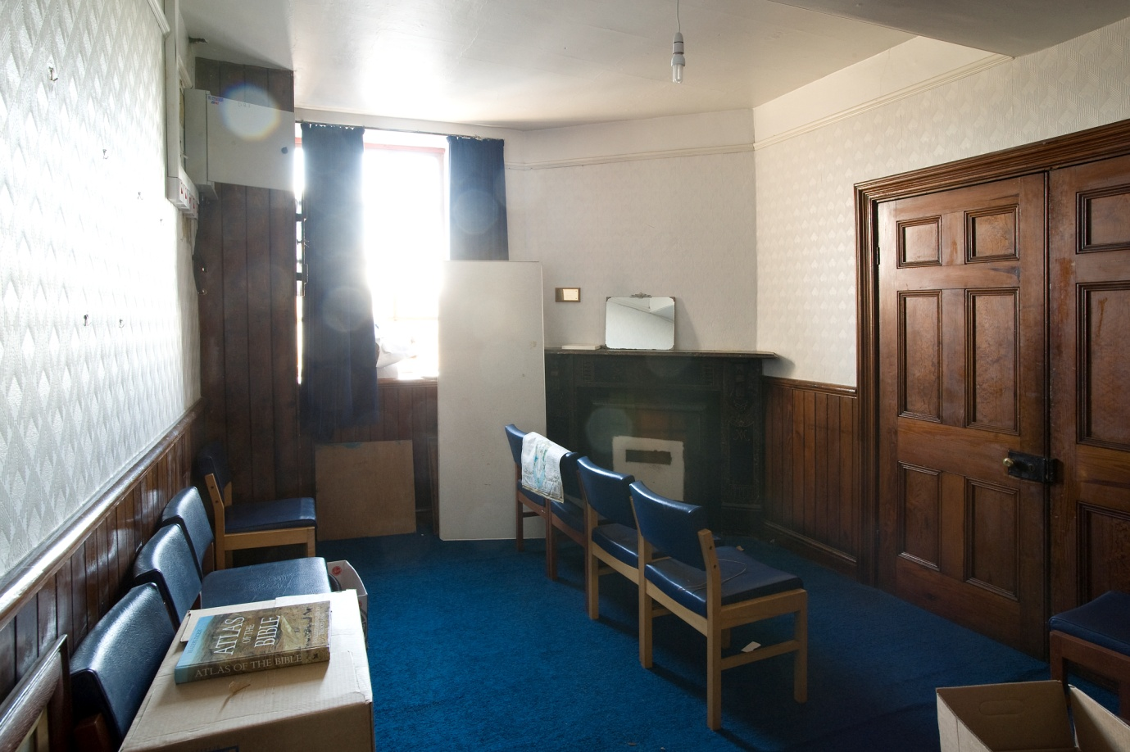
- Former vestry used for worship 2010.

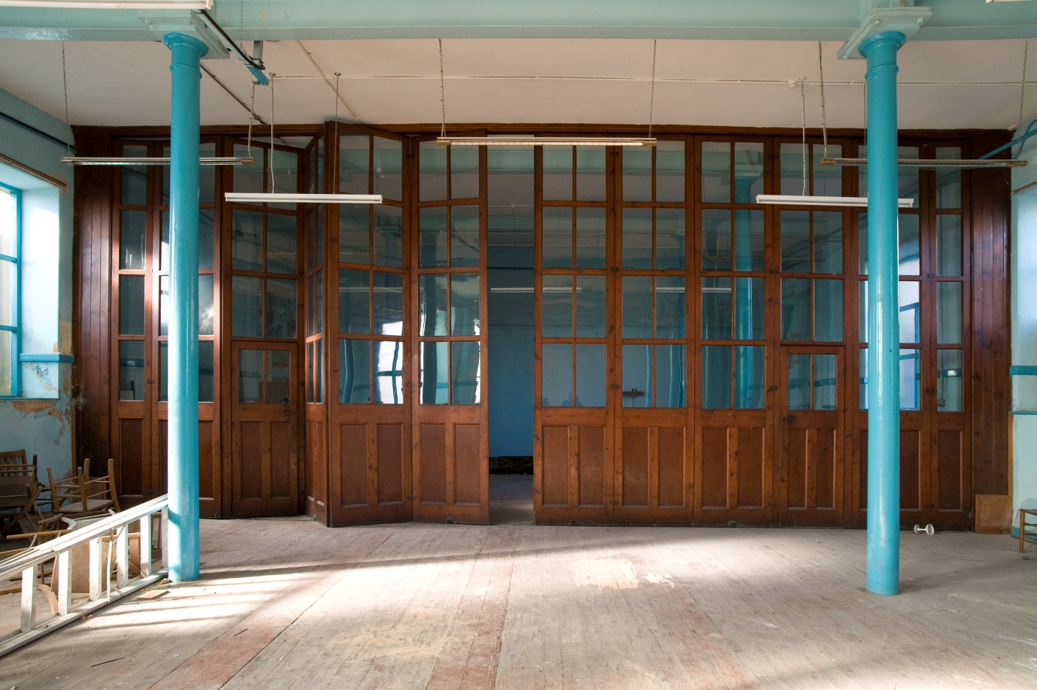

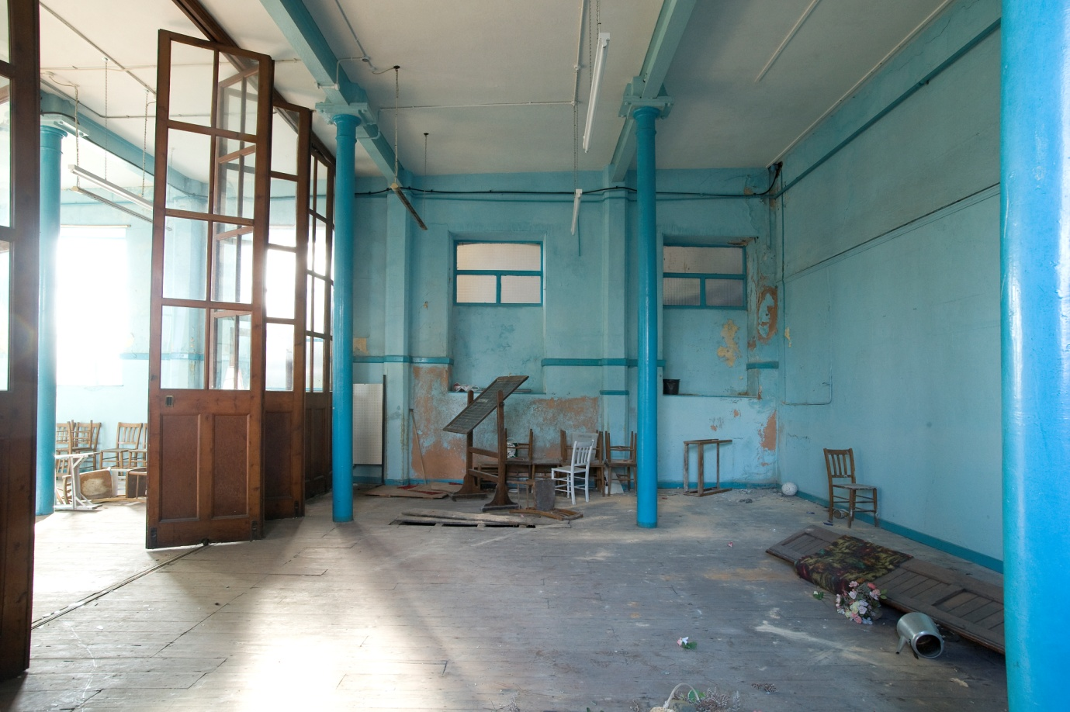
- School-room with folding doors.

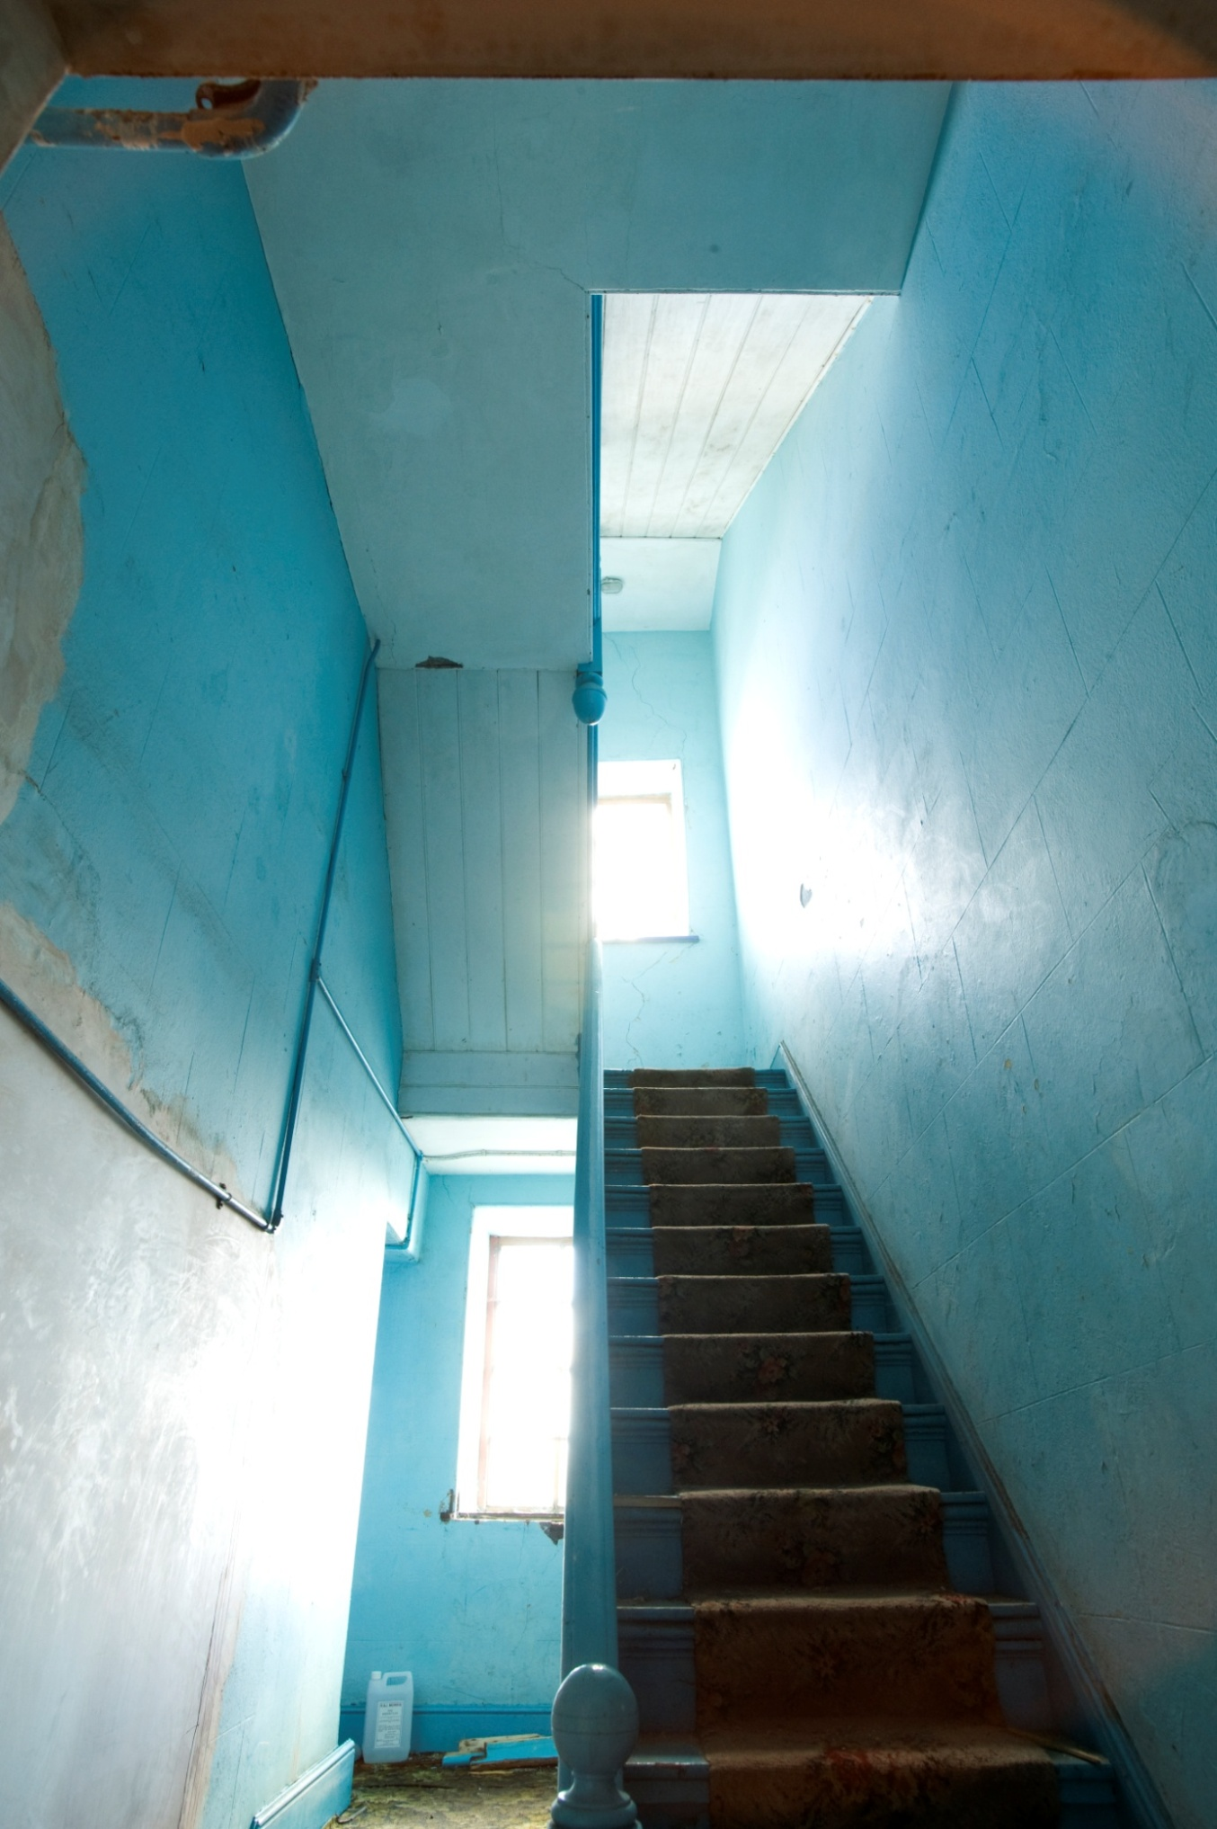
- Stairs at lower level of chapel.
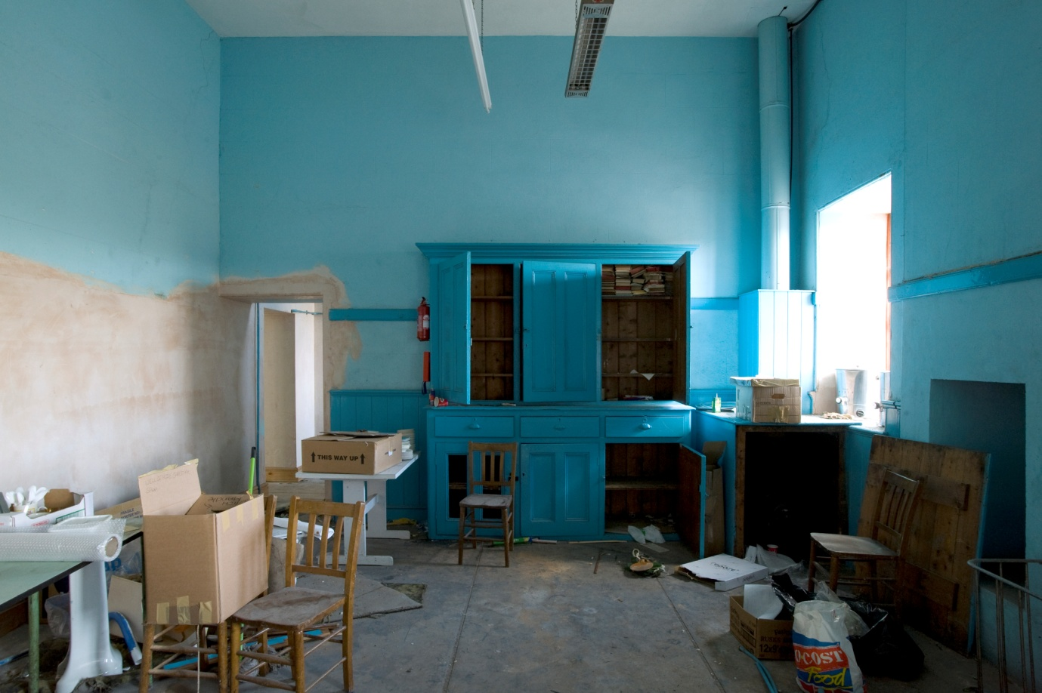

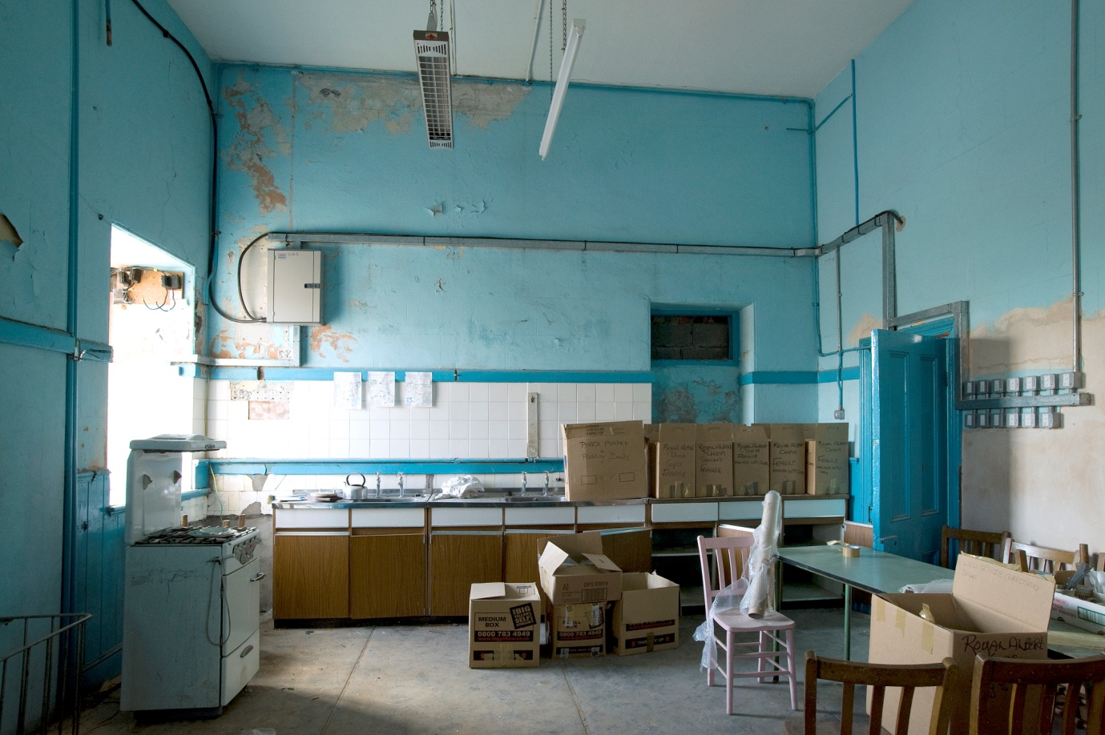
- Basement

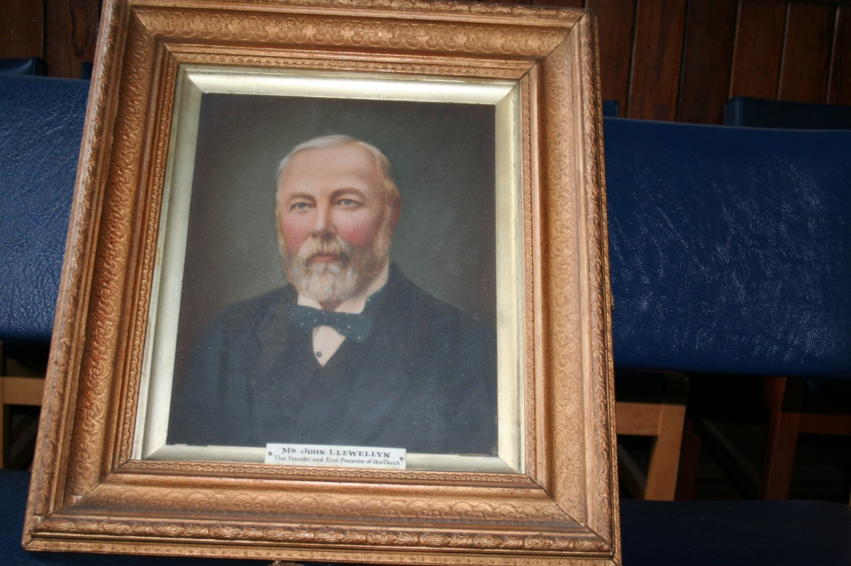

- Portrait of John Llewellyn, founder of the chapel, painted 1902.

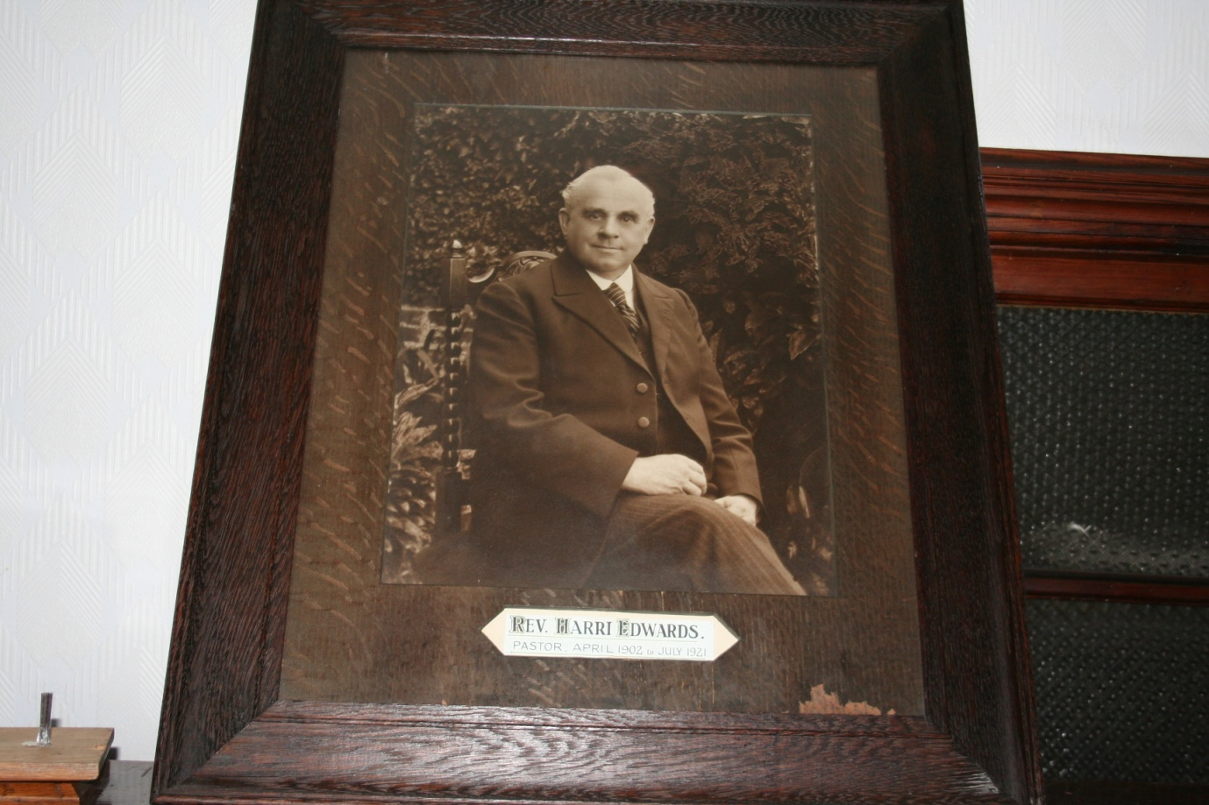
- Photograph of Rev. Harri Edwards, the first pastor.
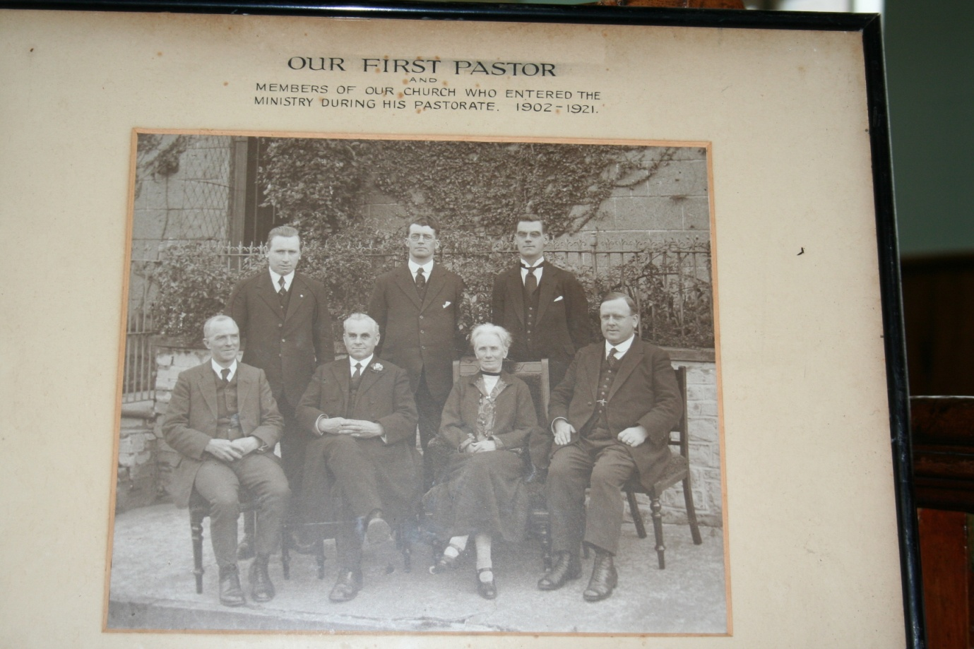
- Photograph of the Rev. Harri Edwards and members of Hanbury Road Chapel who entered the ministry during his pastorate.
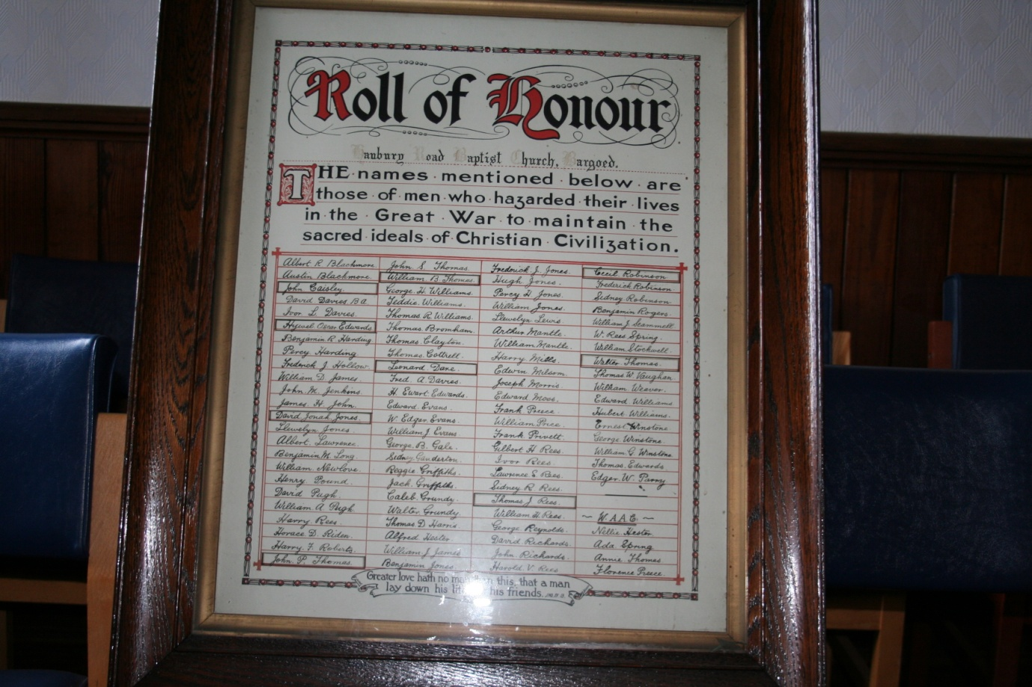
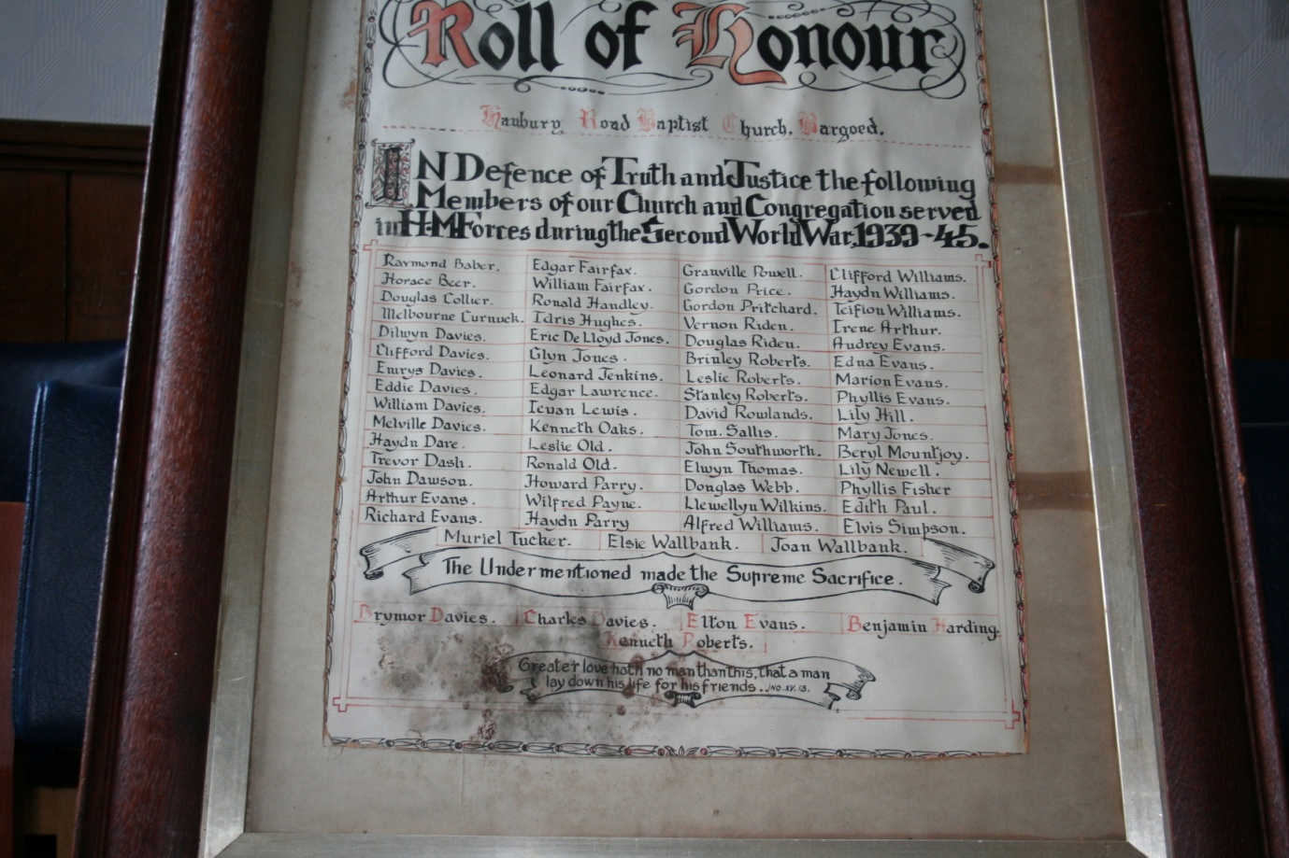

- The Rolls of Honour for World War I and World War II. Transcription of the names by Mr Alwyn Davies appended.

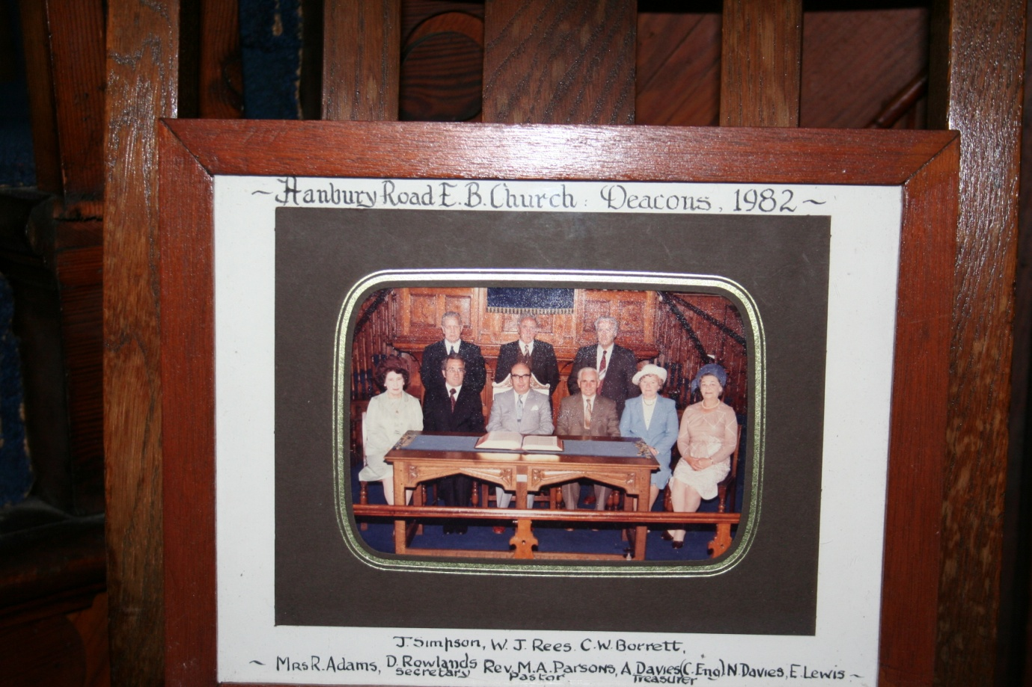
- Hanbury Road Chapel: Deacons, 1982

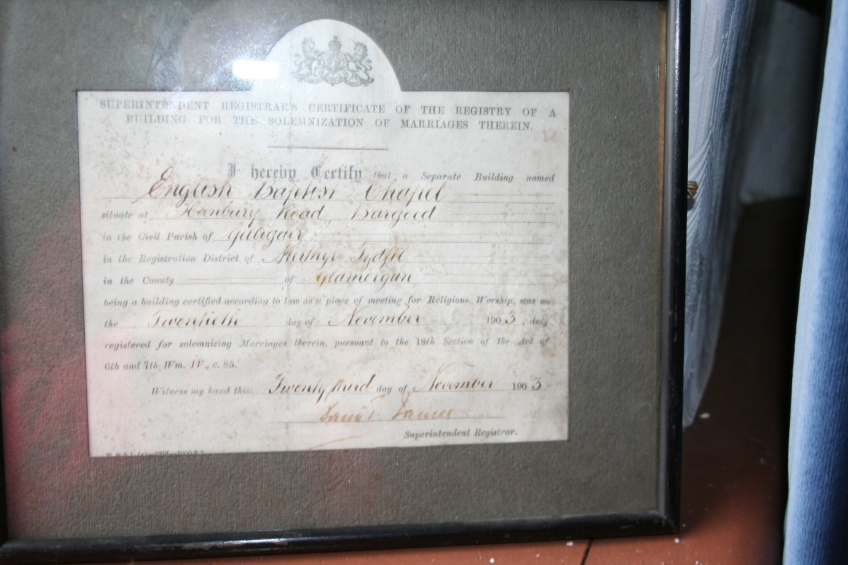
- Superintendant Registrar’s Certificate, 1903.
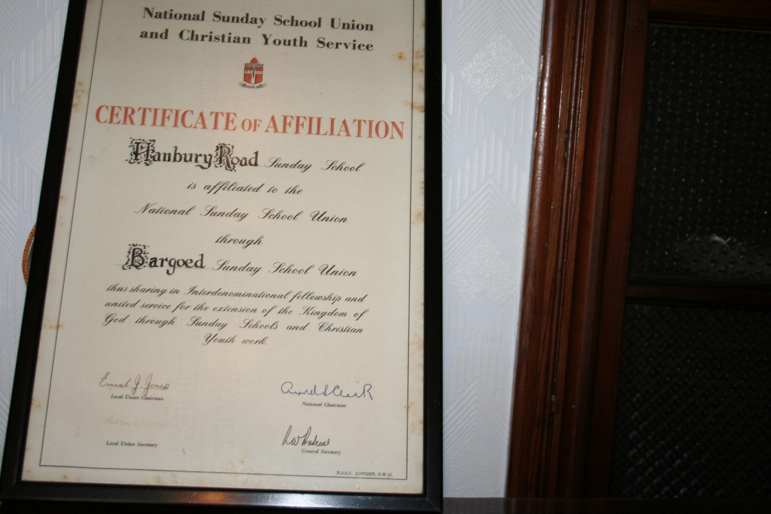
- Sunday School Affiliation Certificate.

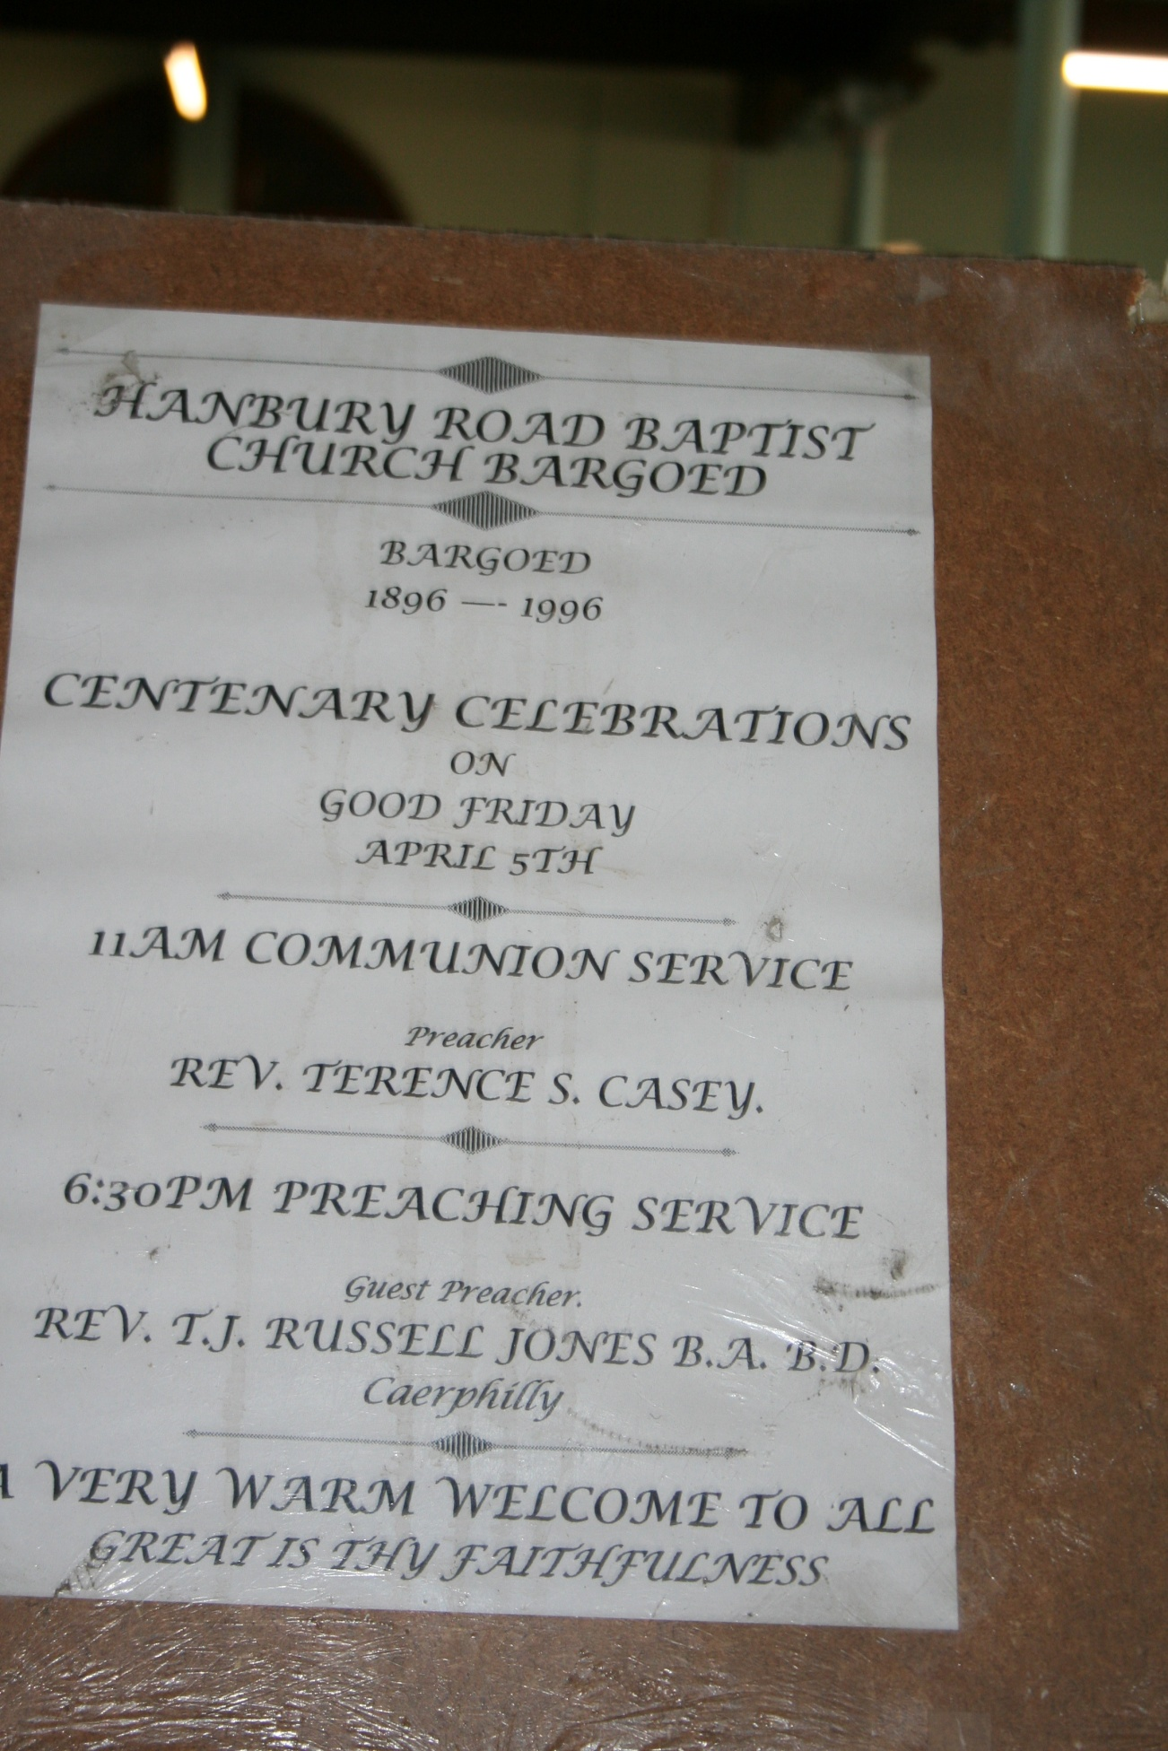

- Centenary poster.

