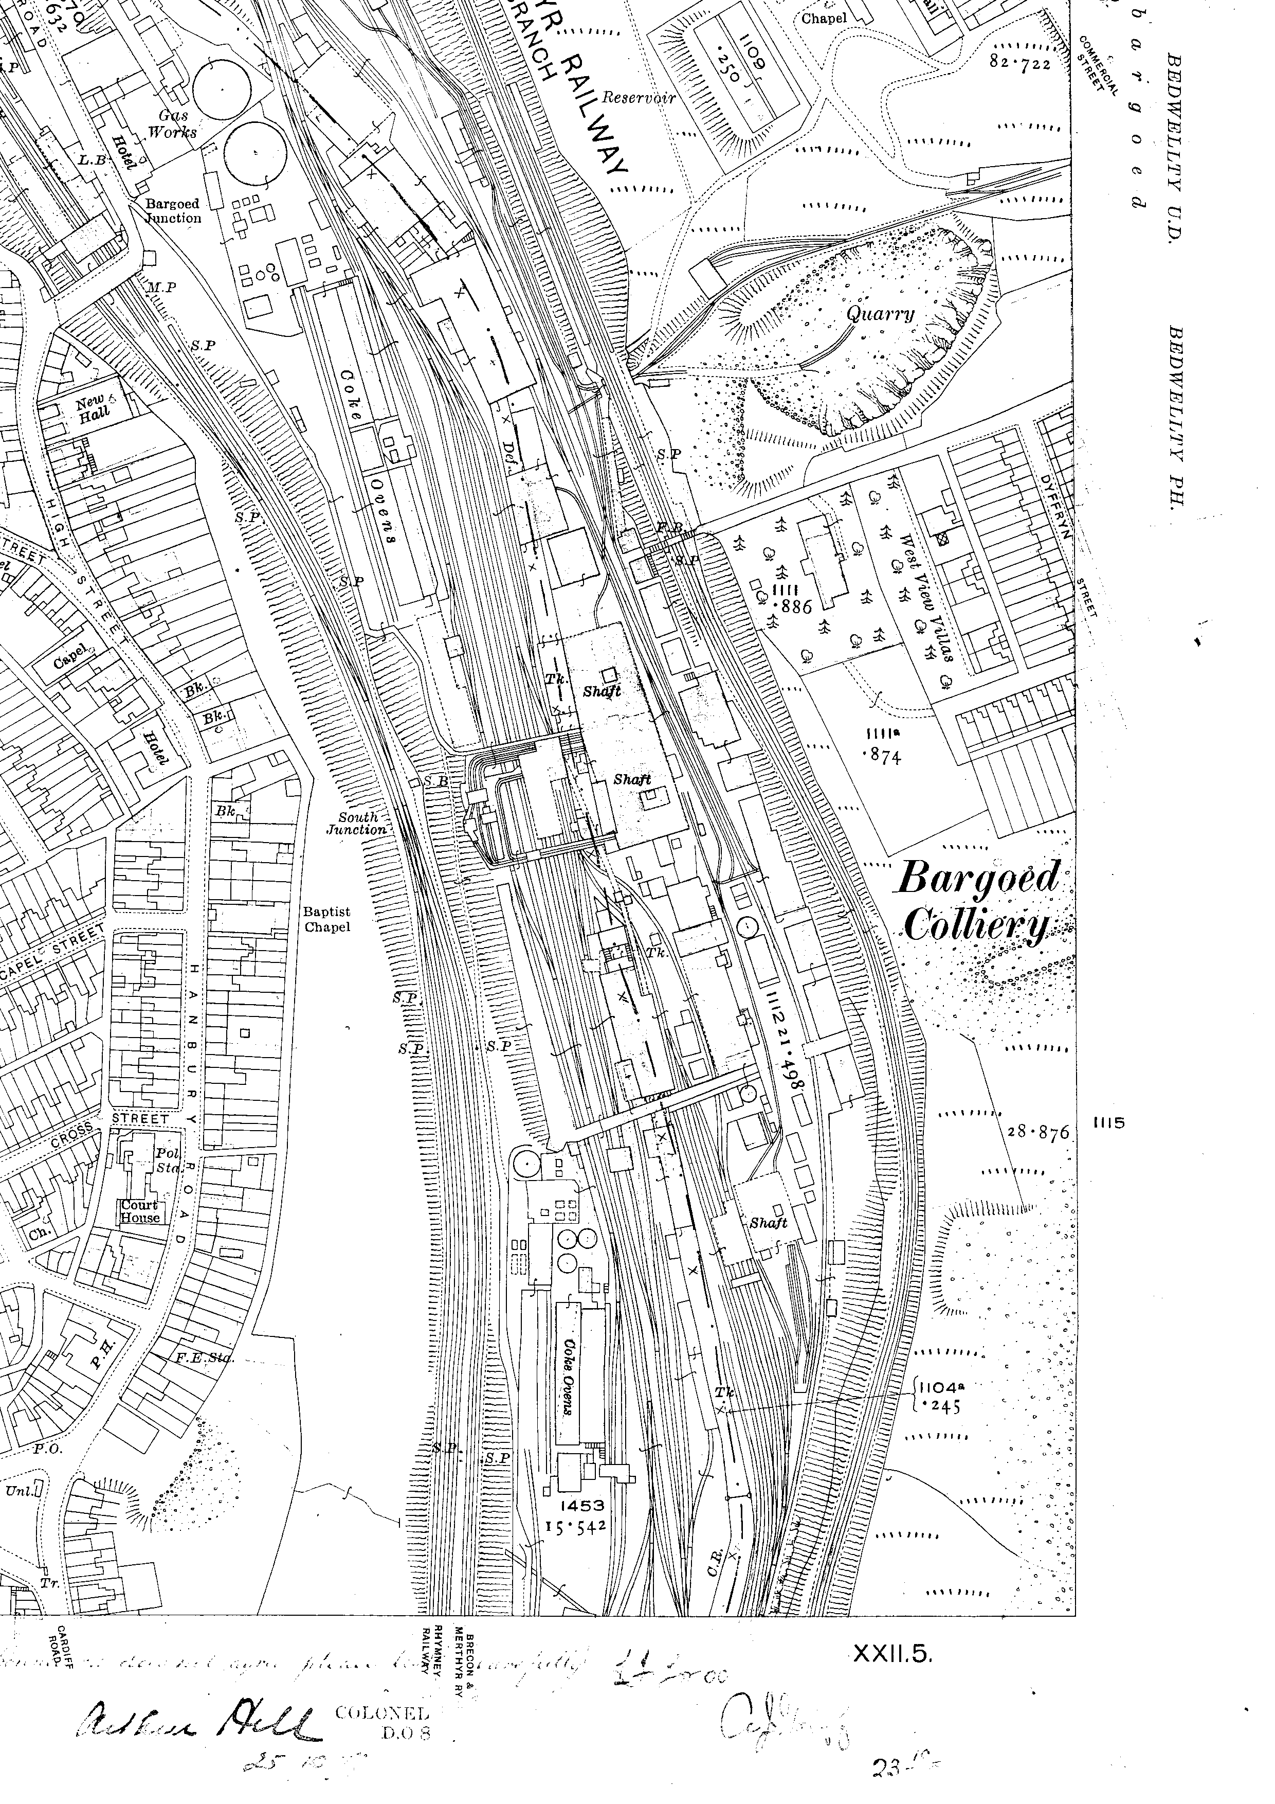
Location of Hanbury Road Baptist Chapel, Bargoed, as depicted on the O.S. 25-inch map (sheet XX:1, 1920 edition).

