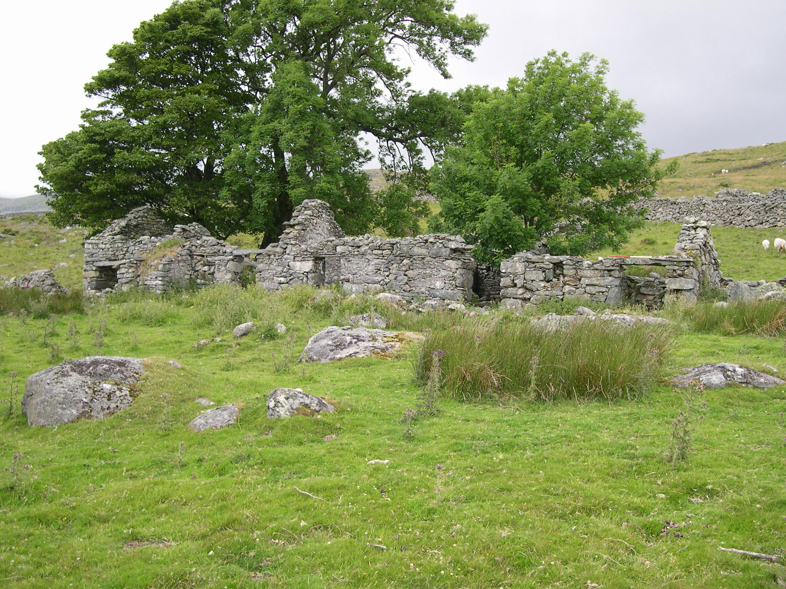

Plate 5: Farmstead at Ffrith-y-Bont (NMR 279146)

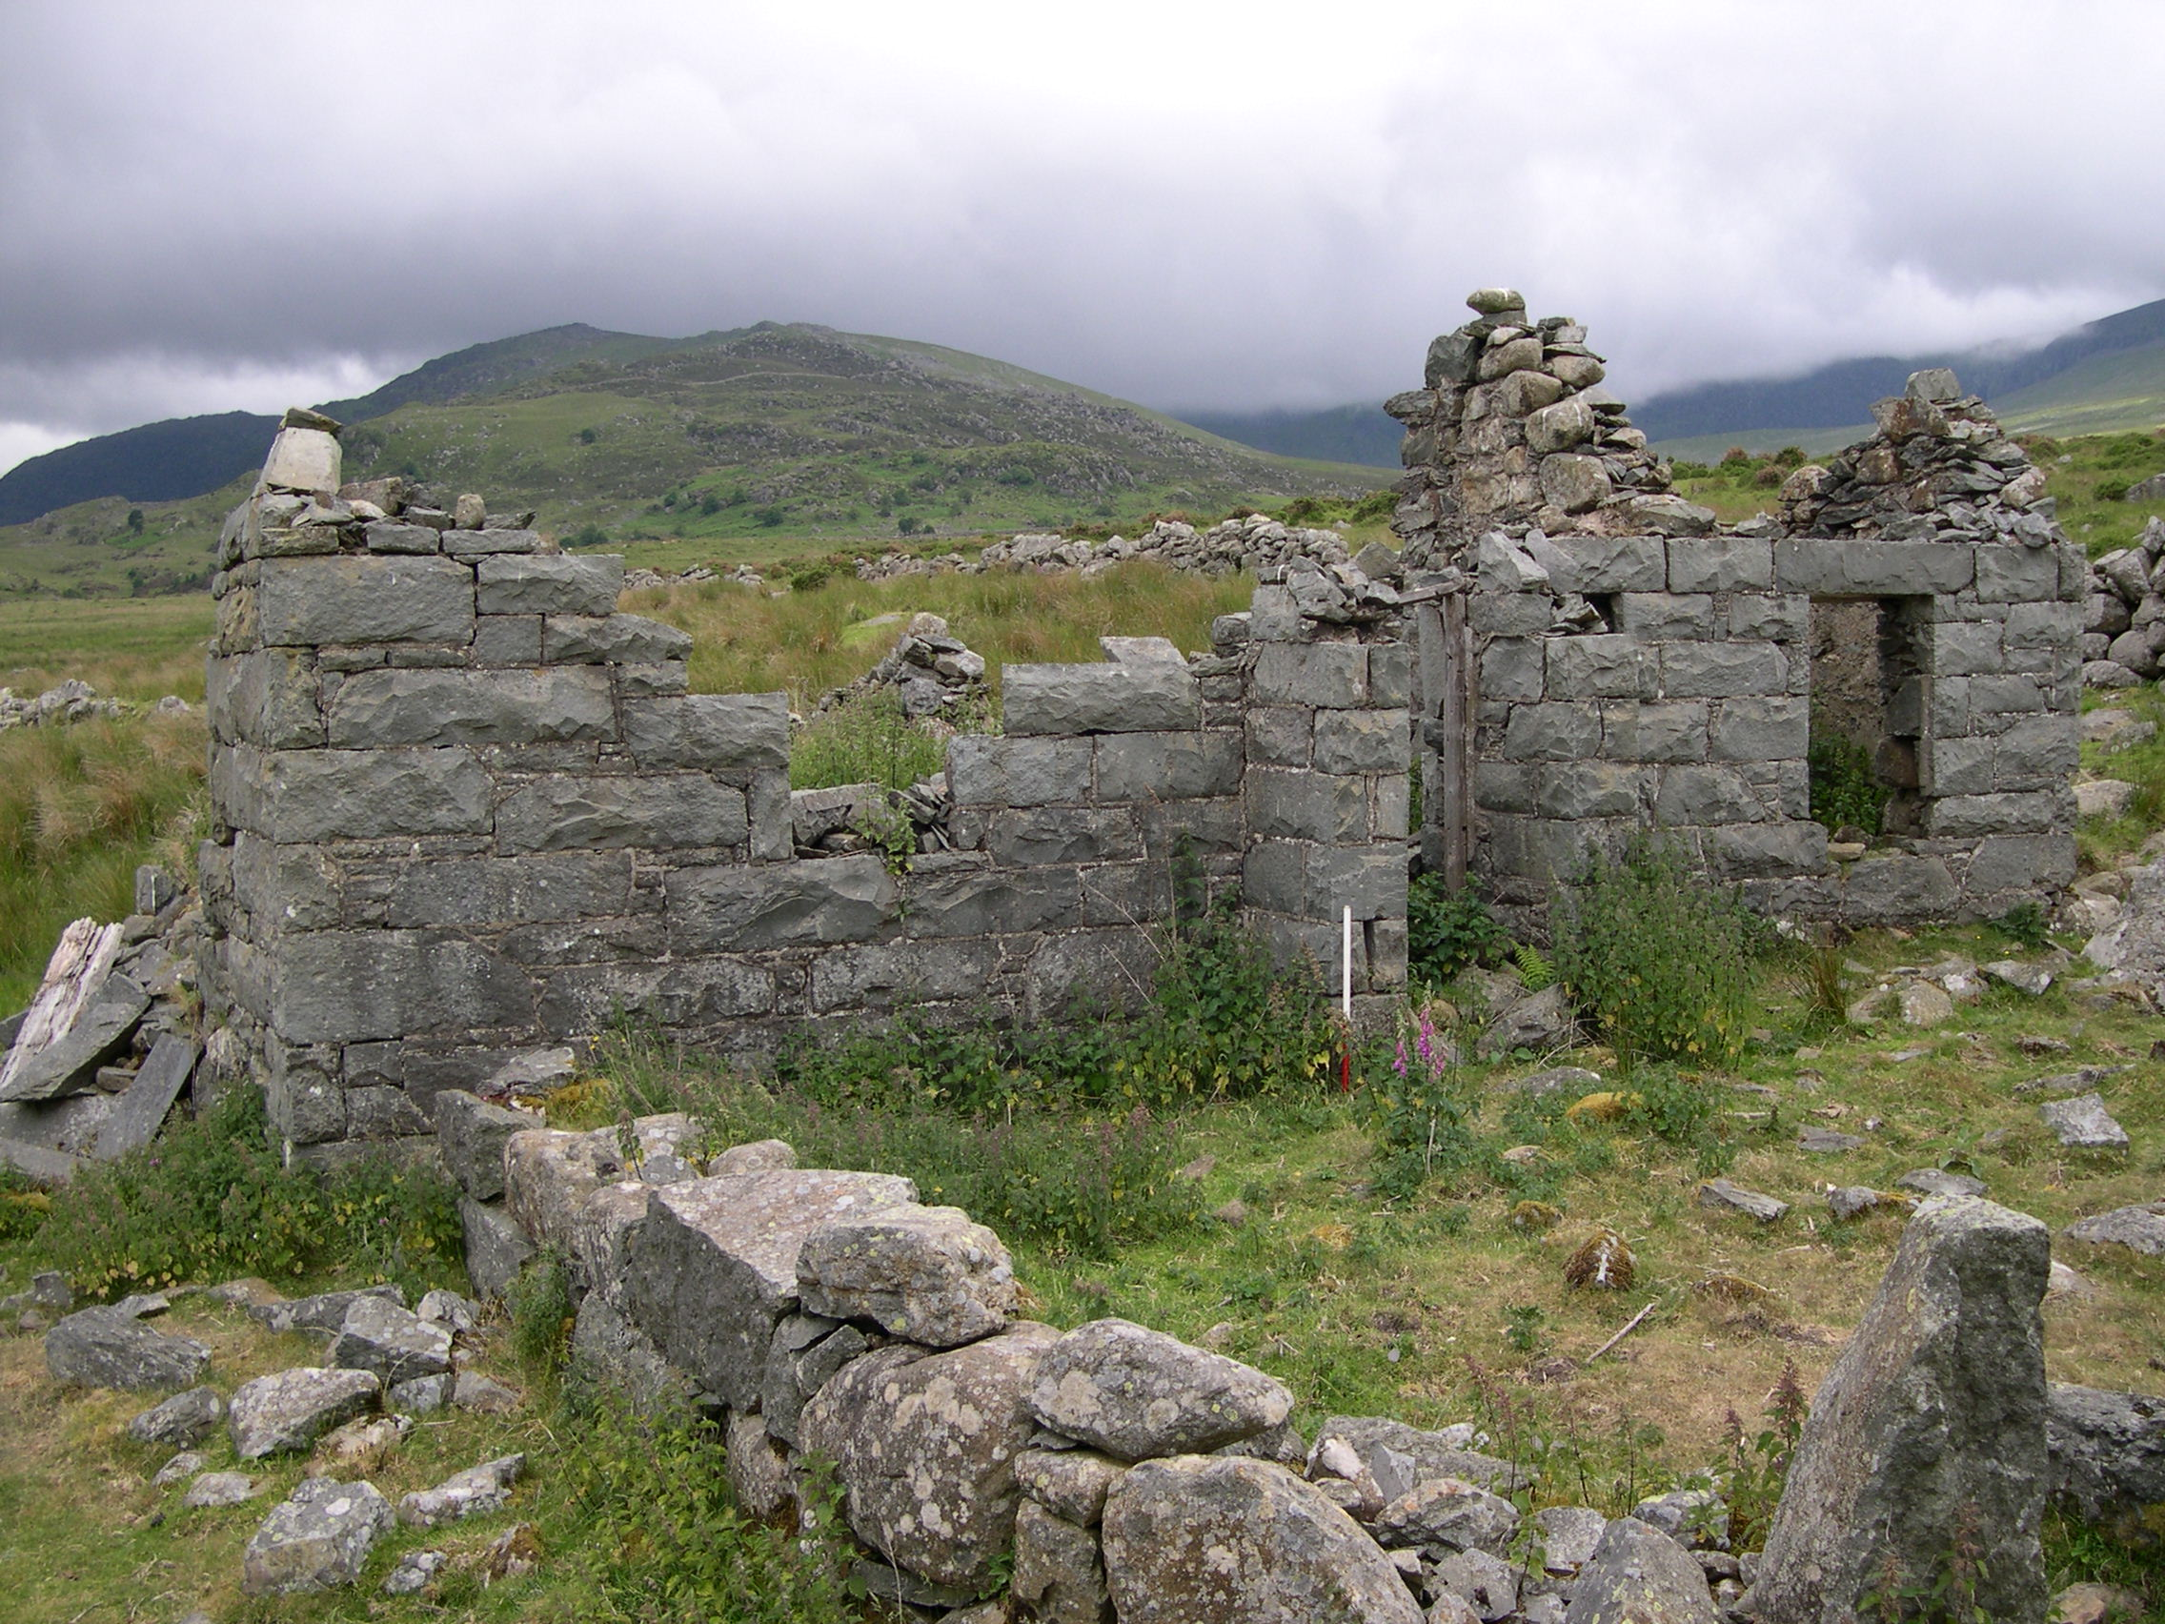

Plate 6: Farmstead at Hafodygors-wen (NMR 279053)

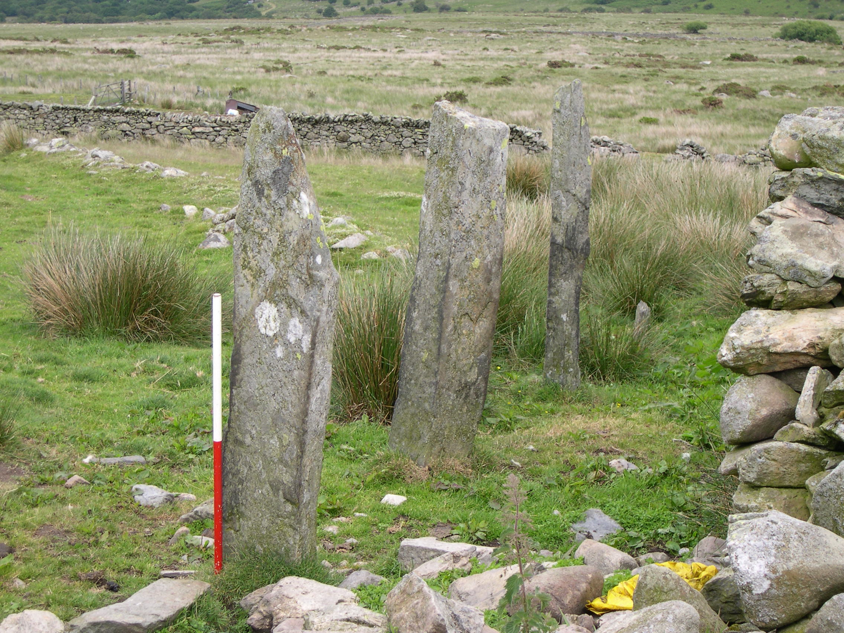

Plate 7: Upright orthostatic stone structure at Ffrith-y-bont (NMR 279061)

