Bancbryn Stone Alignment

A Response to CA Report 12226

‘Programme of Archaeological Recording’
Prepared by Wright, J. et al 2012

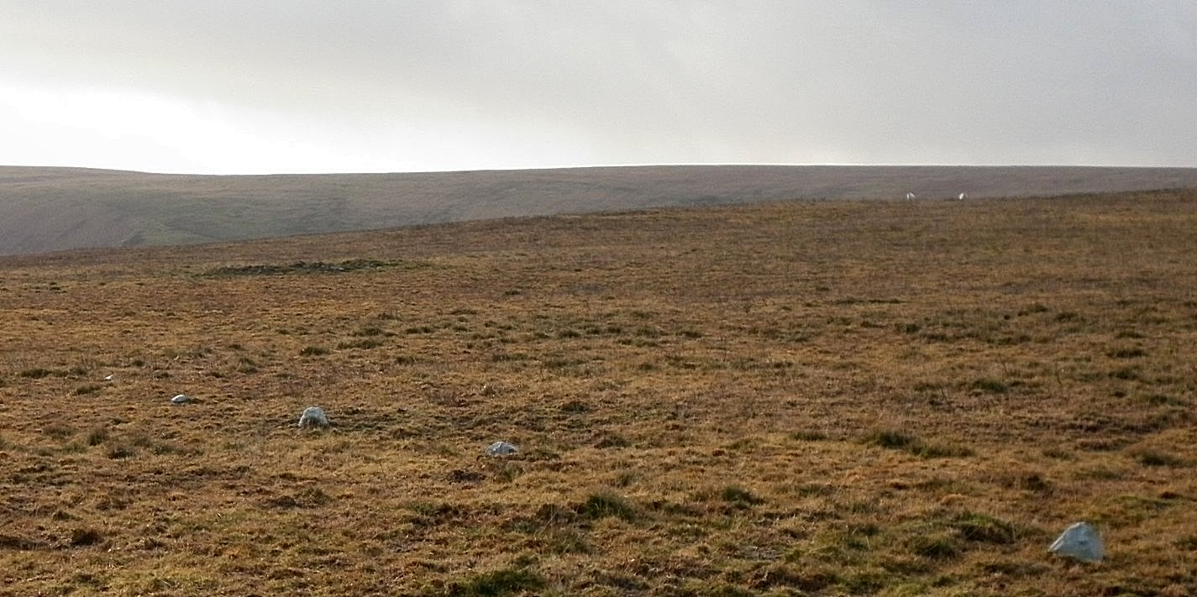

By Dr Sandy Gerrard
29th November 2015

Introduction
This response considers the evidence, information and interpretations offered within Cotswold Archaeology Report No. 12226 available on-line here. The focus of this response is the work associated with the Bancbryn stone alignment, which this author believes considerably understates the prehistoric potential of the monument. As well as examining and constructively challenging the detail, further evidence which has been overlooked or misrepresented by the authors will be examined within the context of stone alignment studies by this response. A strong and convincing case to support the identification of this heritage asset as a prehistoric stone alignment is offered together with evidence that the suggested post-medieval explanations lack any substance or credence whatsoever and are the result of failures to appreciate the character of the resource being studied.
The Cotswold Archaeology report was prepared and completed by the 28th November 2012, but has only recently been released. This delay meant that the scheduling assessment report prepared by Cadw in 2013 was unable to incorporate the results of the excavation and this together with the preparation of further field survey and other pertinent research means that a strong case for a formal re-assessment would appear appropriate and indeed desirable.
The structure of this response is determined by the format of Cotswold Archaeology Report No. 12226 (hereafter referred to as ‘the report’). Therefore, this response deals with the various points in the order in which they appear in the report. Quotes and headings from the report are highlighted by a grey background.
The report is, in my opinion, subjective, poorly written and makes no attempt to present all the available evidence and various interpretations in an unbiased academically rigorous manner. When considering the prehistoric interpretation for the alignment, only the issues which the authors consider to detract from this explanation are explored whilst the numerous reasons to accept the possibility of the hypothesis are not even mentioned. By marked contrast, when it comes to the alternative explanations only the pros are desperately explored and emphasised whilst the cons are ignored. It is clear that all available sources have not been consulted. This is an example of very poor scholarship and any decisions which rely on this report will inevitably be questionable. At three points the excuse of thick vegetation is trotted out for the alignment not being identified during the lengthy planning process. No evidence is presented to support this position which looks increasingly ridiculous as all bodies involved admit that no field survey was carried out at any stage prior to the discovery of the alignment. Surely it is time to admit mistakes were made and commit to changing a system which is clearly unfit for purpose. The very notion that archaeologists are content to allow development of uplands rich in earthworks without first conducting a full search to identify previously unrecorded remains is absurd on so many levels and cannot be justified. In this case, the situation was made far worse by the fact that the planning inspector had already pointed out in his own report the presence of unrecorded visible archaeology. However, even this was not enough to precipitate a final check. The discovery of archaeology during the development process was, therefore, inevitable. Worse still, this important landscape might have been safeguarded entirely had its full archaeological significance only been recognised earlier. The following headings and discussion are in accordance with the layout of the report.

The report summary notes that:
Summary
‘Four stones associated with a possible stone alignment were excavated and recorded. None were contained within associated pits or settings suggestive of a prehistoric stone row. Rather the stone alignment is interpreted as a waymarker for former pathways and access onto the moorland possibly associated with nearby mining activity’ (pg. 2).

- It is worth noting the obvious bias in this statement. To refer to the site as a possible stone alignment is untrue. Cotswold Archaeology’s own survey and further work by Cadw and the present author have confirmed that a stone alignment [an alignment of stones] definitely exists. What is in doubt is its date, function and purpose - a set of characteristics shared by most scheduled and non-scheduled examples of this monument class. It would have been more accurate to describe the site as a possible prehistoric stone alignment, which changes the emphasis of the sentence completely.
- The summary proceeds to note that none of the stones were contained within associated pits or settings. This comment is refuted by the photographic evidence produced in the report. In one [Fig. 8] a pit is clearly visible whilst in another [Fig. 9] the material below the stone has not been examined / removed.
- No other post-medieval waymarkers of this form are specifically recorded as such elsewhere and no explanation is offered to explain why the myriad of other trackways on this mountain or in the uplands of Wales have not been similarly denoted by lines of closely spaced small stones.
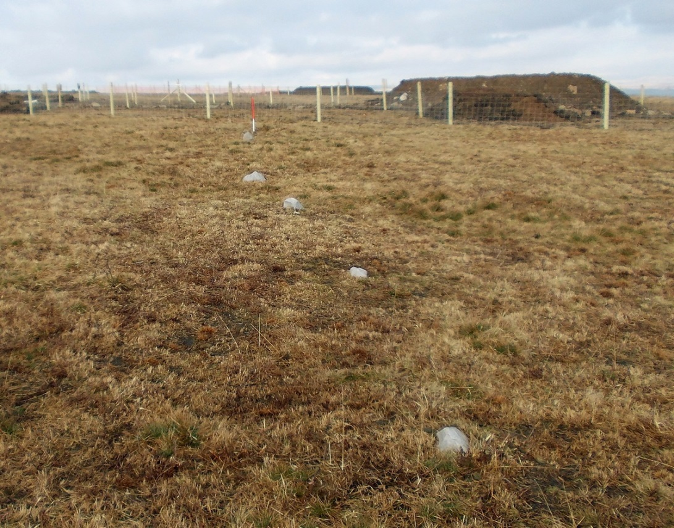
Figure 1. The stone alignment approaching the wind farm access road. View from the south west. (Author.)

Detailed Methodology
1.8 ‘During the development of the proposed layout of the wind farm all known archaeological sites were avoided to prevent direct impact to these remains’ (pg. 5)

- This is blatantly untrue. A small number of sites already recorded within the HER were not avoided. They may have been considered to be of lesser importance, but they were still archaeological sites, were known and have now been damaged, in some instances with no record being made.
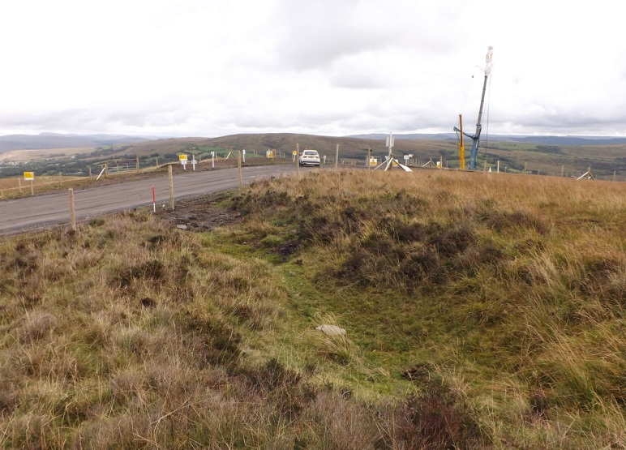
Despite assertions to the contrary, early coal mining earthworks identified by the Royal Commission in the early part of the 20th century were truncated by the wind farm access road. The failure to carry out an earthwork survey prior to destruction means that it is no longer possible to establish the crucial relationship between the known track and coal mining remains at this point - a great pity, given the later attempt to link the alignment with the coal workings. (Author.)
‘no archaeological fieldwork was undertaken during the preparation of the Environmental Statement’ (pg. 5).
- Why was this situation never challenged by Cadw, Dyfed Archaeological Trust or Carmarthenshire County Council? Both Cadw and DAT are on record expressing the importance of the archaeological remains in this area.
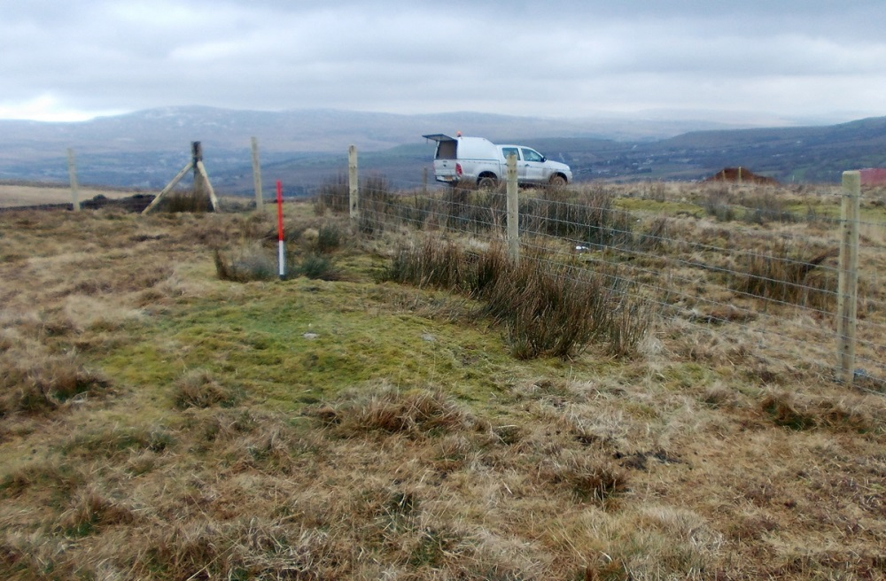
Figure 2. This small cairn (SN 6894910712) has been driven over by a tracked vehicle and had a fence post inserted into its edge. This heritage asset should have been identified during the planning process but was not. View from south west. Scale 1m. (Author.)

1.17 ‘Stage 4 works were undertaken following vegetation burning on the moorland in the summer of 2011
when a stone alignment was discovered between NGR SN 6855 0978 and SN 6890 1032’ (Pg.7).
- It is usual practise to acknowledge those responsible for identifying previously unrecorded sites when other than the creators of the report. This report simply notes that a stone alignment was discovered and thereby implies it was found as a result of work conducted by Cotswold Archaeology, which is incorrect. This churlish start sets the tone for the rest of the report, which clearly intends to minimize the potential significance of the alignment using a mixture of omission and misinformation.
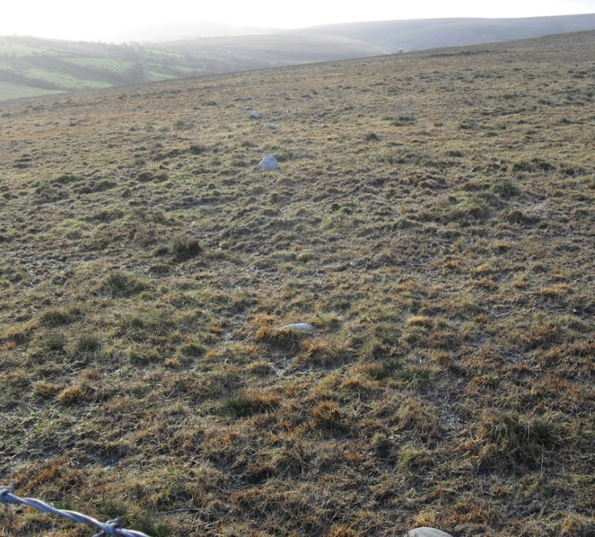
Figure 3. The stone alignment was identified on 2nd January 2012 by Sandy and Helen Gerrard. Looking south west from the access road on 2nd January 2012. (Author.)

‘The excavation of the stone alignment where it would be unavoidably impacted by the development and its protection by a physical barrier from accidental damage where it was not directly impacted by the development (pg. 8).
- The northern of the two interventions did not initially extend to include all of the affected length. The access track at this point was built into a cutting that extends beyond the area investigated. The trench was, therefore, too small to examine the whole extent of the area being destroyed. The additional work was carried out under limited archaeological ‘supervision’ rather than by rigorous ‘full excavation’ promised at the time the alignment was found.
- The plan showing the position of the northern intervention would seem to indicate that it did not, in fact, intercept the course of the alignment. The lack of evidence produced regarding the alignment, is therefore, entirely understandable, since the investigators were looking in the wrong location.
‘The preparation of a detailed non intrusive characterisation of the stone row’ (pg. 8)
- Despite being asked to and agreeing to carry out a characterisation of the alignment there is no evidence this work was ever conducted. There is certainly no mention of it in the report.
1.18 ‘during June 2012
the battering of the sides of the access road to turbine 15 necessitated on Health and Safety grounds threatened to impact on the stone alignment and following further consultation with DATHM. this area was stripped under archaeological supervision’ (pg.8).
- Parts of the alignment were, therefore, not offered the full excavation promised by Cadw and DAT. Indeed a 35m length of the alignment was destroyed with only 5m being archaeologically excavated.
- Throughout DAT have insisted that only 10m of the alignment would be destroyed. It is abundantly clear that considerably more was removed than official statements have previously indicated.
- Survey work carried out in 2012 and published here indicates that the northern intervention completely missed the course of the alignment. Therefore, the entire length within the access road was destroyed without any of the promised archaeological mitigation.
- On 16th February 2012 DAT wrote to the Betws Community Council informing them that:
‘The stone alignment is at least 700m long. In two small 5m long sections the access roads of the development have crossed the linear feature as there was no other reasonable alternative. Here, at these pinch points, the agreed mitigation was archaeological excavation, which has been carried out by the Cotswold Archaeological Trust. This work has been completed and there will be no further impact on the stone alignment from the development.’
This was untrue. A subsequent significant impact occurred in June when further lengths of the stone alignment were destroyed, but this time no form of archaeological mitigation preceded the destruction. There is no evidence that those who expressed concerns were ever informed of this additional destruction.
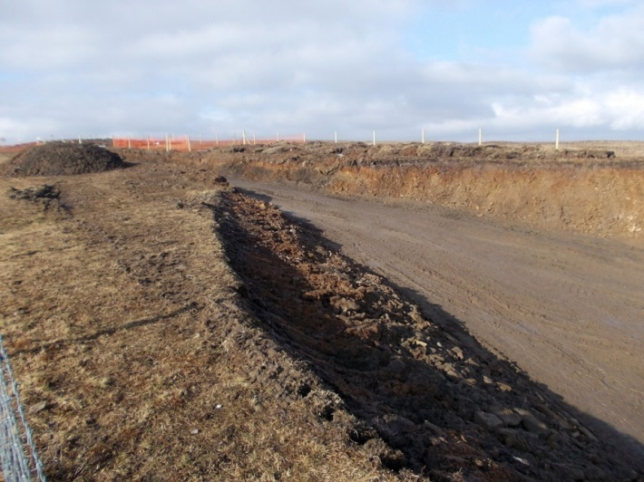
Figure 4. It should have been obvious from an early stage that the near vertical edges of the access road would need to be battered and that this would inevitably mean that more of the alignment would be lost. Despite this, instead of an excavation being carried out prior to destruction a watching brief was conducted instead. View of access road from the south east 7th February 2012. (Author.)
Results
2.1 ‘A non intrusive characterisation of the stone alignment, considering similar features in the region, its topographical setting and including results of the excavation produced in April’ (pg. 9).

- Characterisation of an historic asset would usually start with a detailed survey. No such survey was conducted, despite DAT expressly asking for this to be undertaken. The failure to carry out this fundamental task meant that the writers of the report did not have the necessary information with which to complete a competent assessment of the heritage asset they were examining. Without fully understanding form and character of the features under consideration, any subsequent interpretation will inevitably be misinformed, inaccurate and subject to challenge.
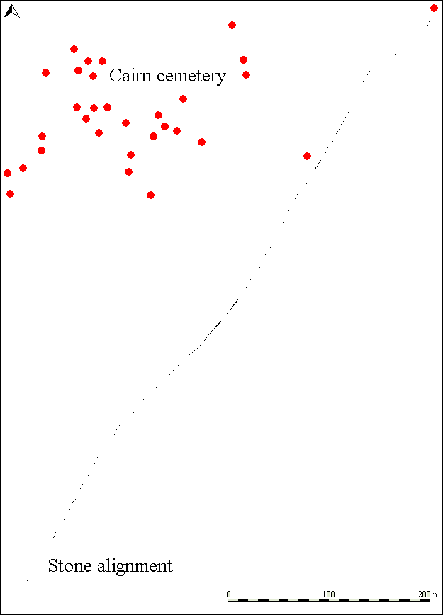
Figure 5. A plan such as this should have been produced to help the characterisation process. (Author.)
2.2 ‘Each stone was cleaned photographed and recorded before being half sectioned and lifted’ (pg. 9).
- How were the stones half-sectioned and why did this happen after recording but before being lifted? Archaeologically this description is inaccurate and written in deplorable English. Are we seriously to believe each stone was cut in half? Sadly, it shows less than due care and attention to detail in the production of this report and this at least, is consistent throughout.
‘None of the stones was contained within a pit or similar cut feature’ (pg. 9).
- The photographs within the report do not support this contention at all. The post-excavation image of Artefact 2 (Fig. 9) shows that the material below the stone remains in situ and has thus not been excavated at all whilst the pre-excavation photograph of stone 1 (Fig. 8) appears to show that the stone is clearly sitting within a cut.
Discussion
3.1 ‘The excavation of the stones of the stone alignment have neither proved nor disproved the age of the stones’ (pg. 11).

- This statement is true, but sadly, indicates work has been grievously omitted. The substantial sealed deposit below at least one stone could have been used to provide a sample to enable pollen or other environmental analysis to be conducted. This in turn might have provided a broad idea of the date or, at the very least, of the prevailing environmental conditions when the stone arrived at this location.

‘ None of the stones has been shown to be contained in a pit cut to hold it and no artefacts were recovered to aid their possible dating’ (pg. 11).
- The evidence provided in the report does not support the contention that none of the stones were associated with pits, only a small number of stones were even examined and of those one may even be in a cut.
- The recovery of artefacts from prehistoric stone alignment excavations is rare. When the 217m long stone alignment at Cholwichtown (SX 585623) was totally excavated in the 1960’s no artefacts were recovered (Eogan G. and Simmons J.G., 1964). It is therefore, inaccurate to infer this lack of evidence is an argument against its prehistoric origin, when it is conversely, entirely consistent with its being so. In addition, artefactual evidence is NOT the only form of dating available as indicated by the environmental evidence mentioned above.
‘The impression gained after excavation is that they had been placed on the ground surface and that some may have become bedded in the subsoil or natural possibly as a result of biological activity’ (pg. 11).
- This sentence makes it very clear that the authors of the report are struggling to explain how a stone recently placed on the surface might have become embedded in the subsoil whilst all the material it was originally sitting on had miraculously vanished. Precisely which ‘biological activity’ might cause such a scenario? Animal burrows, for example, leave archaeologically recognisable traces if excavation is carried out proficiently. No evidence to support the biological activity explanation has been presented. An alternative and much more plausible interpretation is that the soil was ‘removed’ and the stone was placed in a hollow. This would surely suggest, it was located in a cut specifically made to receive it.
‘The relative lack of depth through the soil profile seems to point to a relatively recent origin’ (pg. 11)
- This sentence, which is pivotal to the ‘recent origin’ explanation, does not bear much scrutiny. As a statement it is ambiguous. Are the authors suggesting that the shallowness of the soil means the site cannot by necessity be prehistoric since all such features are always deeply buried? The previous sentence in the report made it very clear that at least one stone was embedded into the natural. By extrapolation, this means at least one was as deep as it could possibly be. If the authors are suggesting that the site cannot be prehistoric because the soil is shallow, this illustrates a fundamental flaw in their position. The depth of soil overlying archaeological remains cannot be used as a clue to their age. The nearby cairns have no or very little soil cover at all and yet they are accepted as being prehistoric. The relatively shallow soil in this area cannot be used to support the position that this alignment is of relatively recent origin, in just the same way that it cannot be used to demonstrate considerable antiquity. The use of the word ‘relative’ is also misleading, to what is the depth of the stones being compared? If the soil on the uplands is already naturally thin, there can never be a huge amount of soil profile to begin with which the depth of the stones may be related.
‘The alignment may represent the remains of an otherwise lost wall, or perhaps the suggestion of waymarkers is correct’ (pg. 11-12).
- Other historic boundaries on Mynydd y Betws consist of banks and ditches. Expansion onto the common elsewhere in the area invariably involved the digging of a corn ditch and the absence of this combined with the regular spacing of the stones means that the wall explanation does not take account of the available evidence and is therefore untenable on any level.
- No pertinent evidence to support the waymarker explanation is offered anywhere in the report. There are however many strong reasons for challenging it and these are presented later in this response (pg.16).
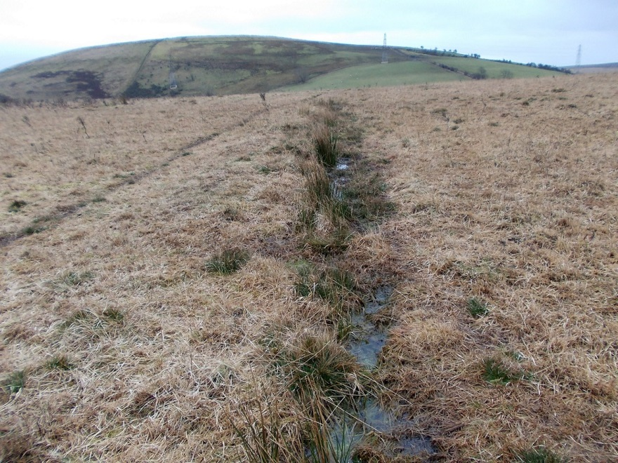
Figure 6. Historic field boundary and ditch on Bancbryn at SN 6914 0997. This is the characteristic form of land division in this area. (Author.)

3.3 ‘no ditches pits or other cut features have been identified during the various phases of archaeological works on Mynydd y Betws’ (pg. 12).
- This is a surprising conclusion since at SN 69072 09788 a bank and ditch truncated by the access road were clearly visible in February 2012.
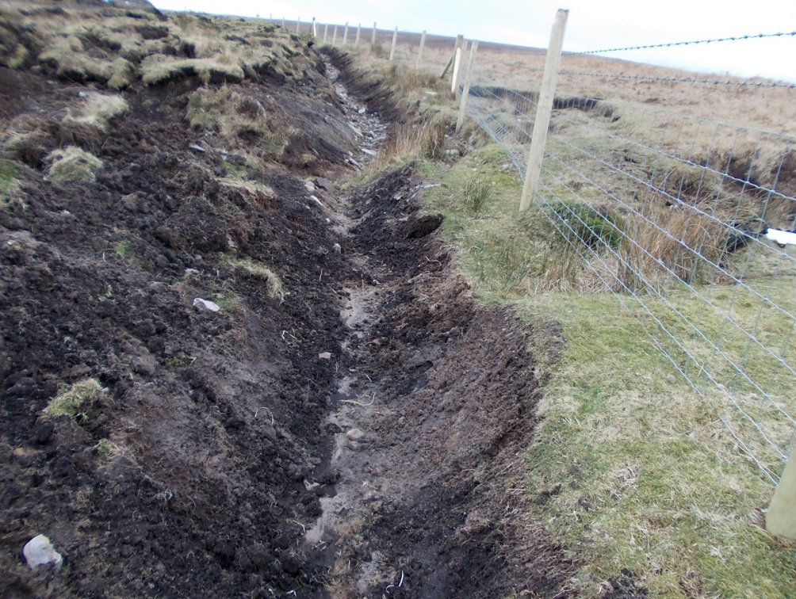
Figure 7. Ditch and bank cut by a channel associated with the access road at SN 69072 09788. View from south east on 16th February 2012. (Author.)
Ditch

Preliminary Statement on a Stone Alignment
The original Preliminary Statement produced in April 2012 is included within the report. Comments on this statement were submitted to Cadw and DAT on 29th May 2012. It is clear that none of these comments have influenced the final report which is rather unfortunate since many were pointing out errors of fact, many of which have implications for the explanations offered. The Preliminary Statement in my opinion is subjective, poorly written and makes no attempt to present all the available evidence and various interpretations in an unbiased academically rigorous manner. When considering the prehistoric interpretation for the alignment, only the negative issues which the authors considered detracted from this explanation being plausible were explored whilst the numerous reasons to accept the possibility of the hypothesis are not even mentioned. By marked contrast, when it comes to the alternative explanations only the pros are desperately explored and emphasised whilst the cons are ignored. Furthermore, it is clear that all available sources have not been consulted with most of the regional comparatives being ignored. The absence of any excavation photographs and drawings truly indicates the superficial and inadequate nature of the Preliminary Statement. This is an example of very poor scholarship and any decisions that rely on this report will inevitably be questionable.
Some aspects of the Preliminary Statement have already been considered above and will not be repeated here. The remaining points which should concern those with an interest in the professional reporting of archaeological matters are dealt with below.

1.7 ‘ the appraisal noted aerial photographic evidence suggestive of shallow adit workings possibly representing seam prospecting in the vicinity of turbines 14 to 16 visible from aerial photography’ (pg.23).
- The report refers to the outcrop coal workings in the vicinity of the stone alignment as shallow adit workings. There is at least one adit associated with these workings but no evidence that it was connected to these surface outcrops. If the adit did form part of these workings it would have been very unwise to build turbines in this area without first checking the stability of the underlying geology. The surface remains strongly suggest the presence of a low capital, labour intensive, small scale and short lived extraction of the outcrop alone and the term 'adit working’ would therefore seem misleading and wholly incorrect.
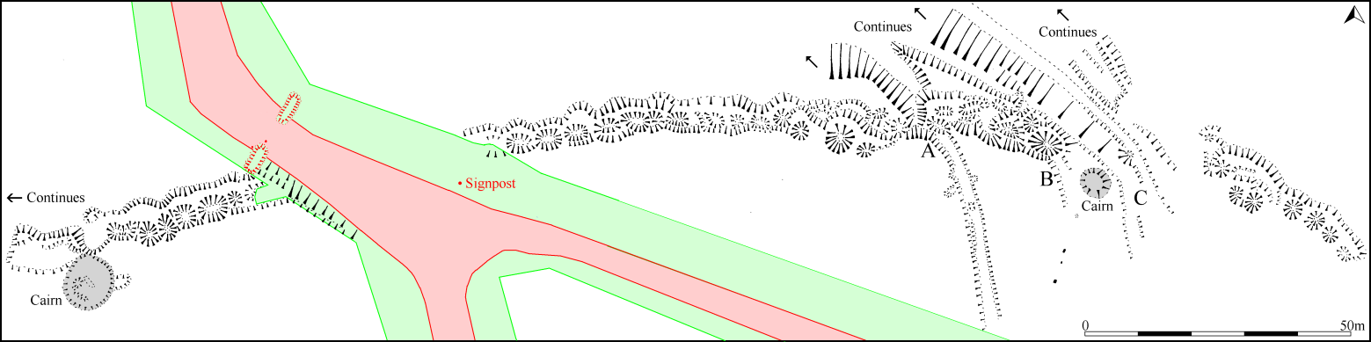
Figure 8. A length of the outcrop coal working earthworks nearest to the stone alignment were destroyed without record. These workings were considered to be 18th or early 19th by the Royal Commission who visited the site in the early part of the 20th century. This was one of at least three separate areas of industrial archaeological remains damaged by the development. The failure to record the earthworks prior to destruction means that the significant relationship between a moorland track and the coal workings is not known. Yet it is consistently referred to as definitive dating evidence for the alignment when the date for the workings themselves has also not been proven. (Author.)

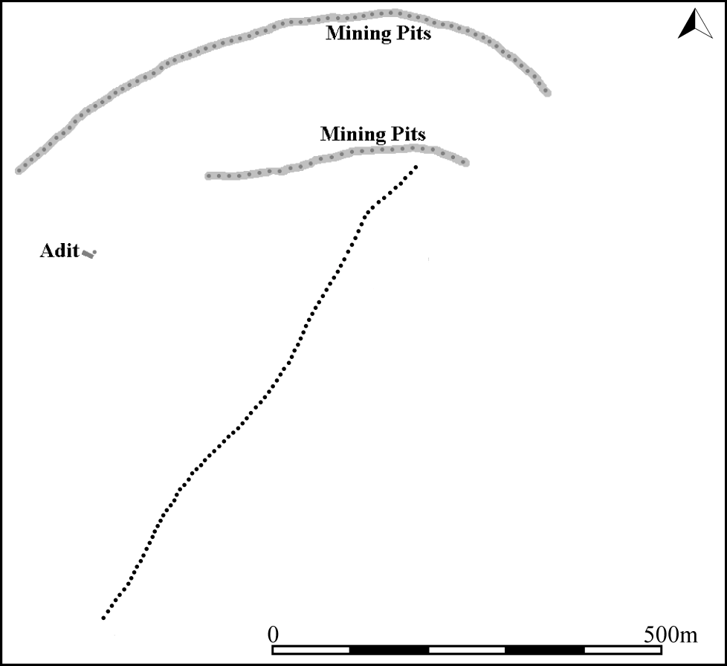
Figure 9. Simplified plan showing the position of the coal workings at Bancbryn together with the stone alignment (Author.)

1.12 ‘In preparation for the current report aerial photographic evidence and Ordnance Survey cartographic sources were consulted at Dyfed Historic Environment Record. No evidence for the stone alignment was revealed on any of the consulted sources’ (pg. 24).
- A short length of the stone alignment is clearly visible on both Google (2010) and Bing (2001) aerial photographs and it is therefore surprising to read that ‘no evidence for the stone alignment was revealed on any of the consulted sources.’ Why was publically available material not consulted? These photographs of course provide further evidence that the stone alignment was clearly visible and not wholly obscured by vegetation as claimed.
- Information released under the Freedom of Information Act contradicts this statement. Internal DAT correspondence notes ‘it really does look as if it’s one of many aligments (sic) that converge on the farm to the south west. it would be a track of some sort. Very important that I get Cotswold to pickup on this information’. Why would the authors of the report chose to ignore this information or perhaps DAT did not inform them. Whatever the reason there is an obvious contradiction here.
2.1 ‘The stone alignment is currently visible subsequent to vegetation burning in late summer 2011 on the moorland’ (pg.24).
- The stone alignment was visible prior to the most recent burning of vegetation. Google (2010) and Bing (2001) images clearly show the larger stones with no vegetation cover. Again evidence to support the contention that the alignment was not previously visible has not been provided. That the archaeological mitigation strategy failed to include an overall field survey element is a much more likely explanation for the failure to identify the feature at the outset. It has been claimed that this is the most studied hilltop in Wales and as much of this work was carried out in 2011 in the period before the fire, surely photographs must be available to demonstrate the precise character of the vegetation that made it impossible to see the archaeology on this hillside. Yet strangely, these have never been produced.
2.2 ‘The stones are mainly laid flat with variable distances between those that are visible’ (pg. 24).
- This wording implies that the stones were originally positioned this way but there is currently no evidence to support this contention. Also what is meant by ‘mainly’? An empiric value or percentage based on the alleged characterisation of this specific stone alignment might have been a more useful indication than the word ‘mainly’. According to this statement detailed investigations were carried out so precise figures on upright and recumbent stones should have been made readily available for academic scrutiny.
- A survey and characterisation of the stone alignment which should have been carried out as part of the agreed programme of works would have revealed that 52.4% of the stones are edge-set and have clearly been placed along the length of the common alignment. The statement that the stones are mainly laid flat is, therefore, completely unsupportable and indeed plain wrong. This misunderstanding of the character of the alignment will have contributed to the incorrect interpretation and explanations being derived and thus offered as fact.
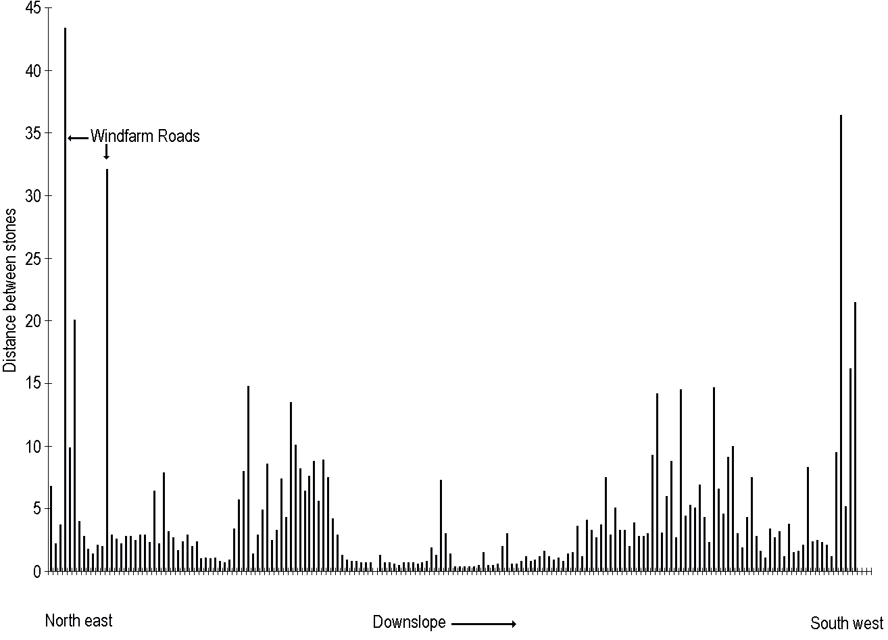
Figure 10. Bar graph showing the distance between stones. This clearly illustrates the damage caused by the wind farm access roads but more importantly highlights the regular spacing along much of the row. Many of the larger gaps are probably the result of damage or as a result of the stones being buried below the turf. No ground penetrating survey was carried out. Characterisation would usually include this type of work and would have helped the authors of the report to produce a more coherent and evidence based assessment. (Author.)

2.3 ‘The land is currently open moorland and there are no direct threats to the integrity of the row’ (pg. 25).
- This is a very bold and inaccurate statement. The authors appear to have a rather optimistic view concerning threat. This area has now been developed and access to it much increased. Unprotected, the site may become a target for unregulated excavations. Compared with many other wind farms the density of turbines is low and there will undoubtedly be pressures to increase the number of turbines on the hillside in future years. If the alignment is not afforded statutory protection it is very likely that it will be damaged again. Perhaps the authors would prefer to view these as indirect threats, although I prefer to see the erection of turbines in its immediate vicinity as having an impact on its setting. A view that Cadw has already expressed.
- Similar fragile stone alignments in comparable open moorland on Exmoor are regularly damaged. Admittedly scheduling has apparently proven an inadequate tool for dealing with these problems although clearly the amount of destruction could have been far greater without statutory protection measures in place. The fragile nature of the alignment has clearly not been factored into the threat assessment.

2.4 ‘During the preceding evaluation a trench (ET 36) was excavated across the then undiscovered stone alignment. No archaeological evidence was identified within this trench with the natural substrate being encountered 0.20m below the existing ground surface’ (pg. 25).
- The methodology used for the original evaluation trench (2011) would have been very unlikely to reveal anything subtle. Confirmation that the alignment was not identified, therefore comes entirely without surprise. The inability to find it does not mean that it was not there, but rather it highlights a significant failure in the methodology employed to locate archaeological evidence.
2.5 ‘ Despite careful hand removal of topsoil and subsoil (encompassing an area 3m either side of the projected line of the stone alignment) no archaeological features or artefacts were encountered where the projected stone alignment crossed the access track to turbine 16. No stones were visible at ground level prior to commencement
of the excavation, and no stones were subsequently encountered during the hand removal of turf and peat removal nor during the subsequent hand cleaning of the trench base’ (pg. 25).
- The trench was positioned west of the alignment’s course as indicated by subsequent survey work and it is therefore not surprising that the alignment was not found since the search was being made in the wrong place.
- There are no overall photographs of this trench within the report and the information provided is therefore insufficient to allow an independent review of the excavated evidence.
Stone alignments - definition
3.1 ‘A stone alignment comprises a single line, or approximately parallel lines, of upright stones. The number and size of stones within an alignment varies a good deal, from very short stretches comprising three or four stones to more extensive lines running across upland landscapes’ (pg. 26).
- The stone alignment at Bancbryn is of the ‘more extensive lines running across upland landscapes’ type.
‘A stone alignment can be distinguished from other types of monuments by its relative straightness’ (pg. 26).
- Stone alignments are rarely precisely straight and all of the longer ones and many of the shorter ones have a sinuous character.
3.3 ‘An alignment was recorded at Saith Maen in the Upper Tawe valley, comprising a single alignment of seven upright and recumbent monolith stones. The largest here are the recumbents one of which is 2.9m long. The upright stones rise to around 1.7m high, and the alignment is approximately north north east to south south west. It may be noted that this alignment is frequently noted for comparable examples on Dartmoor, although the latter are generally of much greater length and frequently associated with round cairns (Leighton 1998, 56). The alignment is undoubtedly of Bronze Age date’ (pg. 27).
- There is no evidence to support the contention that the alignment at Saith Maen is of Bronze Age date. No scientific evidence or artefacts have been produced. The Bronze Age interpretation is based simply on the fact that it looks similar to other sites that are also accepted without any supporting evidence to its being prehistoric. Yet such a situation is bizarrely not admissible when it comes to the Bancbryn stone alignment.
- The comparisons with Dartmoor are perhaps mentioned to give the site at Saith Maen some credibility, which is somewhat ironic, given the Bancbryn alignment has much more in common with the Dartmoor alignments than Saith Maen which looks unlike any Dartmoor alignment. The fresh appearance of the stones together with a lack of prehistoric context and documentation indicating that it was used as a sheep-fold also throw doubt on this sites prehistoric credentials.
- There is a broad consensus that this Saith Maen is Bronze Age on typological grounds. Sadly, the same grounds were not applied to the Mynydd y Betws alignment where the courtesy of linking the site with typologically similar sites such as: Black Tor (Avon), Brent Fore Hill, Corringdon Ball, Langstone Moor, the Upper Erme, three alignments at Fernworthy, Butter Brook, Sharpitor, Shoveldown 1 and 5, White Ladder, White Ridge, and Shaugh Moor alignments was not afforded.

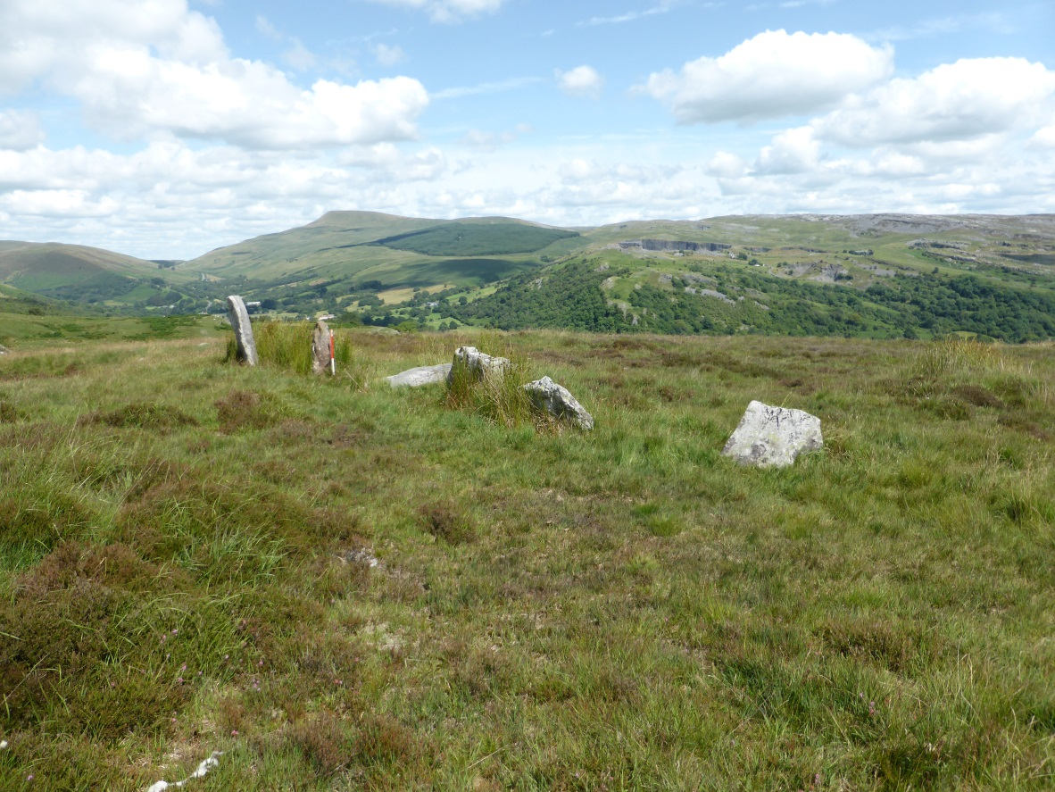
Figure 11. No evidence exists to support the contention that the stone alignment at Saith Maen is of prehistoric date. Its acceptance as prehistoric is based purely on the fact that it looks like other sites that are considered to be prehistoric. It would therefore be inconsistent to suggest that the same typological methods should not be applied to the alignment at Bancbryn which visually has more in common with many of the Dartmoor alignments than the example at Saith Maen. (Author.)

‘The alignment is undoubtedly of Bronze Age date and may be compared to further examples in southern Wales such as Harold’s Stones in Trellech village Pant Serthfa and Carreg Wen Fawr y Rugos. All of these monuments comprise large (over 1m) boulders and follow a straight line usually leading to a stone circle’ (pg. 27).
- This statement is very misleading and inaccurate. The errors underline the inadequacies of the research which underpins the conclusions in the report.
- The Harold’s Stones alignment was described as recently as 1956 as ‘the possible remnants of a cromlech or stone circle’ and clearly at one time it formed part of a field boundary (GGAT Prn. No. 00854g). This alignment is not recorded as having ever led to a stone circle. Furthermore the stones which now measure 2.2m, 2.5m and 3m high were originally described as 0.45m, 0.7m and 0.8m high reflecting the considerable size of the boundary bank into which they were formerly incorporated. There is no evidence to support a prehistoric date and the possibility that they once formed part of a chambered cairn cannot be entirely ruled out. In common with most stone alignments these stones are accepted as such because their appearance is compatible with this explanation.
- The Pant Serthfa stone alignment is described contrarily by different authorities but none record the site as having any stones standing above 1m high. Again there is no mention of an associated stone circle and despite being scheduled (B374) it was at one time interpreted as a fortuitous natural occurrence (CPAT Prn. 3856). Again the character of this alignment is very different to that presented in the report and in common with all those cited there is no evidence (compelling or otherwise) to support a prehistoric date.
- The Carreg Wen Fawr y Rugos stone alignment in common with all those above is not associated with a stone circle. The standing stones are described as 0.75m, 0.6m, 0.24m, 0.44m, 0.85m and a sixth recumbent stone is said to be 2.75m long. (CPAT Prn. No. 5346). This alignment may therefore once have had a single stone which stood over 1m high (definitely not all stones were above 1m high), but employing the reports own terminology it has been ‘laid flat’ as this is the term that has been use throughout the report to describe recumbent stones at Bancbryn.

3.4 The work on Mynydd Du noted an avenue of two converging lines of stones around 46m in length. This alignment follows a direction from the Afon Tawe towards a hut circle but is aligned in such a way as to pass it to the east. It was considered possible that these features were therefore unconnected (ibid) (pg. 27).
- Firstly, before proceeding any further it must be pointed out that the ‘hut circle’ referred to is in fact a very fine and well known stone circle called Cerrig Duon.
- No mention is made in the report regarding the size of the stones but Coflein [NPRN 95] notes that the avenue comprises two lines of stones, the one to the west being 42m long with 17 stones c.0.15m high, whilst the eastern is 25m long with 12 almost imperceptible stones (NPRN 412999). Indeed the stones are smaller than those at Bancbryn and their survival would seem to confirm a tradition of utilising small stones to form prehistoric alignments. This is an important point as the report overlooks this crucial detail necessary for a balanced assessment of the Bancbryn alignment. Some might see this as deceitful.
- This pair of alignments is morphologically identical to the alignment at Mynydd y Betws and the descriptive details illustrate strong similarities between these features. This situation really should have been acknowledged and because it was not, the reasons for doubting the prehistoric interpretation seem increasingly fragile. Leighton’s doubts relate this time only to the relationship between the stone circle and alignments, but he does not appear to be questioning their prehistoric credentials.
- Aubrey Burl describes the stone alignments as an avenue ‘45.7 m long narrowing to about 4.9 m across as it nears the ring. Today it is only just noticeable even in the short grass’. So hardly the 1.5 – 3m high suggested as common by the authors of the Preliminary Statement (Burl, A. 1977, 262).
- W.F. Grimes provides more detail on the character of the stone alignments at this site. He notes that ‘In its surviving state the stones in both rows are more closely set towards the south than towards the north, but this may be an accidental result of stones having disappeared. The western side now has 16 stones with a length of 148 ft.; the eastern side has only 11 stones and is 81 ft. long. One or two stones have fallen in both rows and others are barely visible in the surface’ (Grimes, 1963).
- Llewellyn Morgan’s plan shows 19 on the west (about 140 ft. long), 11 on the east (about 1 10 ft. long), so that some stones have disappeared or may well be buried in the turf, since they are mostly very low and only once exceed 7 in. in height. The stones are usually set with their long axes in the line of the avenue. (CPAT PRN 50466).
- This account is very much at variance with the picture being painted within the Preliminary Statement which when describing the Mynydd y Betws alignment states ‘Most strikingly, the stones within the row are of variable size and shape but generally an average size of 0.3 – 0.5m. This is much smaller than the stones in the Bronze Age alignments in the region’. As demonstrated, this is completely untrue and acceptance of this position would appear to be difficult to justify.
- A separate alignment at Cerrig Duon is entirely ignored by the report providing further evidence of the selective character of the assessment. Overlooking pertinent evidence is a characteristic of the report which must consequently undermine its validity. This alignment is known as Maen Mawr and comprises three stones of very different sizes. The tallest stands 1.9m high whilst the remaining two are 0.5m high and 0.2m high respectively. The considerable variation in size was perhaps not to the liking of the report authors who elsewhere (pg. 28) argue that the variation in the size of the Bancbryn stones was evidence that the stone alignment was unlikely to be prehistoric.
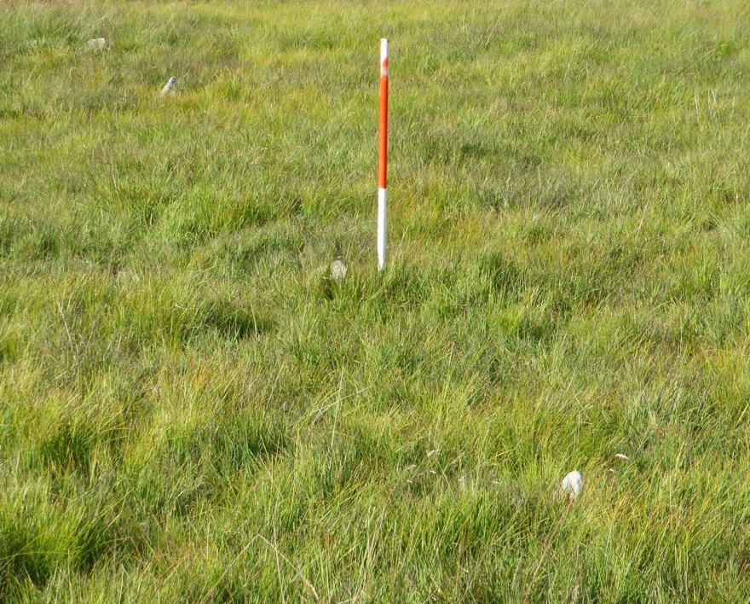
Figure 12. The report failed to mention the size of the stones at Cerrig Duon. Like those at Bancbryn they are small. This evidence clearly contradicts the report’s conclusion that the Bancbryn stones are ‘much smaller than the stones in the Bronze Age alignments in the region’. (Author.)

‘An alignment of stones was also noted at Mynydd Bach Trecastell in proximity to a pair of prehistoric round cairns. This ‘stone alignment’ was interpreted as representing a former post medieval field boundary. The reason for this interpretation is unclear but appears to be due to the much smaller size of stones compared to the Saith Maen example cited above and largely recumbent’ (pg. 27).
- This alignment is associated with a pair of stone circles and not round cairns.
- Leighton does indeed dismiss the stone alignment as ‘probably an old boundary’ but provides no justification which is a great pity (Leighton, 1998, 78) particularly as the alignment leads from a small stone circle. An examination of Coflein [NPRN 413022 &104135] provides no further evidence and indeed there is no mention of the old boundary theory, although J.Wiles noted in 2002 that ‘short lengths of stone alignments, adjacent or nearby (at SN83413101) can be interpreted as 'stone rows' rather than as the remains of field boundaries’ By contrast David Leighton’s entry for 14 February 2011 makes no mention of the alignments or field boundaries. It would therefore seem rather inappropriate and somewhat premature to dismiss the stone alignment identification without good reason.
- Aubrey Burl, whilst clearly not enamoured with the alignment describing it as ‘a miserable alignment crawling towards the circle, its stones now just perceptible in the wet ground.’ saw no reason to doubt’s its identity (Burl, 1977, 260).
- W.F. Grimes describes the alignment as making ‘a good line, which is not directed towards the centre of the circle, but towards its southern half’ (Grimes, W.F., 136).
- At Mynydd Bach Trecastell the broad consensus is that this is a stone alignment composed of very small stones. This conclusion does not sit comfortably with the observation within the Preliminary Statement that the size of stones in alignments in this area is commonly 1.5 – 3m in size. Given that this was one of the stated reasons for objecting to a prehistoric identification there are clearly compelling grounds for doubting their conclusion.
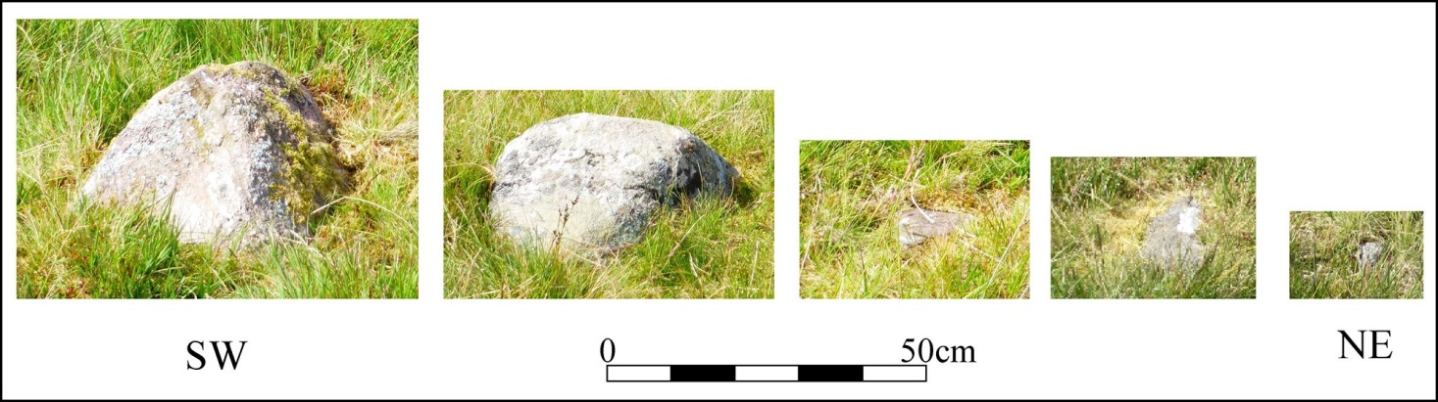
Figure 13. The five small stones forming the stone alignment at Mynydd Bach Trecastell. Contrary to the report stone alignments consisting of small stones do form a constituent part of the archaeological record in South Wales. (Author.)

Eighteenth century stone alignments are well documented from the Black Mountains, for example, and were used as an aid to navigating across the upland (pg. 27).
- Interestingly the Turnpike and Pre-Turnpike Roads report produced by Dyfed Archaeological Trust makes no mentions of the use of boulders (Schlee, D., 2014).
- Post medieval road side stones are frequent in the archaeological record and in a few instances have been confused with prehistoric alignments such as at Harrowbarrow plantation (SX 62346190) and Mably Farm (SW 5865 3341).
- All stone alignments erected beside roads have one thing in common – a road or track. There was no evidence for either at Bancbryn and therefore this explanation most definitely lacks any evidence to substantiate it.
- Navigation stones are generally tall and sited to be seen from a distance. In the medieval period wayside crosses served this function. They are always large enough to be seen from a distance and there are no known parallels for lines of relatively closely spaced small stones being utilised in this way. The small size of the stones means that they are wholly different to those placed elsewhere to aid navigation. If they were placed primarily to aid navigation why did the preliminary archaeological investigations fail to notice them at all?
- A standing stone at Mynydd Illtyd probably represents a good example of an historic navigational stone, but it is scheduled as a prehistoric standing stone despite the absence of any evidence to support this interpretation.
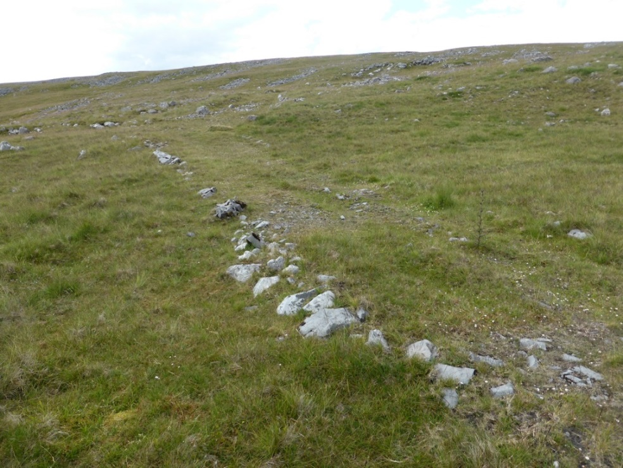
Figure 14. A track at SN 7282 1839 on the Black Mountain overlooking Mynydd y Betws is denoted by boulders along its lower edge. Such alignments have been confused in the past with the stone alignments but the associated track or road provides the context necessary for accurate interpretation. (Author.)

‘Post medieval, probably nineteenth century, lines of stones have also been identified on sites in Carmarthenshire waymarking safe crossing points through bogs’ (pg. 27).
- Bancbryn is not boggy and this suggestion is wholly irrelevant.
- There is an example of a standing stone near Traeth Bach at SN 96287 25432 which has been placed next to a low clapper bridge over a leat. This would have successfully way marked the crossing point and therefore is likely to be of post-medieval origin. This site is scheduled as a prehistoric standing stone despite there being absolutely no evidence to corroborate this interpretation and more to suggest its post medieval identification.
4.1 ‘Previous survey on Mynydd y Betws (including a survey by Cadw; walkover survey by Cambrian Archaeology; and subsequent evaluation trenching by Cotswold Archaeology) did not identify the stone alignment due to the thick vegetation cover obscuring the stones. For the same reason it is not recognizable on aerial photos and the size of the stones would almost certainly not allow identification on LiDAR (which is typically of 2m resolution for this region)’ (pg. 28).
- In this paragraph the report spells out clearly for the first time the explanation for the stone alignment being overlooked. According to the report various bodies failed to find the alignment ‘due to the thick vegetation obscuring the stones’. There is, however, no evidence to support this statement and instead it is much more plausible that the stone alignment was not found because no attempt was made to search the area for unrecorded remains. To make matters worse the planning inspector had previously reported seeing unrecorded archaeology within the development area and still no search was carried out. Until evidence of this thick vegetation is provided it would seem more plausible to accept that the alignment was not identified because no attempt was made to look for visible archaeological remains and instead all of the emphasis was placed on searching for archaeology below the surface or in a database.
4.2 ‘Mynydd y Betws contains a range of prehistoric monuments including funerary cairns and as with landscapes such as Mynydd Du the stone alignment may be interpreted as a part of this prehistoric landscape. Several features of the Mynydd y Betws example however are not consistent with this interpretation’ (pg. 28).
- It is impossible to ignore the fact the Bancbryn stone alignment stands in the midst of a rich prehistoric archaeological landscape and the report acknowledges this before going onto to provide reasons why a prehistoric explanation is not consistent with the evidence.
‘Most strikingly, the stones within the row are of variable size and shape but generally an average size of 0.3 – 0.5m. This is much smaller than the stones in the Bronze Age alignments in the region discussed above (which are
commonly 1.5 – 3m in size)’ (pg. 28).
- This is the first of the reasons given for doubting the prehistoric interpretation.
- Variable size and shape is a feature of both the Welsh and Dartmoor stone alignments and many include stones smaller than the average sized stone at Mynydd y Betws. It has been demonstrated that alignments were built using locally available material and therefore in areas where only small stones were available the alignments are composed of small stones. Often the largest stone in an alignment forms a terminal and at Mynydd y Betws the largest stone indeed forms the south western end. The small size of the stones at Mynydd Y Betws is therefore entirely in keeping with the evidence from Wales and the south west of England. To dismiss this alignment on the grounds that it is not like others in the area is a dangerous thing to do, particularly when there is no evidence to support the contention that it is not prehistoric. Its similarity to SW English examples is the most exciting aspect of the site as it may confirm the presence of social/economic interactions across the Bristol Channel at this time.
- Inclusion of the second alignment at Cerrig Duon would have scuppered this objection and may explain its omission in the discussion of regional parallels. In this regard it is perhaps significant that the stone alignment at Nant Tarw which also consists of stones of very different sizes was also overlooked despite the fact that it is closer to the Mynydd y Betws than most of those which were cited. If the Harold’s Stones alignment, some 80km from Bancbryn, were considered relevant by the report, why were the significant number of physically much closer alignments located to the north and west not assessed and included? Indeed, to put this issue into perspective it worth noting that all of the Exmoor stone alignments are closer than the Harold’s Stones alignment. The evidence of selective and therefore biased collection of evidence undoubtedly undermines the value of the conclusions, particularly when much of the evidence deployed was also inaccurate. This manipulation of the data-set must undermine the basic tenets of the case being made.
- Despite the report’s failure to concede the existence of stone alignments composed of small stones this does not alter the fact that they exist. The alignments at Cerrig Duon and Mynydd Bach Trecastell demonstrate clearly that rows composed of small stones are present in the archaeological record and other examples such as those at Craig-Y-Fan Ddu and Cefn Gwernffrdw II would have been acknowledged in a balanced overview of the resource.
- The report deliberately emphasises the difference in size between those alignments with large stones and the example at Bancbryn by stating that the accepted alignments are commonly between 1.5 and 3m high. This statement like many others in the report is wholly untrue as only the cited Harold’s Stones alignment some 80km from Bancbryn has stones of this magnitude.
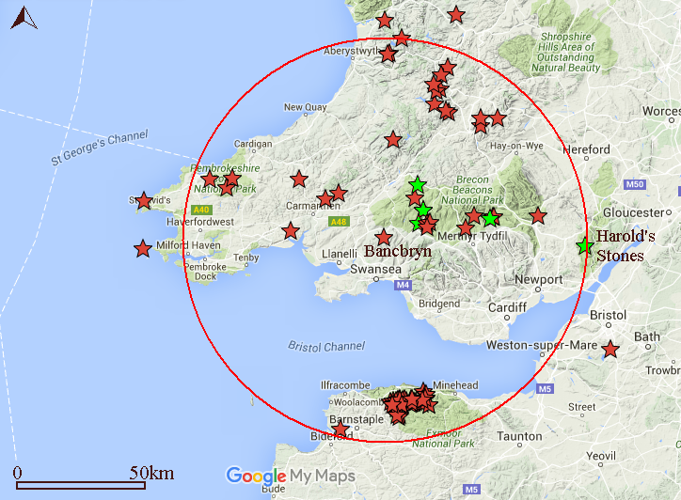
Figure 15. Map showing the distribution of stone alignments. The red circle encloses the area within 80km of Bancbryn. The green stars denote the alignments selected as part of the characterisation and the red ones those that were not. This highlights the extremely biased nature of the exercise. No reason for excluding most of the available evidence was offered. (Data from Archwilio, Burl, Coflein, PastScape and Exmoor HER).

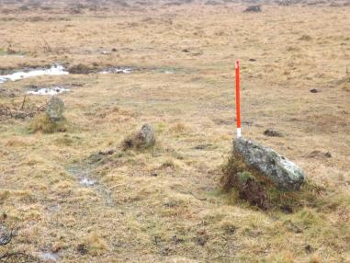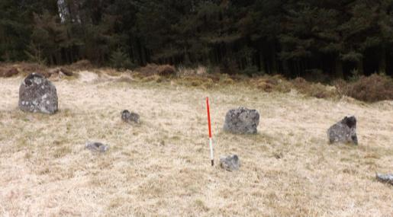
Figure 17. Small and large stones stand side by side at Assycombe, Dartmoor. (Author.)
Figure 16. Stones of variable size are a feature of stone alignments. Butterdon stone alignment, Dartmoor. (Author.)

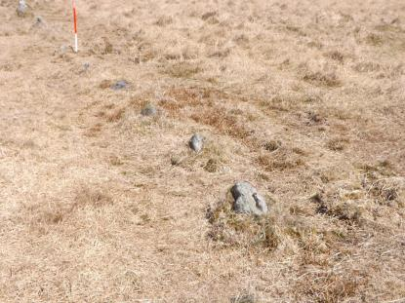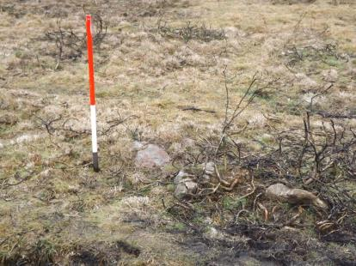
Figure 19. Small stones almost touching at Butterdon stone alignment, Dartmoor. (Author.)
Figure 18. Small stones forming part of the Erme Valley alignment, Dartmoor. (Author.)

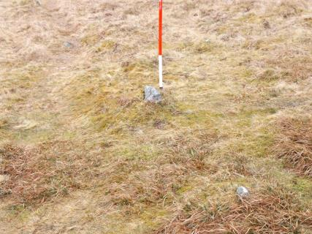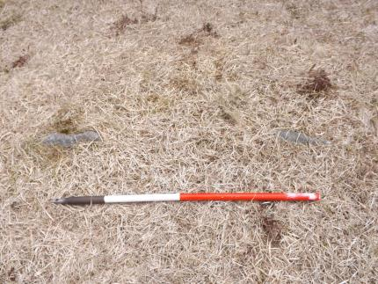
Figure 21. Tiny stones are a feature of many Dartmoor stone alignments. Here at Fernworthy , Dartmoor, they are barely visible. (Author.)
Figure 20. Barely visible stones forming part of the Holne Moor triple alignment Dartmoor. (Author.)

‘The stones investigated during the evaluation were also only shallowly embedded in the soft natural geological substrate and did not lie within deliberately dug pits/sockets’ (pg.28).
- The photographs accompanying the report certainly do not support the contention that the stones were not contained within deliberately dug pits or sockets. Indeed to the contrary photograph 8 clearly shows that the stone labelled artefact 2 (stone 1) is sitting within a distinct cut. Predictably the photograph 9 which purports to be of the same stone following excavation is clearly of a completely different stone. Stone 2 seems the most plausible candidate. The failure of the report to adequately present the evidence upon which the interpretation is based represents a significant failing and seriously undermines its validity. Instead it provides a very good impression of having been produced within a context where there was something to hide.
- Furthermore, the size of any hole dug to receive a stone is necessarily proportionate to the size of the stone being erected. As has been pointed out above the stones are generally small and therefore one would not expect to find large holes dug to receive them. Indeed a small hole cut into the soil which did not penetrate the subsoil would be sufficient to firmly hold stones of this size in place. It is also of interest in this context to note that the 1.2m high Hobajon’s Cross forming part of the sinuous Butterdon Hill stone alignment was found to sit in socket hole measuring a mere 0.15m deep. The socket apparently visible in photograph No 8 would have been perfectly capable of retaining the large associated stone.
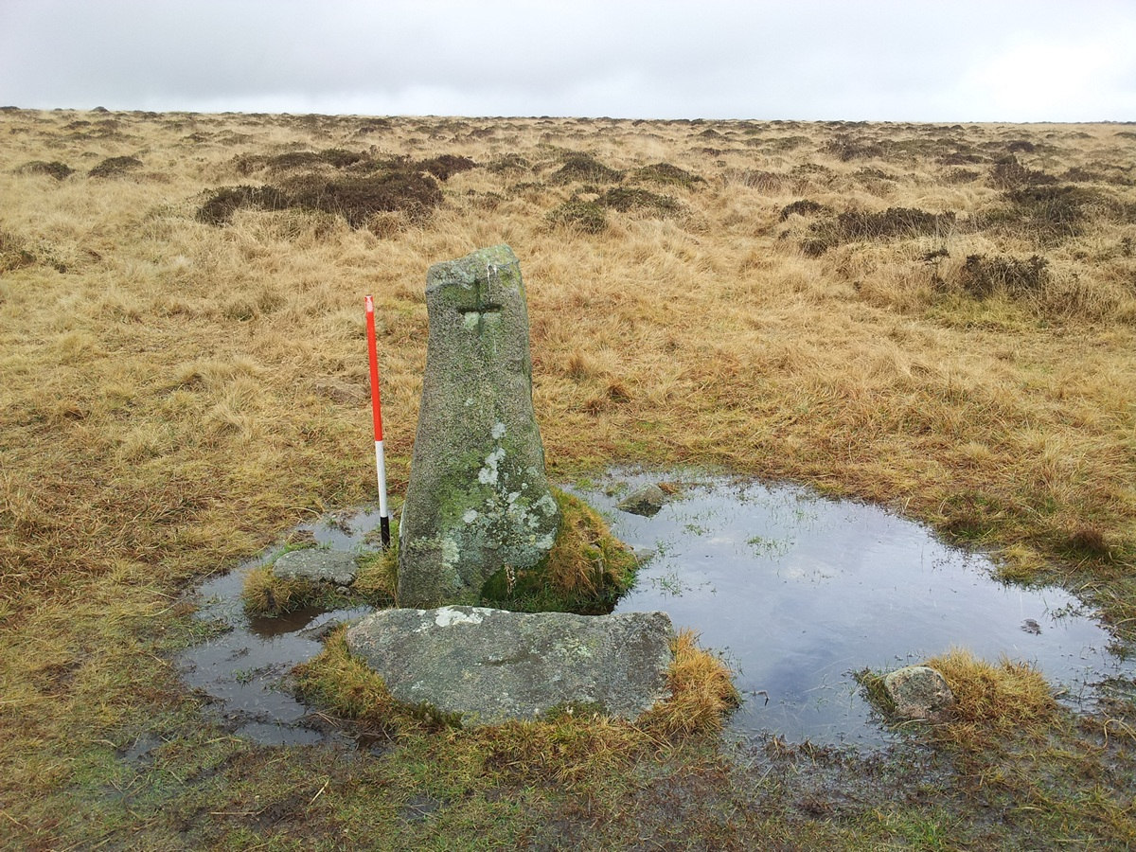
Figure 22. Hobajon’s Cross stood in a 0.15m deep socket. (Author.)

‘The overall alignment of the Mynydd y Betws alignment is sinuous in form which is not typical for prehistoric ceremonial/ritual stone alignments which are….. predominantly straight’ (pg.28).
- This statement is wholly inaccurate. The briefest look at the alignments on Dartmoor and elsewhere would have revealed to the authors of this report that many (particularly the long ones) are usually sinuous in character. The argument that the alignment is unlikely to be prehistoric because of its sinuous character is, therefore, entirely untrue. Indeed it is instead actually another factor in favour of the prehistoric interpretation. These inaccuracies are so blatantly wrong it would be like suggesting that a rectangular earthwork cannot be a Roman fort because all such forts are only ever circular.
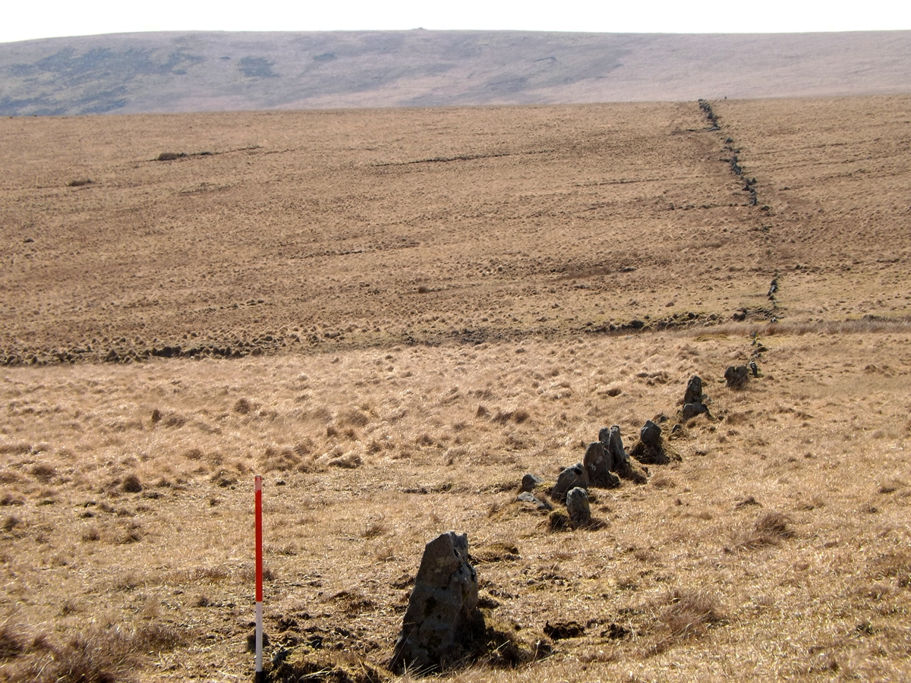
Figure 23. Erme Valley – certainly not straight. (Author.)
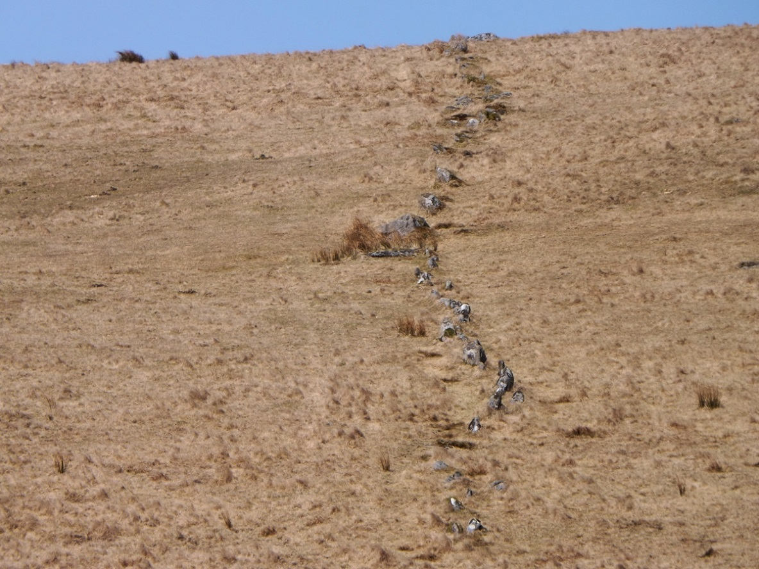
Figure 24. Erme Valley – alignment snaking up a slope. (Author).

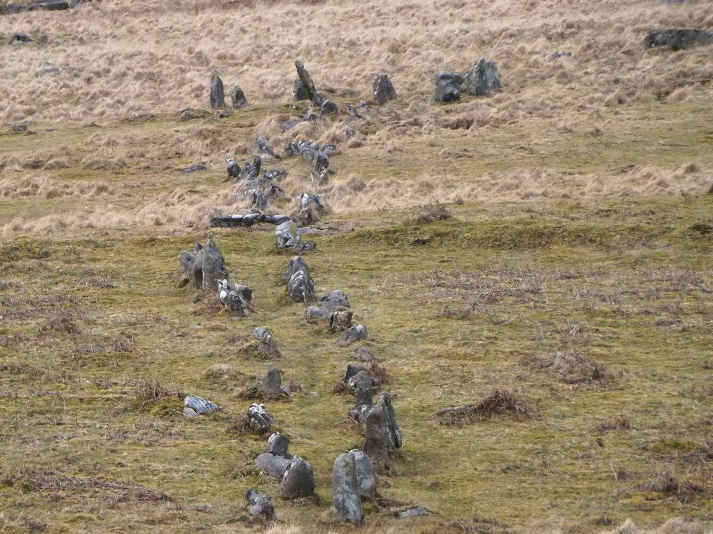
Figure 25. Double alignment at Trowlesworthy meandering towards a cairn. (Author.)
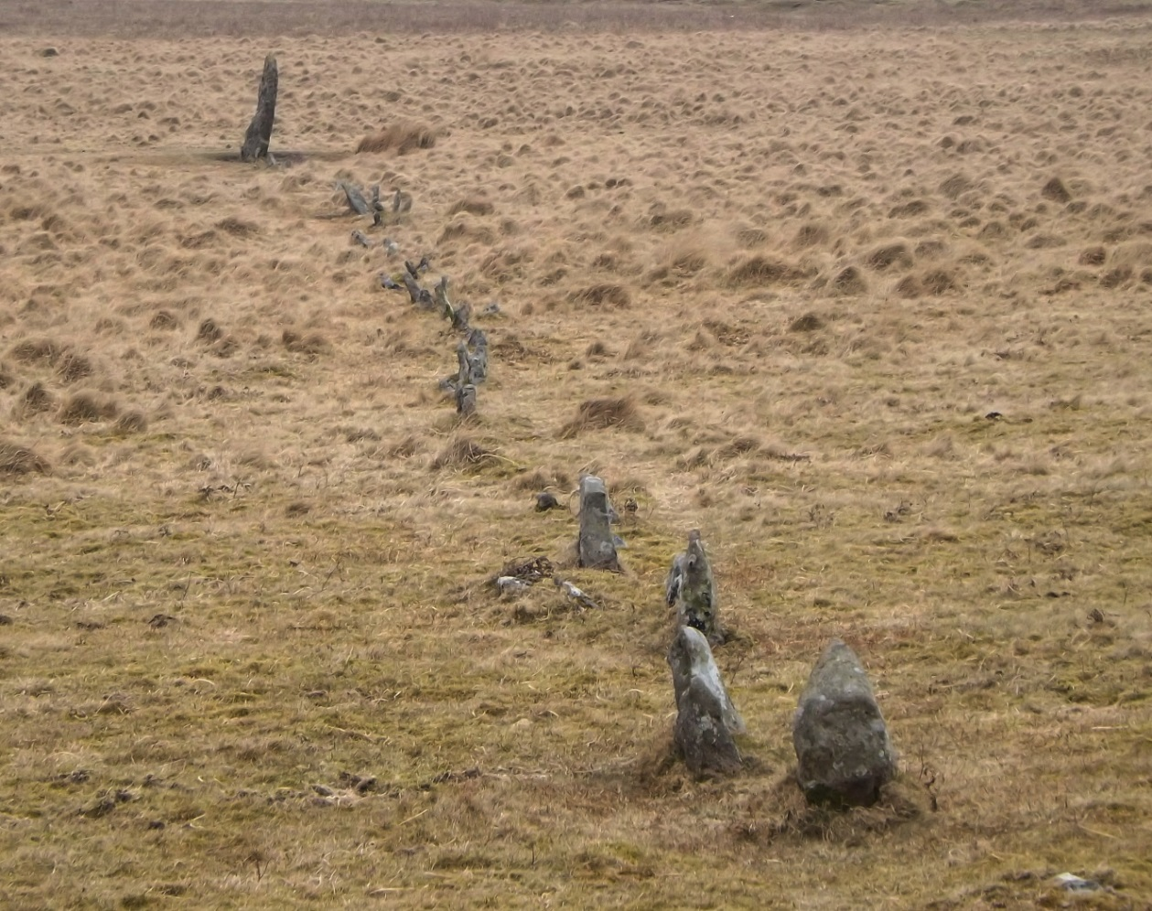
Figure 26. Sinuous alignment at Drizzlecombe twisting towards the terminal pillar. (Author.)
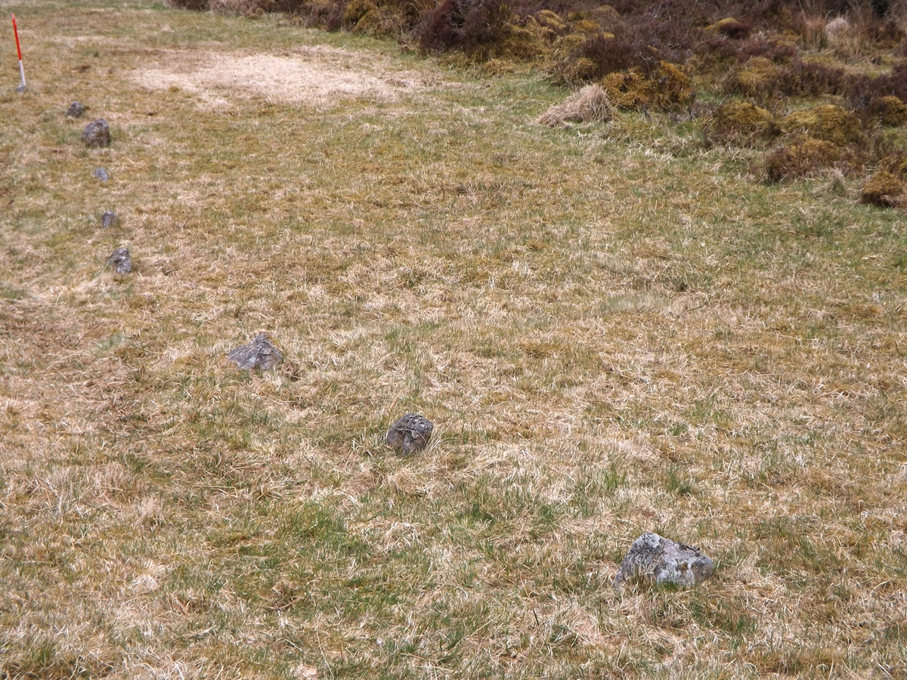
Figure 27. Sinuous line of small stones at Assycombe. (Author.)
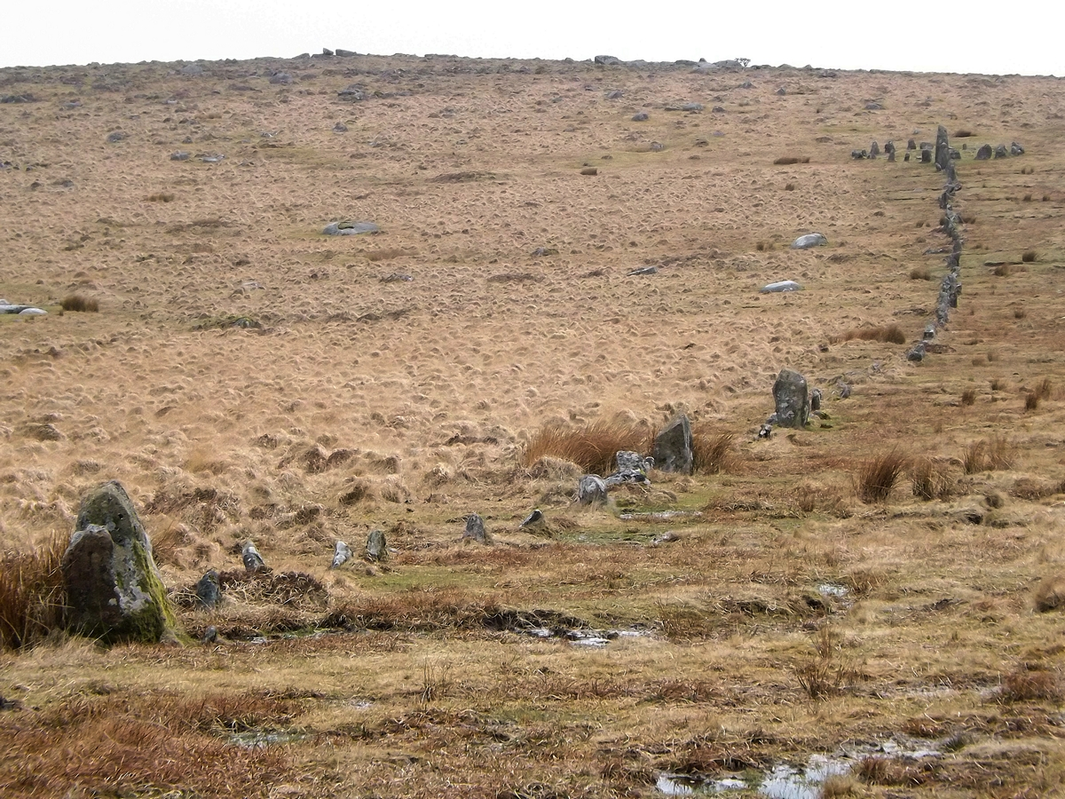
Figure 28. Classic alignment on Hingston Hill is far from straight. (Author.)
4.3 ‘It is likely therefore that the stone alignment represents a later form of feature’ (pg. 28)
- It has been demonstrated that none of the objections to the prehistoric explanation can withstand any level of scrutiny. Indeed the detailed examination of these issues has revealed that their position has been built entirely upon the selective use of inaccurate data combined with a clear failure to understand or engage with the resource being assessed.
- Having considered the reasons why they believed the alignment was unlikely to be of prehistoric origin, the authors of the report helpfully moved on to suggest alternative explanations, being very careful not present any tangible evidence to support their own interpretations.
4.3 ‘One interpretation may be a former boundary/fence line, as post medieval and modern fence lines strengthened by small and large stones are known from various localities in Wales (Charles Hill pers. Comm). Over time most of the smaller stones and embanked material can erode away leaving only the larger boulders in their original position’ (pg. 28).
- The strengthening of fence lines with stones is an interesting thought. The strength in a fence relies on it being kept straight and taut and generally stones are used only to reinforce the fence by being placed on the ground to prevent livestock escaping under gaps created by uneven ground.
- The sinuous character of the alignment combined with the failure to find any post holes in two separate interventions would have seemingly disproved this explanation, but it was nevertheless flown.
- One also needs to question how effective an unconnected fence would be in any agricultural context. Furthermore fence lines tend to attract livestock for scratching purposes and the resultant increased traffic adjacent to it generally creates a linear erosion hollow which in a stable moorland environment would survive for some considerable time. There is no evidence for a hollow associated with this feature.
- Together these details make it very unlikely that the alignment was connected in any way with a fence line.
- The reference to ‘embanked material’ seems to be implying that the authors believe that there may have been a bank. Banks are created by the digging and piling of material which leads to the creation of an associated ditch from which this material was derived. Since no ditch was found in the excavation area any interpretation which relies on the feature being the extremely eroded remains of a bank is actually discounted by the evidence from the excavations. Given this very clear evidence, it is curious that this possibility has even been suggested. Interestingly this very obvious contradiction was not explored within the report. Furthermore, the report notes that many of the stones are buried below the soil. This suggests a depositional environment rather than the erosive one implied by this report and indicates the suggested interpretation is not supported by the field evidence.
‘The locality is not suitable for arable agriculture and the current pasture land use is likely to represent a long term use of the site. Hence the alignment may feasibly correspond to a demarcation of grazing rights (pg. 28-9).
- No evidence or parallels are offered to support this explanation.
- Grazing rights are traditionally denoted using large stones which are difficult to move.
- There are no grazing rights boundaries of this type recorded in the archaeological/ documentary record.
- The stone alignment wholly lies within moorland and therefore could not have functioned effectively. What are the rights situation at either end for example?
4.4 ‘An alternative although closely related interpretation is that the stone alignment may act as a waymarker for former pathways and access onto the moorland. In the second half of the 18th century the Llangadog Trust placed a line of boulders to improve an old trackway across the Black Mountain (Evans 1985 p. 40-41). The stones acted as a visible waymarker for the path presumably even in poor weather and snow’ (pg. 29).
- The report suggests that the path would have provided access from Bryn Mawr farmstead to the ‘adit workings near the summit’. Ignoring the fact that there are no adits near the summit (as discussed previously) it is perhaps worth asking why a huge amount of effort would be expended by the farmers in building a marked footpath from their farmstead to a small scale temporary working which by its very nature would have been constantly moving when there were already two trackways leading to the area: one to the north of the alignment and another to the south.
- It is also perhaps worth asking why none of the other very obvious trackways on the hillside were similarly marked and why the stones which were used would have become completely invisible after even moderate snow fall. It seems to be stretching a point to suggest that the low capital venture represented by the outcrop workings would bother to invest considerable time and effort in laying out an official path to part of the mine from which they would have probably moved by the time it was completed. Such an idea is not logical and so farfetched it may only be seen as either desperate or laughable.
- The attempt to associate the Bancbryn alignment with the stones placed alongside the Llangadog Trust roads is wholly inappropriate. These road side rocks are referred to as boulders and most importantly are associated with a road. No evidence of a road or track was found adjacent to the Bancbryn alignment. There are many examples of stones being placed beside tracks throughout the United Kingdom but all have one thing in common that is not present at Bancbryn – a road or track.
‘A pathway following the direction of the Mynydd y Betws stone alignment is visible on 20th century aerial photographs’ (pg. 29)
- The presence of animal paths roughly following alignments and other linear features of any date is a common feature of upland moorland landscapes and implies nothing. It is also worth noting that where paths are built with stone markers the path or track is always established on the upper side of the stones and there is no evidence to suggest that a path or track ever formed in this position. The path which the authors have identified is on the lower side of the alignment and has almost certainly been formed exclusively by animals respecting the adjacent uneven ground. As there is no evidence for a path or track on the upslope side of the alignment this interpretation would seem to be seriously flawed. Perhaps even worse, the suggestion that the occupiers of Bryn Mawr farmstead needed a line of stones to help them find their way across a small area of moorland immediately outside their home is bordering on the insulting, particularly as there were two existing built trackways they could have used if the weather was particularly inclement.
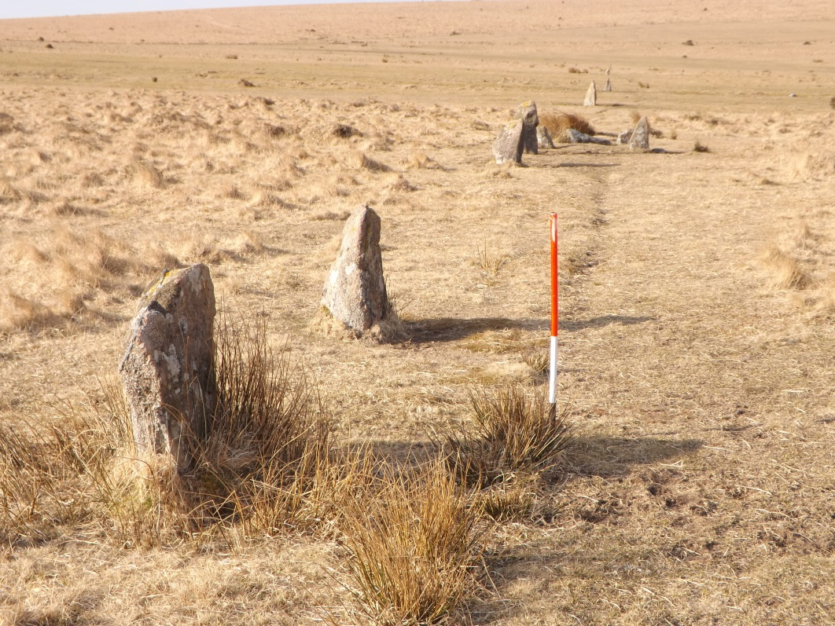
Figure 29. Many stone alignments have paths leading beside them. This path at Ringmoor Down is similar in character and form to the one at Bancbryn. The presence or absence or presence of paths is completely irrelevant.

‘A number of paths in the area link the farms at the foothill of the mountain with the former adit workings near the summit’ (pg. 29).
- There are a large number of tracks and paths crossing the moorland in this area. Many are shown on historic and current mapping and most survive as distinct earthworks. None are associated with lines of stones.
- The stone alignment is crossed by two separate paths/tracks shown on the first edition Ordnance Survey map. This relationship clearly indicates that the alignment pre-dated the Victorian route network.
- There is no obvious context for the alignment as a route marker from Bryn Mawr Farm. The farm in common with other moorland fringe farmsteads is clearly of a relatively recent date with access to the north, west and south being provided by a pair of tracks connecting it to a long established route across the mountain. A third track not shown on the Ordnance Survey mapping but surviving as an earthwork provided direct access to the route network to the east.
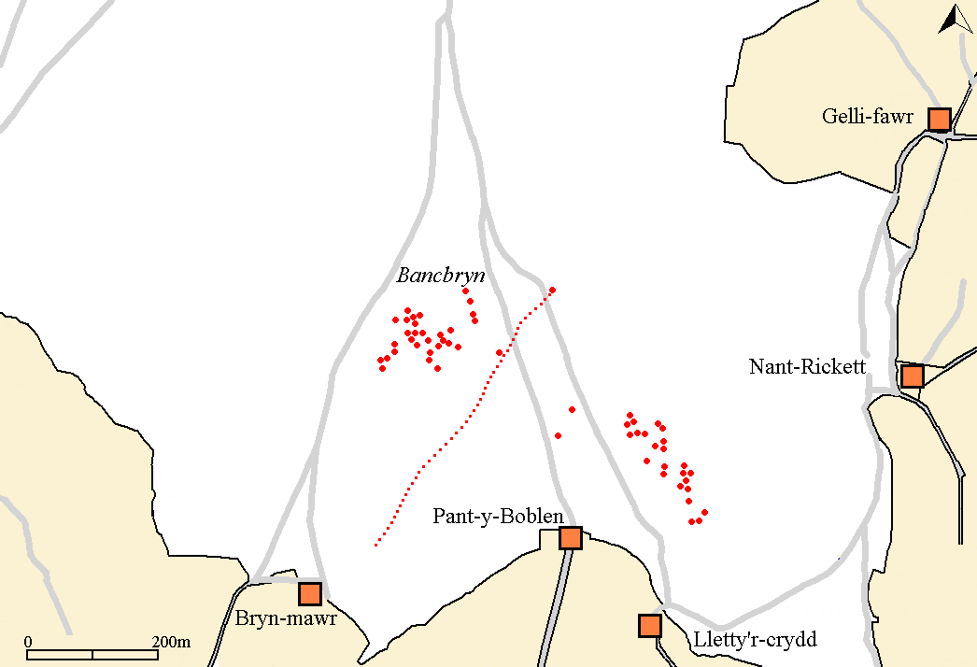
Figure 30. Map showing Victorian paths and tracks on and around Bancbryn. It is significant that two tracks cross the alignment. This relationship strongly suggests that the alignment predates the Victorian route network.
(Base Map Source: Ordnance Survey 1878).

Conclusion
5.1 ‘No conclusive evidence has been identified during either the recent fieldwork or the compilation of this Interim Statement to date the construction of the stone alignment on Mynydd Y Betws’ (pg. 29).
- Dating of stone alignments is notoriously difficult. One normally relies on an assessment of the surviving form together with relationships and associations with adjacent archaeological features and structures. A line of stones leading up to a stone circle or cairn is generally accepted as proof of antiquity in the same way that the cairns on Mynydd Y Betws are accepted as prehistoric because they are in an appropriate location and look like other examples which have been dated.
- Clearly it is always possible that the stones forming an alignment may have been added much later and that cairns could simply be cartloads of dumped stone. Ignoring the circumstances of its discovery for the moment, the difficulty with accepting this feature as prehistoric appears to revolve around the fact that monuments of this form have not yet been identified in South Wales. To reach this conclusion the report has ignored several sites within the region that comprise only small stones and exaggerated the size of the stones at the sites that have been taken in account.
- Whilst the report draws on evidence from a site over 80km from Bancbryn, a large number of alignments situated close by and also consisting entirely of small stones have been ignored. The evidence used has been carefully selected to illustrate a single stance and the apparently deliberate omission of all the data which would have supported the prehistoric interpretation should be lamented on many levels. It seems hardly credible that all the information which would have supported a prehistoric interpretation should have been overlooked, whilst at the same time, the information which was deployed was repeatedly exaggerated to emphasise the differences at Bancbryn. This approach is unlikely to be in accordance with CIfA standards.
- The reasons given for doubting the prehistoric interpretation are all erroneous and whilst clearly without any positive dating evidence it is not possible to state with absolute confidence that this alignment is of prehistoric date, the combined body of evidence suggests this is the most probable explanation. If absolute proof is seen as necessary for the recognition of a prehistoric stone alignment then only about 1% of the current number would meet this exacting threshold. To expect the Bancbryn alignment to meet this threshold of proof when all the other examples in Wales would also fail to do so, should be seen as unjustifiable discrimination.
- The report makes no mention of the cairn at the upper end of the alignment, nor the large terminal stone at the lower end. A proper characterisation of the alignment would have revealed these features.
‘Although the alignment does cross an area of open moorland in close proximity to known prehistoric monuments, it appears to originate (at its south western limit) close to Bryn Mawr farmstead, and end at, or close to, the shallow adit workings and footpath emanating from Pant y Boblen farmstead. For much of this distance, the alignment runs broadly parallel with a sinuous footpath or sheep track’ (pg. 29).
- These points have been dealt with above, but as the report choses to emphasise them it may be worth repeating them briefly.
- The stone alignment is crossed by routeways contemporary with Bryn Mawr. This means that it was probably built before the farmstead whose own trackways are stratigraphically late.
- The coal workings identified in the report are not adit workings. They are shallow outcrop workings and would have operated only for a very short time and the focus would have been constantly shifting.
- Many prehistoric stone alignments have footpath or sheep tracks leading beside them. This does not mean that they are not prehistoric.
5.2 ‘Although a prehistoric origin for the alignment can not be wholly dismissed there are a number of inconsistencies between this alignment and more securely dated examples not least the variable size and shape of the stones the lack of evidence for the stones being set within associated pits or sockets and its sinuous alignment’ (pg. 29).
- This statement makes the wholly inaccurate assumption that the other alignments considered within the report have been securely dated. They have not, therefore, any claims based on this erroneous belief can bear no scrutiny. It is assumed that alignments are prehistoric because they look like others that have been assumed to be prehistoric. The failure of the report to accept this important point is astonishing.
- It has already been demonstrated that variable size and shape is a characteristic of prehistoric stone alignments and to suggest otherwise highlights a total ignorance of the resource being examined.
- The photographs in the report do not support the contention that there were no associated pits.
- Most of the longer stone alignments are sinuous in character.
- All of the reasons presented for doubting the prehistoric interpretation are entirely fallacious.
‘It is therefore more plausible that the current alignment is representative of a later boundary, perhaps demarcating grazing rights on the moorland, or more probably a waymarker between Bryn Mawr and the twentieth century adit workings’ (pg. 29).
- Given that every single reason highlighted in the report for suggesting that the alignment is not prehistoric has been exposed as erroneous and the alternative unsubstantiated explanations can be easily dismantled I would suggest this conclusion is wholly invalid.
- It is perhaps fitting that the final conclusion in the report can be convincingly demonstrated to be wholly inaccurate. The report in a final attempt to discredit the stone alignment suggests that it was probably connected with coal workings of 20th century date. The briefest of research would have shown that the coal workings could not be of 20th century date. These workings are described by the Royal Commission as bell pits in a report published in 1917 which states they are likely to be late 18th or early 19th century in date. This crucial information is readily available online and the failure to use it further emphasises the reporting inadequacies and bias which characterises this report. The manipulation and selective use of data throughout this report inevitably means the conclusions it draws must be considered wholly unreliable.
The illustrations
An examination of the illustrations accompanying the report should give reasonable cause for concern. Several mistakes, inconsistencies and points of interest were identified.

Figure 4 Plan of excavated stones
- The orientation of stone 1 is depicted as being WNW – ESE but photograph No. 8 shows the stone to have been aligned NNE – SSW. How could such a fundamental error have occurred?
- The excavated area is depicted as extending about 3m north west and south east of the stones but photograph implies that the excavated area was much smaller.
- There is no overall photograph showing the whole of the excavated area.
Photograph 7 Hand excavation along main access road showing observed stones
- This photograph implies that the excavated area was smaller than that shown in Figure 4.
- The surface revealed is not particularly clean and the potential for subtle unidentified cuts exists.
Photograph 8 Registered Artefact 2 pre excavation
- This is clearly a photograph of stone 1 shown in Figure 4 but is not labelled as such.
- The stone appears to be sitting in a cut.
- The stone is aligned NNE – SSW.
Photograph 9 Registered Artefact 2 post excavation
- This is clearly not a photograph of the stone referred to in the caption. It seems more likely to be stone 2 shown in Figure 4.
- This is not a post-excavation photograph. The material below the stone remains in situ and has not been excavated.
- The stone looks smaller than depicted in Figure 4.
- There is no indication of orientation.
- The material below the stone looks suitable for environmental analysis.
Photograph 10 Registered Artefact 5 pre excavation
- There is no information in the report to indicate where this stone was found. It probably came from the northern intervention.
- The area around the stone has already been cleaned.
Photograph 11 Registered Artefact 5 post excavation
- Assuming this is the same area as in Photo 10 it is noted that areas which were previously clean have been covered with fresh soil.
Conclusion
This report has clearly set out to disprove only the prehistoric interpretation for the stone alignment at Bancbryn. Despite claims that a detailed archaeological excavation has been carried out the resulting report is so tightly focussed on disproving one interpretation it chooses to include only the evidence to support the alternative interpretations, however weak. Indeed much of the crucial evidence has been ignored or manipulated in such a way as to render this report worthless. There is no pretence at objectivity and the way in which the evidence has been manipulated / ignored to suit one particular outcome is highly questionable.
No two stone alignments are the same. They share common characteristics but each one is unique. Usually context, presence of the recognised components and visual character are sufficient to confirm identification, but in this instance despite its obvious credentials, every effort has made to discredit the stone alignment at Bancbryn. Fallacious, biased, unsubstantiated, inaccurate and misleading objections have been incompetently gathered together to challenge the prehistoric interpretation, but instead simply serve to illustrate fundamental failings and ignorance.

SUMMARY OF EVIDENCE
This monument is likely to be a prehistoric stone alignment because:
- It is visually most similar to known prehistoric alignments in SW England
- Its NE to SW alignment is common for this type of site
- It is closely associated with a large number of different types of cairn
- The sinuous character of the alignment is a recognised characteristic
- There is a mound at the north east terminal which is probably a cairn. This is a common feature of such alignments
- There is a fallen terminal pillar at the SW end
- The variable size of stones used is typical for this form of alignment
- Whilst socket holes would not have been necessary to hold these stones upright the excavated evidence suggests that at least some of the stone may have sat in sockets
- There are very precise visual links with the sea and Hartland Point

This monument is unlikely to be the remnants of a fence line because:
- Its sinuous character is not typical for a fence line
- No post holes were identified in the excavation trenches
- No associated erosion hollow has been identified
- Stones were not routinely laid along the entire length of a fence
- It has no obvious purpose

This monument is unlikely to be the remnants of a boundary bank because:
- No associated ditch was encountered during the excavation
- Other boundary banks in the vicinity survive as earthworks
- Many of the stones are buried suggesting depositional processes rather than erosional ones that would lead to the exposure and removal of the bank material

This monument is unlikely to be a waymarker for a path or track because:
- There is no logical need for a third route to the summit of Bancbryn
- None of the other paths or tracks on the moor are waymarked
- The small size of the stones means that they are soon covered by snow or vegetation (apparently)
- There is no path or track on the upslope side
- There is no need to build a path to a small scale outcrop working whose focus would have been continually shifting
- The alignment is crossed by two mid-19th century tracks/paths.

Summary of evidence errors
- Claiming that a possible stone alignment was identified when a stone alignment was definitely identified.
- ‘all known archaeological sites were avoided to prevent direct impact to these remains’. This is untrue.
- One of the excavation trenches was placed in the wrong location.
- A length of the alignment destroyed by the development was not excavated.
- Detailed characterisation of the alignment asked for by DAT was not carried out.
- The excavation photographs do not support the report’s conclusions.
- There is no evidence that environmental analysis of material below the stones was considered.
- The apparent suggestion that the alignment is unlikely to be prehistoric because the soil profile was shallow.
- Referring to the coal outcrop working as adit workings.
- Failure to record early coal mining earthworks prior to their destruction.
- Failure to consult publically available aerial photographs of the area.
- Describing recumbent stones as ‘laid flat’ despite the lack of evidence to support this.
- Stating that the Saith Maen alignment is undoubtedly of Bronze Age date. There is no evidence to support this.
- Stating that the cited Welsh examples usually lead to a stone circle. None of them do.
- Stating that the cited Welsh examples comprise large (over 1m) boulders. Only one does.
- Failing to mention that the stones at Cerrig Duon avenue are all very small.
- Failing to take account of the Maen Mawr alignment despite it being on a few metres from the Cerrig Duon avenue.
- Describing the Cerrig Duon stone circle as a hut circle
- Failing to fully research the Mynydd Bach Trecastell alignment.
- Describing the Mynydd Bach Trecastell stone circles as cairns.
- Failing to appreciate that most stone alignments include stones of different sizes and shape.
- Failure to concede the existence of stone alignments composed of small stones.
- Exaggerating the height of the stones in the examples cited.
- Photographs of the excavated stones do not corroborate the assertion that no pits or cuts were found.
- Photographs have been mislabelled and none show the fully excavated stones in the southern trench.
- The suggestion that the alignment cannot be prehistoric because it is sinuous illustrates a total ignorance of the monument class being examined.
- Suggesting that it could be a fence despite the obvious absence of any post holes in the excavated area.
- Suggesting that it could be the remains of a weathered bank despite the absence of a ditch in the excavated area.
- Presenting the grazing boundary explanation with no supporting evidence.
- Sheep paths neither prove nor disprove that something is prehistoric or post-medieval and should certainly not have been used to imply a modern date for the alignment.
- The upper cairn and terminal stone are not mentioned.
- Failure to appreciate that the other alignments in the region have not been securely dated.
- Assertion that the coal workings were of 20th century date despite powerful evidence to the contrary.
- The plans and photographs are not consistent with each other. A serious error in the planning of this site has occurred.
- failure to utilise Burl (1977 and especially 1993)
- failure to consult Coflein
References
Burl, A., 1977, The Stone Circles of the British Isles, Yale University Press New Haven and London.
Burl, A., 1993, From Carnac to Callanish – The prehistoric rows and avenues of Britain, Ireland and Brittany, Yale University Press, New York and London.
Butler, J., 1991-97, Dartmoor Atlas of Antiquities, Vols. 1 -5, Devon Books.
Eogan G. and Simmons J.G., 1964, ‘The Excavation of a Stone Alignment and Circle at Cholwichtown, Lee Moor, Devonshire, England’, Proceedings of the Prehistoric Society, 30, 25-38.
Grimes, W.F., 1963 ‘The stone circles and related monuments of Wales, Culture and Environment’, Essays in Honour of Sir Cyril Fox (eds. Foster., I. and Alcock, L.), 93-152, London.
Leighton, D.K., 1988, Mynydd Du and Fforest Fawr – The evolution of an upland landscape in South Wales, Royal Commission on the Ancient and Historical Monuments of Wales, Aberystwyth.
Schlee, D., 2014, Turnpike and Pre-turnpike roads – Medieval and Early Post Medieval Sites Scheduling Enhancement Project – 2014 Interim Report, Prepared by Dyfed Archaeological Trust for Cadw.

Online Sources Consulted:
Archwilio
Coflein
PastScape
Exmoor National Park Authority HER

And available via hyperlink:
Mynydd y Betws stone row: ‘very poor scholarship’ and ‘a system which is clearly unfit for purpose’
Time machine archaeology: an extraordinary discovery on Mynydd y Betws
A stone alignment at Bancbryn, Mynydd y Betws, Carmarthenshire (part one)
A stone alignment at Bancbryn, Mynydd y Betws, Carmarthenshire (part two)
A stone alignment at Bancbryn, Mynydd y Betws, Carmarthenshire (part three)
A stone alignment at Bancbryn, Mynydd y Betws, Carmarthenshire (part four)
A stone alignment at Bancbryn, Mynydd y Betws, Carmarthenshire (part five)
Bancbryn stone alignment – More Evidence for Cadw to ponder
The curious case of the standing stone near Traeth Bach
Standing stone on Mynydd Illtyd – Another dubious scheduling?
Pigwn prehistoric stone alignment – another mountain but the same old story!
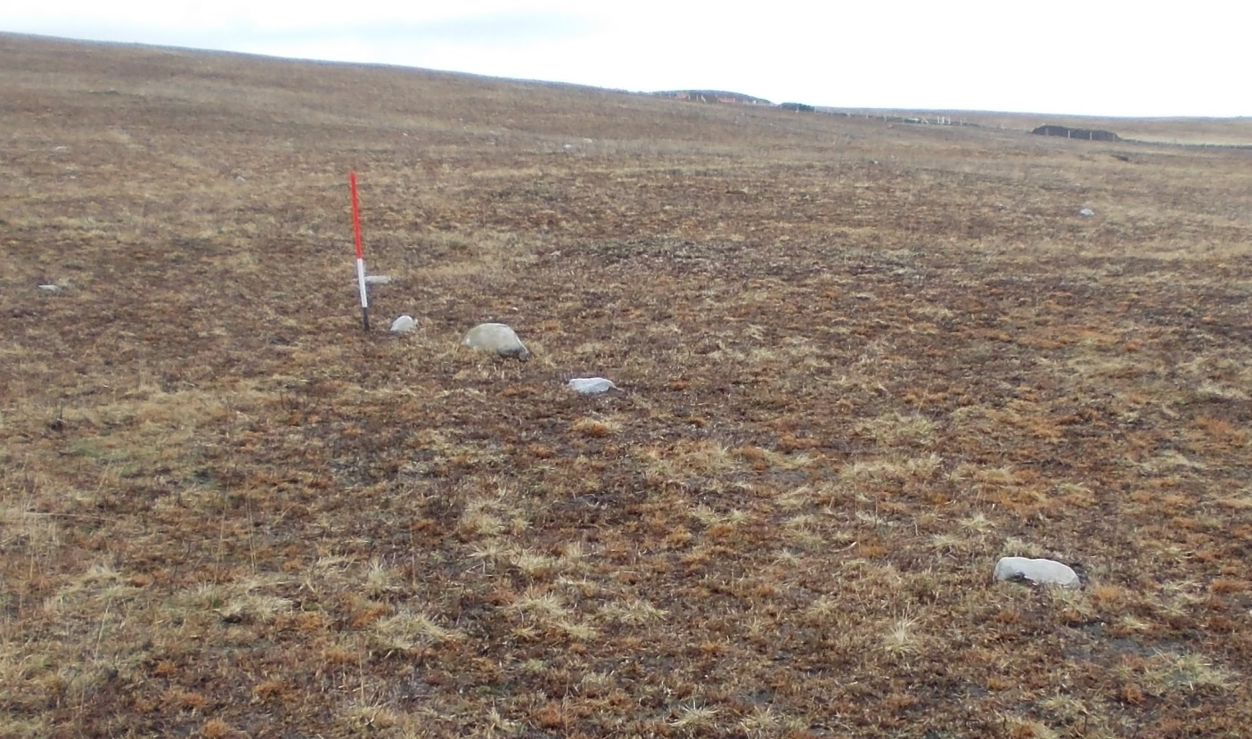
Figure 31 Part of the alignment at Bancbryn. View from west. (Author.)

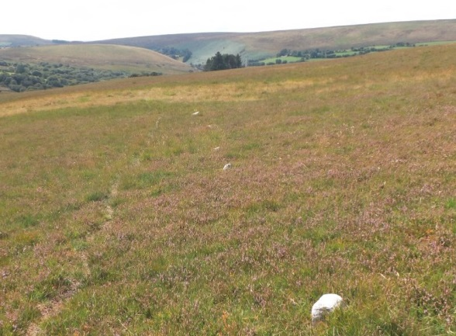
Figure 32 A stone alignment comprises a single line of upright stones set at intervals along a common axis. Looking south westward along the Bancbryn stone alignment. (Author.)

