Cwm Ffrydlas and Mynydd Du: A Study of Prehistoric Upland Field Systems in Gwynedd.

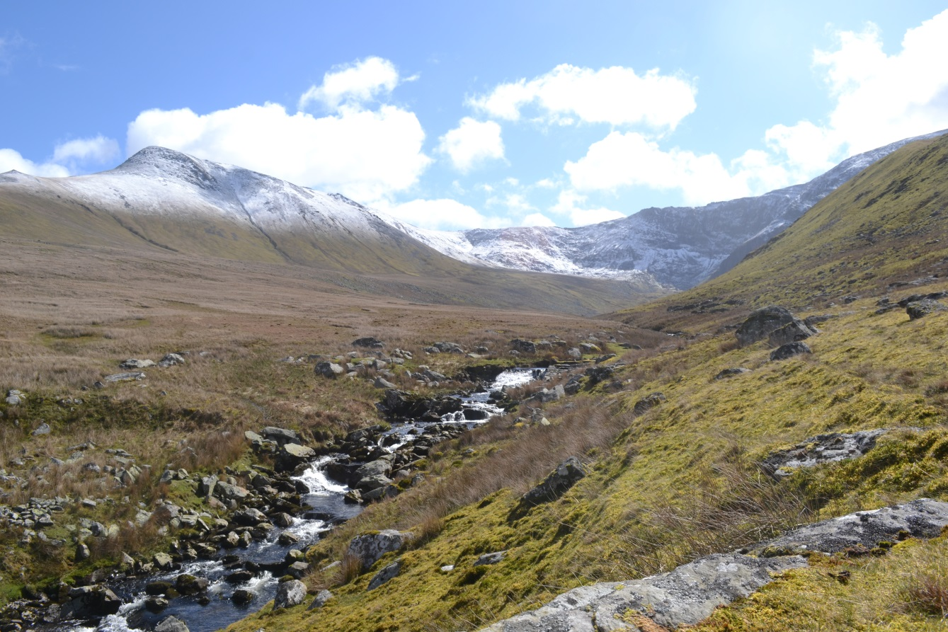

BA Archaeology
Archaeology Dissertation HDA 3075 0

Author: Sam Birchall Date: 28/04/2015
Declaration

‘I certify that this dissertation is my own unaided work, and has been personally researched and written by me.’

Signature: Date: 28/04/2015

Word count: 11088

List of Figures, Plans, Photographs and Tables

Figure 1: | Distribution map of field systems referred to in text | Page 9
Figure 2: | Site plan of Standrop Rigg (Jobey 1983, 3) | Page 10
Figure 3: | Green Knowe site plan (Jobey 1978-80, 74) | Page 11
Figure 4: | Carwcwellt West. Right 1998 (Crew 1998 22). Left 1989. (Crew, 1989 12) | Page12
Figure 5: | Llyn Morwynion site plan (Caseldine et al 2001 22)
Figure 6: | Distribution map showing Cwm Ffrydlas and Mynydd Du | Page 15
Figure 7: | Cwm Ffrydlas site plan (RCAHMW 1956 145) | Page 16
Figure 8: | Mynydd Du site plan (RCAHMW 1956 140) | Page 17
.
Plan 1: | :Cwm Ffrydlas survey data with RCAHMW 1956 plan | Page 19
Plan 2: | Mynydd Du survey results and RCAHMW 1956 plan | Page 20
Plan 3: | Plan 3: Cwm Ffrydlas site plan with interpreted greyscale plot (report 1). Blue – high magnetic response. Red line- possible linear anomaly. Red cross grid- area of magnetic disturbance. Red single line hash- possible area of magnetic disturbance | Page 22
Plan 4: | Plan 4: Mynydd Du site plan with grey scale interpretation. Red- high magnetic disturbance. Blue- Ferromagnetic response. Red single hash area- area of magnetic disturbance. Red line- possible linear anomaly. Green line- possible geological response. | Page 32
Plan 5: | Mynydd Du illustrated. Solid line - Rover Survey. Dot line - RCAHMW 1956 plan | Page 44
Plan 6: | Cwm Ffrydlas illustrated, over RCAHMW 1956 plan | Page 45
Plan: | Illustrated plan of Cwm Ffrydlas with interpreted magnetometer result | Page 46
Plan 8: | Illustrated plan of Mynydd Du with interpreted magnetometer results | Page 47
Plan 9: | Suggested morphology for Mynydd Du | Page 48

Photograph 1: | Cwm Ffrydlas Eastern Enclosure | Page 23
Photograph 2: | Cwm Ffrydlas Western Enclosure | Page 24
Photograph 3: | Cwm Ffrydlas Southern Enclosure | Page 25
Photograph 4: | Cwm Ffrydlas Feature 1 | Page 26
Photograph 5: | Cwm Ffrydlas Feature 2 | Page 26
Photograph 6: | Cwm Ffrydlas Feature 3 | Page 27
Photograph 7: | Cwm Ffrydlas Features 4 and 5 | Page 28
Photograph 8: | Cwm Ffrydlas Feature 6 | Page 29
Photograph 9: | Cwm Ffrydlas Feature 7 | Page 29
Photograph 10: | Cwm Ffrydlas Feature 8 | Page 30
Photograph 11: | Mynydd Du Enclosure 1 | Page 32
Photograph 12: | Mynydd Du Enclosure 2 | Page 33
Photograph 13: | Mynydd Du Feature A | Page 34
Photograph 14: | Mynydd Du Feature B | Page 35
Photograph 15: | Mynydd Du Enclosure 3 | Page 36
Photograph 16: | Mynydd Du Enclosure 4 | Page 37
Photograph 17: | Mynydd Du Enclosure 5 | Page 37
Photograph 18: | Mynydd Du Enclosure 6 | Page 38
Photograph 19: | Mynydd Du Enclosure 7 | Page 39
Photograph 20: | Mynydd Du Feature C | Page 39
Photograph 21: | Mynydd Du Feature D | Page 40
Photograph 22: | Mynydd Du Feature E | Page 41
Photograph 23: | Mynydd Du Feature F | Page 41
Photograph 24: | Mynydd Du Feature G | Page 42

Table 1 | Cwm Ffrydlas space analysis | Page 31
Table 2 | Mynydd Du space analysis | Page 43

Acknowledgements

Special thanks must be given to Professor Raimund Karl of Bangor University for making the surveys possible and for providing guidance and support throughout the project including supervising the survey at Cwm Ffrydlas.
Thanks also go to Kathy Laws of the National Trust for her help in gaining permission from the National Trust and Cadw to undertake the work at Cwm Ffrydlas and Mynydd Du.
Thanks to the National Trust and Cadw for granting permission for the work.
Thanks to Dr Kate Waddington of Bangor University for her help as my supervisor and her guidance, especially with GIS.
Thanks to Ian Brooks of Archaeological Services Ltd for providing the equipment and training to enable me to conduct the magnetometer survey.
Thanks also go to Katharina Moeller for her help conducting the Rover survey at Cwm Ffrydlas.
And to my friends who braved the walk up to Cwm Ffrydlas and Mynydd Du with me on multiple occasions, often not in hospitable weather conditions.
Thank you Chris, Simon, Jessie and Nebu.

Contents
Declaration: Page 2
List of Figures, Plans, Photographs and Tables: Page 3
Acknowledgements: Page 5
Contents: Page 6
Chapter 1: Research Context: Page 8
  - Introduction
  - Research Context Page 9
    - Coaxial Field Systems Page 14
    - Cwm Ffrydlas Page 16
    - Mynydd Du Page 17
Chapter 2: Fieldwork methodology and Results Page 18
  - Methodology
    - Site Plan Survey
    - Magnetometer Survey
    - Photographic Survey
  - Results Page 19
    - Cwm Ffrydlas
    - Mynydd Du Page 20
Chapter 3: Analysis Page 22
  - Cwm Ffrydlas
  - Mynydd Du Page 32
Chapter 4: Discussion Page 44
- The Accuracy of Knowledge Page 44
- The similarities between Cwm Ffrydlas and Mynydd Du Page 46
- The Nature of Occupation at Cwm Ffrydlas and Mynydd Du Page 49
- The Functionality of Cwm Ffrydlas and Mynydd Du Page 50
- Similarities between Cwm Ffrydlas, Mynydd Du and other Page 51
Upland Field Systems
Chapter 5: Conclusion Page 54
Bibliography Page 57
Appendix 1: Maps and Plans Page 59
Appendix 2: Photographic Archive Page 66
Appendix 3: GPS Rover Points Page 89
Appendix 4: Specialist Reports Page 103

Chapter 1: Research Context
Introduction
During the Early Bronze Age there is a distinctive shift in settlement patterns in Britain evident in the archaeological record. Field systems start to be constructed in the uplands throughout Britain during the Early Bronze Age and in some cases continue to be used in to the Romano-British period. Despite their frequency our understanding of these sites is limited as there has been little archaeological fieldwork undertaken on them. This report will show the results and analysis of geophysical survey undertaken in November 2014 of two upland field systems; Cwm Ffydlas (SH64376841) and Mynydd Du (SH64926487) which are situated in the hills above Bethesda, Gwynedd. Both sites hold Scheduled Ancient Monument status with Cadw and are relatively well preserved although Mynydd Du is better defined. In the valleys close by both sites are areas of marshy ground which could arguably be covering associated features. The surveys aim to answer the following research questions:
- How much insight into Prehistoric field systems can be gained from unobtrusive archaeological survey of Cwm Ffrydlas and Mynydd Du?

  - What is the extent and accuracy of our current understanding of Prehistoric Field systems and of Cwm Ffrydlas and Mynydd Du specifically?
  - How similar are Cwm Ffrydlas and Mynydd Du to field systems in other areas?
  - How similar is the layout of Cwm Ffrydlas and Mynydd Du?
  - What evidence is there to indicate the nature of occupation at Cwm Ffrydlas and Mynydd Du
  - What can we tell about the function of the sites?

Research Context
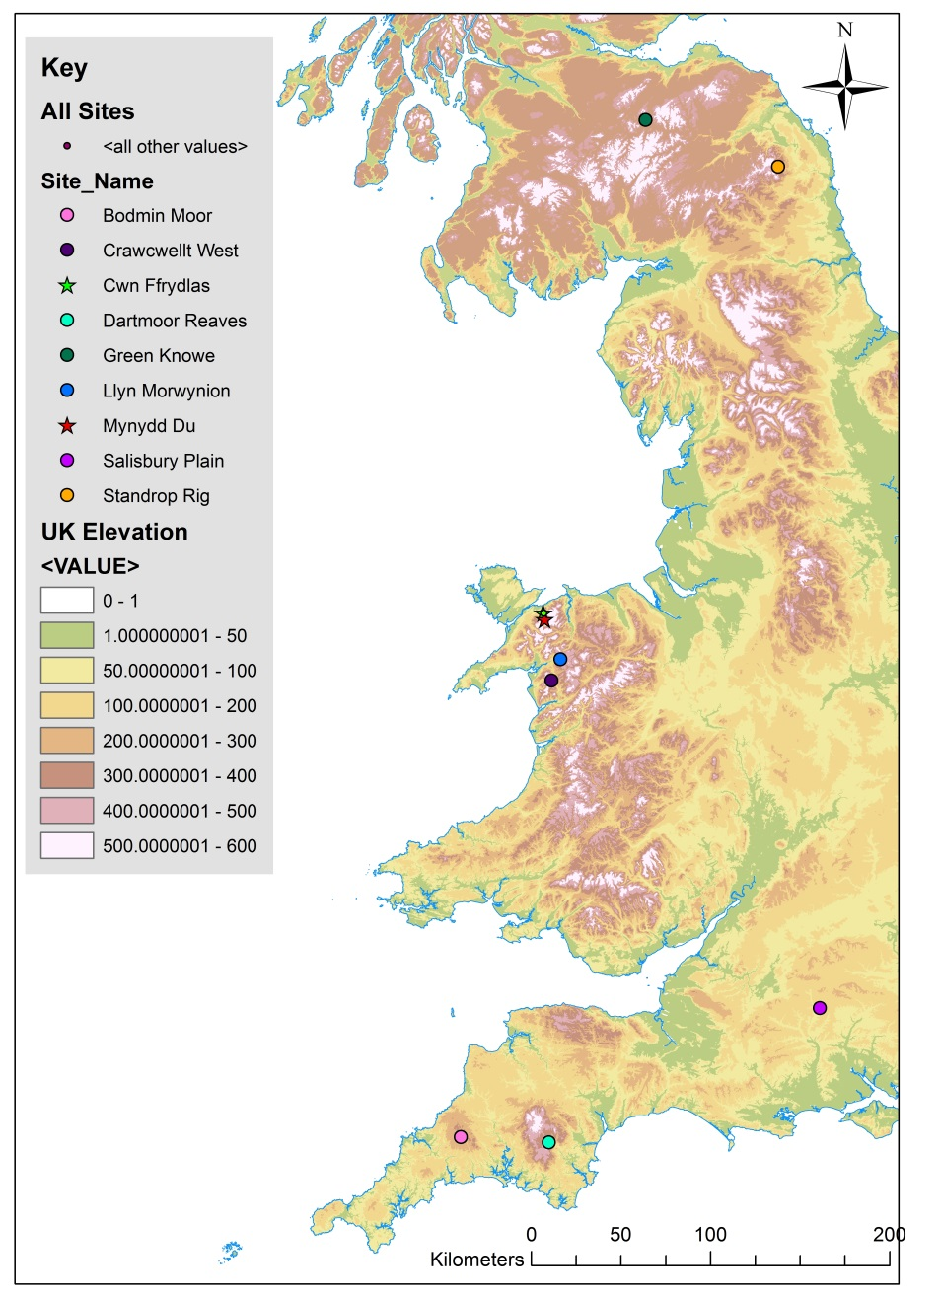
Figure 1: Distribution map of field systems referred to in text
Upland curvilinear field systems represent some of the first examples of possible sedentary settlement to occur in Britain. They first appear during the Early Bronze Age (1500-1150BC); they show a shift in Bronze Age society away from a more mobile way of life which had been the norm through Earlier Prehistory (Waddington, 2013, 13). They are generally in use throughout the Bronze Age but there is some evidence of these sites being in use during the Iron Age. Standrop Rigg in Northumberland produced carbon dates from a pit in a range of the later Iron Age and, 350 ±70BC (Jobey, 1983, 10). However it is worth noting that this is just one date and there were limited samples taken due to bioturbation caused by gorse roots and animal burrows. Crawcwellt West was also in use during the Iron Age and to some extent the early Roman period (Crew, 1989, 1998)
These field systems are found in abundance in the upland areas of Britain; there are hundreds of examples throughout Wales, Northern England and Scotland. They are generally defined by low stone banks which are created through the act of land clearance. The field walls are often associated with small round houses built in a similar manner to the field walls which are often incorporated into them. There are some examples from Northumberland at the sites of Green Knowe and Standrop Rigg (Jobey, 1978-80, 1983) of stake walled roundhouses associated with the field system although these examples also have clearance stone built up around them, which were interpreted as ring banks to protect the structures from the elements. Clearance cairns are also found along the field boundaries or inside the enclosed areas. Due to the curvilinear nature of the boundaries it has been argued that these field systems grew over time, also meaning that not all the round houses evident today were contemporary (Brück, 1999).
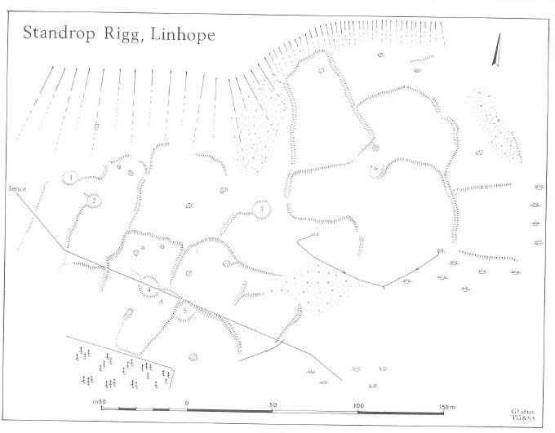
Figure 2: Site plan of Standrop Rigg (Jobey 1983, 3)
Standrop Rigg is an upland field system in the Cheviot mountains, set on the south east slopes of Great Standrop at about 380m OD (NT951174) (Jobey, 1983, 1) (see Figure 1). The site is formed by low stone field boundaries and platforms for stake built round houses with ring banks surrounding them (Figure 2). There were some problems encountered during the excavations with thin stratigraphy, animal burrows and two antiquarian disturbances on the site which make the formulation of a chronology for the site difficult (Jobey, 1983, 4). Two viable samples recovered from two pits in Area 4 did provide carbon dates. Pit A was overlaid by stones of the clearance bank indicating it was from an earlier phase and Pit B was not associated with the stake built phase, Jobey (1983,9) concludes it must be intrusive. The date produced from Pit A was 2070±80BC putting some of the earliest activity on the site during the early second millennium, although it is interesting that the area could have had a long history of human activity it is not relevant to any of the field system phases. Pit B produced a date of 350±70BC showing activity on the site during the middle or late Iron Age. Although as neither samples are from contexts associated with a structural phase of the site the dates give little insight into the settlements chronology.
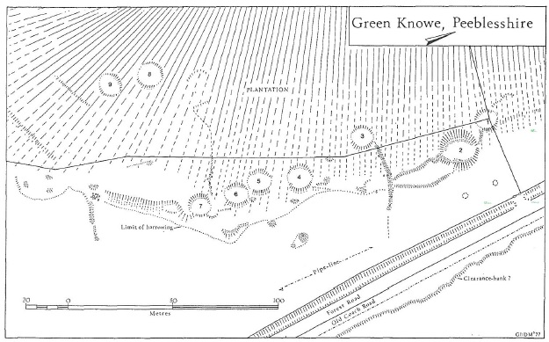
Figure 3: Green Knowe Site Plan (Jobey 1978-80, 74)
The settlement at Green Knowe is situated on the Meldon Burn in Upper Tweeddale, Northumberland (NT212434). There is a high density of field systems in the area, Jobey (1978-80, 73) noting that there are other examples in the area. Green Knowe consists of nine round house platforms and series of curvilinear field boundaries (Figure 3). Round house 4 was excavated in 1961, it was interpreted as being built using cavity wall method which would have been lined with wattle. Platforms 2, 5 and 8 were excavated in 1977 and 1978 as well as one of the field boundary junctions associated with platform 2 which was interpreted as being built using wooden stakes (Jobey 1978-80, 78). Jobey (1978-80, 94) argues that the site would not have been long lived and would likely have seen sporadic episodes of settlement. Despite the three phases of building on platform 2 the narrow groupings of carbon dates from each phase makes long term settlement unlikely according to Jobey (1983 94). Brück (2007, 29) expresses similar ideas about the short life cycles of Middle Bronze Age round houses in Wessex. Although other dates were produced from platform 8 for the 9th to 11th century BC or platform 5 giving dates between the 15th and 17th centuries BC although Jobey does emphasise that the dates from platform 5 and 8 are from single samples therefore they are less reliable (Jobey 1983, 94).
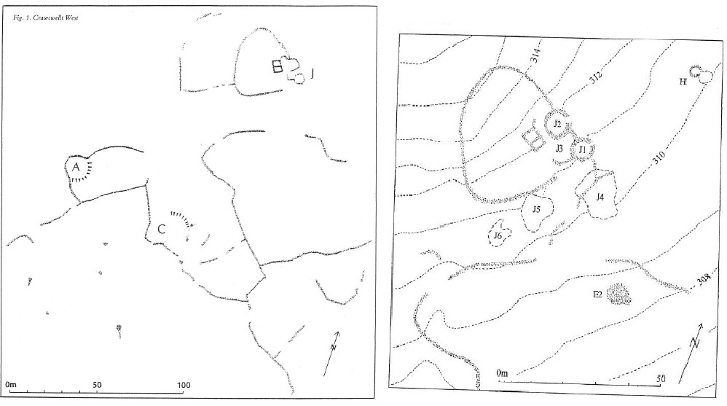
Figure 4:Carwcwellt West. Right 1998 (Crew 1998 22). Left 1989. (Crew, 1989 12)
Carwcwellt West is situated on the East side of the Rhinog Mountains on Moel y Gwartheg at around 300m OD (SH686308)(Figure 4). Typical of upland field systems it is defined by meandering stone walls and platforms for round houses, the system covers approximately 4 hectares (Crew, 1989, 11). It was excavated by Peter Crew throughout the 1980’s and 1990’s. From both excavation and extensive geophysical survey Crew has established that there was a high amount of ironworking both smelting and smithing undertaken on site. The majority of the dates for the site fall in to the middle and late Iron Age.
Archaeomagnetic dates produced from the furnaces in platform A indicate that the last time they were fired was sometime between 250BC-25AD 2 sig. This date refers to features F04, F10, F41 and F61, with F04 and F41 being the latest features stratigraphically (Crew 1989, 15). Although similar to Standrop Rigg the stratigraphy at Carwcwellt West is very thin. (Crew 1998 22). Further dates were recovered from furnaces in areas J5 and H. J5 produced a date of 300BC and H a date of 50BC, showing a long tradition of iron working at Crawcwellt West.
Some relative dates have also been produced from artefacts found during excavation. The blue glass bangle fragment found in Area A, Crew draws a comparison between it and similar items found at Bryn y Castell suggesting it could have originated there and giving it a possible date of 0-50AD (Crew 1989 15). One of the most interesting finds came from a pit in the area of J1 which produced fragments of Bronze Age pottery and flint working debris. This suggests a much earlier phase to the settlement.
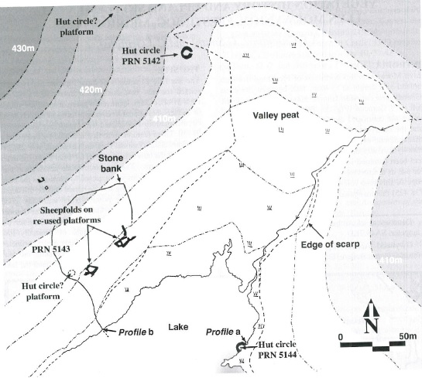
Figure 5: Llyn Morwynion Site Plan (Caseldine et al 2001 22)
The site at Llyn Morwynion (SH73724270) consists of two round houses and a group of sheep folds which overlay a number of earlier round platforms with associated ‘wandering walls’ (Caseldine et al 2001, 21). One of the huts was revealed by the peat being eroded by the reservoir of Llyn Morwynion. Radiocarbon dates recovered for this hut from pollen cores gave an Early Bronze age date for its construction.
The nature of the settlement and “agriculture” practiced at these upland sites is highly debated. The traditional view held by the likes of (Bradley 1980. Burgess 1985) perceive these upland field systems as an almost imperialistic colonisation of the uplands in an effort to gain more suitable land for agriculture which was available due to the warmer climate during the Bronze Age. An alternative interpretation is postulated by Johnston (2005b) that upland field systems were not an expansion or optimisation of agriculture in an effort to maximise production but were personal “garden plots”. He argues that the enclosures were used to experiment with different plants to gain better knowledge of the natural world. The social value of the garden is emphasised instead of the economic.
Coaxial Field Systems
In the lowlands of Britain coaxial field systems are more common. A coaxial field system is also defined by stone or earth banks and often have round houses associated with them like curvilinear field systems however they differ dramatically. Coaxial systems generally cover a much larger area and their boundaries branch off from a “terminal” boundary in an almost grid like pattern. Some of the most influential work on this site type was carried out by Andrew Fleming during the 1970’s on the Dartmoor Reaves (Fleming, 2008). Other examples of coaxial field systems in the UK are most notably on Salisbury Plain (McOmish et al 2007) which has been subject to damage from the British Army as the field system lies on Salisbury Army training ground. Despite this there is still a significant amount of surviving archaeology. Other examples are evident on Bodmin Moor such as the coaxial system East Moor which are likened to the Dartmoor Reaves due to their uniform layout and path through the landscape unhindered by terrain (Johnson and Rose, 1994, 62-64)
Prior to Fleming’s work the Dartmoor Reaves were thought to date to the Medieval Period but Fleming established that they date to the Bronze Age. Fleming argued that the huge scale and apparent continuity and adherence to the “terminal reaves” showed some kind of social shift and mass reorganisation of the landscape possibly in a relatively short period of time. This is a complete contrast to curvilinear systems which seem to grow over time as more ground is cleared and don’t adhere to any predefined plan as supported through the morphology of curvilinear boundaries (Johnston, 2008, 15). Johnston (2005) opposes Fleming’s suggested interpretation of mass reorganisation and instead argues that the Reaves represent the “formalisation” of existing social or economic boundaries in stone. He argues for continuity rather than drastic change although he does accept that even if that is the case there must have been some shift in Bronze Age society to require those boundaries to be defined physically. His argument is supported by the findings of hoof prints when a reave was excavated, leading to the interpretation that there was a track-way that predated the reave, which was then formalised by the reave system (Johnston 2005 4-6). Bradley (1980) emphasises the economic importance of the large enclosures for crop production for the wider community, which is opposite to Johnston’s (2005) which is focused mainly on the social aspects.
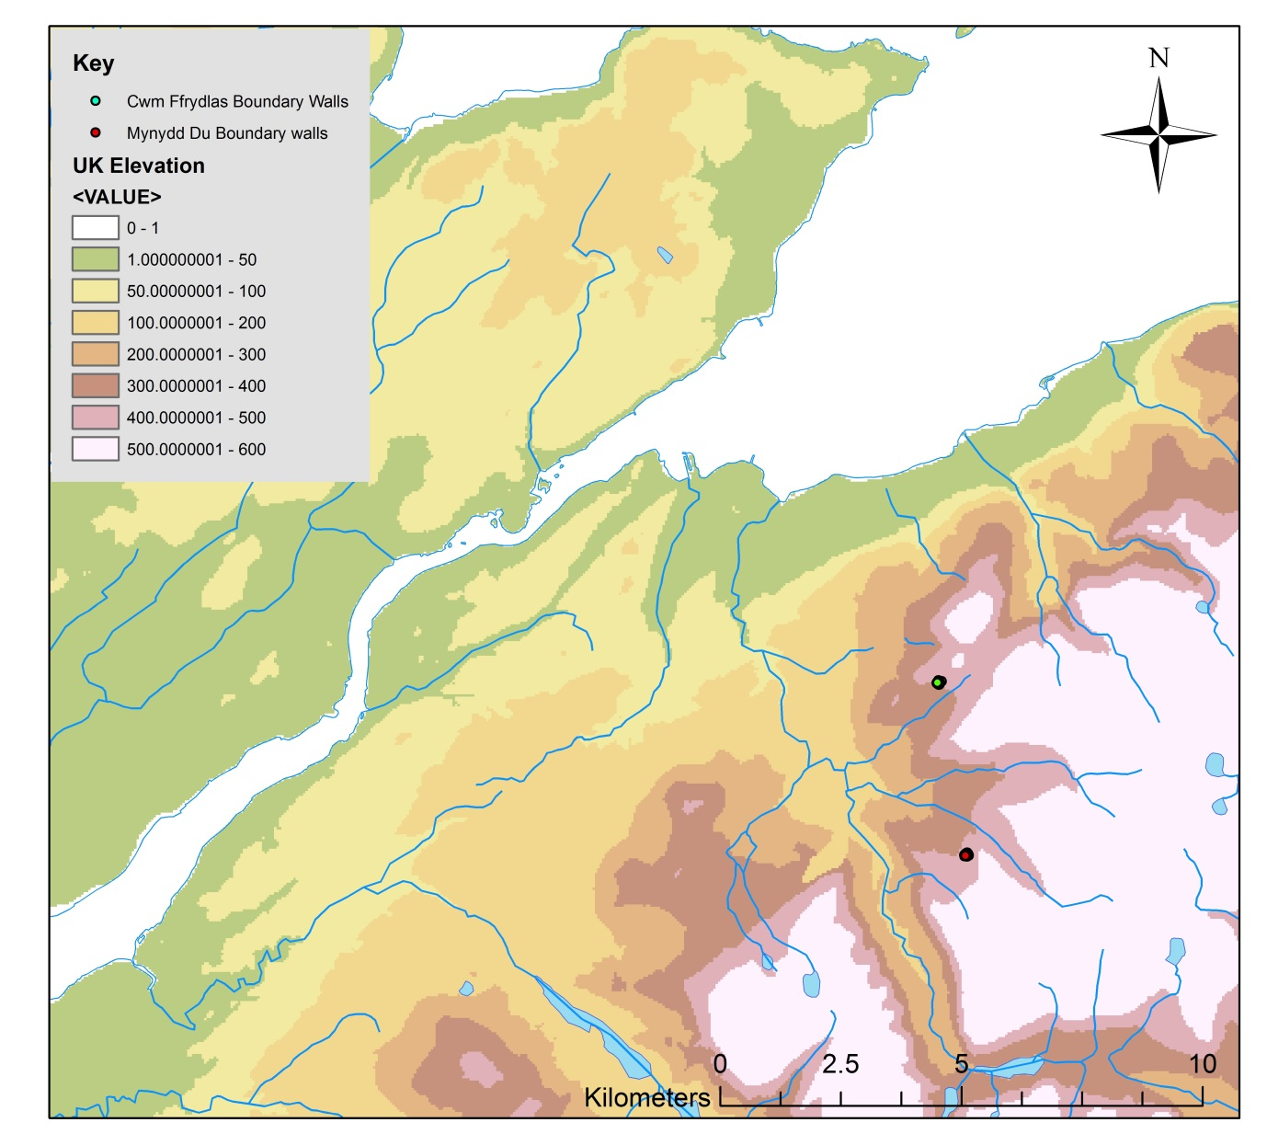
Figure 6: distribution map showing Cwm Ffrydlas and Mynydd Du
Cwm Ffrydlas
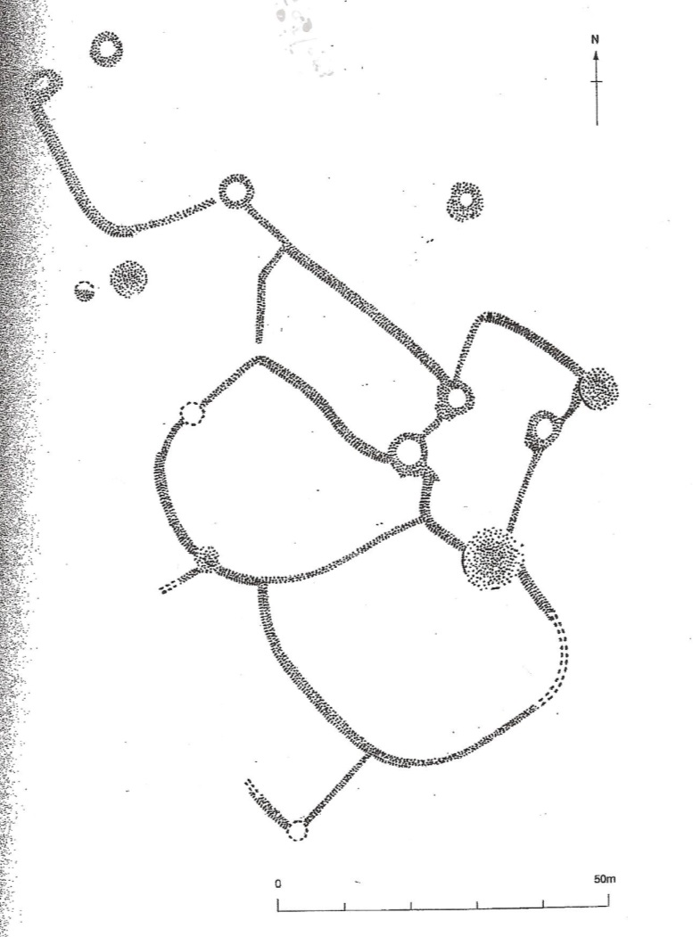
Figure 7: Cwm Ffrydlas site plan (RCAHMW 1956 145)

Cwm Ffrydlas is a curvilinear upland field system situated to the north east of Bethesda, Gwynydd on the edge of the Carneddi on the south side of Llefn at around 400m OD (SH64376841) (Figure 1 & 6). Cwm Ffrydlas was first recorded in the 1950’s by Griffiths (1951, 45-47) who created the site plan and a description of the site. The site plan was also published in in the Royal Commission on the Ancient and Historic Monuments of Wales Inventory of Caernarfonshire volume 1 (1956, 145 shown Figure 6). It is worth noting that on the original RC plan the north arrow is actually pointing to the south. The RCAHMW’s work was the only work to have been undertaken at Cwm Ffrydlas until a survey by Johnston (2008, 115) which provided detailed annotations of the RCAHMW’s plan. Also featured in Johnston’s article was a proposed morphology for the site (2008, 117), which he drew from the nature of boundary construction and how they relate to other boundaries where they intersect. There have been no excavations or any absolute dates produced from the site.
Mynydd Du
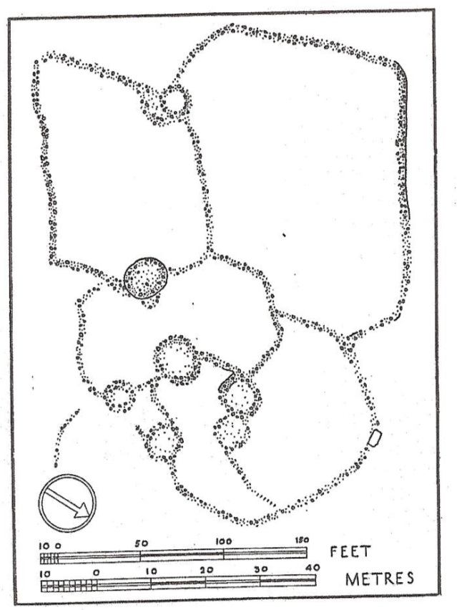
Figure 8: Mynydd Du site plan (RCAHMW 1956 140)
The field system of Mynydd Du is situated to the southeast of Bethesda, Gwynydd on a hill of the same name just above 420m OD (SH64926487) (Figure 1 & 6). Similar to Cwm Ffrydlas the first work undertaken at Mynydd Du was by the RCAHMW in the 1950’s to create a site plan (Figure 7). The plan of Mynydd Du can also be found in the Inventory of Caernarfonshire volume 1 (1956, 140). Johnston’s (2008, 118) article also touches upon Mynydd Du, including an annotated plan of the site, which is much less in depth than the one produced for Cwm Ffrydlas. No excavations have been held on Mynydd Du and no absolute dates produced for the site.

Chapter 2: Fieldwork Methodology and Results

Methodology
Site Plan
The first aim of fieldwork undertaken at Cwm Ffrydlas and Mynydd Du was to create an accurate site plan of each site and a topographical map. This was achieved using a Leica GPS Smart Pole to take GPS points along the banks and walls of the field systems. The Smart Pole is accurate to within centimetres when properly connected to multiple satellites and a phone network. Once the survey was complete the points created by the Smart Pole were imported in to ArcGIS 10.2. GIS allows the survey data to be layered up together along with other data such as maps.
Magnetometer Survey
The magnetometer survey was undertaken to provide insight into any potential magnetic anomalies on the sites such as possible hearths. As the department does not have access to the necessary equipment Ian Brooks of Archaeological Services Ltd provided the equipment, training and interpretation of the data. The survey itself was carried out using a Geoscan FM36 Fluxgate Gradiometer with readings being taken every 0.5 meters on a zig-zag pattern with the machine set to a resolution of 0.1nT. A grid was set out using ropes and pegs ensuring the pegs did not penetrate more than 10cm in accordance with CADW’s rules when working on Scheduled Ancient Monuments. The data was interpreted using Geoplot v.3.00v by Ian Brooks who also produced grey scale plots, colour contour plots and X-Y plots were be produced with “Surfer” v.10.
Photographic Survey
The aim of the photographic survey was to record the two sites as they currently survive on the surface and their relative levels of preservation. There is also the possibility of digitally recreating the sites in 3D using AgiSoft Photoscan Standard Edition, which could also be loaded in to GIS and interpreted in conjunction with the other survey data.
Results
Cwm Ffrydlas
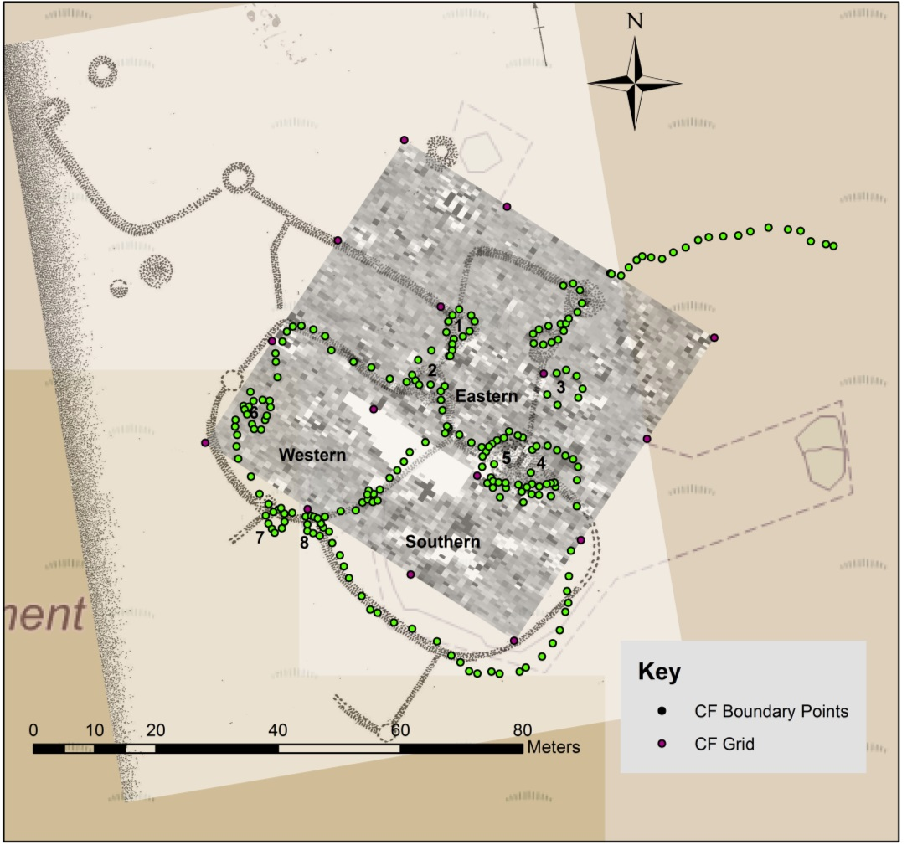
Plan 1: Cwm Ffrydlas survey data with RCAHMW 1956 plan
The site plan for Cwm Ffrydlas was completed although due to time restraints caused by weather conditions the topographical map was not produced; the equipment is not waterproof and becomes unreliable in temperatures below 10°C. The magnetometer survey was also completed across a 60m by 60m square which included all of the possible house platforms as this would be the most likely place for detectable human activity. There is an area which was not surveyed due to vegetation preventing access as illustrated in Plan 1 as a white area. The data was represented as grey scale, colour contour and X-Y plots by Ian Brooks and is contained in report 1 (appendix 4). The photograph survey was also completed however AgiSoft Photoscan was unable to create a 3D model from the photos. This is most likely due to the low grassy banks at Cwm Ffrydlas; the program needs to find points which it can recognise on multiple photographs to then knit them together. The grass causes problems for the program as is creates too many reference points for the program to compute making it impossible to construct a model. Although the photographic archive will still be useful for interpretation and for records of the sites
Mynydd Du
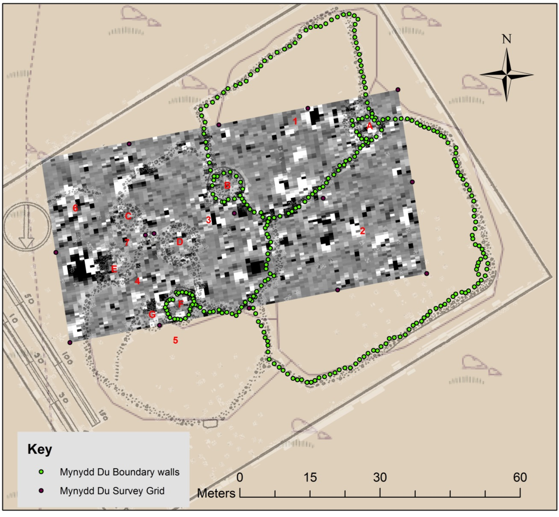
Plan 2: Mynydd Du survey results and RCAHMW 1956 plan
The site plan of Mynydd Du was not fully completed nor was the topographical map produced again due to time restraints caused by weather. However what was produced of the site plan can still be used as reference points for the magnetometer survey. The magnetometer survey was completed over a 80m by 40m rectangle, again covering all possible round houses. The results were again represented using all three plot types by Ian Brooks and are included in his report along with his interpretations, as seen in report 2 (appendix 4). Again AgiSoft Photoscan was unsuccessful in creating 3D images from the photographs from Mynydd Du. Although they were of better quality than those attempted from the photographs of Cwm Ffrydlas they were still not accurate. The stone banks of Mynydd Du probably make it easier for the program to create the models but the surrounding grass seems to disrupt the process from being completed.

Chapter 3: Analysis
The analysis of the data produced by geophysical survey was conducted using ArcGIS 10.2. GIS stands for Geographical Information Systems and has become widely used in archaeology for its ability to work with large databases of information as well as specific analytical features. Using GIS all of the information gathered for each site can be layered over each other to build a composite map of the site. It is particularly useful for studying the relationship between any magnetic anomalies detected by the magnetometer survey and specific features on site, as well as for specific analysis of the field systems such as special analysis of features.
Cwm Ffrydlas
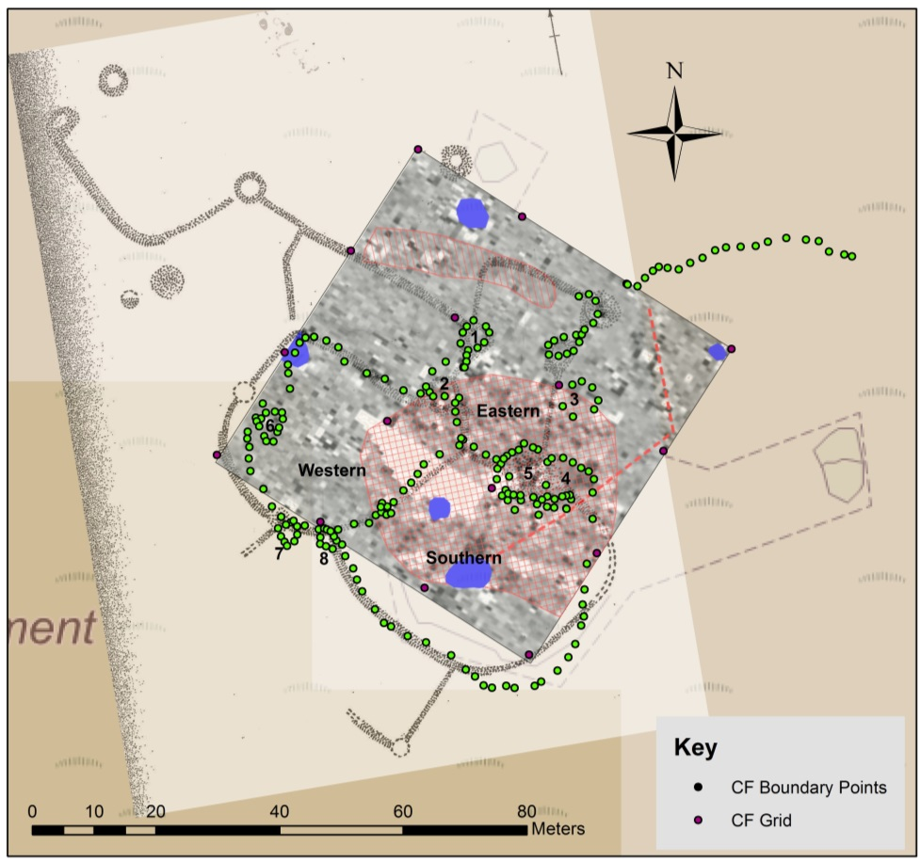
Plan 3: Cwm Ffrydlas site plan with interpreted greyscale plot (report 1). Blue – high magnetic response. Red line- possible linear anomaly. Red cross grid- area of magnetic disturbance. Red single line hash- possible area of magnetic disturbance

Eastern Enclosure
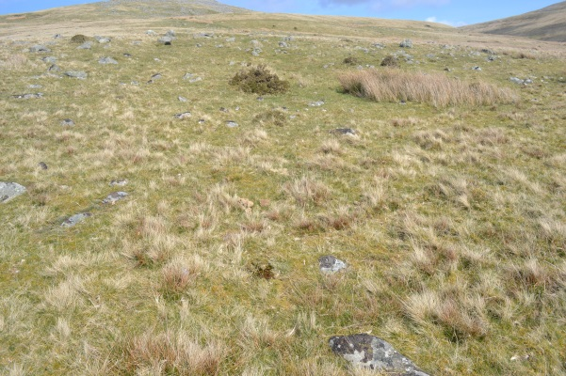
Photograph 1: Cwm Ffrydlas Eastern Enclosure
The eastern enclosure shown on the plan of Cwm Ffrydlas (Plan 3) is surrounded by possible round houses 1, 2 , 3 and features 4 and 5. The field boundaries are defined by low linear banks of stones collected through land clearance. This area seems to be the central focus of the settlement as the majority of the features are concentrated in this area. The land inside the enclosure is relatively well cleared of stone and mostly covered in grass with some patches of reeds (as shown in Appendix 2). The enclosure is the smallest of the three surveyed on the site with an area of 245.89m² (table1), although the north and eastern sides are not fully enclosed by visible field walls it is possible that those parts of the boundary have been buried or lost to stone robbing. The land clearance inside does indicate that the area was enclosed. The magnetometer survey covered the entirety of the eastern enclosure, in the interpretation of the results provided by Ian Brooks (Report 1) the southern part of the enclosure is demarcated as an “area of magnetic disturbance”. This possibly indicates human activity present in the southern half of the field.

Western Enclosure
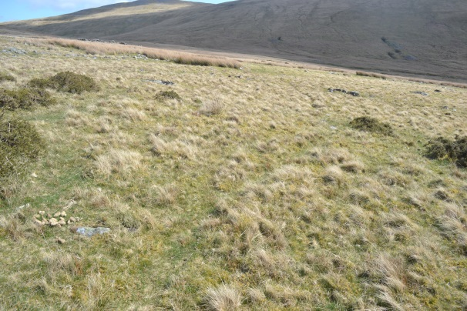
Photograph 2: Cwm Ffrydlas Western Enclosure
The western enclosure abuts the eastern enclosure (Plan 3) and the southern enclosure on its eastern side as well as possible round house 2. Along its western boundary is feature 6, possibly a small cairn or very small hut, and on its southern boundary are two small cairns, features 7 and 8 which are incorporated in to the field wall. The enclosure itself has an area of 652.64m² making it much larger than the eastern enclosure. However the land inside the western enclosure is also well cleared of stone, although there is more vegetation in this area, especially in the northern part with an extensive patch of gorse bushes (Photograph 2). The boundary banks are preserved in much the same manner as the rest of the site, as low linear alignments of stones (Appendix 2). The area of magnetic disturbance also spreads into the eastern side of the western enclosure, although around half of the area shown is covered up by the area which was unable to be surveyed due to thick vegetation and treacherous footing. Another magnetic anomaly is present on the northwest boundary of the western enclosure; it is marked as a high magnetic disturbance in the report. Considering it is not associated with any feature and just sits on the line of the field wall it is possible that it represents geological magnetic response however it is nearly impossible to say without excavation.

Southern Enclosure
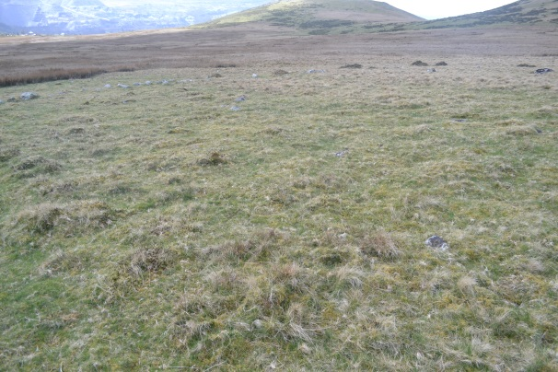
Photograph 3: Cwm Ffrydlas Southern Enclosure
The Southern enclosure has features 4 and 5 on its northern border and cairn 8 on its western corner (Plan 3); the boundaries are similarly defined by low lines of stones. The enclosure itself is the largest of the three with an area of 1005.81m² and is on the whole clear of stone inside the enclosure apart from a few patches (Photograph 3). It is worth noting that a short distance to the south of the enclosure at the bottom of the valley, the land becomes boggy with an abundance of dense reeds which is very different to that inside the enclosure. The magnetometer survey shows the area of magnetic disturbance present in the eastern and western enclosures spreading into the top half of the southern enclosure. Also present on the survey is a possible linear feature possibly a ditch or wall which is no longer visible on the surface. Brooks also highlights two areas of high magnetic disturbance. The southernmost is the most interesting result to come from the survey at Cwm Ffrydlas. Brooks highlights this feature in the colour contour plot as the readings appear to show a dipolar alignment which is typical of areas that have been exposed to excessive heat, such a hearths or foundries. This also seems to have some relationship to the linear anomaly mentioned previously which runs past feature 4 then appears to turn to the north. This possible dipolar reading is interesting although the position of this feature is odd, it appears in the middle of an enclosure not associated with any cairn or round house. If it had been inside one of the roundhouses this would have been significant evidence to support possible year round settlement.

Feature 1
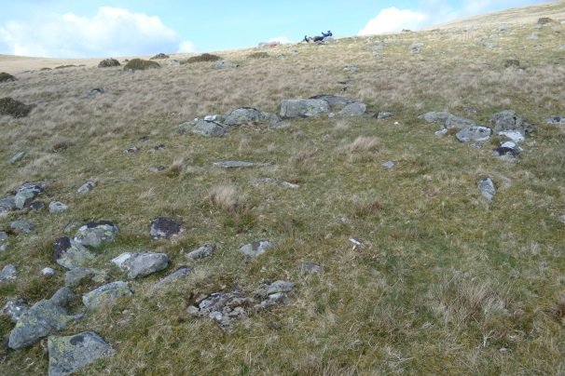
Photograph 4: Cwm Ffrydlas Feature 1
Feature 1 (plan 3, photograph 4) is the remains of a possible round house. It is fairly well defined with an estimated diameter of 4.93m (Table 1). There are two gaps in the wall in the west and south east, it is impossible to discern if it is due to stone robbing or the presence of an entrance to the house. The gap in the southeast could have been an entrance giving access on to enclosure A, although this cannot be proved from the current data. The magnetometer survey did not provide any clear insights into feature 1, the survey picked up no evidence of burning inside the round house.
Feature 2
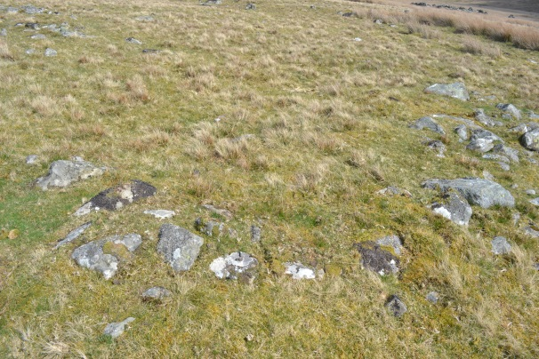
Photograph 5: Cwm Ffrydlas Feature 2
Feature 2 (plan 3, Photograph 5) sits on the boundary of the eastern and western enclosures and southwest of feature 1; it is defined by a thickening of the bank as well as a curl to the north as shown in the plan and photographs. It is possible that this is the remains of a round house as there is some evidence of the wall continuing round in a somewhat circular manner, from the survey an approximate diameter can be given of 5.57m and area of 26.50m² for this possible round house. The area inside the possible circle is clear of any stone also supporting the possibility of it being a round house. However, it could also be a kink in the bank from different building phases. The southern half of feature 2 is included in the large area of magnetic disturbance although no structured magnetic anomalies are present which would indicate the presence of a hearth.
Feature 3
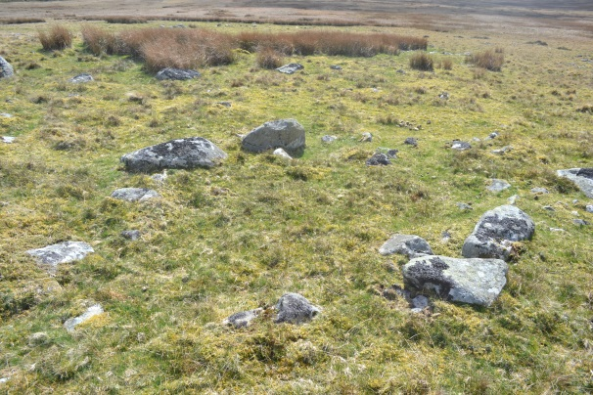
Photograph 6: Cwm Ffrydlas Feature 3
Feature 3 (Plan 3, Photograph 6) is situated on the east side of the eastern enclosure although it is not incorporated in to any of the field boundaries. Feature 3 is defined by a sub circular alignment of stones with an interior diameter of 3.15m and area of 11.66m² which is clear of stone. The wall of feature 3 is not as substantial as that of feature 1 but the outline of the structure is clear. Similar to feature 2 the southern half of the feature is encompassed in the area of magnetic disturbance but there is no evidence of burning or intense magnetic activity inside the small round house.

Feature 4 and 5
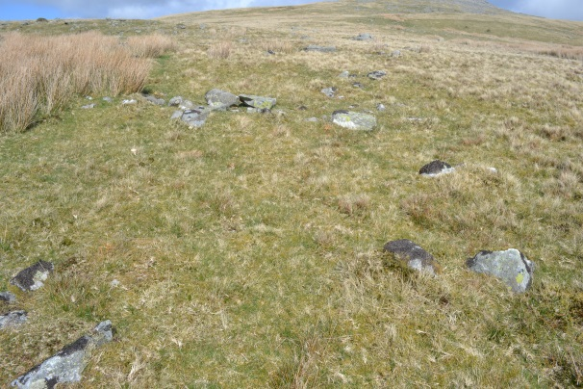
Photograph 7: Cwm Ffrydlas Features 4 and 5
Feature 4 (Plan 3, Photograph 7) is situated on the northern boundary of the southern enclosure and is 7.40m south of feature 3. Feature 4 is defined by a partial curved stone wall and slight dip in the area partially encompassed by the possible wall, from the survey an approximate diameter of 5.90m and an area of 21.47m². This feature is hard to distinguish, not only due to the sparse nature of the remains but also because there is a large patch of very dense reeds encroaching on it.
Feature 5 (Appendix 2) is in the middle of this thick area of reeds. This makes it very difficult to give any interpretation for it. There is definitely a feature in amongst the reeds as some stone can be distinguished most likely meaning that it is a large cairn covering an area of approximately 96.11m².
Features 4 and 5 are also inside the area of magnetic disturbance as with the other structures there is no evidence of burning inside them. However, feature 4 is associated with the possible linear alignment highlighted by Brooks.

Feature 6
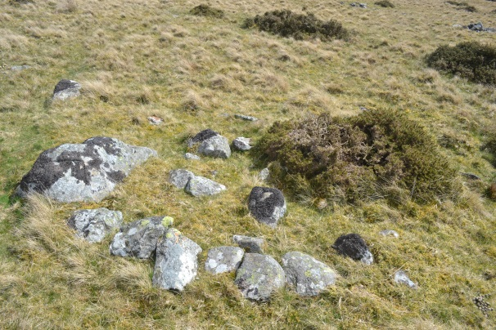
Photograph 8: Cwm Ffrydlas Feature 6
Feature 6 is a small possible round house that sits on the west boundary of the western enclosure. Feature 6 is the second smallest possible round house at Cwm Ffrydlas measuring 4.32m in diameter and covering an area of 13.89m², it is defined by a ring of stone although it is partially obscured by a gorse bush (photograph 8). The magnetometer survey did not detect any anomalies associated with feature 6 (Plan 3)
Feature 7
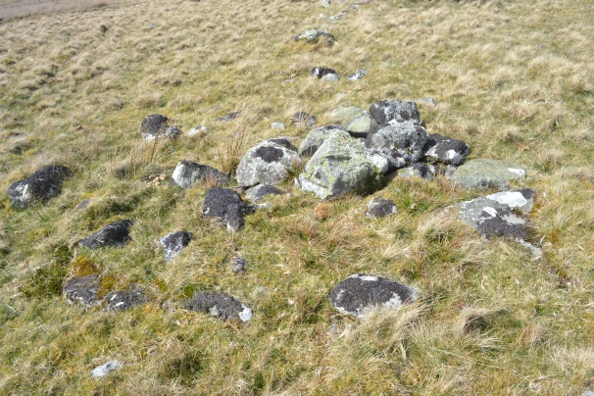
Photograph 9: Cwm Ffrydlas Feature 7
Feature 7 (Plan 3) is a small cairn which sits incorporated in to the southern boundary of the western enclosure, 3.74m away from feature 8. The cairn itself is relatively small covering an area of 3.83m², it is constructed of a small pile of stones with further ring of stones running around it (Photograph 9), most likely exposed facing stones which have been revealed by stone robbing. Feature 7 was not covered by the magnetometer survey.

Feature 8
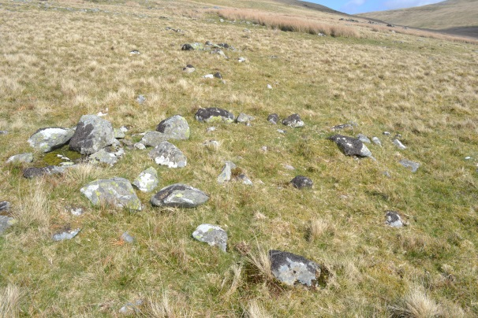
Photograph 10: Cwm Ffrydlas Feature 8
Feature 8 (Plan 3, Photograph 10) is situated on the boundary where the western and southern enclosures meet. Feature 8 could likely be another cairn with facing still visible, similar to feature 7. They are close to one another and are of comparable sizes, feature 8 has an area of 7.15m² and feature 7 7.93m². However, the possible cairn, shown (photograph 10) is offset and the area inside the facing is mostly clear of stone although not completely. This raises the possibility of it being a small round house, it would be below average for these upland sites but it could be possible (Smith 1999, 37).
Feature 8 was only minimally covered by the magnetometer survey, and no meaningful results came from that very small area covered.
Also shown on the magnetometer survey is a long thin area of possible magnetic disturbance to the north of feature 1 as well as an area of high magnetic disturbance slightly north of that. These readings are not associated with any features recorded during the field plan. Investigation into these lone readings could reveal new insights into the settlement; they could represent now lost portions of the settlement. When lined up with the RCAHMW’s (1956) plan there is a cairn shown slightly to the north which could be what the magnetometer detected, highlighting that the old plan is not completely accurate

Table 1: Cwm Ffrydlas
Feature | Perimeter (m) | Area (m²) | Diameter (m)
Eastern Enclosure | 60.17 | 254.89
Western Enclosure | 109.00 | 652.64
Southern Enclosure | 129.06 | 1005.81
Total Enclosed Space |  | 1913.34
1 (RH) | 14.21 | 14.58 | 4.93
2 (RH) | 19.74 | 26.50 | 5.57
3 (RH) | 26.49 | 11.66 | 3.15
4 | 17.33 | 21.47 | 5.90
5 | 43.23 | 96.11 | 6.18
6 (RH) | 14.80 | 13.89 | 4.32
7 Cairn | 11.00 | 7.96 | 3.83
8 Cairn | 11.29 | 7.15 | 2.55
Total Area Covered |  | 2112.62

Mynydd Du
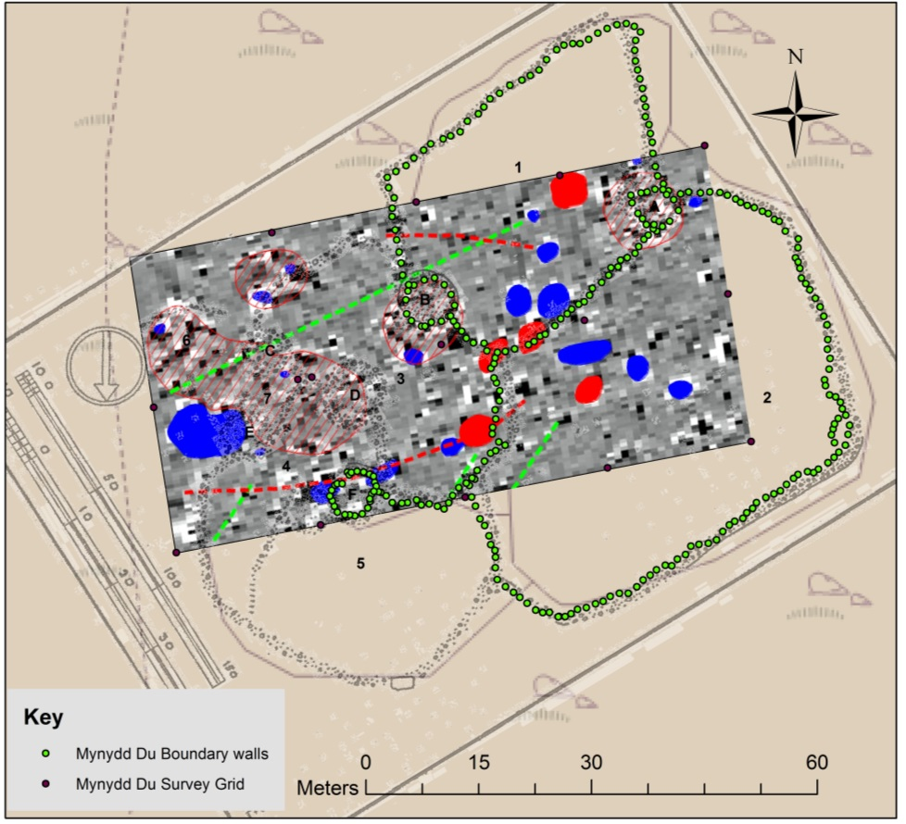
Plan 4: Mynydd Du site plan with grey scale interpretation. Red- high magnetic disturbance. Blue- Ferromagnetic response. Red single hash area- area of magnetic disturbance. Red line- possible linear anomaly. Green line- possible geological response.
Enclosure 1
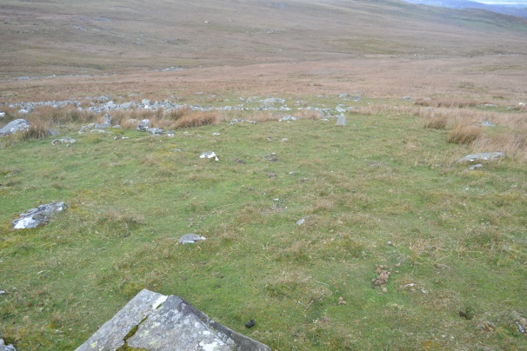
Photograph 11: Mynydd Du Enclosure 1
Enclosure 1 (Plan 4, Photograph 11) at Mynydd Du is the second largest enclosure at the settlement with an area of 978.57m². It shares a boundary with enclosures 2 and 3 also with round house A at its northwest corner and cairn B on its boundary with enclosure 3. The boundaries are built of clearance stone and are often over a metre wide. The area inside the structure is relatively well cleared with some stone spread throughout, however the southern part of the enclosure is full of large immoveable pieces of geology. Also inside the enclosure is an orthostat which is set into the hill (Appendix 2) which has a flattened area around its south western side; it is possible that it is the remains of a cairn.
The magnetometer survey produced very high readings at Mynydd DU, as shown in Ian Brook’s report (Report 2). Enclosure 1 is no exception, with multiple areas of ferromagnetic responses. On the northern edge of the survey close to the edge of the first 20m grid is an area of high magnetic disturbance. This reading is not associated with any of the field walls or other features; it is seemingly close to the area of magnetic disturbance associated with feature A although there is no obvious link. Brooks also identified a possible linear anomaly which runs from inside enclosure 1 to its boundary with enclosure 3, possibly joining with the corner of the boundary of enclosure 3. This could represent the remains of an earlier phase of the site, such as an extension of enclosure 3 which was cleared and reused to create a new part of the field system. Also two areas of high magnetic disturbance were recorded under the boundary of enclosure 1 and 2 just southwest of this under the boundary where enclosures 1, 2 and 3 meet close to feature B. These two highly magnetic areas could be associated with each other and could represent an area of human activity in the past, possibly before the boundaries were built or during their construction. However it is difficult to interpret these kinds of readings without excavation.
Enclosure 2

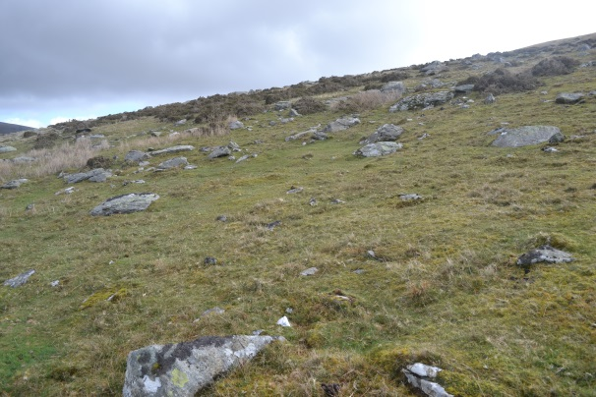
Photograph 12: Mynydd Du Enclosure 2
Enclosure 2 (Plan 4, Photograph 12) is the largest enclosure associated with the settlement with an area of 1769.34m², there is a fair amount of large stones inside the enclosure, however there are patches of cleared ground. It is possible that the smaller stones were removed during clearance and used to construct the boundaries or buildings and those left were the ones that could not physically be moved. It should also be taken into account that a portion of the stone inside the enclosure could have slipped downhill over time.
The magnetometer survey covered over half of the area of enclosure 2; there was only one area of high magnetic disturbance inside enclosure 2 which was not associated with any obvious feature. Also present were three areas of ferromagnetic response although more interestingly the start of a long possible linear anomaly starts in enclosure 2 close to its boundary with enclosure 3. The anomaly runs through enclosures 3 and 4 as well as part of features F and likely G.
Feature A
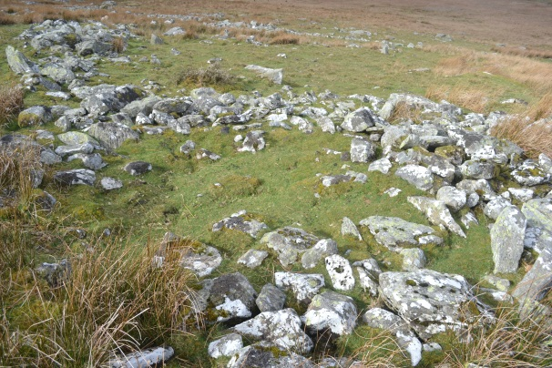
Photograph 13: Mynydd Du Feature A
Feature A (Plan 4, Photograph 13) consists of a well-defined round house with a diameter of 4.81m and area of 21.36m² which is incorporated into the boundary between enclosures 1 and 2. There is some evidence of remaining outer facing and a possible north facing entrance (appendix 2) defined by an orthostat and possible stone threshold slab. Part of the interior of the round house drops below the level of the surrounding area, this is on the opposite side to the possible entrance. Also close to the wall inside enclosure 1 there is a crescent build-up of stone against the wall of the round house. This could be tumble from the walls as they collapsed however it is only found on one side, therefore it could effectively be a clearance cairn which sprang up against the side of the house or it could be the remains of an earlier wall.
The magnetometer survey of feature A showed it situated inside an area of magnetic disturbance. This is significant as this most likely represents occupation practices. However there are no particularly high readings inside the house or dipolar readings typical of hearths. It is interesting that the area of magnetic disturbance also extends to an area outside of feature A inside enclosure 1. This small crescent on the western side of feature A is built up by accumulated clearance stone which could possibly be the cause of the reading outside the house.
Feature B
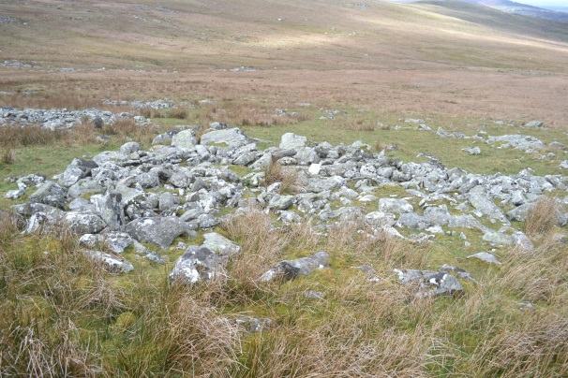
Photograph 14: Mynydd Du Feature B
Feature B is a large cairn constructed of clearance stone measuring 6.64m in diameter and covering an area of 30.57m². It is incorporated into the boundary between enclosures 1 and 3 (Plan 4, Photograph 14). On the north side there is good evidence of outer facing still visible for a few meters around the cairn (Appendix 2). The magnetometer survey shows that feature B is situated inside an area of magnetic disturbance. It is similar to feature A in that the disturbance extends beyond the feature itself and includes an area to the south inside enclosure 3. Also similar to feature A is the crescent of stone present in the disturbed area, most likely produced by clearance.

Feature F
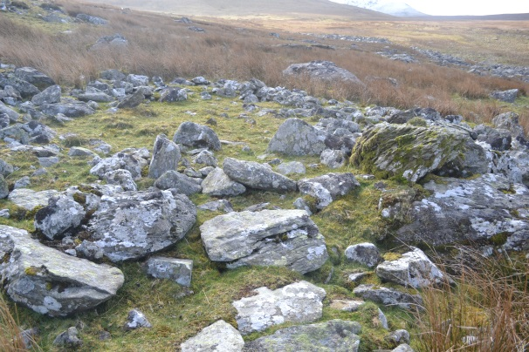
Photograph 15: Mynydd Du Feature F
Feature F is a good example of a stone built round house; it remains in remarkably good condition measuring 5.50m in diameter and covers an area of 27.92m² with minimal wall tumble in the centre of the round house. There are good examples of inner and outer wall facing still evident. Also present is a possible entrance facing north or slightly northwest (Photograph 23, Appendix 2, Plan 4) it is defined by two large orthostatic stones. There is a perceivable curve in the house wall to join up with the left hand stone indicating this was an entrance. However, there are four stones in a linear alignment which cut across this possible entrance. Although this alignment is not as high as the actual wall its self, possibly demarcating a threshold rather than the presence of a wall. The only magnetic activity in feature F is a limited ferromagnetic response and the possible linear anomaly which runs through the northern wall of the round house. There is no evidence of a hearth inside Feature F (Report 2, Plan 4).
*The following measurements have been taken from the RCAHMW 1956 plan of Mynydd Du as the full site plan could not be produced in the time frame
Enclosure 3
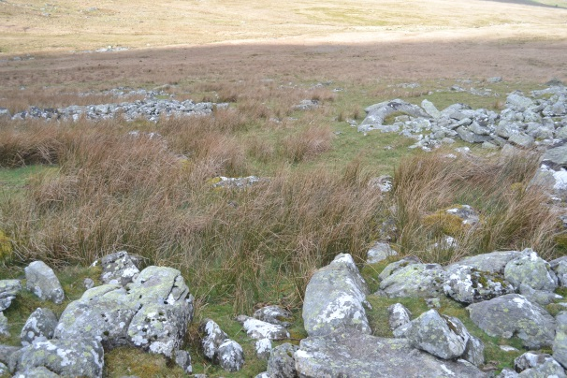
Photograph 16: Mynydd Du Enclosure 3
Enclosure 3 is set in the middle of the site; it borders all of the other enclosures and is sub circular in shape although the enclosure narrows in the middle where cairns B and D sit on its boundary with enclosure 1 and 4 (Plan 4, Photograph 15). The enclosure itself covers an area of 580.30m² although due to it narrowing in the middle it could be argued for it effectively being two separate enclosures. The interior of each side of enclosure 3 is different to one another, the southern side is full of reeds and littered by rocks yet the northern side is mostly clear except a few patches of reeds (Appendix 2).
A large area of high magnetic disturbance is present close to the boundary with enclosure 2, on the path of the possible linear anomaly. The linear anomaly continues in a generally western direction to intersect with the wall of feature F. Also on the northern boundary of enclosure 3 is an area of disturbance which encompasses part of the boundary itself but also appears to be sub-circular in shape (Plan 4, Report 2).
Enclosure 4
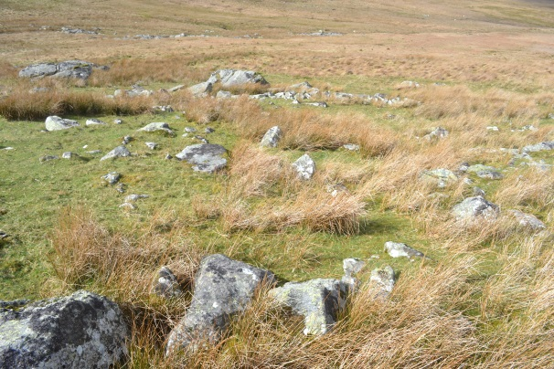
Photograph 17: Mynydd Du Enclosure 4
Enclosure 4 is surrounded by enclosures 3, 5, 6 and 7 as well as features C, D, E, F, and G (Plan 4). Enclosure 4 is one of the smaller enclosures on Mynydd Du only covering an area of 313.76m² and stands out for its long thin shape. The area inside the enclosure is largely taken up by thick patches of reeds and a substantial amount of stone in the area; although there are clearings between the stones in some places (Appendix 2).
The magnetometer survey shows the possible linear anomaly running through the southern end of the enclosure and along its western path past the western boundary. Also the northern part of the enclosure is encompassed by the large area of magnetic disturbance which covers a number of features in that area of the field system (Plan 3, Report 2). Little can be drawn from the survey in this area.
Enclosure 5
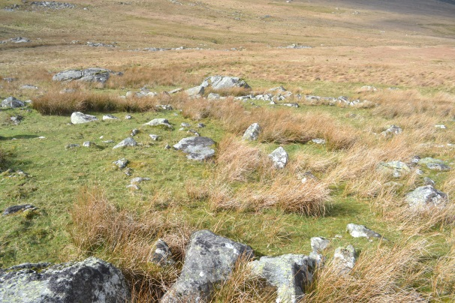
Photograph 18: Mynydd Du Enclosure 5
Enclosure 5 is the southernmost enclosure at Mynydd Du sharing boundaries with enclosures 2, 3 and 4 as well as with features F and G (Plan 4). The land inside the enclosure is largely defined by a large amount of stone especially on the western side. In the east there is more space between the stone; thick patches of reeds are present throughout the enclosure (Photograph 17, Appendix 2). Enclosure 5 was not covered by the magnetometer, only in very small areas near features G and F but not enough to give any insight in to the enclosure.

Enclosure 6
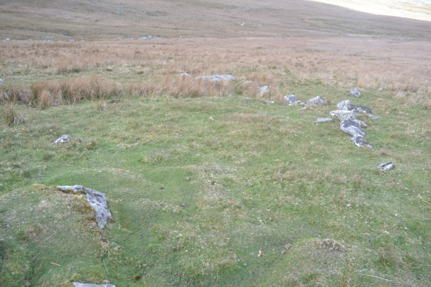
Photograph 19: Mynydd Du Enclosure 6
Enclosure 6 is merely a possible enclosure; it consists of a lone boundary wall which runs west away from feature C; however the area immediately south of the bank is clear of stone which could imply human activity (plan 4, photograph 18). The bank itself continues west then terminates just after a large outcrop (Appendix 2). The land beyond the outcrop becomes increasingly boggy and dominated by reeds as you venture further into the valley.
The area demarcated as possible enclosure 6 is covered by the area of magnetic disturbance in the south western part of the site (Plan 4, Report 2). This supports the interpretation of this once being an enclosure associated with the settlement but has since been lost, possibly engulfed by peat formation in the lower part of the valley.
Enclosure 7
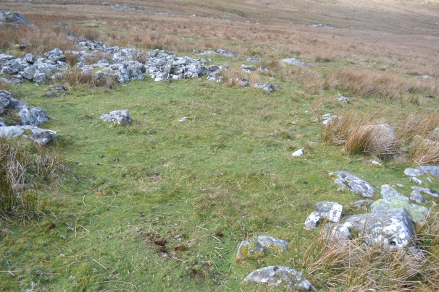
Photograph 20: Mynydd Du Enclosure 7
Enclosure 7 is the small area demarcated between features C and E, sharing a boundary with Enclosure 3, 4 and 6 (Plan 4). It is the smallest enclosure on the site covering only 45.61m², the area inside is well cleared of stone and has minimal patches of reeds which are concentrated at the edges of the small enclosure. It is probably one of the best cleared areas at the site (Photograph 19). Enclosure 7 sits in the middle of the large area of magnetic disturbance, although there are no other magnetic features present in this area other than one small ferromagnetic response in the north corner (Plan 4, Report 2).
Feature C
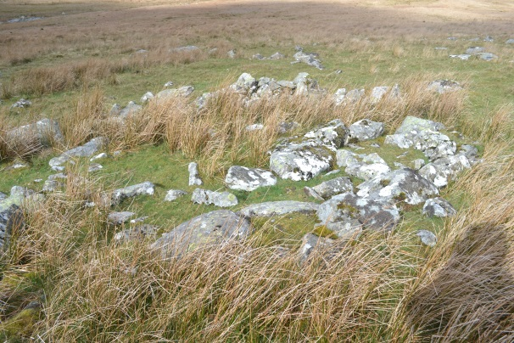
Photograph 21: Mynydd Du Feature C
Feature C is situated on the boundary of enclosures 3, 6 and 7 (Plan 4) and is one of the smaller round houses evident at Mynydd Du measuring 4.30m in diameter and covering an area of 14.77m². The area inside the house is full of rocks presumably tumble from the walls, the reeds in this area are thick (Photograph 20). The walls of the house are very thick in places with good examples of outer facing still visible (Appendix 2). The magnetometer survey also shows feature C being encompassed by the large area of magnetic disturbance as well as having the possible geological response running through it. It could be possible that the geological response could hide more detailed readings. There is no strong evidence of a hearth inside feature C (Plan 4, Report 2).

Feature D
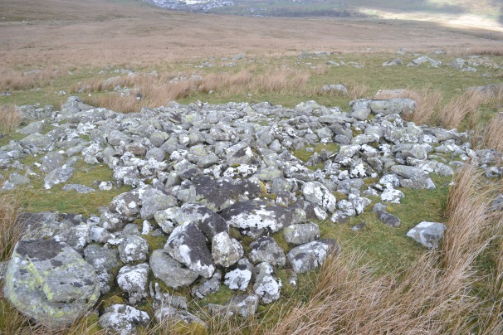
Photograph 22: Mynydd Du Feature D
Feature D is a cairn that sits on the boundary between enclosure 3 and 4, it is the largest cairn at Mynydd Du covering an area of 42.79 m². The cairn itself is made of clearance stone; there is an evident depression in the middle and some evidence of facing on the outer edge of the cairn in places (Photograph 21). The area (Plan 4, Appendix 2) suggests that there was an earlier pre-existing wall there before the cairn was built. There is evidence of possible facing stones on the section of wall meaning that the cairn built up alongside it, much like the build-up next to round house A. Feature D is also included inside the area of magnetic disturbance however its north-eastern wall is not included; this could be due to the RCAHMW’s plan (1956) being slightly inaccurate.
Feature E
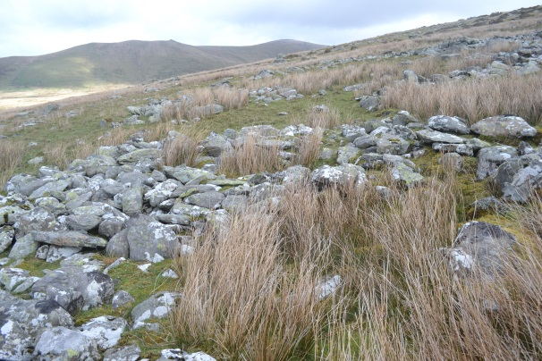
Photograph 23: Mynydd Du Feature E
Feature E is a cairn associated with enclosure 7, it measures 5.79m in diameter and 27m² in area. The cairn is made from clearance stone piled up although there is a slight depression in the middle of the cairn which has a lower density of stone than the surrounding area (Plan 4, Photograph 22). Feature E is partially covered by the large ferromagnetic response on its western side and partially by the area of magnetic disturbance to the east. However what is more likely is that feature E is solely associated with the large ferromagnetic response and the RCAHMW’s plan (1956) is slightly inaccurate.
Feature G
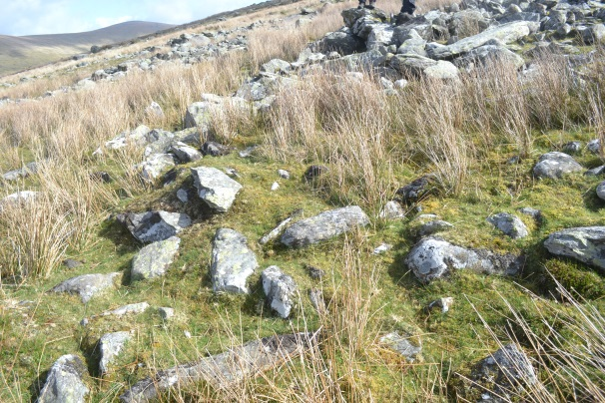
Photograph 24: Mynydd Du Feature G
Feature G is hard to distinguish on the ground due to a substantial amount of tumble from feature F covering much of the area, at least part of the structure’s wall is still visible (Photograph 24), from the RCAHMW plan structure G should measure 5.44m in diameter and 22.35m² in area (plan 4). Feature G also has very little magnetic activity associated with it, the linear anomaly could possibly run under the wall and there is a large ferromagnetic response in the wall between Feature G and F. There is no evidence of a hearth inside feature G (Report 2, Plan 4)

Table 2: Mynydd Du
Feature (from survey) | Perimeter (m) | Area (m²) | Diameter (m)
Enclosure 1 | 136.44 | 978.57
Enclosure 2 | 172.40 | 1769.34
Enclosed Space |  | 2747.91
A (RH) | 17.63 | 21.36 | 4.81
B (Cairn) | 20.16 | 30.57 | 6.64
F (RH) | 19.63 | 25.51 | 6.78
(from RCAHM plan)
Enclosure 3 | 116.49 | 580.30
Enclosure 4 | 94.61 | 313.76
Enclosure 5 | 96.87 | 599.44
Enclosure 7 | 28.80 | 45.61
Total Enclosed Space |  | 4287.02
C (RH) | 13.90 | 14.77 | 4.30
D (Cairn) | 23.55 | 42.79 | 7.01
E (Cairn) | 18.79 | 27.00 | 5.79
F (RH) | 18.97 | 27.92 | 5.50
G (RH) | 16.87 | 22.34 | 5.44
Total Area Covered |  | 4499.28

Chapter 4: Discussion
The Accuracy of knowledge
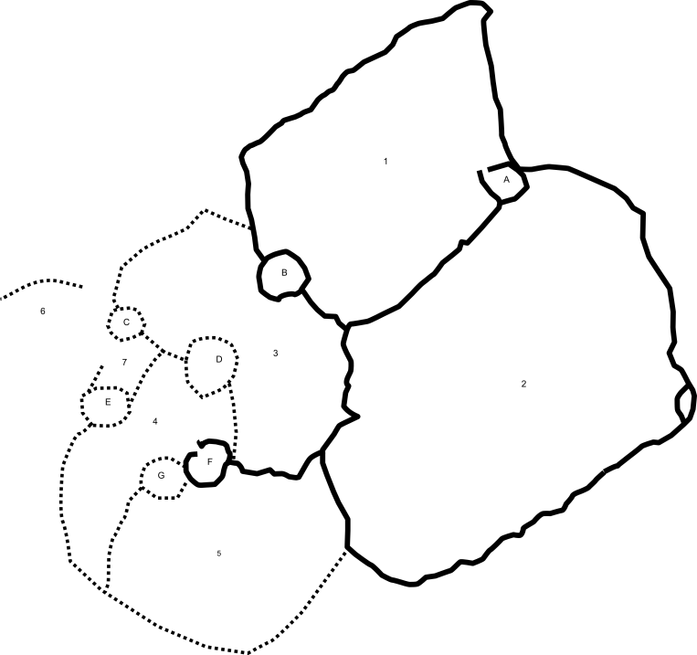
Plan 5: Mynydd Du illustrated. Solid Line - Rover Survey. Dot Line - RCAHMW 1956 plan
Like all curvilinear field systems Mynydd Du shows evidence of having been built in stages most likely over an extended period of time, being added to as more space is required. Whatever the reason, be-it social, economic or purely functional it is clear from the morphology of the site that this is the case. The RCAHMW’s (1956) plan was the base of understanding Mynydd Du since its production with little further investigation being undertaken in the following decades. One of the aims of the current work undertaken was to assess the accuracy of the original site plans which has been the base of our knowledge for almost sixty years. From the portion of the site that was covered by the rover survey the Commission’s plan is accurate, being almost identical to the rover survey results (Plan 2, 4 & 5). Ideally the survey would be completed to confirm this but from the current data the Commission’s plan looks reliable. It is this result which justified to me the use of the 1956 plan for measurements and analysing parts of the settlement that were not covered by the rover survey. While this is not ideal it provides a mostly reliable base to work from, although some minor inaccuracies are most likely present it serves as a suitable substitute in this situation when used together with the new partial site plan.
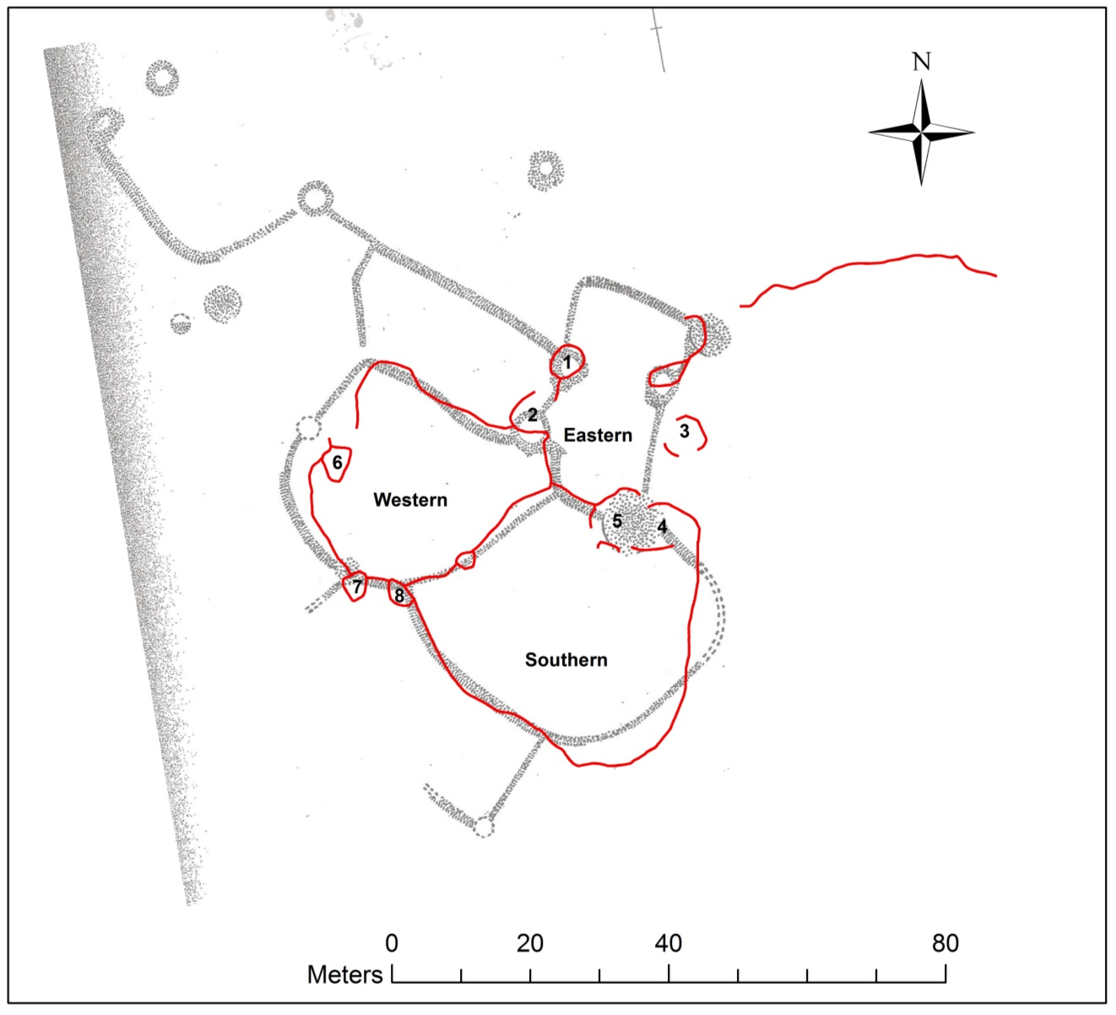
Plan 6: Cwm Ffrydlas Illustrated, over RCAHMW 1956 plan.
However, the same cannot be said for the RCAHMW’s (1956) plan of Cwm Ffrydlas. While some parts of the Commission’s plan do arguably correspond to points produced by the rover survey, notably all three enclosures seem to roughly line up well as features 1, 2, 4, 5 and possibly 6 which is favourable for the original plan there is a larger problem (Plan 6). As shown in the map the entire northern portion of boundaries and cairns recorded on the Commission’s plan were not found during the new survey, also referring to the photographic archive for feature one there is no perceivable boundaries running to the north or northwest from feature 1. Furthermore there was no trace of the possible enclosure wall shown on the RCAHMW’s plan next to feature 7 or of the corresponding boundary which is shown at the south end of the southern enclosure (Plan 6). Similar to the phantom boundaries near feature 1 there is no evidence on the photographs taken of feature 7 of any other boundaries connected to it from the south (appendix 2), although there are no photographs for the area on the southern enclosures boundary.
It is possible that the missing boundaries from the Commission’s plan were present when the settlement was surveyed during the 1950’s and have since been lost to sediment accumulation or damage. Although it still demonstrates that the plan which formed the foundation of our knowledge of Cwm Ffrydlas is essentially flawed. This could warrant further more detailed investigation to establish the actual extent of the boundary walls and other features at Cwm Ffrydlas.
Similarities between Mynydd Du and Cwm Ffrydlas
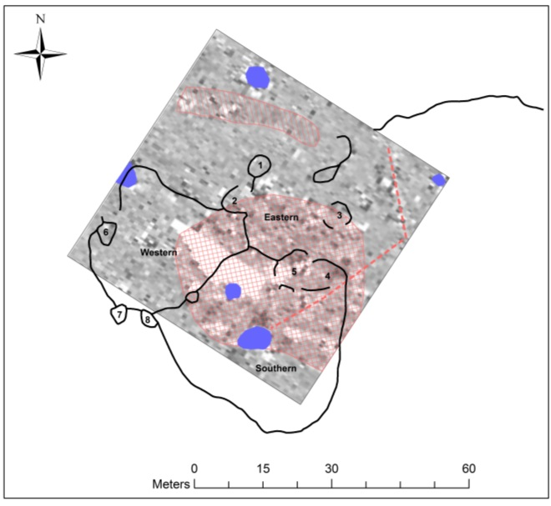
Plan 7: Illustrated Plan of Cwm Ffrydlas with Interpreted Magnetometer Results
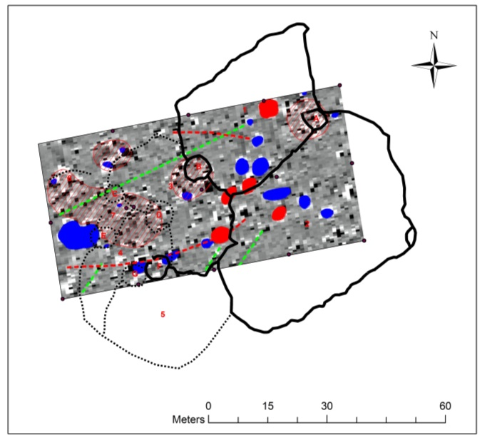
Plan 8: Illustrated Plan of Mynydd Du with Interpreted Magnetometer Results
Although Cwm Ffrydlas and Mynydd Du are both curvilinear upland field systems which both sit around 400m OD and are only 3.55km away from one another they are strikingly different. From a purely analytical point of view Mynydd Du is far larger than Cwm Ffrydlas, covering a total area of 4499.28m² opposed to Cwm Ffrydlas’ 2112.62m². Furthermore, Mynydd Du’s enclosed potential pastoral or cultivatable land is again far greater than that of Cwm Ffrydlas at 4287.02m² contrasting 1913.34m² at Cwm Ffrydlas. This is strange as there are the same amount of possible round houses at Cwm Ffrydlas and Mynydd Du. The houses at Mynydd Du are on average 5.366m in diameter, the largest feature F being 6.78m and the smallest feature C being 4.30m. This is comparable to Cwm Ffrydlas where the houses are on average slightly smaller, 5.14m in diameter with the largest feature 5 being 6.18m and the smallest feature 3 being 3.15m. The round houses of both sites generally fit into the average range for upland stone built round houses (Smith 1999, 37) which are generally smaller than their lowland counterparts. Although this is not relative as more than likely the round houses were not all contemporary with one another, the vast difference in the area of enclosed space at each site could indicate they held different functions.
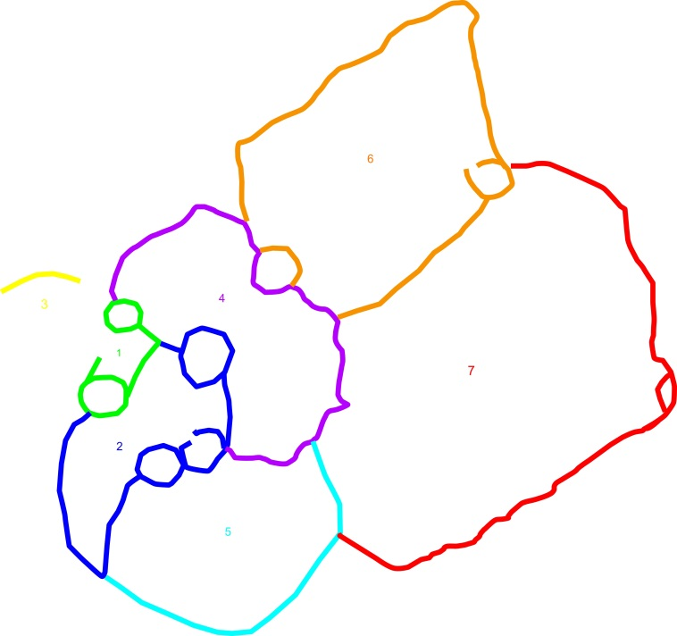
Plan 9: Suggested morphology for Mynydd Du
The morphology of the two sites is also noticeably different although they both appear to have a focus. The features at Mynydd Du seem to be crowded into the area around enclosure 4 and 7 which is also where the large area of magnetic disturbance covers. The features at Cwm Ffrydlas also seem to be focused around the eastern enclosure. This is interesting as Johnston’s (2008, 18) suggested morphology for Cwm Ffrydlas started with the two features that are most likely features 1 and 2 on the plan. This could still serve as a viable first phase at Cwm Ffrydlas, although a full morphology would be difficult to estimate due to the few enclosures. However I would argue that the eastern enclosure was the first as the rest seem to span off from it. Mynydd Du on the other hand can provide much more information, from the plan I would say that the first phase at Mynydd Du consisted of round house C, enclosure 7 and cairn E. I would argue this firstly because the focus of the other features seems to be on that area. Secondly enclosures 3 and 4 and to an extent 6 seem to respect the boundaries of enclosure 7 and join with them. Following this would have been enclosure 5 and then 1 and 2 (Plan 9). It is worth noting that enclosures 1, 2 and 5 are the three largest at Mynydd Du (Table 2) and look morphologically different to the other enclosures on the site. Enclosures 1, 2 and 5 create the fields by travelling in a wide ark from one boundary to another, using the old boundary as their own. This supports the theory that they represent a later phase of the field system.
With reference to the photographic archive produced from the sites it is clear that the enclosed areas at Cwm Ffrydlas are on the whole far better cleared of stone than Mynydd Du. Mynydd Du is plagued by large immovable pieces of geology throughout the enclosures; the surrounding area is also much rockier than at Cwm Ffrydlas. This sheer amount of stone likely contributed to Mynydd Du’s preservation because the building materials were so abundant. However there are some areas of Mynydd Du which have been cleared of stone completely. The northwest side of enclosure 3 is extremely well cleared, however the south eastern area is not cleared to the same degree, it is possible that they were two different enclosures but the central boundary wall has been lost from view. Further patches of clear ground can be found in enclosures 1 and 2 with enclosure 5 being arguably the least cleared. The area that would have been encompassed by the possible enclosure 6 is also very clear of stone, this area is near to the bottom of the valley and starts to disappear into the peat build up at the bottom. Some of the rock inside the enclosures could also be accounted for by tumble from the boundary walls as they fell over time.
From a heritage or conservation stand point the features at Mynydd Du are much clearer and better preserved than the field system at Cwm Ffrydlas. This could be due to Cwm Ffrydlas being the victim of stone robbing during the historic and early modern periods. As both sites are Scheduled Ancient Monuments it illustrates that they are both important for the future study of upland field systems.
The Nature of Occupation of Cwm Ffrydlas and Mynydd Du
It is unknown whether these curvilinear upland field systems were occupied permanently or seasonally. The most compelling evidence for permanent settlement would be the presence of hearths inside the round houses. However there are no possible hearths in any of the round houses at Cwm Ffrydlas or Mynydd Du according to the magnetometer survey. Therefore, this supports the theory of annual visitation rather than year round settlement as it would be close to impossible to survive a winter living in the uplands without a fire inside the house.
One area of prehistoric settlements which has been the focus of a large amount of research is the round house itself. Numerous models have been produced regarding the organisation of round houses. One of the earliest was Hingley’s (1990) centre/ periphery model which focused on examples from Scotland which were divided using stone partitions which created small rooms around the edge of the house with an open area in the middle where the hearth was situated. Hingley also attributed different social and gender roles to some of the small rooms such as cooking or weaving. Although there are no stone remains at either Cwm Ffrydlas or Mynydd Du of a centre/ periphery division like the Scottish examples it is possible that organic partitions were used such as textile or wattle screens which would allow the space to adapt to the time of day or activity. A later model was produced by Parker-Pearson (1996) which focused on the orientation of the house; Parker-Pearson argued that the majority of round houses in Wessex from the Middle Bronze Age through to the Middle Iron Age had southeast facing entrance. Parker-Pearson argued that this was to line up with the midwinter sunrise and suggests that the light from the sunrise through the door of the house was how people divided space in the house as different parts would be light at different time of day or year. This also went further to suggest that the house formed the centre of the cosmology or at least reflected it.
Features A and F at Mynydd Du both have possible north facing entrances (Appendix 2, Plan 5), there were no north facing round houses in the Wessex survey (Sharples, 2010, 199). However this has limited relevance to Mynydd Du as if the houses faced southeast they would be at least partially facing the slope of the hill, therefore the sun would be obscured and little light would reach the interior of the house. furthermore a northwest facing entrance would be in line with the midsummer sunrise which could also have been cosmologically significant.
The Functionality of Cwm Ffrydlas and Mynydd Du
Linking back to an earlier point of the vast difference in enclosed area between Cwm Ffrydlas and Mynydd Du it is possible that this is an indicator that the function of each site differed. Traditionally these upland settlements were associated with seasonal pastoral use due to the irregular fields and small round houses, they were dubbed Hafods from the medieval Welsh transhumance practice (Waddington 2013, 32). Research had generally focused on the economic and functional aspects of these kinds of settlements (Brück 2000, 3).
Johnston (2005b) proposed an alternative to the intensive “agricultural” model that had been attributed to many curvilinear field systems instead proposing a “garden plot” system. He stresses the importance of the small enclosures and suggests that they were used to experiment with different plants and crops but on a small scale. Enclosure 7 at Mynydd Du would be well suited to this model, it is far too small to be ploughed but it could easily be worked with a hoe. The good level of land clearance in the enclosure also supports this model. The larger enclosures such as 1 and 2 would be less suited as a hoe plot and more as pasture land for animals; although using this hoe cultivation plants could easily be planted in the gaps between the stones that could not be moved. Cwm Ffrydlas as a whole is well cleared of stone and would also be suited to this kind of small scale hoe cultivation.
Brück stresses the importance of social aspects of the settlements functions. Brück states that these settlements represent the ‘identity, integrity and independence of each household group’ (2000, 286). The importance of the act of land enclosure is especially important when talking about curvilinear field systems because they are some of the first examples of land enclosure being used for a domestic purpose. Even though Brück is discussing Wessex the idea is transferable to North Wales. The nature of Mynydd Du’s boundaries can be related to this idea; they form a complete enclosure unlike Cwm Ffrydlas’ boundaries. This process of fully enclosing an area of land could have created a social as well as physical barrier between those inside and everything outside. The opposite is also possible, that the physical boundaries were created to reflect new or changing social practices and associations.
Similarities between Cwm Ffrydlas, Mynydd Du and other Field Systems
As different as Cwm Ffrydlas and Mynydd Du are to each other comparisons can be drawn between the two, this is also true of curvilinear field systems in other areas of the UK. The hut platforms at Green Knowe (Figure 3) are in an almost linear alignment with each other, the construction methods used to create the round houses is also different to that of the stone built round houses of Cwm Ffrydlas and Mynydd Du. As earlier mentioned the Green Knowe houses are stake built (Jobey 1978-80, 78). The round houses at Standrop Rig (Figure 2) were also stake built however they also have stone ring banks which surround the houses. These ring banks could be comparable to the crescents of clearance material next to features A and B at Mynydd Du. However the overall morphology of the site is far closer to that of Cwm Ffrydlas than Mynydd Du. However, Standrop Rigg covers a far larger area than Cwm Ffrydlas.
Llyn Morwynion (Figure 5) is also far more dispersed than either Cwm Ffrydlas or Mynydd Du (Plan 7 & 8) and does not have fields associated with the round houses only a large partially enclosing stone bank. One of the hut platforms was well preserved by the valley peat, this could be the case at Mynydd Du or Cwm Ffrydlas as well and there could be more features associated with the field systems which have been covered by peat in the lower valleys. Furthermore peat can provide a very good environment for the preservation of organic matter such as bone, wood or pollen. This can be used for dating the site as well as reconstructing the past environment as was done at Llyn Morwynion (Caseldine et al 2001).
Crawcwellt West (Figure 4) is morphologically much more dispersed than either Cwm Ffrydlas or Mynydd Du (Plan 7 & 8). However it is very different in its function, Carwcwellt West was an iron production site with in situ furnaces found inside the round houses as well as extensive slag heaps (Crew 1989, 1998). Although there was one possibly significant magnetic feature at Cwm Ffrydlas it is miniscule compared to the mass of iron working debris at Carwcwellt West. The three successive round houses on platform A (plan) were all stake built round houses although Crew (1989 13) states that the later structure could have been associated with a ‘hood’ of stone to the north. This is possibly similar to what was found at Green Knowe and also present at Mynydd Du on features A and B (Appendix 2).
Even in this small sample it is apparent that there is a large amount of variation between sites that have been identified as upland field systems. It is not only morphological differences but also variations in their function and occupation practice. Many of the examples here were occupied in different time periods which could be the root of many of the differences however even contemporary sites could have functioned in different ways or been used differently in prehistory. No doubt the social or cosmological perception of these settlement types fluctuated through time.

Chapter 5: Conclusion
The fieldwork undertaken for this dissertation at Cwm Ffrydlas and Mynydd Du represents the first geophysical survey of either site as well as some of the limited fieldwork focused on upland curvilinear field systems as a whole. Its strengths lie in the accuracy of the surveys undertaken which creates a solid base of knowledge to work from. This will be useful if any future work is carried out on either site as it will allow investigations to be more focused than they otherwise could have been. Just the production of the survey data has significantly increased our knowledge of this very common site type which has held little focus of researchers.
The only weakness of the survey would be that the site plan of Mynydd Du could not be completed, however what was surveyed lines up almost exactly with the RCAHMW’s (1956) plan which can be used in conjunction with the new partial survey to give at the very least a rough idea of the site. The digital terrain models were also unable to be created which would possibly have added a great deal to the understanding of the sites; they could possibly have highlighted features in the landscape that are not obvious to the naked eye. This could have led to the discovery of further areas of the field systems. The production of a 3D model of each site was also not able to be produced; this was unfortunate as it would have provided a complete representation of the sites as they are preserved today in a way that a photographic survey alone cannot capture.
The data that was produced through the unobtrusive surveys do give significant insight into both settlements. The absence of magnetic evidence of hearths inside any of the round houses at either site does make wintering at the sites seem unlikely. All of the data is comparable to other field systems in North Wales as well as the rest of the UK which could provide relatable data to draw from.
These surveys only provide a small insight in to upland field systems as a whole; further work should be carried out to continue investigations into the two sites and curvilinear field systems as a whole. The need for further work has also been stressed by Waddington (2013, 118) and Smith (1999, 49). It would be optimal to complete the surveys proposed in this campaign of work which were not completed; especially the digital 3D reconstructions of the sites which would be a valuable archival resource. Whilst on this occasion using photographs taken from the ground were unsuccessful in creating 3D models, an alternative would be to use remote controlled drones to conduct large scale photographic surveys of entire landscape to then create 3D models. This technique has been used commercially and could work very well for sites like Cwm Ffrydlas or Mynydd Du.
Once all of the survey work is complete the next natural step would be to excavate each site. The excavations could be focused by the data retrieved from the surveys and aim to answer specific questions such as; the occupation and function of the round houses on both sites, the use of the enclosed spaces, the significance of clearance cairns and origin of specific features identified by the geophysical survey, what is the chronology of the site?
Investigation in to the use of the fields could be achieved through micro soil analysis in the enclosures. A good target for this could be enclosure 7 at Mynydd Du, due to its very clear interior coupled with the magnetic response detected it is likely that it was used for cultivation of some kind. This could also be undertaken at Cwm Ffrydlas’ southern enclosure, samples should be taken from the section of the trench using overlapping tins. This would also allow the source of the dipolar magnetic response to be investigated as it is one of the most significant results from the magnetometer survey. It would also be interesting to establish if it was in any way related to the possible linear anomaly.
Excavation and sampling of one or more of the round houses on each site would likely be a good focus for another trench. Phosphate samples taken on a grid from the interior of the round house could help to identify different activities that were associated with different areas of the structures. Any of the houses at either site would be suitable but house A or C at Mynydd Du would be suitable due to the magnetic response and house 1 at Cwm Ffrydlas as it is one of the better preserved examples. Detailed magnetic susceptibility surveys conducted on the same grid as phosphate sampling of the round houses could also provide further insight into the function of the structures.
Some further investigation into the clearance cairns could possibly help to shed some light on their significance, cairn B and C at Mynydd Du would be good choices as they both show significant magnetic activity associated with them.
Also any samples should only be taken from any secure contexts that could be used to provide carbon dates for any features which could help to build a chronology for each site.
To conclude the unobtrusive geophysical survey of Cwm Ffrydlas and Mynydd Du has given a more accurate and extensive understanding of the two sites and of upland field systems as a whole. They also provide a solid foundation from which to continue work on the sites in the future.

Bibliography
Bradley, R. 1980. Subsistence, Exchange and Technology – a social framework for the Bronze Age in Southern England C.1400-700 BC. British Archaeological Reports. 83 (1) pp.57-77. Ion,
Brück, J. 1999. Houses, Lifestyle and deposition on Middle Bronze Age Settlements in Southern England. Proceedings of the Prehistoric Society. 65. 1-22
Brück, J. 2000, Settlement, Landscape and Social Identity: the Early- Middle Bronze Age Transition in Wessex, Sussex and the Thames Valley. Oxford Journal of Archaeology. 19(3) pp.279-300. Oxford: Blackwell Publishers Ltd.
Brück, J. 2007. The Character of Late Bronze Age Settlement in Britain. In Haslegrove, C. and Pope, R. (eds) The Earlier Iron Age in Britain and the Near Continent. Oxbow Books: Oxford.
Caseldine, A, E. Smith, G. & Griffiths, C, J. 2001. Vegetation History and Upland Settlement at Llyn Morwynion, Ffestiniog, Merionnydd. Archaeology in Wales. 41. pp.21-33
Crew , P. 1989. Excavations at Crawcwellt West, Merioneth, 1986-1989: a late prehistoric upland iron-working settlement. Archaeology in Wales. 39, 22-35.
Crew, P. 1998. Excavations at Crawcwellt West, Merioneth, 1990-1998: a late prehistoric upland settlement. Archaeology in Wale.38,22-35
Hingley, R. 1990. Domestic organisation and gender relation in Iron Age and Romano British households. In Samson, R. (ed) The Social Archaeology of Houses. Edinburgh: Edinburgh University Press,
Fleming, A. 2008. The Dartmoor Reaves: Investigating Prehistoric Land Divisions. Oxbow Books: Oxford
Griffiths, W, E. 1951. Early Settlements in Caernarvonshire. In Archaeologia Cambrensis. 101. 38- 71.
Jobey, G. 1978-82. Green Knowe unenclosed platform settlement and Harehope cairn, Peeblesshire. Proceedings of the Society of Antiquaries Scotland. 110. pp.72-113
Jobey,G . 1983 . Excavations of an Unenclosed Settlement on Standrop Rigg, Northumberland . Archaeologia Aeliana. The society of antiquaries of Newcastle upon Tyne: Newcastle-Upon-Tyne
Johnson, N. & Rose, P. 1994. Bodmin Moor an archaeological survey volume 1: the human landscape to c.1800. English Heritage: Oxford 125-149
Johnston, R. 2005. Pattern without Plan: rethinking the Bronze Age Coaxial Field Systems on Dartmoor, South West England. Oxford Journal of Archaeology. 24 (1) pp.1-21
Johnston, R. 2005b. A Social Archaeology of Garden Plots in the Bronze Age of Northern and Western Britain. World Archaeology. 37. (2). Pp.211-223
Johnston, R. 2008. The Place and materiality of an Upland Field System at Cwm Ffrydlas, North Wales. In Chadwick, A, M. (ed) Recent Approaches to Land Allotment. Archaeopress: Oxford
Mc Omish, D. et al 2002. The Field Archaeology of the Salisbury Plain training area. English Heritage: Swindon
Parker Pearson, M. 1996. Food, fertility and front doors in the first millennium BC. in Champion, T. & and Collis, J. (eds). The Iron Age in Britain and Ireland. Sheffield: J. R. Collis Publications, 117-132
RCAHMW. 1956. An Inventory of the Ancient Monuments in Caernarvonshire, Volume I. London: HMSO
Sharples, N. 2010. Social Relations in Later Prehistory Wessex in the First Millenium BC. Oxford: Oxford University Press.
Smith, G. 1999. Survey of Prehistoric and Romano-British Settlement in North-West Wales. In Archaeologia Cambrensis. 148. pp. 22 – 53
Waddington, K. 2013. The settlements of North West Wales: From the Late Bronze Age to the Early Medieval Period. University of Wales Press: Cardiff

Appendix 1: Maps and Plans
Mynydd Du
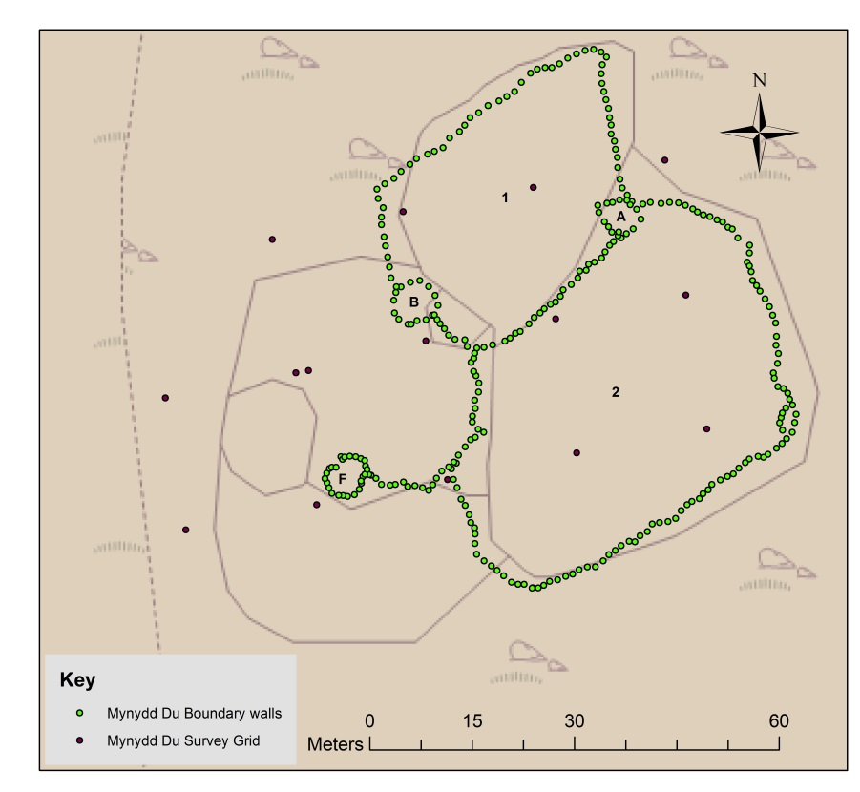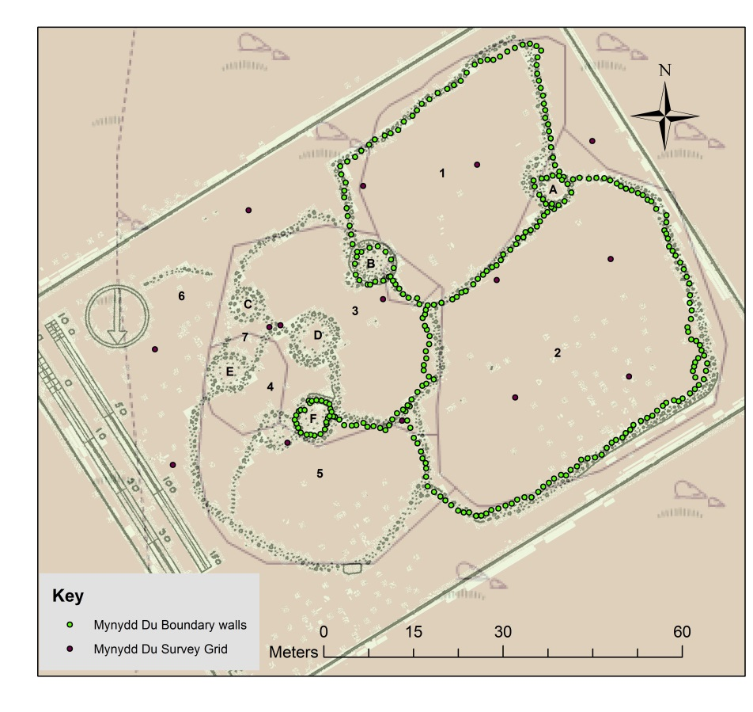
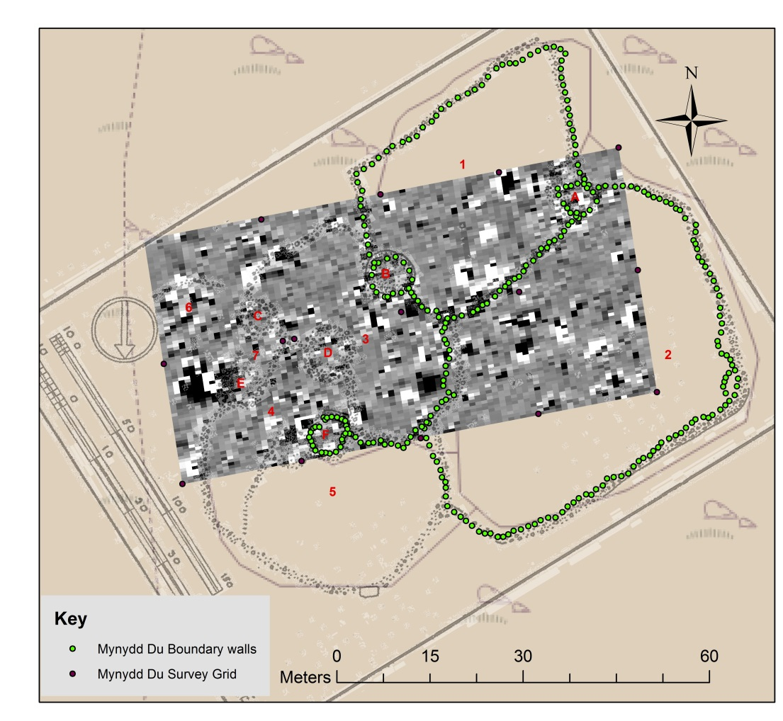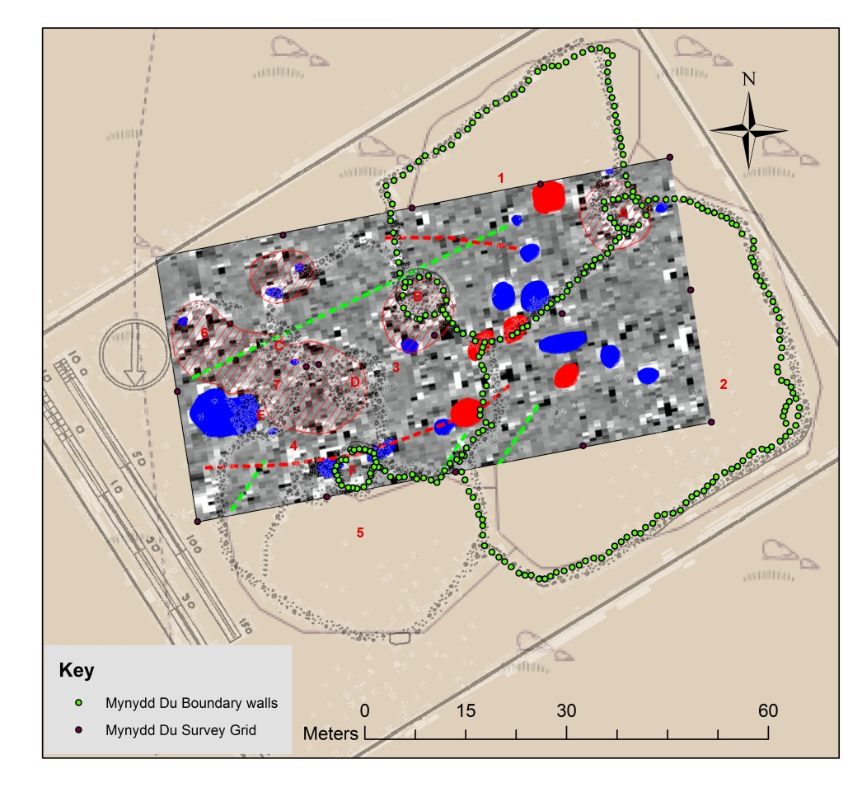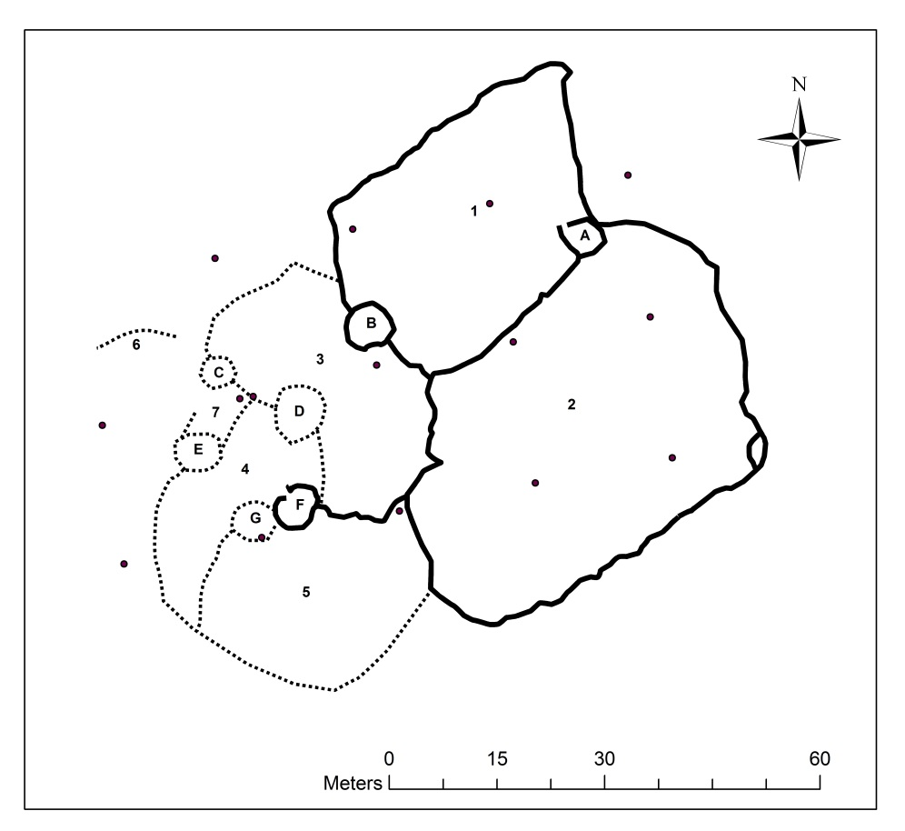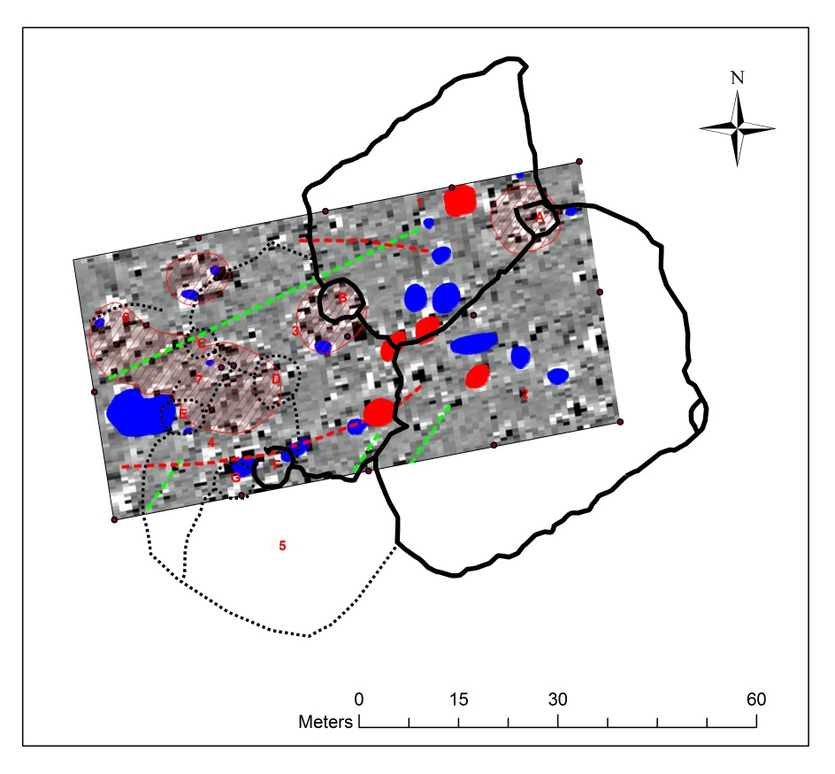
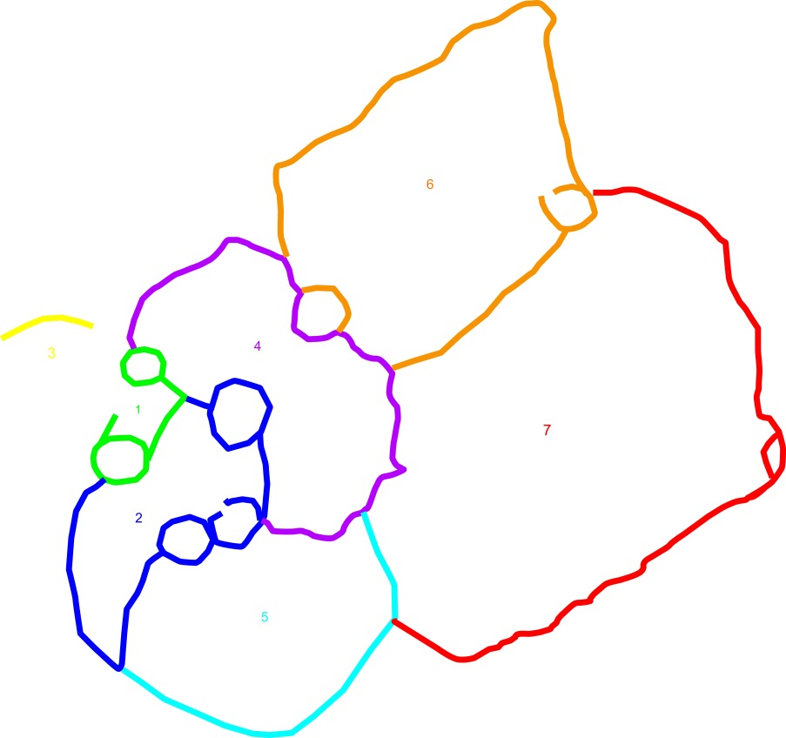
Cwm Ffrydlas
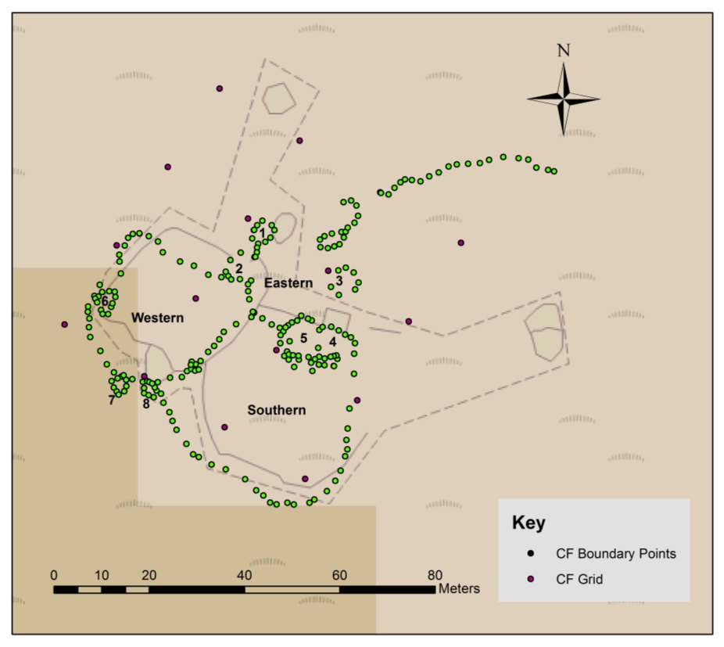
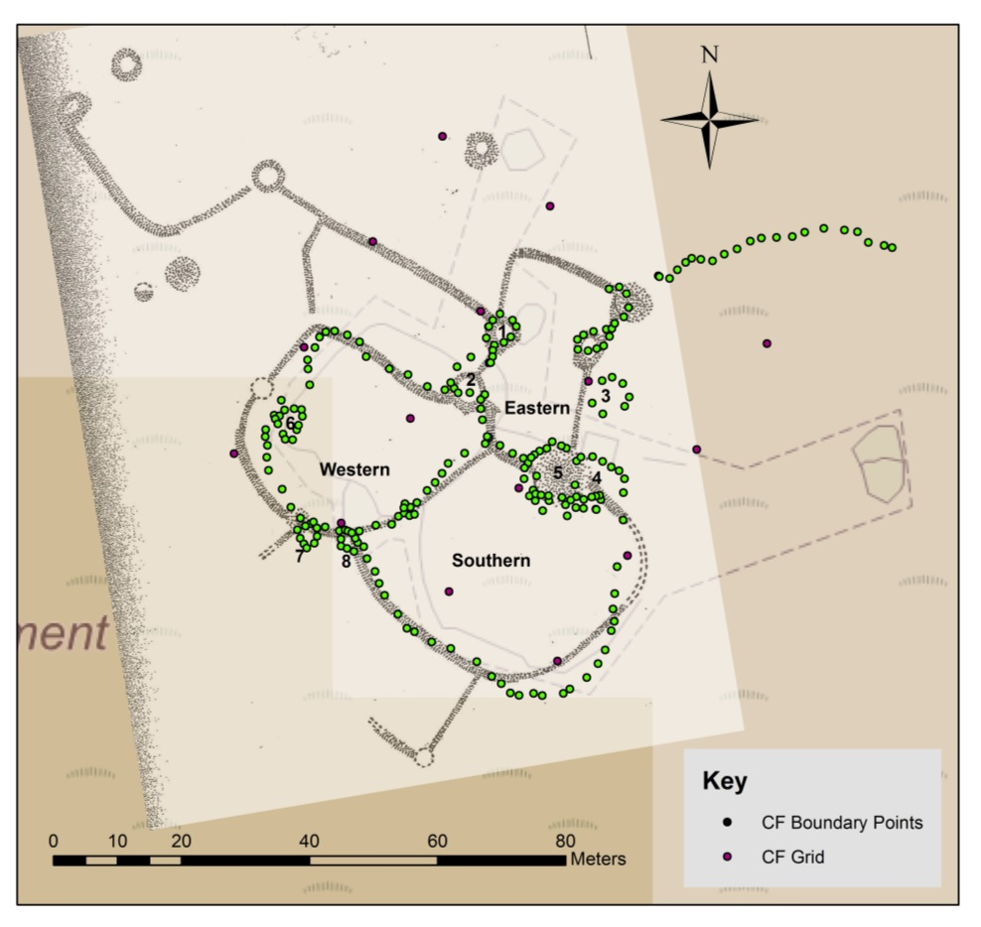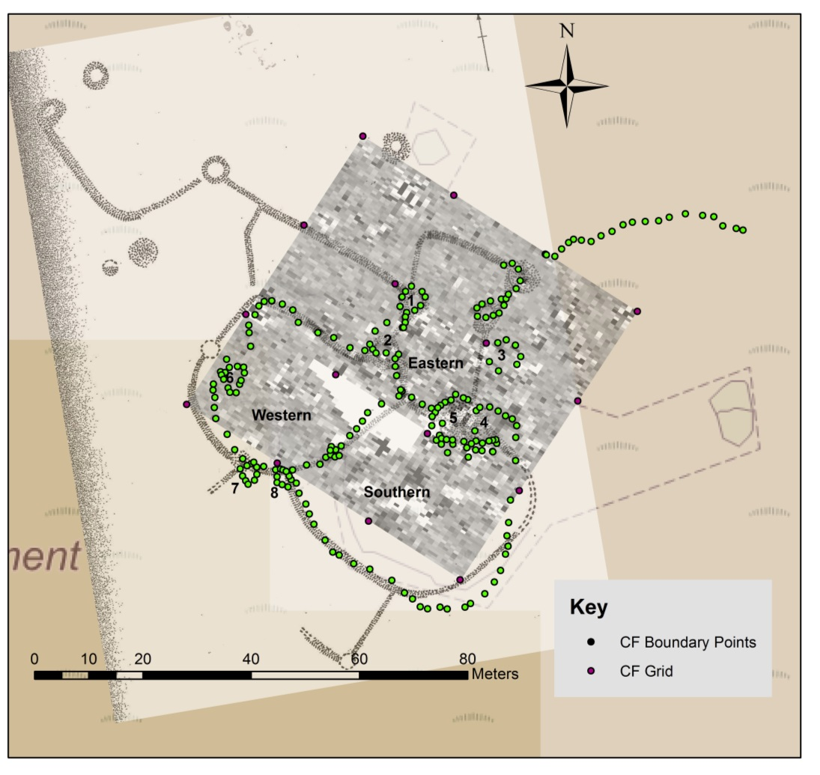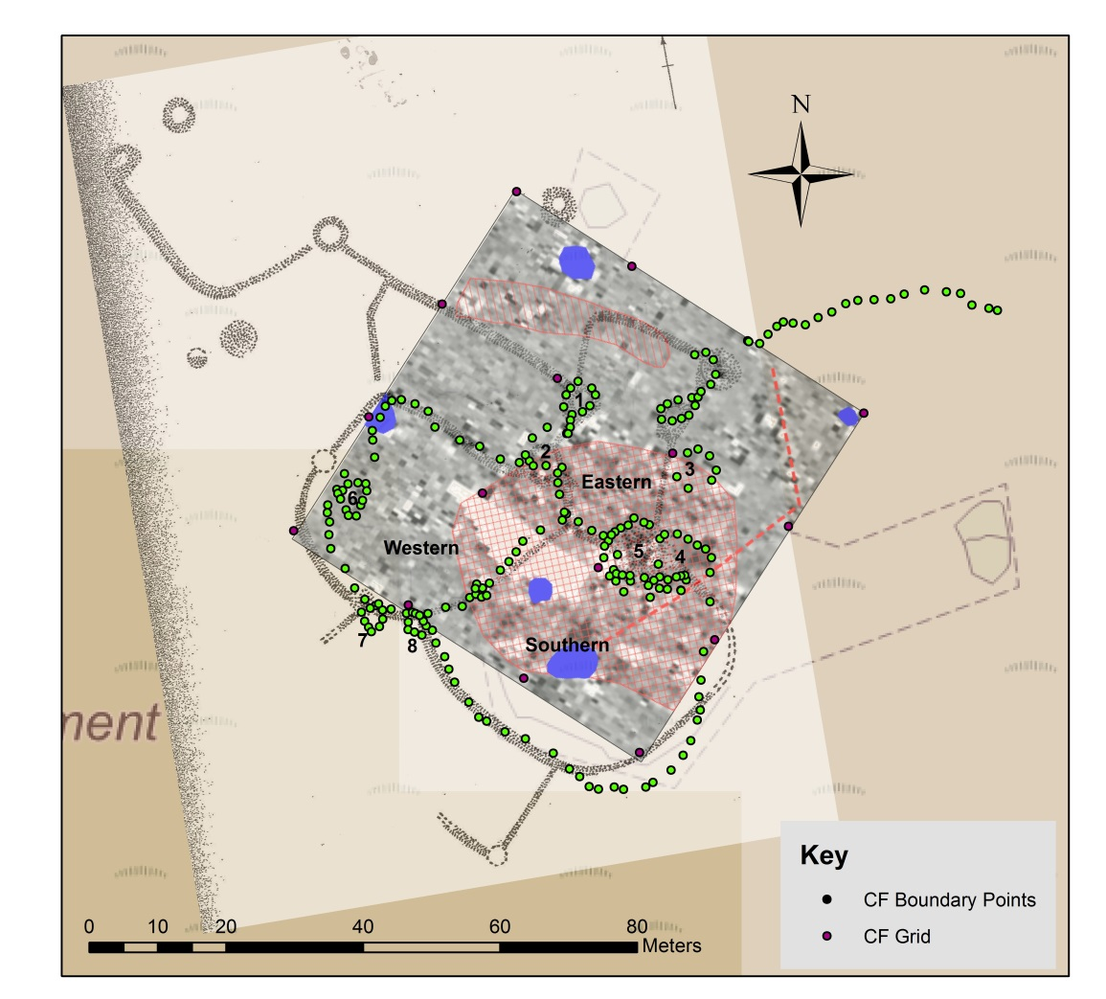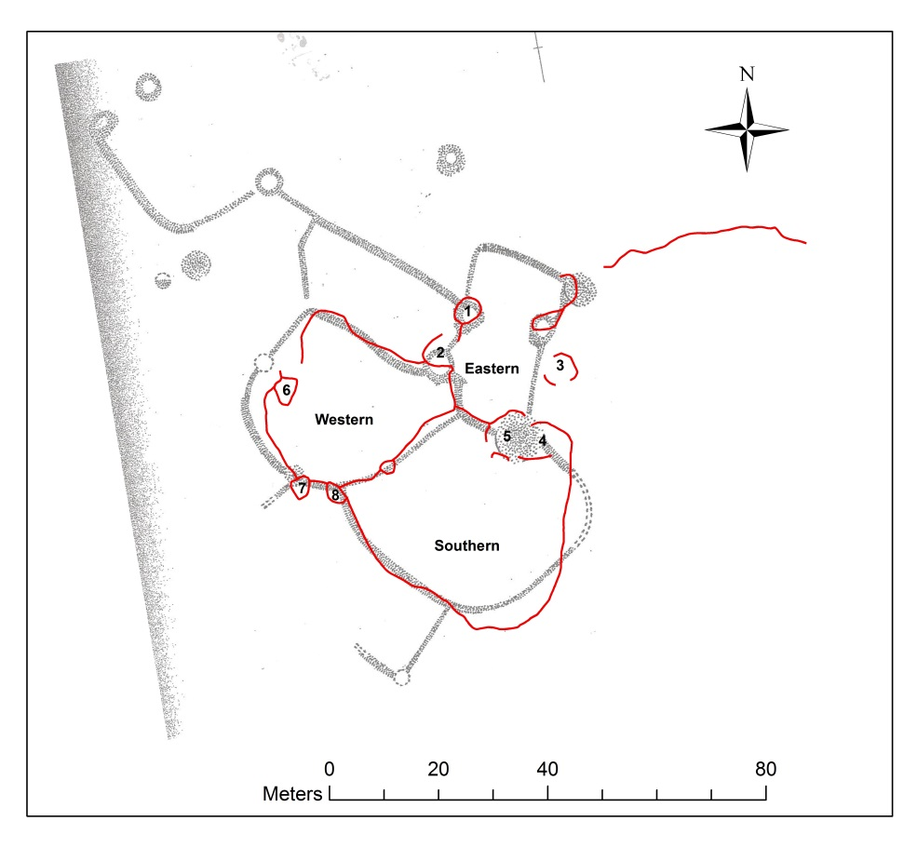
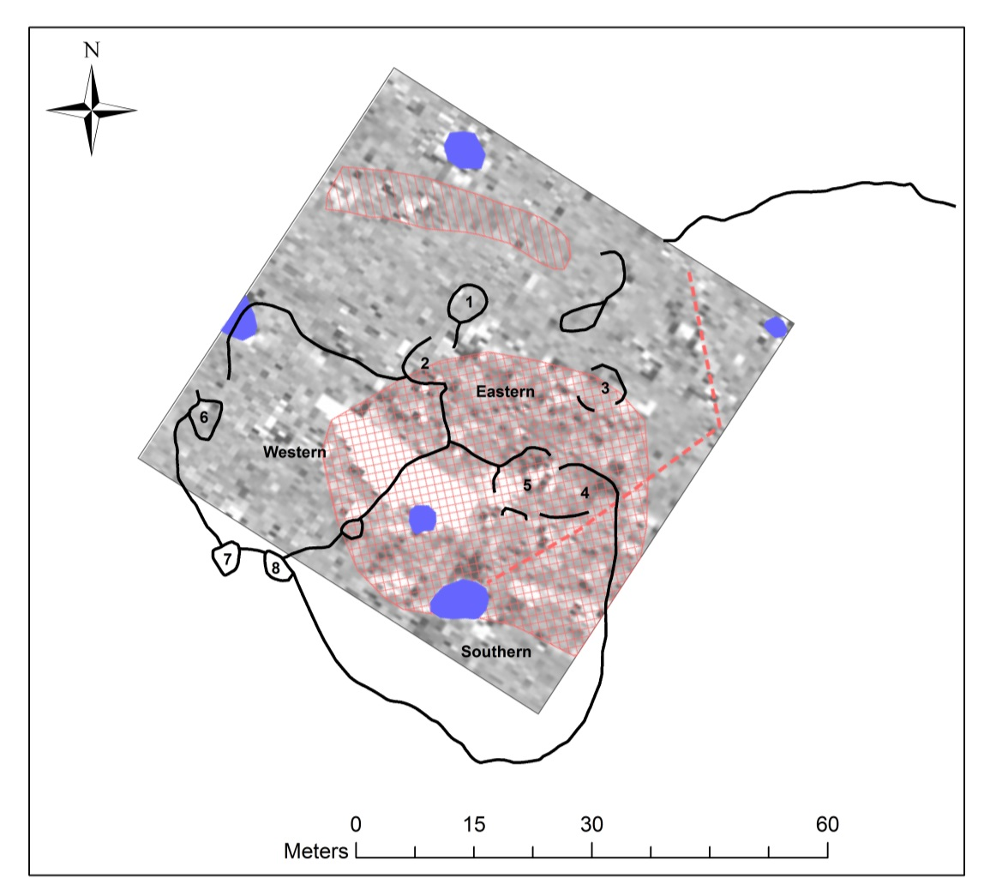
Appendix 2: Photographic Archive
Eastern enclosure:
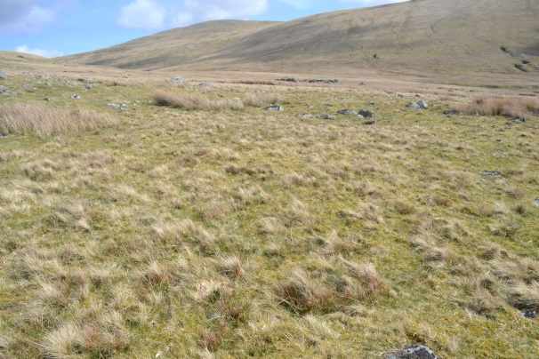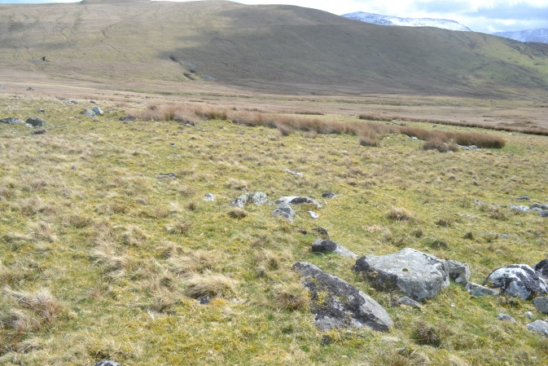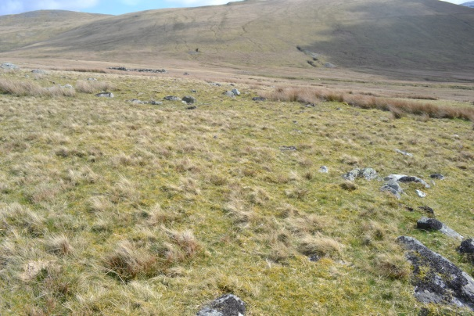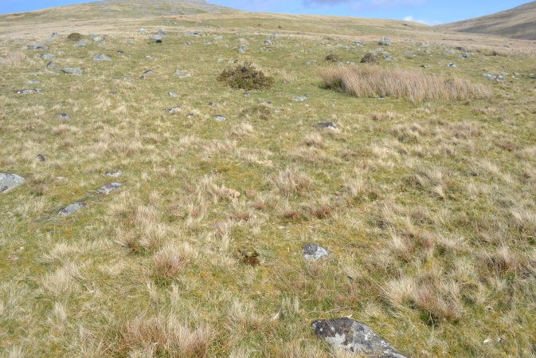
Western Enclosure
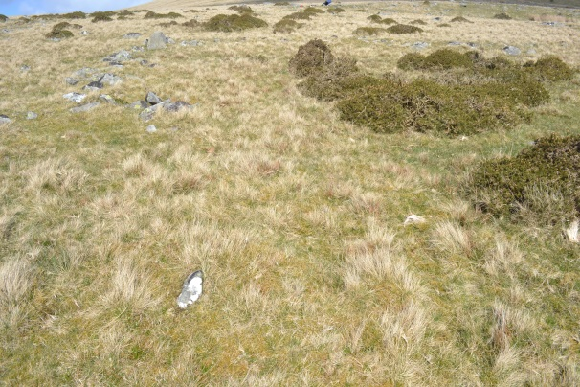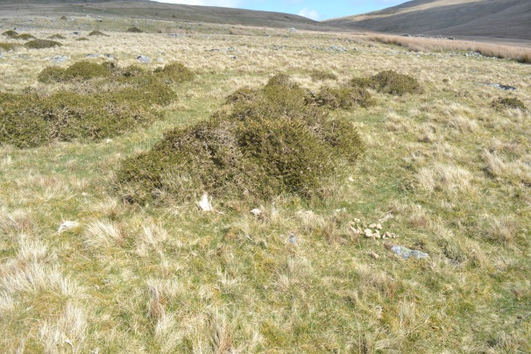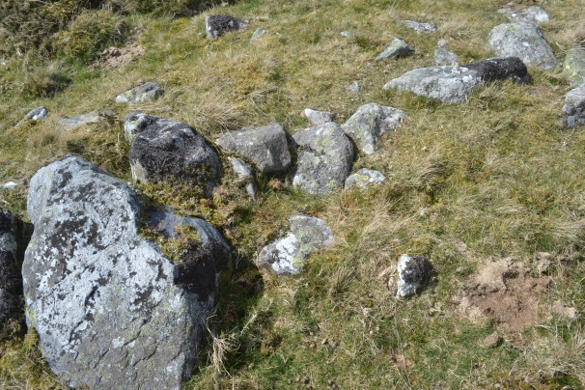
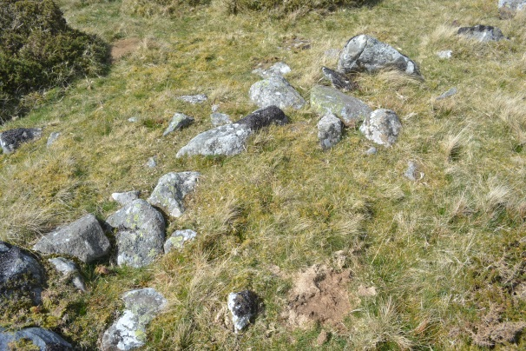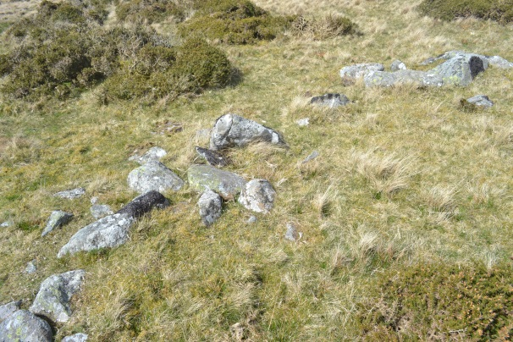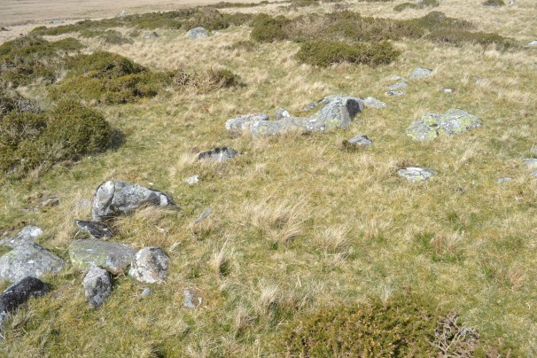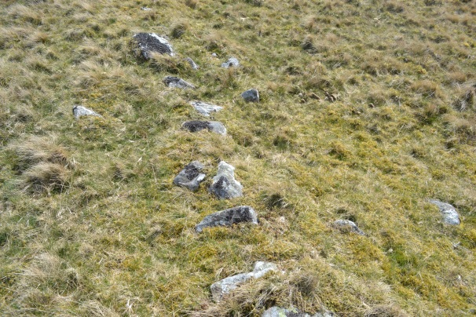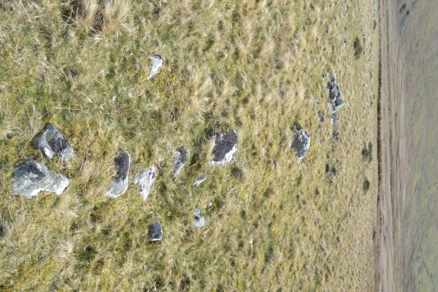
Southern Enclosure
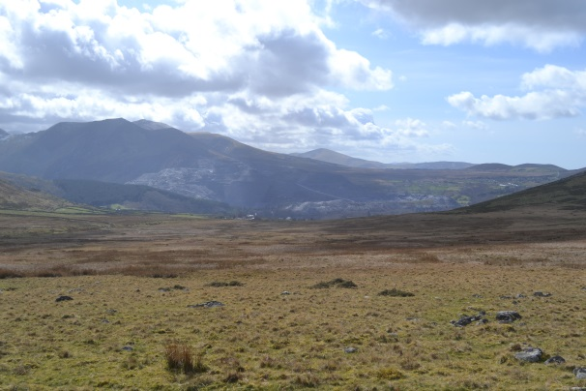
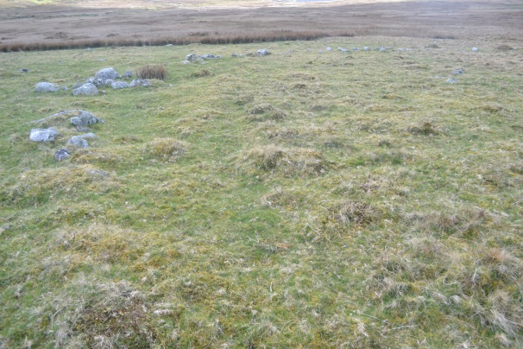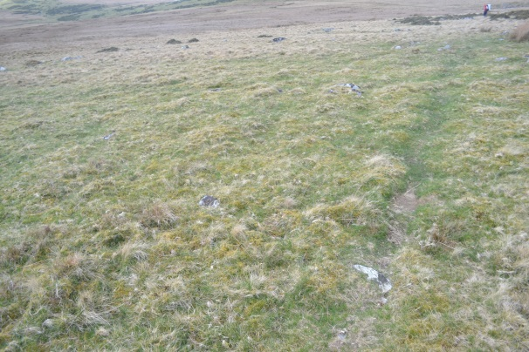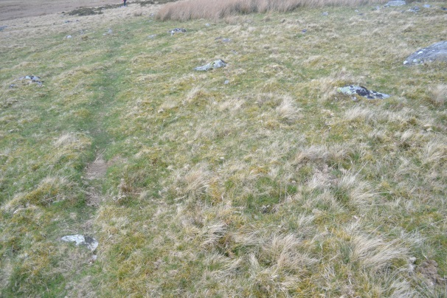
Top Wall
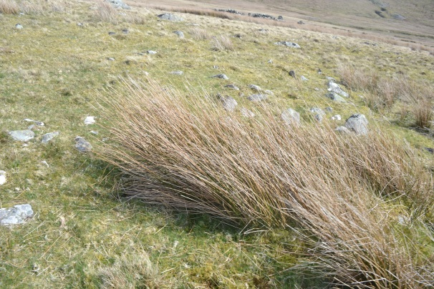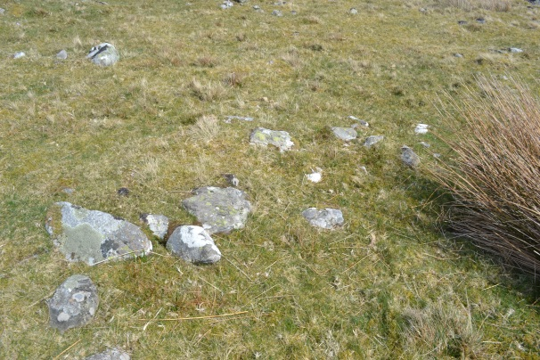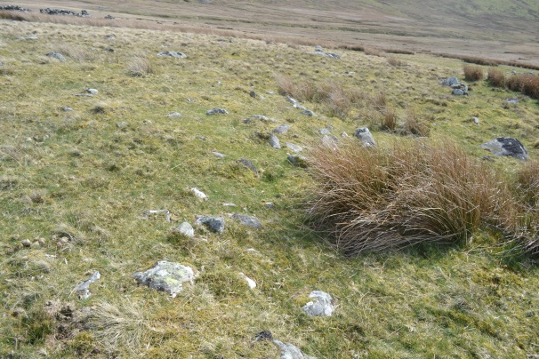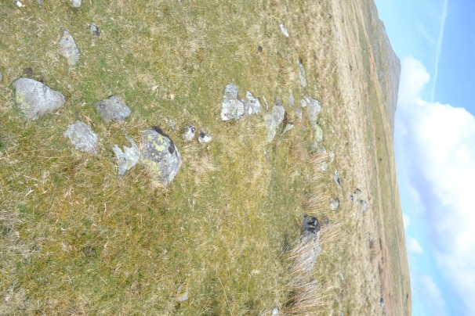
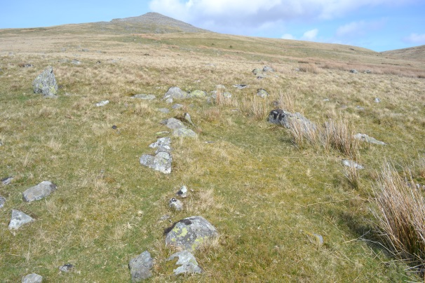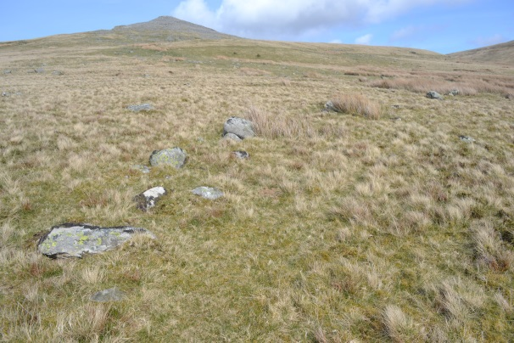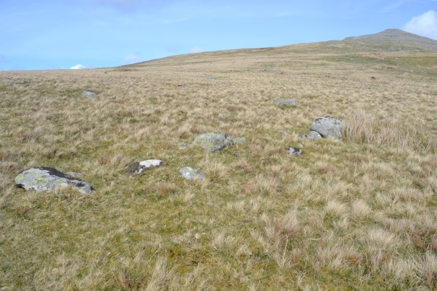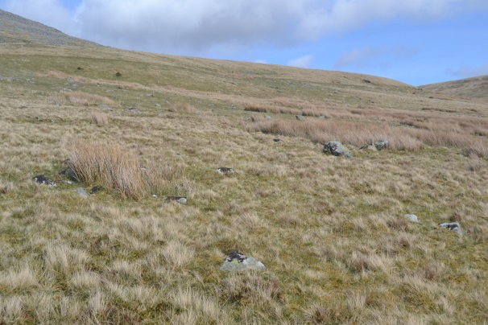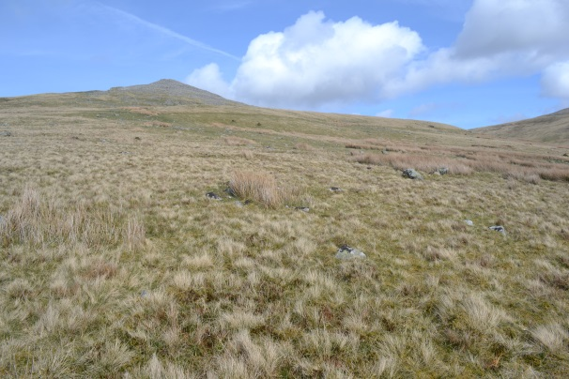
Feature 1
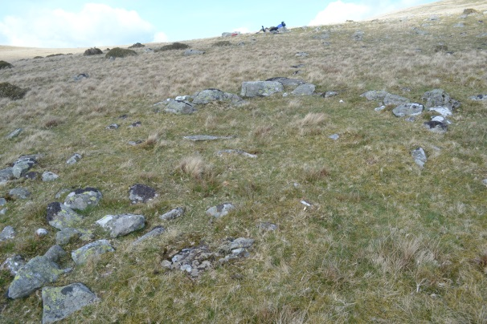
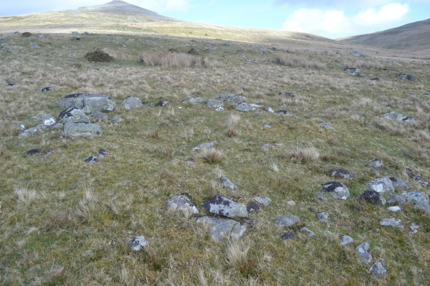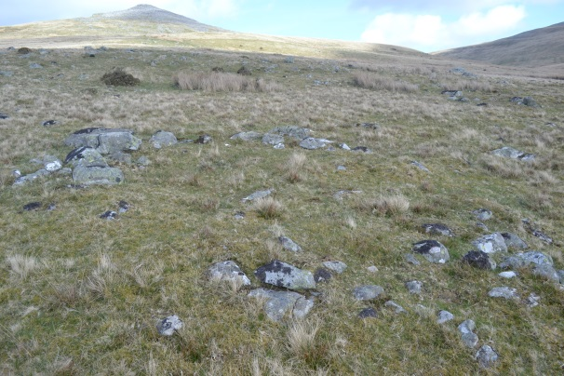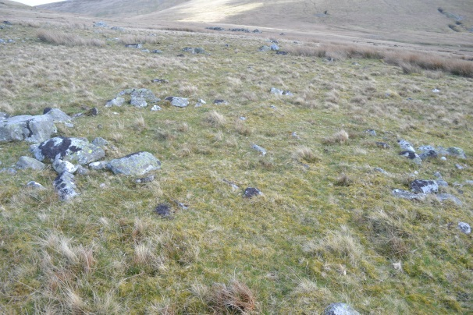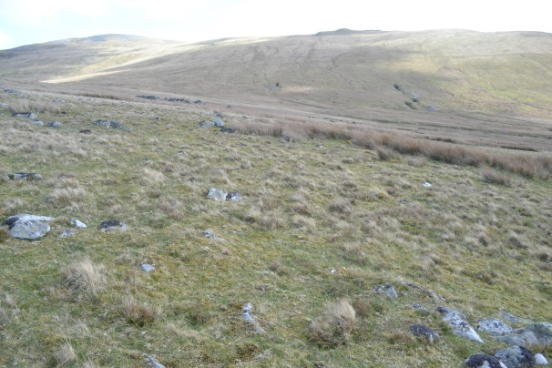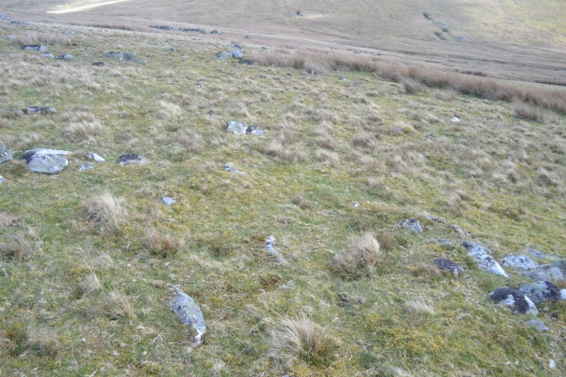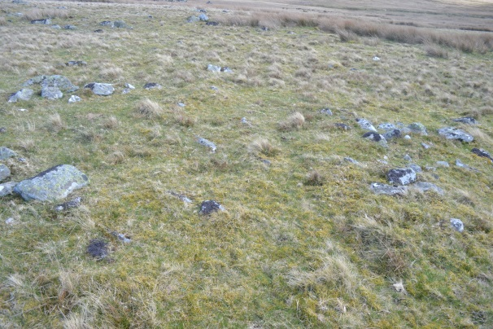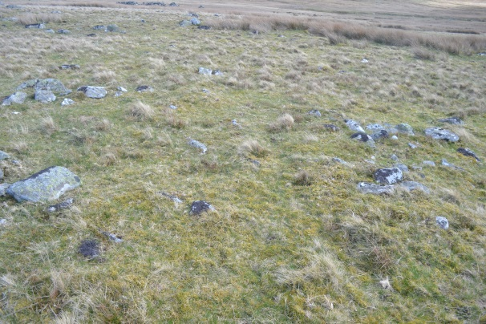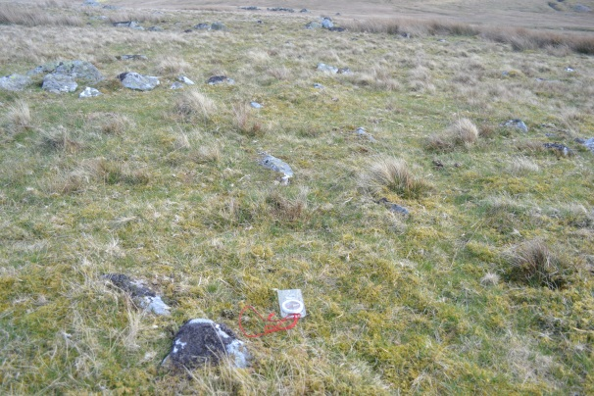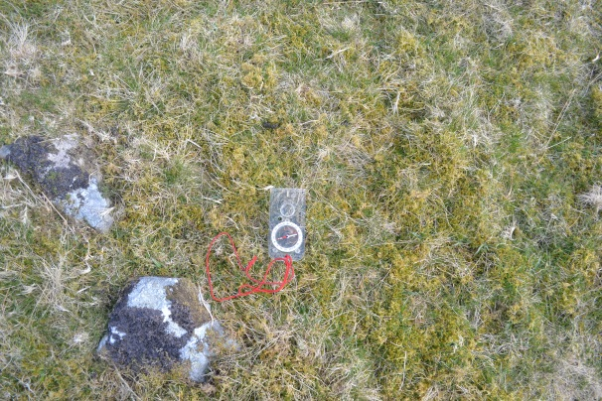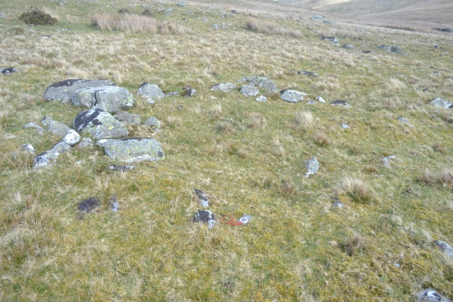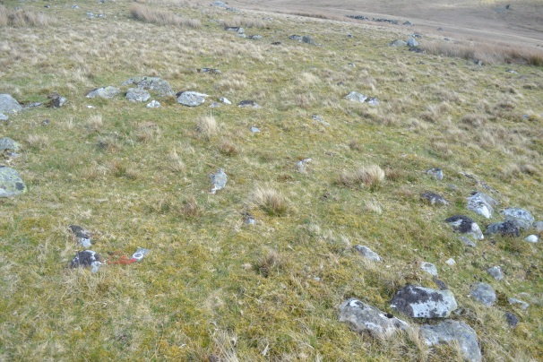
Feature 2
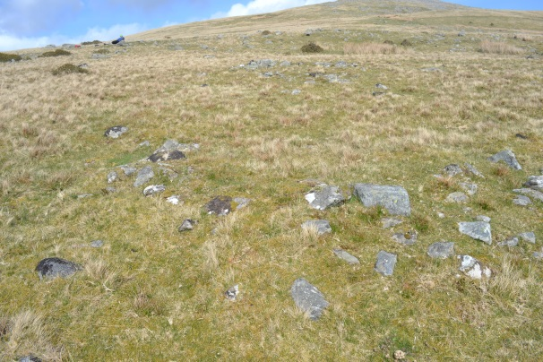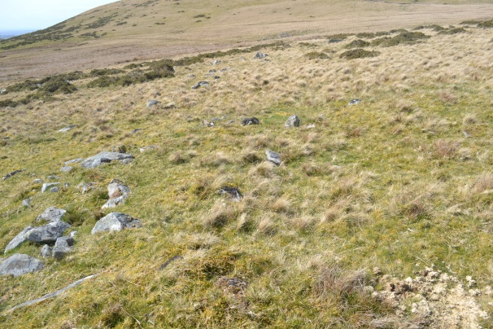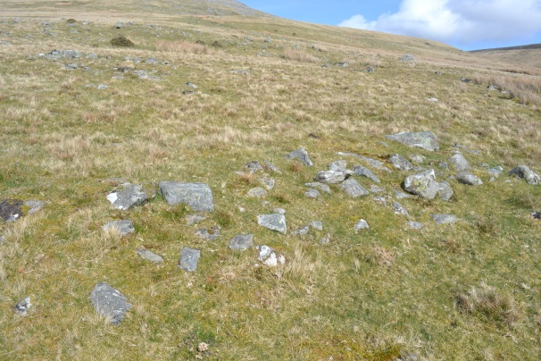

Feature 3
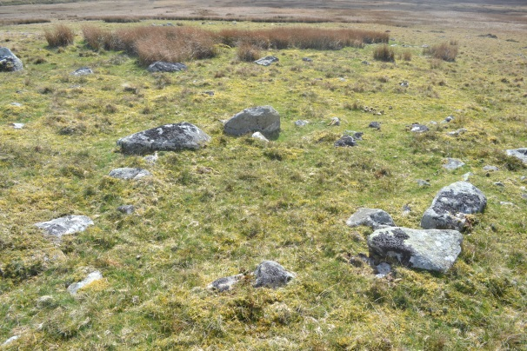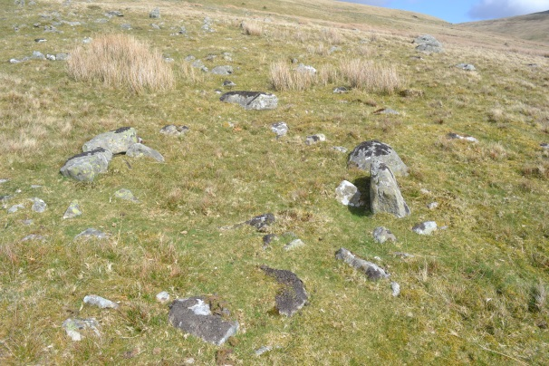
Feature 4 and 5
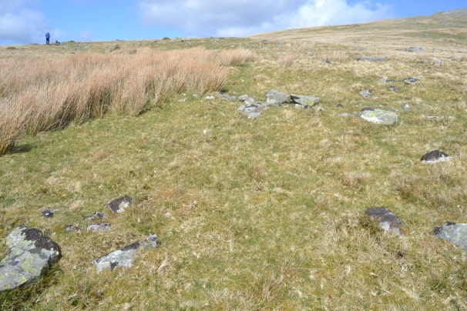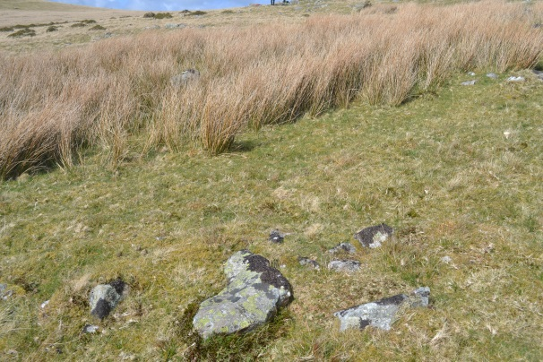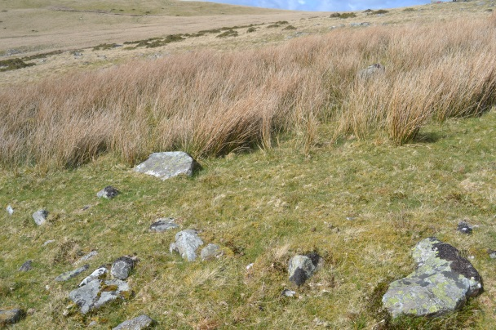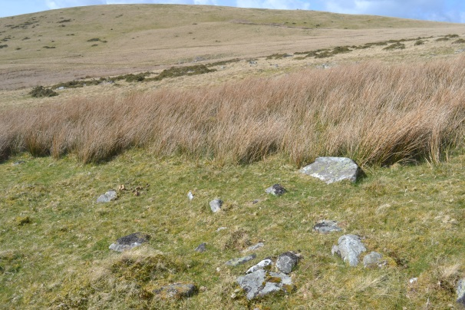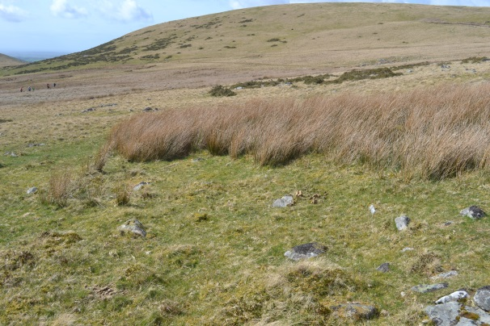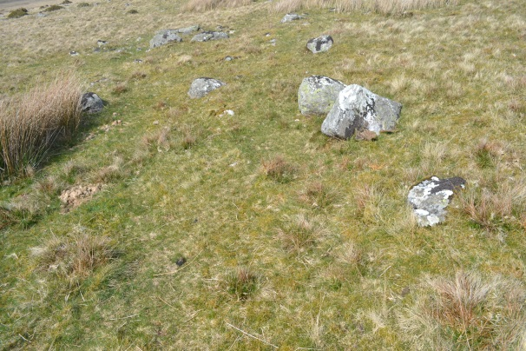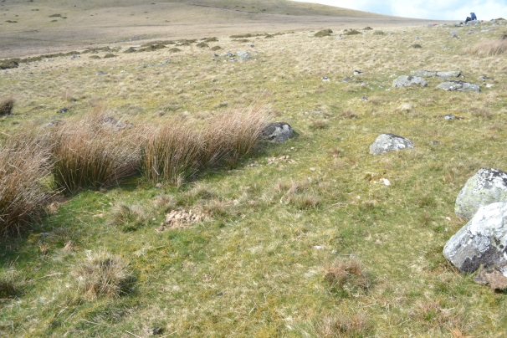
Feature 6
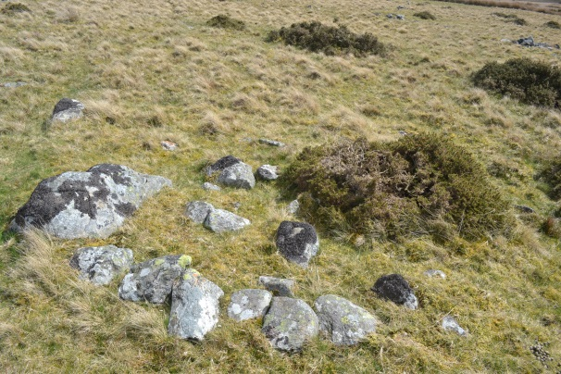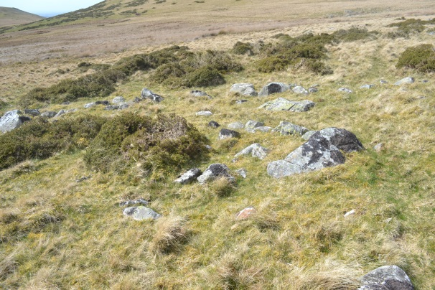
Feature 7
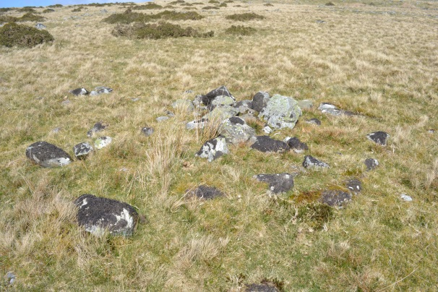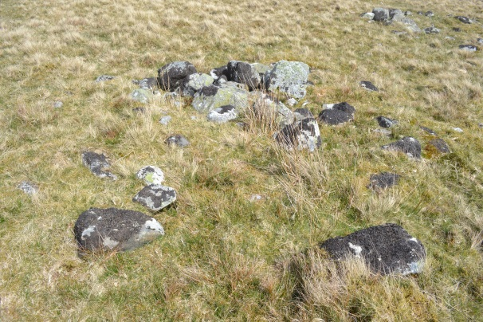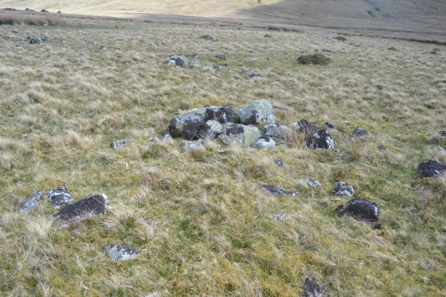
Feature 8
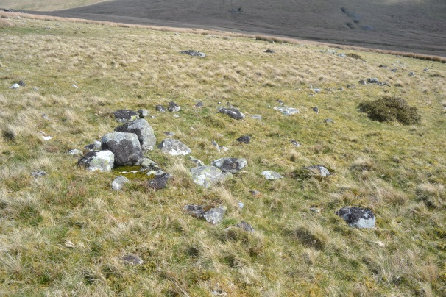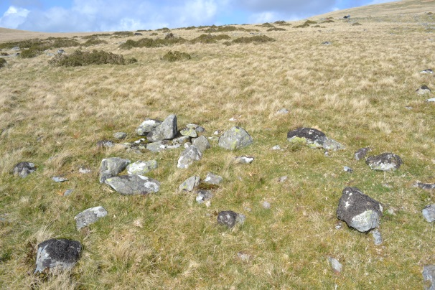

Mynydd Du
Enclosure 1
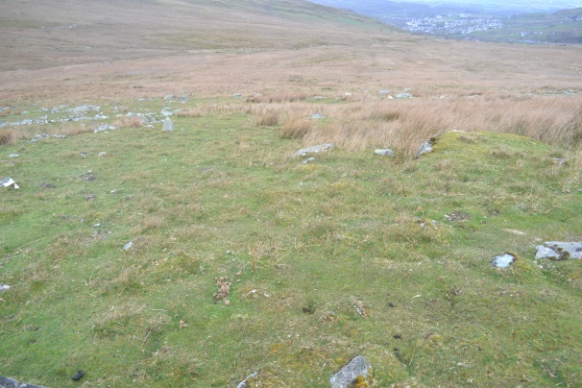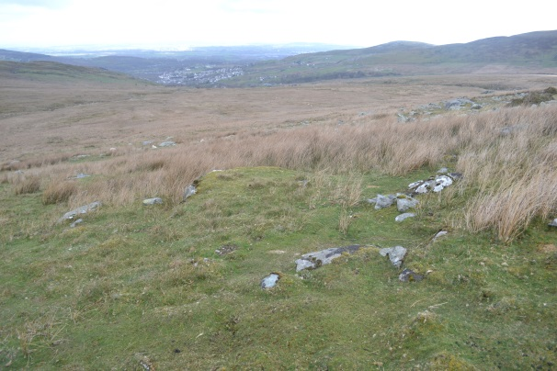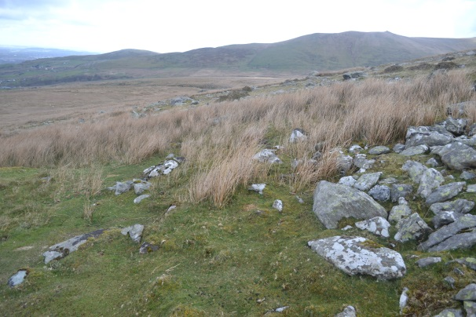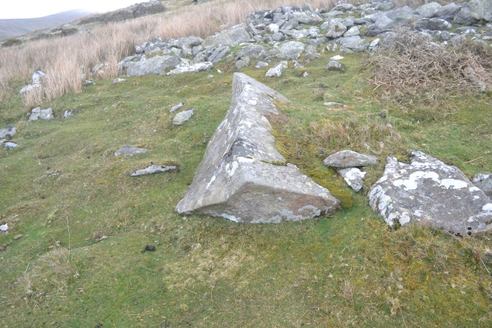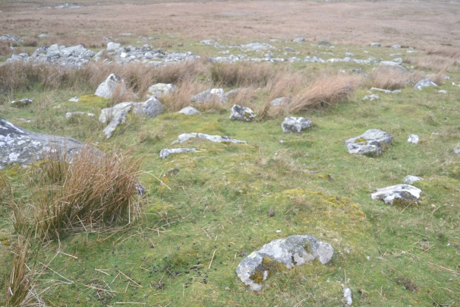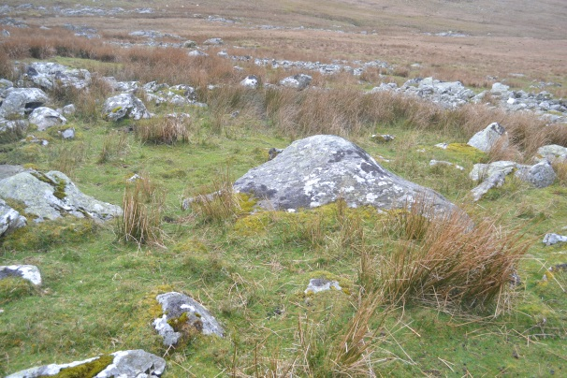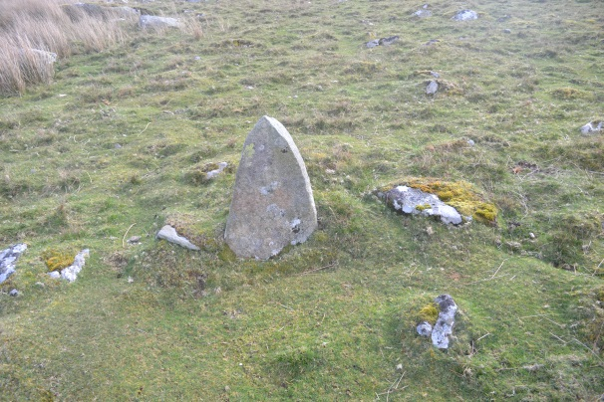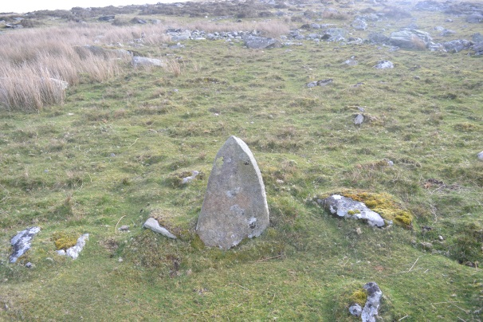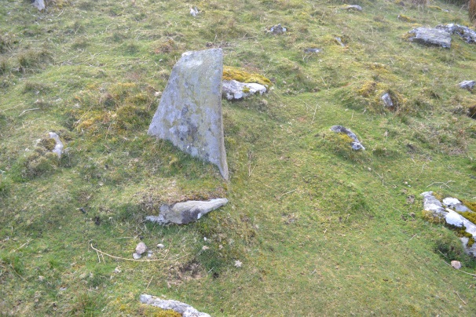A

Enclosure 2
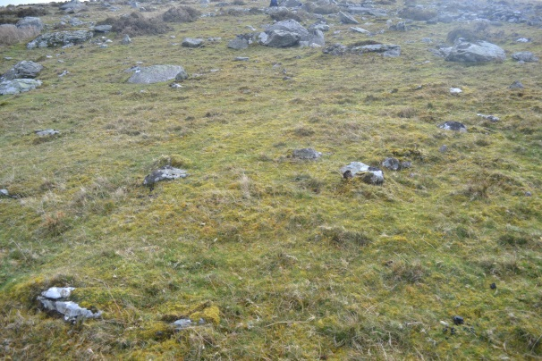
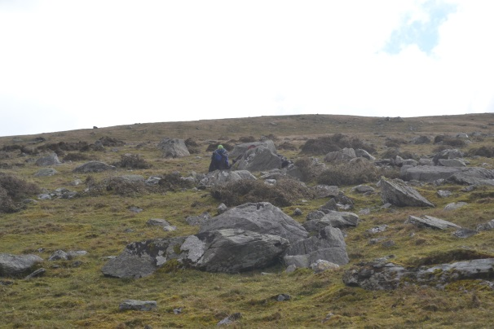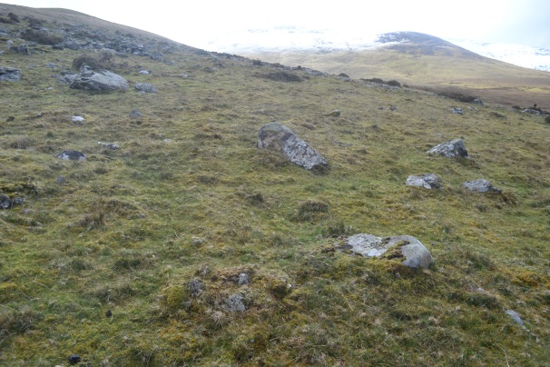

Enclosure 3
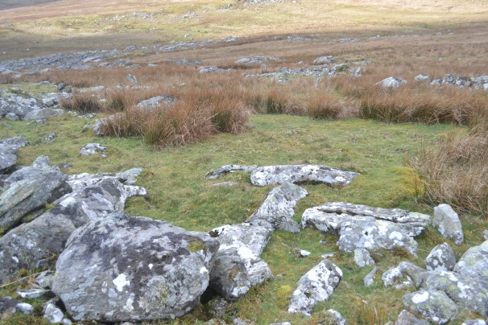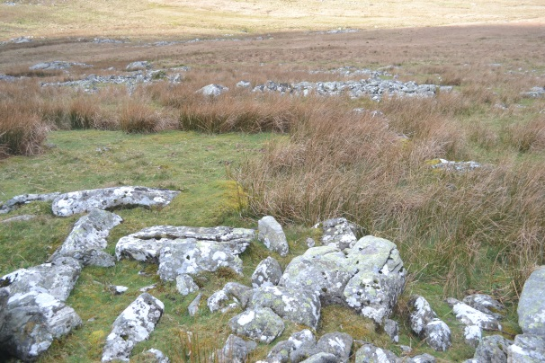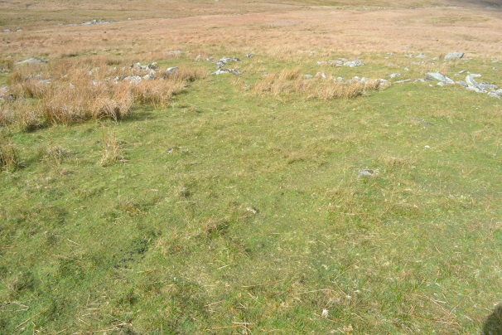
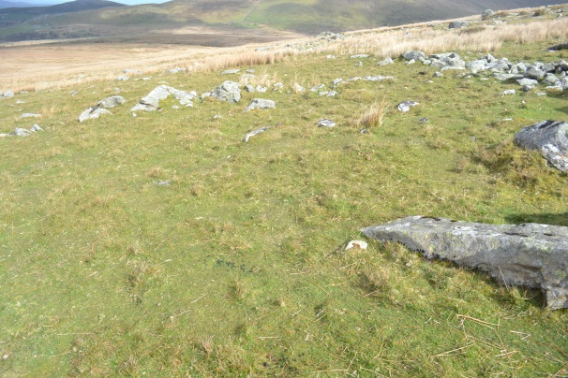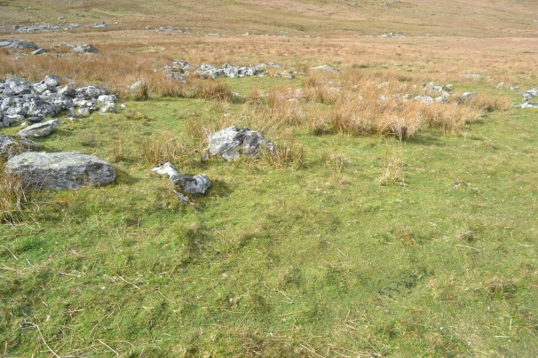
Enclosure 4
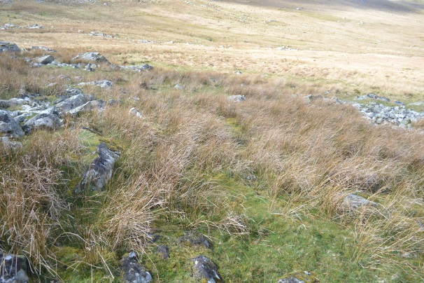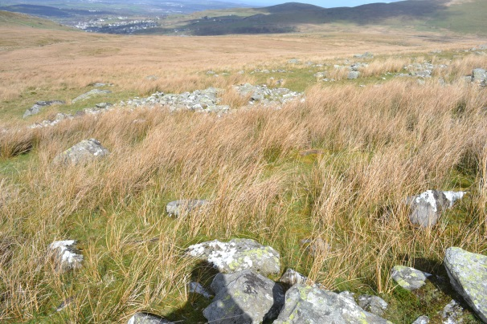
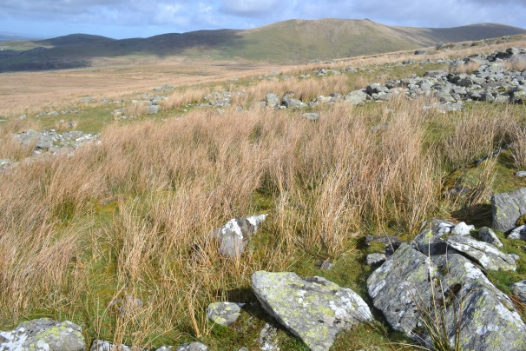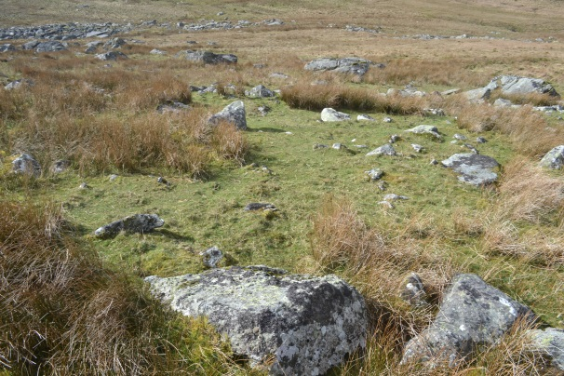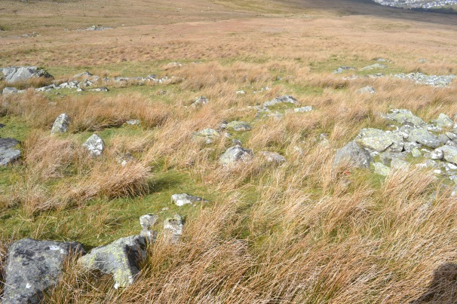
Enclosure 5
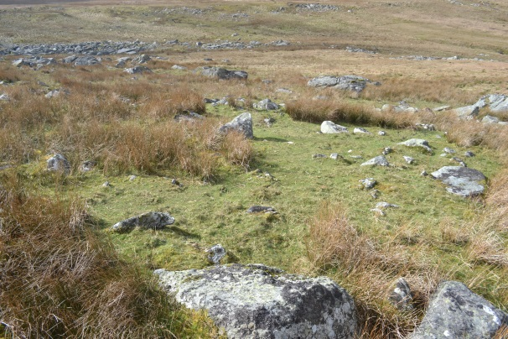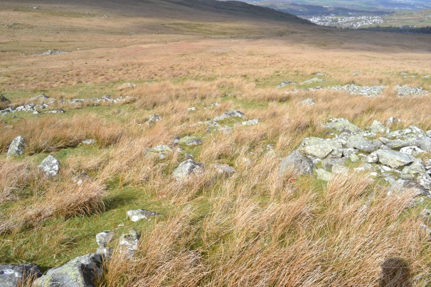

Enclosure 6
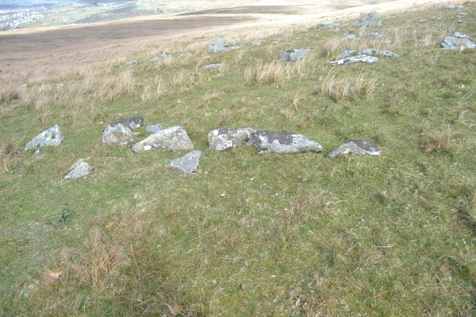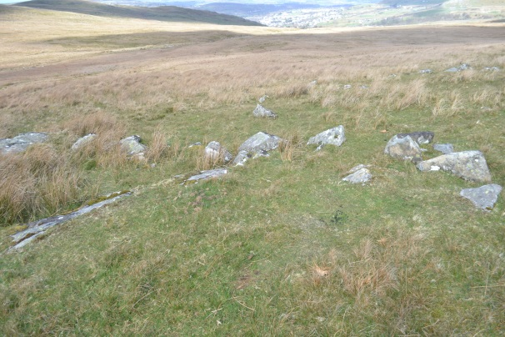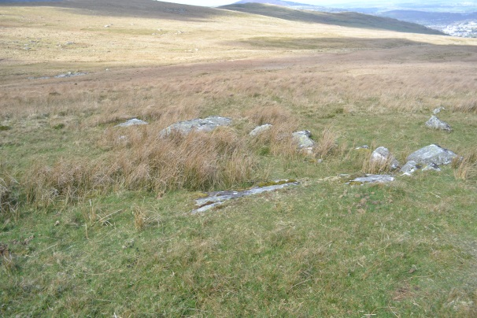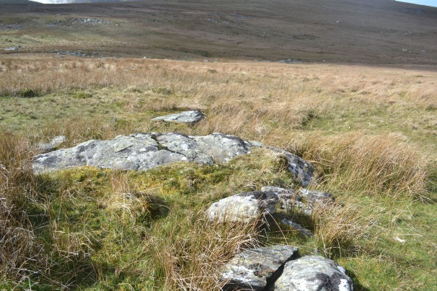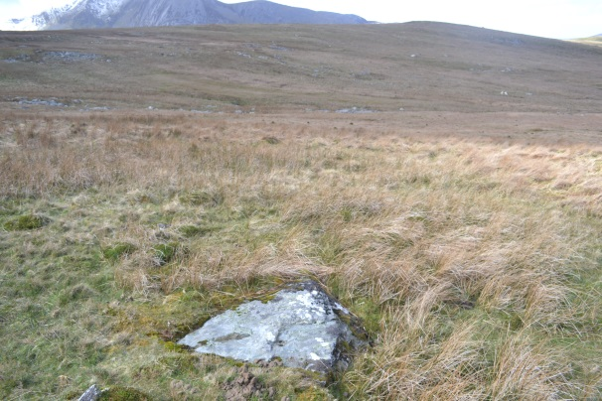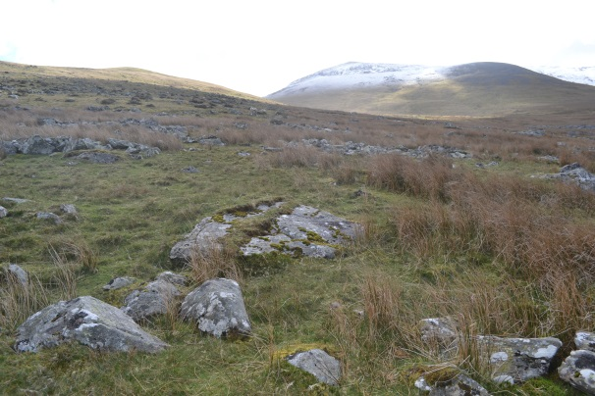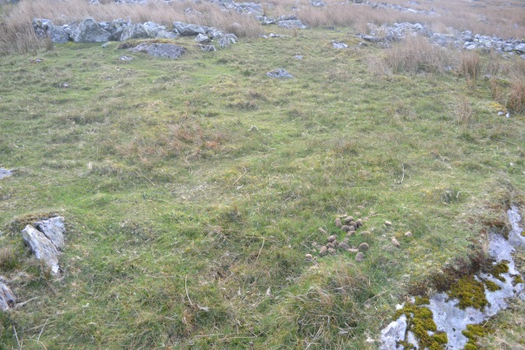

Enclosure 7
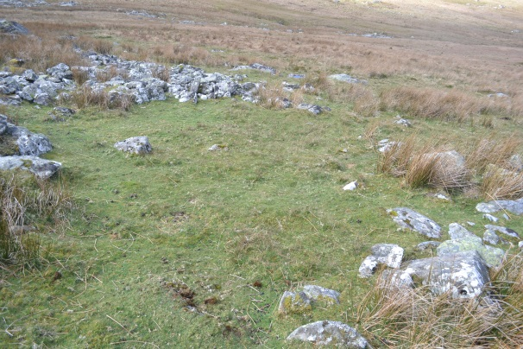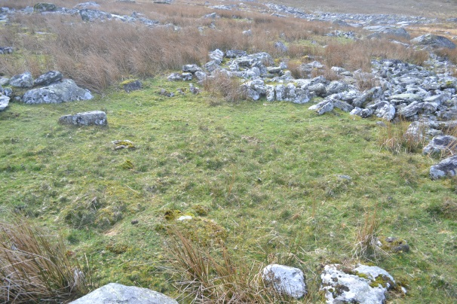
Feature A
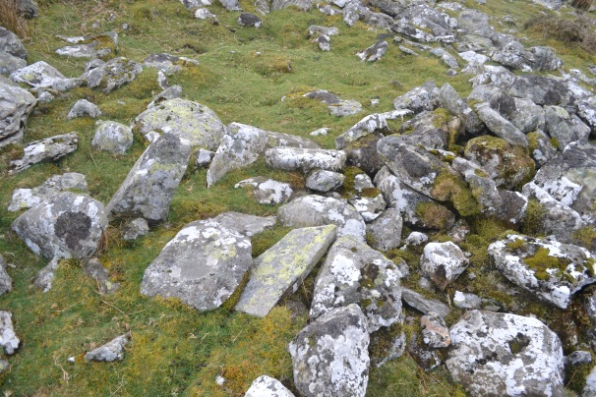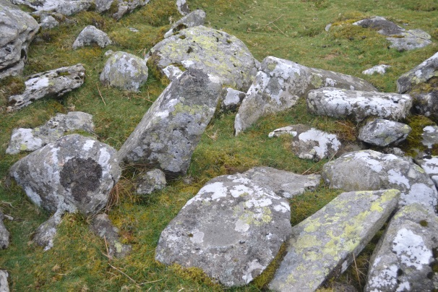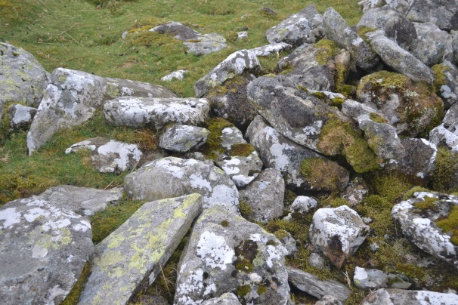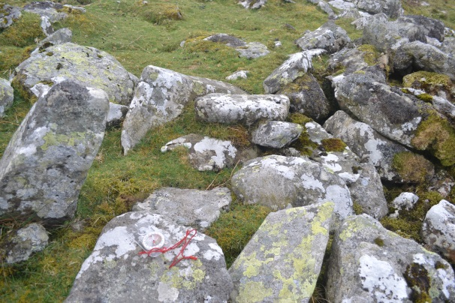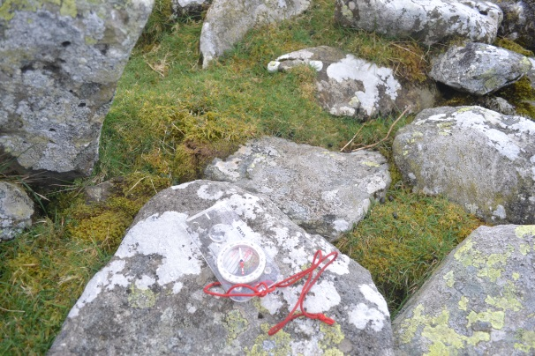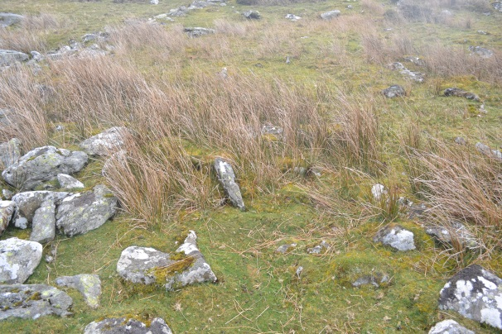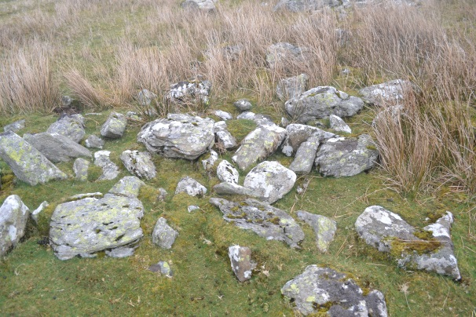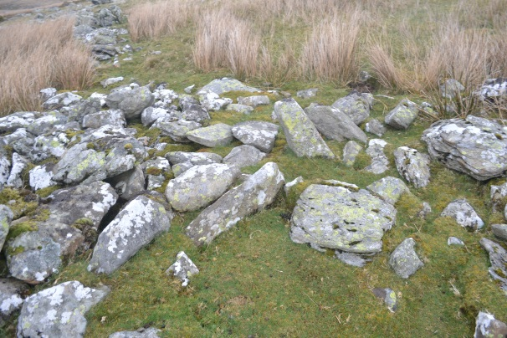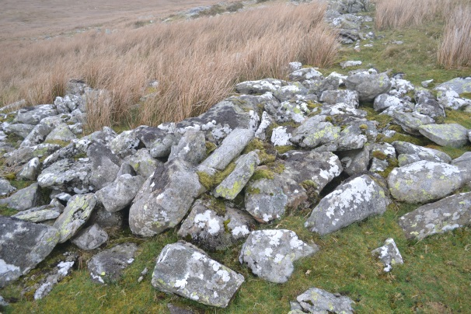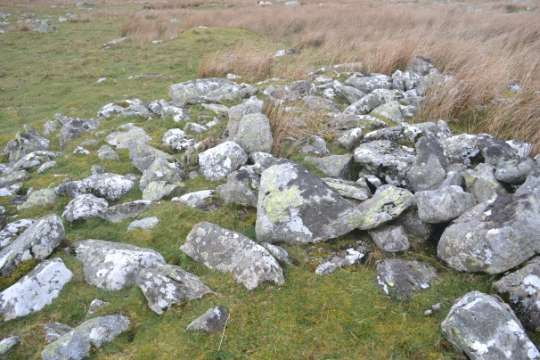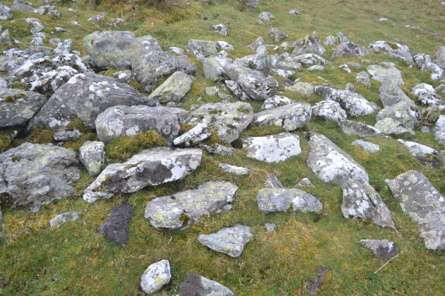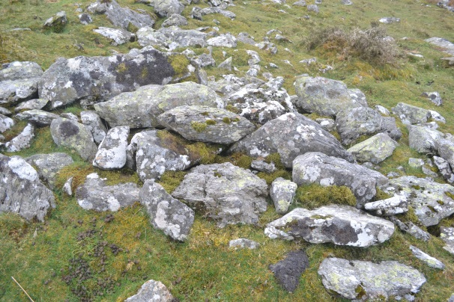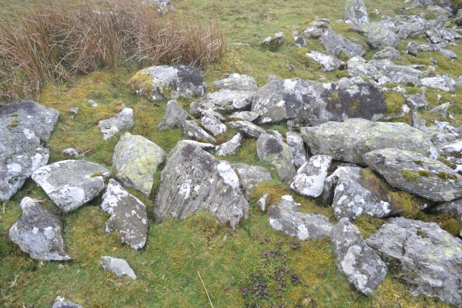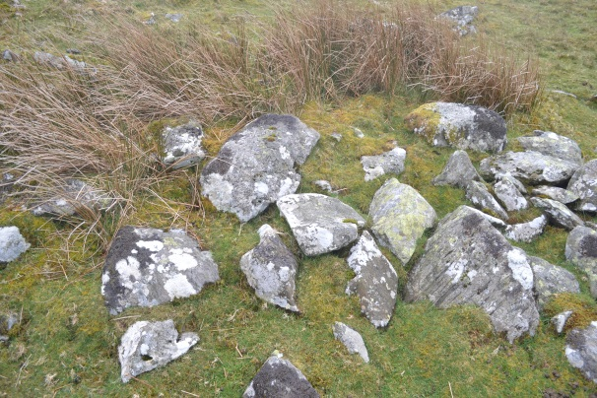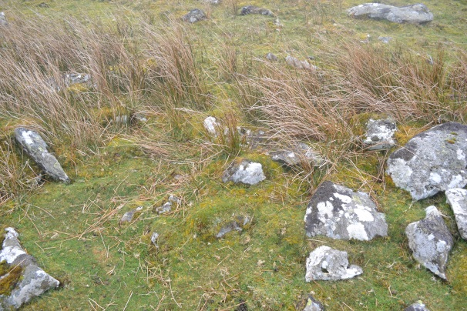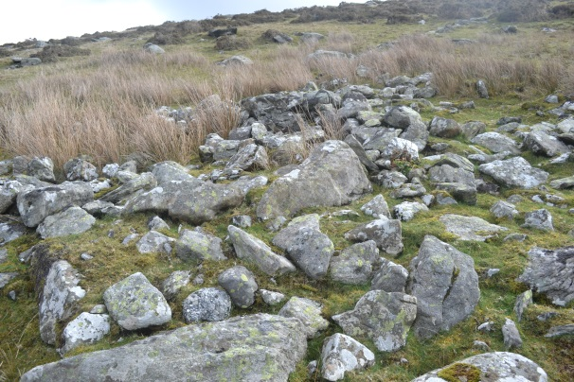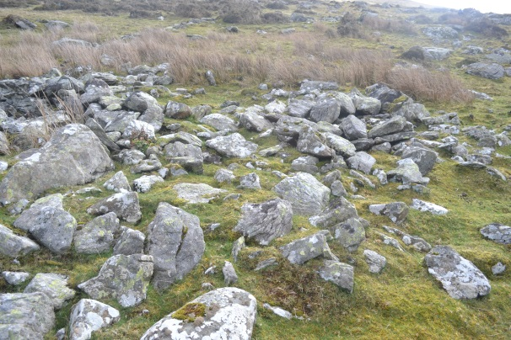
Feature B
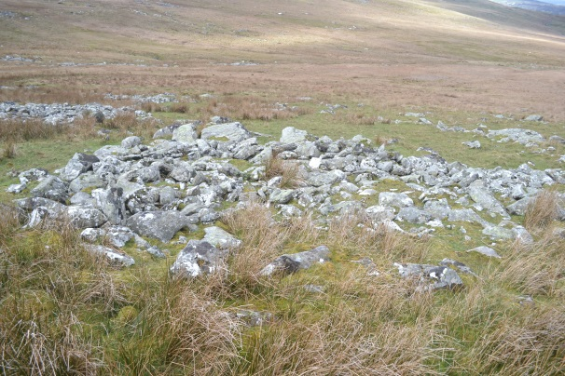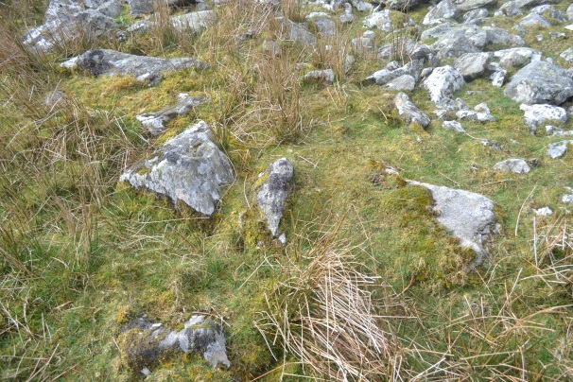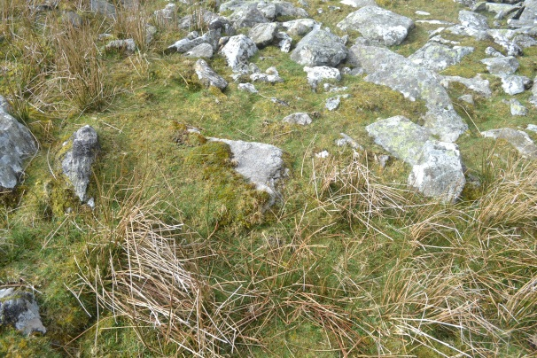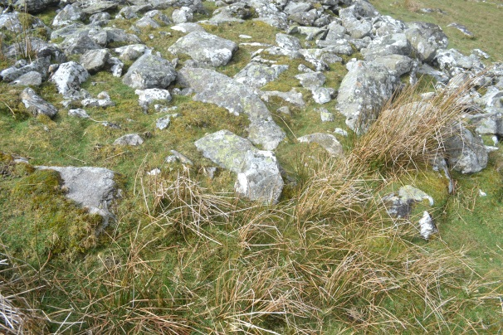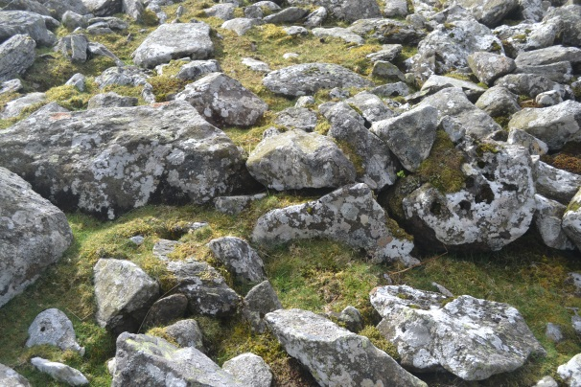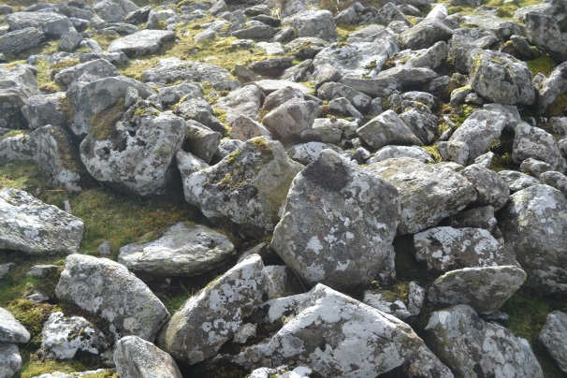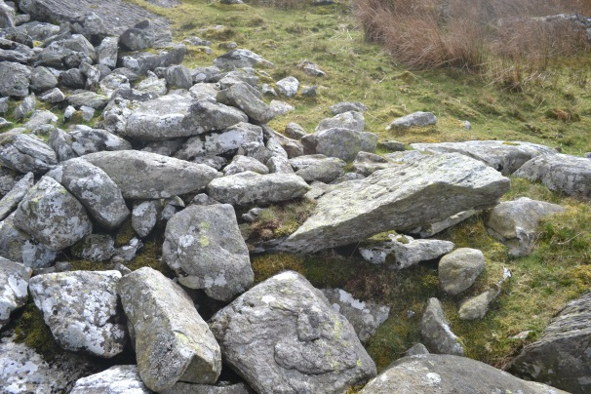
Feature C
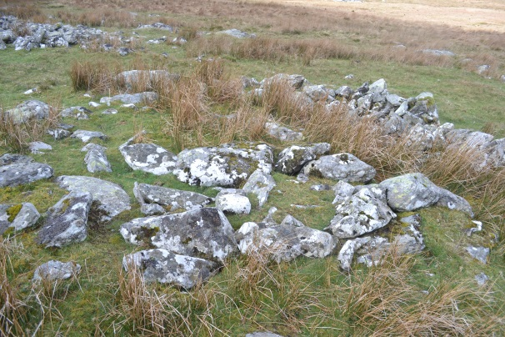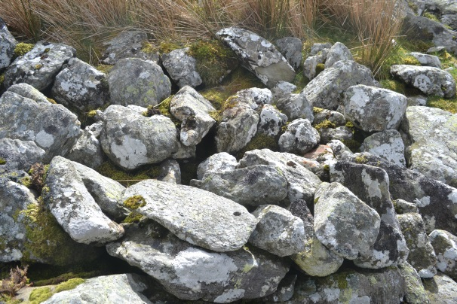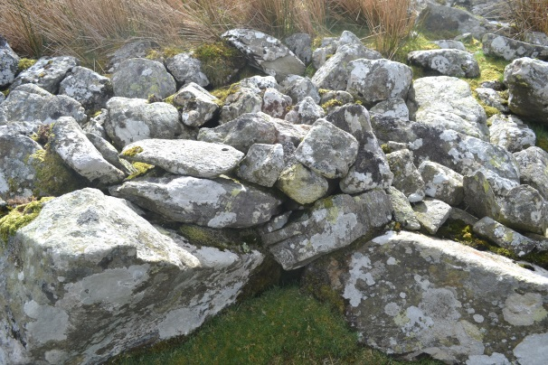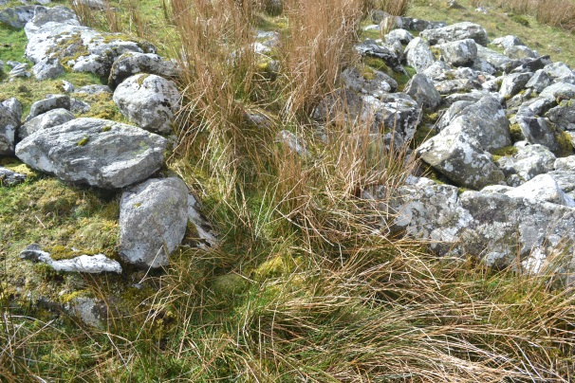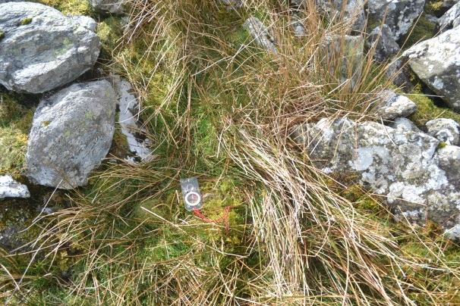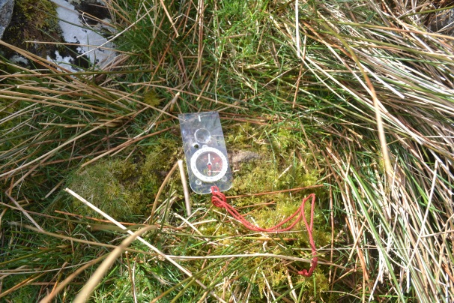
Feature D
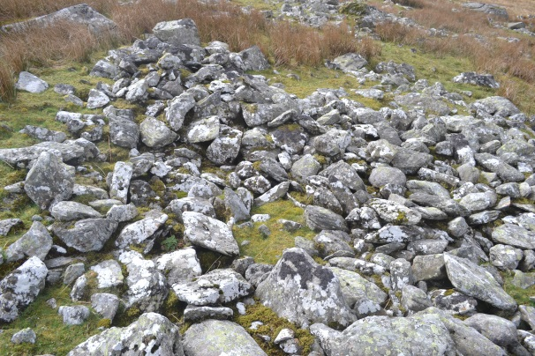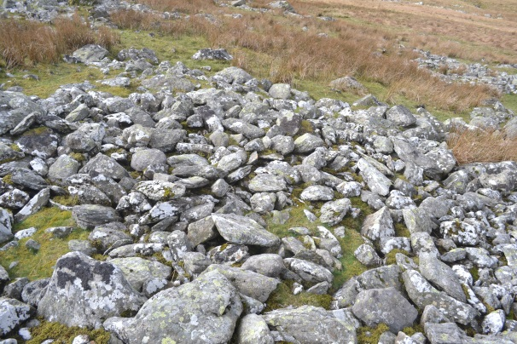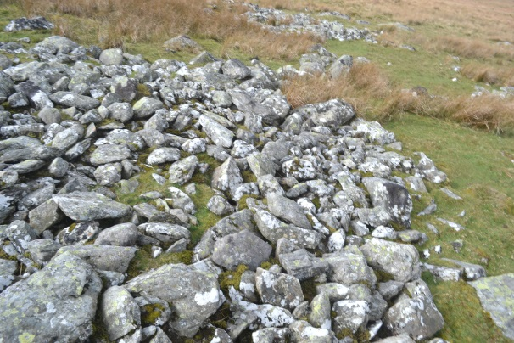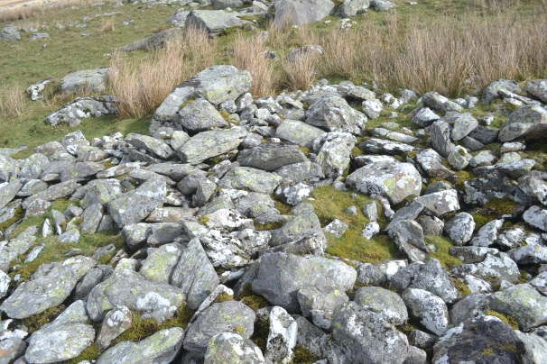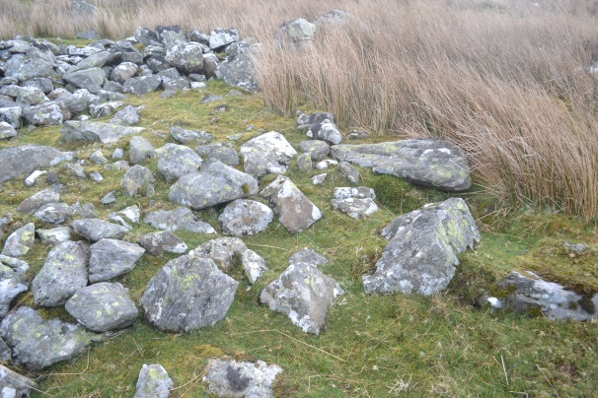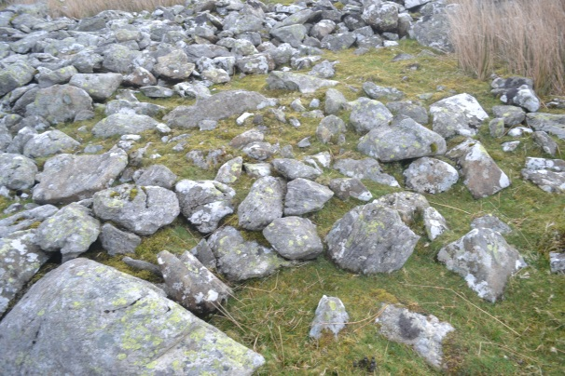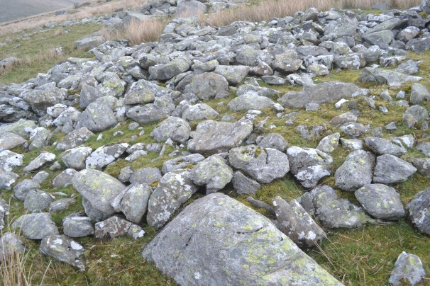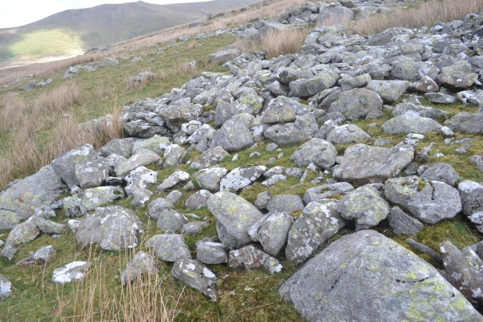
Feature E
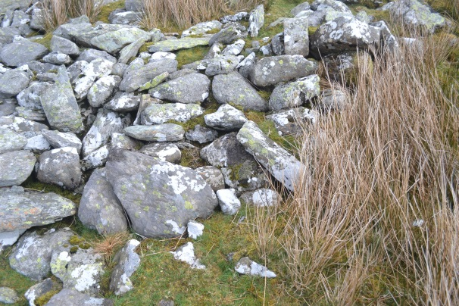
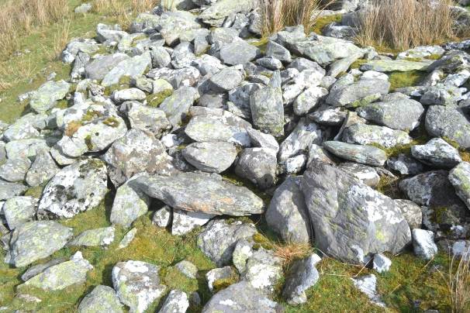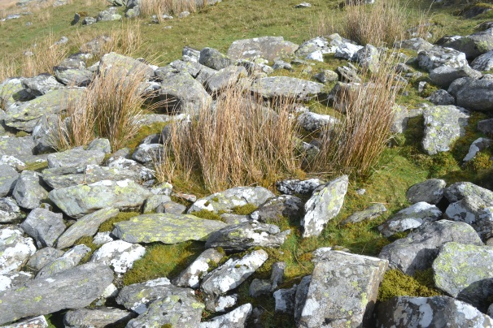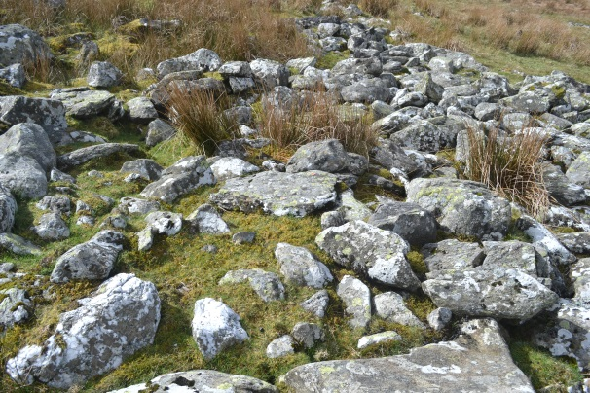
Feature F
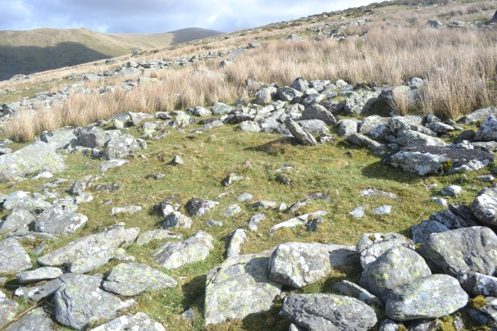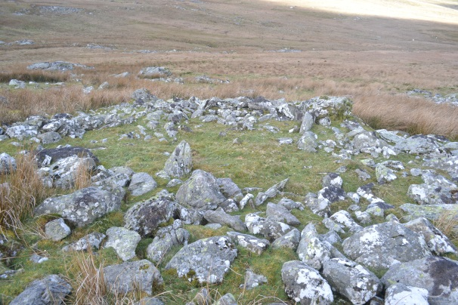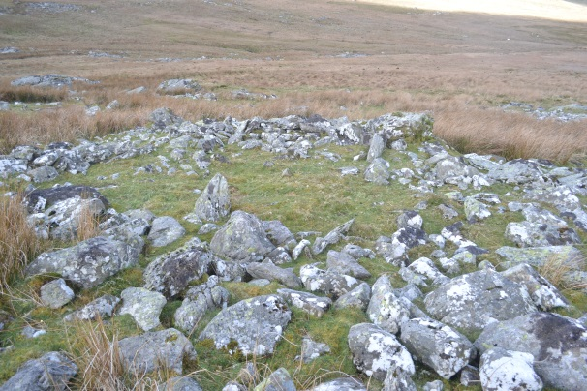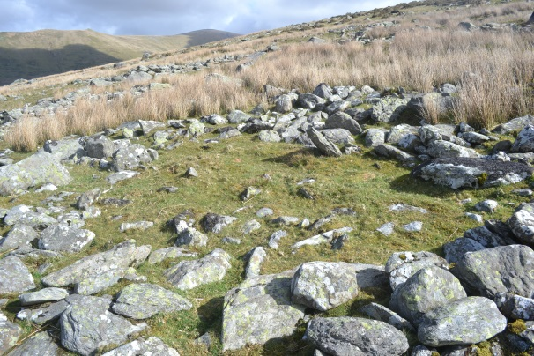
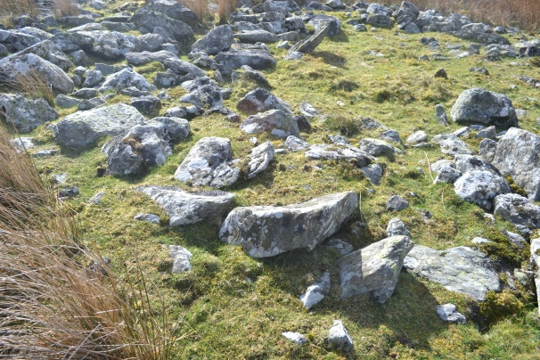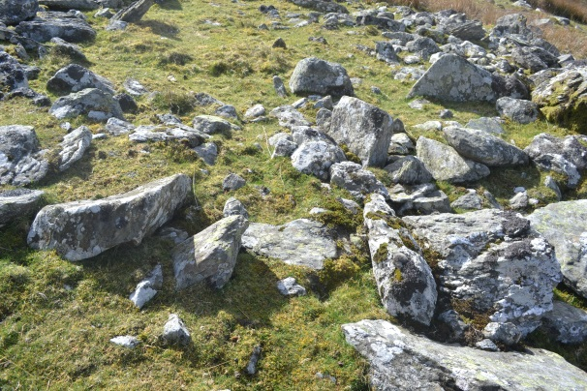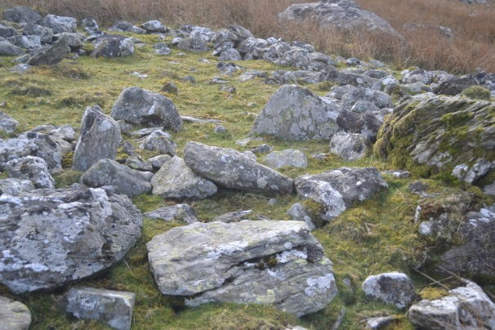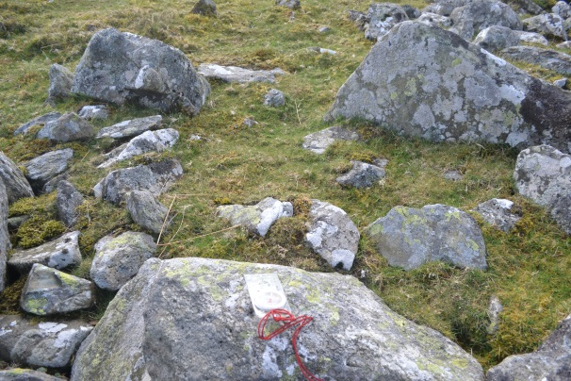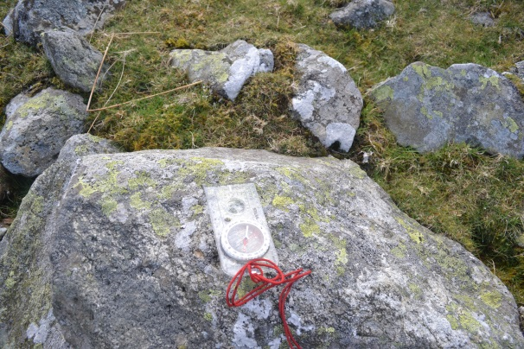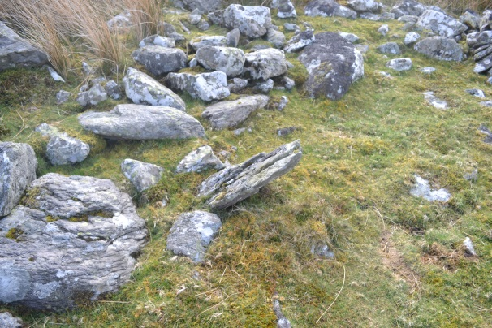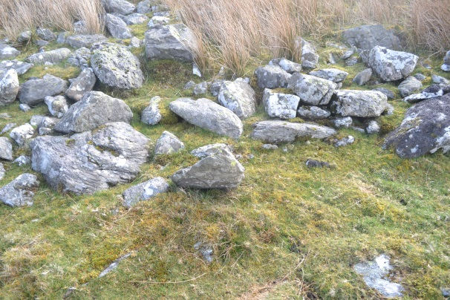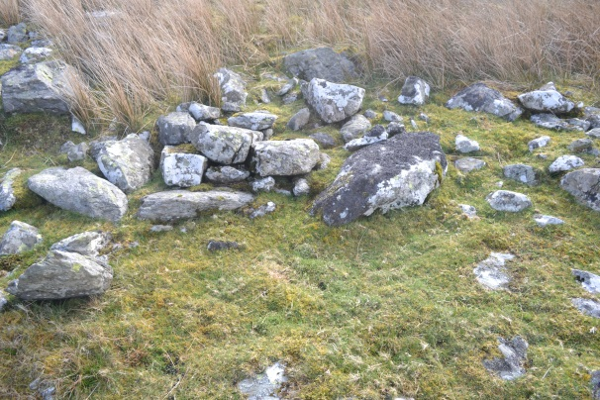
Feature G
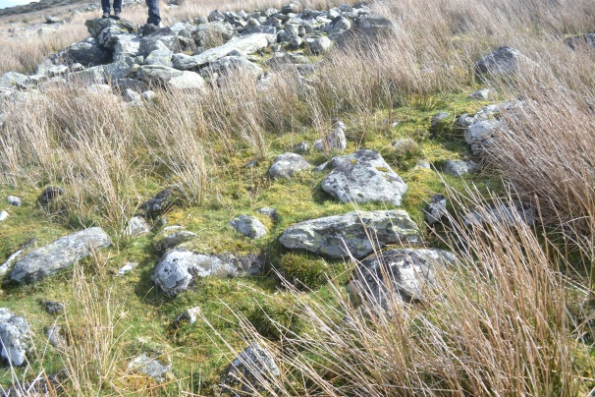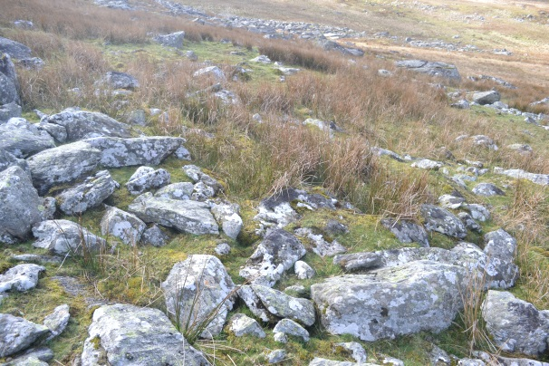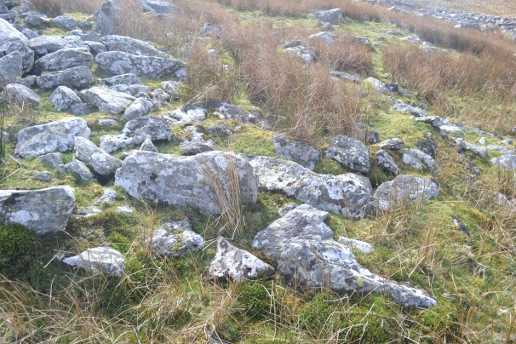
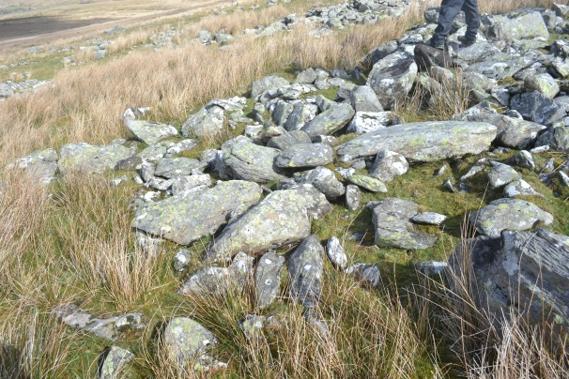

Appendix 3: GPS Rover Points
Cwm Ffrydlas
Survey Grid
Column1 | Column2 | Column3 | Column4 | Column5
Leica System 1200 | Local Coords CSV
Point ID | Easting | Northing | Ortho Height | Code
Job Name: 00000000CF141104
Date: 04/11/2014
RTCM-Ref 0165 | 301344.506 | 373724.044 | 49.609
1 | 264331.276 | 368446.153 | 409.556
2 | 264320.566 | 368429.68 | 406.125
3 | 264309.607 | 368413.074 | 403.023
4 | 264326.335 | 368402.218 | 402.715
5 | 264343.2 | 368391.505 | 402.813
6 | 264360.121 | 368380.667 | 402.811
7 | 264371.074 | 368397.151 | 405.687
8 | 264354.087 | 368407.683 | 405.758
9 | 264337.166 | 368418.546 | 405.937
10 | 264348.121 | 368435.304 | 409.308
11 | 264364.958 | 368424.361 | 409.112
12 | 264381.867 | 368413.712 | 409.285
13 | 264392.86 | 368430.237 | 412.411
14 | 264375.884 | 368440.817 | 412.623
15 | 264358.979 | 368451.678 | 412.487
16 | 264342.16 | 368462.601 | 412.886

Boundary points
Column1 | Column2 | Column3 | Column4 | Column5
Leica System 1200 | Local Coords CSV
Point ID | Easting | Northing | Ortho Height | Code
Job Name: 000000CF141104S2
Date: 04/11/2014
RTCM-Ref 0165 | 301344.506 | 373724.044 | 49.609
TOF0001 | 264323.931 | 368432.073 | 407.3 | TB
TOF0002 | 264322.967 | 368431.264 | 406.794 | TB
TOF0003 | 264322.231 | 368429.642 | 406.571 | TB
TOF0004 | 264321.082 | 368427.71 | 406.111 | TB
TOF0005 | 264321.153 | 368426.292 | 405.97 | TB
TOF0006 | 264321.432 | 368423.802 | 405.562 | TB
TOF0009 | 264317.008 | 368421.399 | 404.856 | TB
TOF0010 | 264315.885 | 368419.078 | 404.589 | TB
TOF0011 | 264314.568 | 368416.835 | 404.241 | TB
TOF0012 | 264314.501 | 368415.708 | 403.939 | TB
TOF0013 | 264314.833 | 368414.347 | 403.94 | TB
TOF0014 | 264314.731 | 368412.491 | 403.505 | TB
TOF0015 | 264314.998 | 368410.444 | 403.26 | TB
TOF0016 | 264317.114 | 368407.526 | 403.01 | TB
TOF0017 | 264318.499 | 368404.71 | 402.891 | TB
TOF0018 | 264319.991 | 368403.02 | 402.657 | TB
TOF0021 | 264321.523 | 368402.122 | 402.568 | TB
TOF0022 | 264320.767 | 368401.752 | 402.472 | TB
TOF0023 | 264319.487 | 368401.175 | 402.335 | TB
TOF0024 | 264319.956 | 368399.84 | 402.199 | TB
TOF0025 | 264320.535 | 368398.984 | 402.005 | TB
TOF0026 | 264320.956 | 368398.336 | 402.033 | TB
TOF0027 | 264322.136 | 368399.069 | 402.134 | TB
TOF0028 | 264322.599 | 368400.155 | 402.387 | TB
TOF0029 | 264322.565 | 368401.463 | 402.541 | TB
TOF0030 | 264321.997 | 368402.399 | 402.479 | TB
TOF0033 | 264323.828 | 368401.602 | 402.539 | TB
TOF0034 | 264326.042 | 368401.016 | 402.634 | TB
TOF0035 | 264326.953 | 368401.148 | 402.731 | TB
TOF0038 | 264327.38 | 368400.973 | 402.861 | TB
TOF0039 | 264326.319 | 368399.728 | 402.534 | TB
TOF0040 | 264326.297 | 368398.634 | 402.355 | TB
TOF0041 | 264327.245 | 368398.248 | 402.409 | TB
TOF0042 | 264328.335 | 368397.804 | 402.368 | TB
TOF0043 | 264328.927 | 368399.176 | 402.614 | TB
TOF0044 | 264328.533 | 368399.863 | 402.974 | TB
TOF0045 | 264328.003 | 368400.685 | 402.875 | TB
TOF0048 | 264329.198 | 368400.959 | 403.072 | TB
TOF0049 | 264331.781 | 368401.886 | 403.457 | TB
TOF0050 | 264334.223 | 368402.021 | 403.626 | TB
TOF0051 | 264335.306 | 368403.292 | 403.833 | TB
TOF0054 | 264336.203 | 368403.774 | 403.794 | TB
TOF0055 | 264337.027 | 368403.382 | 403.767 | TB
TOF0056 | 264337.789 | 368403.597 | 403.943 | TB
TOF0057 | 264337.159 | 368404.697 | 404.145 | TB
TOF0058 | 264336.321 | 368405.254 | 404.025 | TB
TOF0059 | 264336.122 | 368404.609 | 403.934 | TB
TOF0062 | 264338.18 | 368405.417 | 404.129 | TB
TOF0063 | 264339.763 | 368407.305 | 404.564 | TB
TOF0064 | 264341.02 | 368408.563 | 404.967 | TB
TOF0065 | 264342.099 | 368409.978 | 405.222 | TB
TOF0066 | 264343.055 | 368411.539 | 405.468 | TB
TOF0067 | 264345.628 | 368413.151 | 405.921 | TB
TOF0068 | 264348.83 | 368414.627 | 406.405 | TB
TOF0069 | 264349.422 | 368415.537 | 406.693 | TB
TOF0072 | 264329.867 | 368398.535 | 402.763 | TB
TOF0073 | 264330.377 | 368396.654 | 402.526 | TB
TOF0074 | 264331.642 | 368394.664 | 402.396 | TB
TOF0075 | 264332.258 | 368392.824 | 402.275 | TB
TOF0076 | 264333.109 | 368390.953 | 402.222 | TB
TOF0077 | 264335.173 | 368388.009 | 401.947 | TB
TOF0078 | 264336.618 | 368385.807 | 401.904 | TB
TOF0079 | 264337.787 | 368385.248 | 401.959 | TB
TOF0080 | 264340.461 | 368383.674 | 401.962 | TB
TOF0081 | 264343.453 | 368382.659 | 402.168 | TB
TOF0082 | 264347.51 | 368380.582 | 402.122 | TB
TOF0083 | 264349.87 | 368378.268 | 401.948 | TB
TOF0084 | 264351.356 | 368377.161 | 402.048 | TB
TOF0085 | 264352.768 | 368375.689 | 401.825 | TB
TOF0086 | 264354.114 | 368375.318 | 401.771 | TB
TOF0087 | 264356.41 | 368375.633 | 402.13 | TB
TOF0088 | 264357.753 | 368375.281 | 402.29 | TB
TOF0089 | 264361.033 | 368375.632 | 402.512 | TB
TOF0090 | 264362.055 | 368376.308 | 402.777 | TB
TOF0091 | 264364.701 | 368378.1 | 402.906 | TB
TOF0092 | 264366.461 | 368380.265 | 403.556 | TB
TOF0093 | 264367.591 | 368382.397 | 403.708 | TB
TOF0094 | 264368.525 | 368385.411 | 404.086 | TB
TOF0095 | 264368.988 | 368386.863 | 404.347 | TB
TOF0096 | 264368.786 | 368388.815 | 404.443 | TB
TOF0099 | 264325.362 | 368432.168 | 407.047 | TB
TOF0100 | 264325.315 | 368432.207 | 407.052 | TB
TOF0101 | 264327.308 | 368431.605 | 407.158 | TB
TOF0102 | 264329.23 | 368430.503 | 407.237 | TB
TOF0103 | 264330.239 | 368428.217 | 406.93 | TB
TOF0104 | 264333.864 | 368426.303 | 406.994 | TB
TOF0104 | 264333.864 | 368426.303 | 406.994 | TB
TOF0105 | 264336.779 | 368425.401 | 407.111 | TB
TOF0106 | 264339.788 | 368423.521 | 407.157 | TB
TOF0107 | 264342.548 | 368423.013 | 407.157 | TB
TOF0108 | 264344.009 | 368423.254 | 407.347 | TB
TOF0111 | 264348.784 | 368422.295 | 407.615 | TB
TOF0112 | 264346.451 | 368422.59 | 407.553 | TB
TOF0113 | 264344.594 | 368422.544 | 407.437 | TB
TOF0114 | 264343.439 | 368424.156 | 407.532 | TB
TOF0115 | 264344.444 | 368426.609 | 407.855 | TB
TOF0116 | 264346.607 | 368428.154 | 408.207 | TB
TOF0117 | 264349.468 | 368427.244 | 408.238 | TB
TOF0120 | 264351.762 | 368430.434 | 408.892 | TB
TOF0121 | 264350.258 | 368430.024 | 408.798 | TB
TOF0122 | 264349.024 | 368431.136 | 408.863 | TB
TOF0123 | 264349.36 | 368432.892 | 409.154 | TB
TOF0124 | 264349.401 | 368432.918 | 409.158 | TB
TOF0125 | 264350.044 | 368433.911 | 409.403 | TB
TOF0126 | 264351.145 | 368434.873 | 409.72 | TB
TOF0127 | 264353.112 | 368433.903 | 409.589 | TB
TOF0128 | 264353.67 | 368432.907 | 409.428 | TB
TOF0129 | 264352.843 | 368431.307 | 409.102 | TB
TOF0132 | 264350.018 | 368429.206 | 408.612 | TB
TOF0133 | 264349.991 | 368428.215 | 408.266 | TB
TOF0134 | 264349.678 | 368427.262 | 408.196 | TB
TOF0137 | 264367.745 | 368432.492 | 410.299 | TB
TOF0138 | 264365.736 | 368432.156 | 410.314 | TB
TOF0139 | 264364.187 | 368431.599 | 410.019 | TB
TOF0140 | 264363.227 | 368430.894 | 409.956 | TB
TOF0141 | 264363.324 | 368429.313 | 409.761 | TB
TOF0142 | 264364.897 | 368429.115 | 409.813 | TB
TOF0143 | 264366.249 | 368429.475 | 410.15 | TB
TOF0144 | 264367.332 | 368429.92 | 410.186 | TB
TOF0145 | 264368.244 | 368431.351 | 410.376 | TB
TOF0146 | 264368.631 | 368432.568 | 410.662 | TB
TOF0149 | 264369.076 | 368433.397 | 410.594 | TB
TOF0150 | 264370.491 | 368434.428 | 411.147 | TB
TOF0151 | 264371.221 | 368435.882 | 411.473 | TB
TOF0152 | 264370.882 | 368438.038 | 411.575 | TB
TOF0153 | 264369.781 | 368439.102 | 411.535 | TB
TOF0154 | 264368.175 | 368438.773 | 411.343 | TB
TOF0157 | 264376.06 | 368440.675 | 412.721 | TB
TOF0158 | 264377.638 | 368440.398 | 412.913 | TB
TOF0159 | 264378.875 | 368441.761 | 413.302 | TB
TOF0160 | 264380.156 | 368442.923 | 413.62 | TB
TOF0161 | 264381.098 | 368443.543 | 414.016 | TB
TOF0162 | 264382.534 | 368443.389 | 414.07 | TB
TOF0163 | 264384.334 | 368443.138 | 414.135 | TB
TOF0164 | 264386.179 | 368444.193 | 414.478 | TB
TOF0165 | 264388.186 | 368445.001 | 414.723 | TB
TOF0166 | 264390.239 | 368446.239 | 414.969 | TB
TOF0167 | 264391.968 | 368446.696 | 415.427 | TB
TOF0168 | 264394.344 | 368446.82 | 415.098 | TB
TOF0169 | 264396.807 | 368446.952 | 415.513 | TB
TOF0170 | 264398.75 | 368447.626 | 415.846 | TB
TOF0171 | 264401.735 | 368448.242 | 415.878 | TB
TOF0172 | 264404.941 | 368447.963 | 416.017 | TB
TOF0173 | 264406.984 | 368447.704 | 416.109 | TB
TOF0174 | 264408.665 | 368446.027 | 416.336 | TB
TOF0175 | 264411.131 | 368445.549 | 416.224 | TB
TOF0176 | 264412.395 | 368445.23 | 416.404 | TB
TOF0177 | 264367.104 | 368424.441 | 409.52 | TB
TOF0178 | 264365.551 | 368420.958 | 408.678 | TB
TOF0179 | 264367.216 | 368419.271 | 408.791 | TB
TOF0180 | 264370.626 | 368420.445 | 409.311 | TB
TOF0181 | 264371.325 | 368421.899 | 409.571 | TB
TOF0182 | 264370.335 | 368424.002 | 409.874 | TB
TOF0183 | 264368.644 | 368424.999 | 409.718 | TB
TOF0186 | 264348.133 | 368421.511 | 407.335 | TB
TOF0187 | 264348.167 | 368420.074 | 407.233 | TB
TOF0188 | 264348.403 | 368418.364 | 407.045 | TB
TOF0189 | 264349.137 | 368415.761 | 406.761 | TB
TOF0190 | 264351.158 | 368414.368 | 406.725 | TB
TOF0191 | 264353.125 | 368413.092 | 406.819 | TB
TOF0192 | 264354.816 | 368412.363 | 406.727 | TB
TOF0193 | 264355.554 | 368411.62 | 406.66 | TB
TOF0194 | 264354.976 | 368410.83 | 406.474 | TB
TOF0195 | 264354.903 | 368409.147 | 406.458 | TB
TOF0196 | 264355.736 | 368406.471 | 406.004 | TB
TOF0197 | 264356.654 | 368405.703 | 405.915 | TB
TOF0198 | 264357.817 | 368404.163 | 405.65 | TB
TOF0201 | 264358.788 | 368405.709 | 405.899 | TB
TOF0202 | 264360.834 | 368406.222 | 406.181 | TB
TOF0203 | 264360.833 | 368406.223 | 406.193 | TB
TOF0204 | 264362.864 | 368408.185 | 406.689 | TB
TOF0205 | 264363.097 | 368411.914 | 407.531 | TB
TOF0206 | 264361.527 | 368413.927 | 407.587 | TB
TOF0207 | 264360.741 | 368414.285 | 407.486 | TB
TOF0208 | 264359.308 | 368414.919 | 407.567 | TB
TOF0209 | 264358.462 | 368413.877 | 407.282 | TB
TOF0210 | 264357.348 | 368413.481 | 407.045 | TB
TOF0211 | 264356.52 | 368412.884 | 406.91 | TB
TOF0212 | 264356.02 | 368412.455 | 406.788 | TB
TOF0213 | 264356.878 | 368409.574 | 406.356 | TB
TOF0214 | 264356.324 | 368407.375 | 406.047 | TB
TOF0215 | 264356.702 | 368406.781 | 406.132 | TB
TOF0216 | 264357.594 | 368406.607 | 406.004 | TB
TOF0217 | 264358.73 | 368406.508 | 406.215 | TB
TOF0220 | 264363.772 | 368412.534 | 407.575 | TB
TOF0221 | 264365.619 | 368412.596 | 407.649 | TB
TOF0222 | 264367.179 | 368411.842 | 407.785 | TB
TOF0223 | 264368.529 | 368410.957 | 407.758 | TB
TOF0224 | 264369.757 | 368410.386 | 407.822 | TB
TOF0225 | 264370.6 | 368409.14 | 407.639 | TB
TOF0226 | 264370.406 | 368406.962 | 407.257 | TB
TOF0227 | 264370.389 | 368402.709 | 406.496 | TB
TOF0228 | 264369.446 | 368395.426 | 405.376 | TB
TOF0229 | 264369.082 | 368391.231 | 404.759 | TB
TOF0232 | 264366.125 | 368404.387 | 406.411 | TB
TOF0233 | 264366.902 | 368405.872 | 406.749 | TB
TOF0234 | 264366.709 | 368406.569 | 406.847 | TB
TOF0235 | 264366.13 | 368406.44 | 406.768 | TB
TOF0236 | 264365.476 | 368406.304 | 406.695 | TB
TOF0237 | 264364.235 | 368405.922 | 406.485 | TB
TOF0238 | 264363.056 | 368406.314 | 406.446 | TB
TOF0239 | 264362.204 | 368405.801 | 406.196 | TB
TOF0240 | 264361.377 | 368405.065 | 406.027 | TB
TOF0241 | 264361.648 | 368403.338 | 405.912 | TB
TOF0242 | 264363.013 | 368404.648 | 406.111 | TB
TOF0243 | 264364.175 | 368404.531 | 406.231 | TB
TOF0244 | 264366.178 | 368404.33 | 406.416 | TB
TOF0247 | 264320.132 | 368419.954 | 404.947 | TB
TOF0248 | 264318.984 | 368420.075 | 404.78 | TB
TOF0249 | 264317.512 | 368419.892 | 404.55 | TB
TOF0250 | 264316.731 | 368418.953 | 404.471 | TB
TOF0251 | 264316.045 | 368418.499 | 404.283 | TB
TOF0252 | 264316.449 | 368417.717 | 404.227 | TB
TOF0253 | 264317.256 | 368416.121 | 404.086 | TB
TOF0254 | 264317.601 | 368415.29 | 403.953 | TB
TOF0255 | 264318.753 | 368415.235 | 404.007 | TB
TOF0256 | 264319.396 | 368416.789 | 404.299 | TB
TOF0257 | 264319.668 | 368417.502 | 404.432 | TB
TOF0258 | 264320.265 | 368418.889 | 404.647 | TB
Mynydd Du
Survey Grid
Column1 | Column2 | Column3 | Column4 | Column5
Leica System 1200 | Local Coords CSV
Point ID | Easting | Northing | Ortho Height | Code
Job Name: 0000000MDD112514
Date: 25/11/2014
RTCM-Ref 0165 | 301344.506 | 373724.044 | 49.609
1 | 264955.287 | 364860.173 | 434.658
2 | 264936.199 | 364856.676 | 430.134
3 | 264917.182 | 364853.454 | 425.342
4 | 264899.986 | 364849.103 | 421.883
5 | 264898.134 | 364848.79 | 421.289
6 | 264901.165 | 364829.448 | 423.002
7 | 264920.347 | 364833.139 | 427.461
8 | 264939.286 | 364837.036 | 432.238
9 | 264958.355 | 364840.545 | 436.899
10 | 264952.194 | 364879.919 | 433.152
11 | 264932.933 | 364875.946 | 428.412
12 | 264913.855 | 364872.389 | 423.98
13 | 264894.669 | 364868.328 | 419.92
14 | 264881.982 | 364825.761 | 418.577
15 | 264878.982 | 364845.086 | 417.348

Boundary Points
Column1 | Column2 | Column3 | Column4 | Column5
Leica System 1200 | Local Coords CSV
Point ID | Easting | Northing | Ortho Height | Code
Job Name: 00000MDDFS112514
Date: 25/11/2014
RTCM-Ref 0165 | 301344.506 | 373724.044 | 49.609
1 | 264914.569 | 364855.898 | 424.992
2 | 264913.21 | 364856.636 | 424.9
3 | 264912.586 | 364857.55 | 424.631
4 | 264912.471 | 364859.391 | 424.766
5 | 264912.767 | 364860.556 | 424.683
6 | 264913.538 | 364861.359 | 424.87
7 | 264914.917 | 364862.046 | 425.119
8 | 264916.293 | 364862.308 | 425.21
9 | 264917.59 | 364861.399 | 425.48
10 | 264918.515 | 364860.105 | 425.738
11 | 264918.961 | 364858.663 | 425.848
12 | 264918.145 | 364857.209 | 425.911
13 | 264917.209 | 364856.553 | 425.589
14 | 264915.871 | 364856.422 | 425.31
15 | 264915.012 | 364855.894 | 425.147
16 | 264912.859 | 364861.391 | 424.608
17 | 264912.057 | 364862.668 | 424.098
18 | 264911.848 | 364864.29 | 424.237
19 | 264911.592 | 364865.745 | 423.842
20 | 264911.257 | 364867.368 | 423.706
21 | 264911.062 | 364868.695 | 423.563
22 | 264910.665 | 364870.482 | 423.555
23 | 264910.683 | 364871.592 | 423.484
24 | 264910.928 | 364872.961 | 423.483
25 | 264910.187 | 364874.316 | 423.35
26 | 264910.01 | 364875.682 | 423.309
27 | 264911.166 | 364876.476 | 423.647
28 | 264912.508 | 364877.247 | 423.747
29 | 264913.548 | 364878.277 | 423.856
30 | 264914.845 | 364879.314 | 424.272
31 | 264915.792 | 364880.154 | 424.27
32 | 264917.438 | 364880.82 | 424.619
33 | 264918.425 | 364881.213 | 424.812
34 | 264919.701 | 364881.749 | 425.151
35 | 264920.661 | 364883.168 | 425.421
36 | 264922.104 | 364884.126 | 425.59
37 | 264922.853 | 364885.046 | 425.752
38 | 264923.649 | 364886.142 | 426.134
39 | 264924.934 | 364886.89 | 426.252
40 | 264926.307 | 364887.94 | 426.552
41 | 264927.906 | 364888.626 | 426.916
42 | 264929.03 | 364889.252 | 427.301
43 | 264930.183 | 364889.976 | 427.339
44 | 264931.177 | 364891.341 | 427.837
45 | 264932.527 | 364892.684 | 427.903
46 | 264933.497 | 364893.272 | 428.079
47 | 264934.659 | 364893.49 | 428.494
48 | 264935.638 | 364893.483 | 428.822
49 | 264936.759 | 364894.046 | 429.043
50 | 264937.978 | 364894.885 | 429.295
51 | 264939.241 | 364895.495 | 429.523
52 | 264940.531 | 364896.009 | 429.907
53 | 264941.77 | 364896.164 | 430.201
54 | 264942.849 | 364895.784 | 430.399
55 | 264943.644 | 364895.031 | 430.779
56 | 264943.029 | 364893.919 | 430.501
57 | 264942.89 | 364892.601 | 430.75
58 | 264942.989 | 364891.169 | 430.598
59 | 264943.268 | 364889.988 | 430.555
60 | 264943.573 | 364888.783 | 430.728
61 | 264943.945 | 364887.513 | 430.893
62 | 264944.09 | 364886.145 | 431.038
63 | 264944.332 | 364885.08 | 431.095
64 | 264944.319 | 364883.764 | 431.088
65 | 264944.807 | 364882.713 | 431.243
66 | 264944.968 | 364881.526 | 431.292
67 | 264945.234 | 364880.34 | 431.58
68 | 264945.296 | 364878.869 | 431.732
69 | 264945.63 | 364877.138 | 431.546
70 | 264945.945 | 364875.869 | 431.734
71 | 264946.701 | 364874.811 | 431.854
72 | 264947.389 | 364873.892 | 431.969
73 | 264948.073 | 364872.73 | 432.236
74 | 264948.697 | 364871.292 | 432.509
75 | 264947.552 | 364869.855 | 432.144
76 | 264946.569 | 364869.158 | 431.953
77 | 264945.805 | 364868.538 | 431.876
78 | 264944.436 | 364869.396 | 431.532
79 | 264943.943 | 364870.179 | 431.414
80 | 264943.328 | 364870.913 | 431.287
81 | 264942.538 | 364872.287 | 431.08
82 | 264942.377 | 364873.314 | 431.118
83 | 264943.72 | 364873.627 | 431.359
84 | 264944.547 | 364873.741 | 431.635
85 | 264945.583 | 364874.111 | 431.778
86 | 264946.639 | 364874.066 | 432.033
87 | 264947.123 | 364873.403 | 431.943
88 | 264948.988 | 364873.492 | 432.533
89 | 264950.061 | 364873.755 | 432.927
90 | 264951.641 | 364873.613 | 433.211
91 | 264952.882 | 364873.744 | 433.476
92 | 264954.216 | 364873.683 | 433.947
93 | 264955.205 | 364873.322 | 434.252
94 | 264956.303 | 364872.799 | 434.72
95 | 264956.972 | 364872.338 | 434.928
96 | 264957.845 | 364871.932 | 435.199
97 | 264958.806 | 364871.659 | 435.502
98 | 264959.853 | 364871.194 | 435.782
99 | 264960.66 | 364870.875 | 436.068
100 | 264961.453 | 364870.092 | 436.38
101 | 264962.087 | 364869.831 | 436.558
102 | 264962.909 | 364868.545 | 436.92
103 | 264964.636 | 364867.487 | 437.464
104 | 264964.597 | 364866.329 | 437.503
105 | 264964.261 | 364864.98 | 437.418
106 | 264964.604 | 364864.427 | 437.681
107 | 264964.852 | 364863.596 | 437.809
108 | 264965.05 | 364862.284 | 437.917
109 | 264965.638 | 364861.555 | 438.082
110 | 264966.161 | 364860.747 | 438.295
111 | 264966.9 | 364859.592 | 438.492
112 | 264967.522 | 364858.463 | 438.863
113 | 264968.003 | 364857.203 | 438.952
114 | 264968.44 | 364856.078 | 439.109
115 | 264968.555 | 364854.114 | 439.228
116 | 264968.502 | 364852.821 | 439.345
117 | 264968.845 | 364851.594 | 439.538
118 | 264968.718 | 364850.163 | 439.617
119 | 264968.12 | 364848.759 | 439.405
120 | 264968.246 | 364848 | 439.616
121 | 264968.778 | 364846.742 | 439.818
122 | 264969.593 | 364846.477 | 440.06
123 | 264970.216 | 364845.777 | 440.244
124 | 264970.486 | 364844.893 | 440.314
125 | 264970.93 | 364844.051 | 440.483
126 | 264971.437 | 364842.713 | 440.76
127 | 264971.237 | 364841.487 | 440.873
128 | 264970.885 | 364840.066 | 441.197
129 | 264970.029 | 364839.119 | 440.721
130 | 264969.45 | 364840.382 | 440.434
131 | 264969.035 | 364841.441 | 440.009
132 | 264969.251 | 364842.224 | 440.103
133 | 264969.436 | 364842.892 | 440.185
134 | 264969.94 | 364843.618 | 440.22
135 | 264969.381 | 364838.429 | 440.702
136 | 264968.57 | 364837.719 | 440.385
137 | 264967.315 | 364836.852 | 440.133
138 | 264966.663 | 364836.402 | 439.75
139 | 264965.863 | 364836.537 | 439.535
140 | 264964.575 | 364836.146 | 439.344
141 | 264964.004 | 364835.63 | 439.012
142 | 264963.049 | 364834.818 | 438.946
143 | 264962.251 | 364833.981 | 438.61
144 | 264961.382 | 364833.589 | 438.586
145 | 264960.325 | 364833.09 | 438.186
146 | 264959.079 | 364832.424 | 437.778
147 | 264958.565 | 364831.646 | 437.731
148 | 264957.785 | 364831.065 | 437.528
149 | 264957.262 | 364830.327 | 437.501
150 | 264956.178 | 364829.925 | 437.329
151 | 264955.455 | 364829.45 | 437.164
152 | 264954.604 | 364828.588 | 436.978
153 | 264953.776 | 364827.451 | 437.053
154 | 264952.663 | 364826.996 | 436.737
155 | 264951.414 | 364826.843 | 436.295
156 | 264950.35 | 364826.618 | 435.979
157 | 264949.643 | 364825.501 | 435.867
158 | 264948.566 | 364824.901 | 435.561
159 | 264947.813 | 364824.007 | 435.445
160 | 264946.966 | 364824.083 | 435.215
161 | 264945.797 | 364823.462 | 434.922
162 | 264944.945 | 364822.754 | 434.729
163 | 264943.997 | 364822.13 | 434.465
164 | 264943.159 | 364821.223 | 434.301
165 | 264942.024 | 364820.347 | 434.21
166 | 264940.856 | 364820.338 | 433.704
167 | 264939.634 | 364819.93 | 433.439
168 | 264938.703 | 364819.28 | 433.172
169 | 264937.671 | 364818.953 | 432.771
170 | 264936.47 | 364818.455 | 432.526
171 | 264935.304 | 364818.216 | 432.248
172 | 264934.444 | 364817.627 | 431.953
173 | 264933.633 | 364817.259 | 431.723
174 | 264932.82 | 364817.269 | 431.466
175 | 264931.57 | 364817.797 | 431.012
176 | 264932.736 | 364817.218 | 431.321
177 | 264930.681 | 364817.791 | 430.773
178 | 264929.734 | 364818.101 | 430.366
179 | 264928.584 | 364819.024 | 430.154
180 | 264927.621 | 364819.81 | 429.914
181 | 264926.775 | 364820.477 | 429.635
182 | 264925.713 | 364821.231 | 429.389
183 | 264924.63 | 364822.171 | 429.242
184 | 264924.374 | 364823.759 | 429.003
185 | 264924.389 | 364825.162 | 428.967
186 | 264924.315 | 364826.061 | 428.883
187 | 264923.766 | 364826.83 | 428.6
188 | 264923.531 | 364827.986 | 428.57
189 | 264922.939 | 364829.357 | 428.746
190 | 264922.327 | 364830.26 | 428.109
191 | 264921.738 | 364831.96 | 427.8
192 | 264921.217 | 364833.157 | 427.406
193 | 264920.923 | 364834.71 | 427.163
194 | 264921.633 | 364835.548 | 427.25
195 | 264921.951 | 364836.705 | 427.892
196 | 264922.931 | 364837.939 | 427.619
197 | 264923.739 | 364838.983 | 427.674
198 | 264924.414 | 364839.323 | 427.722
199 | 264925.663 | 364840.062 | 428.505
200 | 264924.836 | 364840.499 | 427.677
201 | 264923.971 | 364841.559 | 427.752
202 | 264924.006 | 364842.431 | 427.702
203 | 264924.42 | 364843.551 | 428.116
204 | 264924.343 | 364844.762 | 427.45
205 | 264924.904 | 364845.957 | 427.77
206 | 264924.958 | 364847.293 | 428.026
207 | 264924.518 | 364848.351 | 427.841
208 | 264924.188 | 364848.995 | 427.345
209 | 264923.795 | 364850.309 | 426.948
210 | 264924.199 | 364850.917 | 427.001
211 | 264924.347 | 364851.663 | 427.192
212 | 264923.258 | 364852.618 | 426.941
213 | 264922.883 | 364853.619 | 427.087
214 | 264921.442 | 364853.689 | 426.767
215 | 264920.515 | 364854.292 | 426.613
216 | 264919.889 | 364855.229 | 426.773
217 | 264919.251 | 364855.965 | 426.22
218 | 264918.815 | 364856.576 | 425.933
219 | 264918.427 | 364857.261 | 425.797
220 | 264924.645 | 364852.419 | 427.472
221 | 264925.703 | 364852.518 | 427.758
222 | 264925.69 | 364852.526 | 427.746
223 | 264926.944 | 364852.86 | 427.957
224 | 264928.771 | 364853.433 | 428.18
225 | 264929.517 | 364853.859 | 428.477
226 | 264930.305 | 364854.572 | 428.709
227 | 264931.005 | 364854.824 | 428.945
228 | 264932.295 | 364855.958 | 429.101
229 | 264933.059 | 364856.874 | 429.177
230 | 264933.922 | 364857.544 | 429.46
231 | 264934.514 | 364858.157 | 429.488
232 | 264935.441 | 364858.806 | 430.004
233 | 264936.183 | 364859.139 | 429.915
234 | 264936.895 | 364859.996 | 429.96
235 | 264937.288 | 364860.927 | 430.193
236 | 264938.489 | 364861.714 | 430.887
237 | 264939.448 | 364862.665 | 430.752
238 | 264939.741 | 364863.666 | 430.498
239 | 264940.677 | 364863.799 | 430.689
240 | 264941.018 | 364864.674 | 430.688
241 | 264941.89 | 364864.997 | 431.066
242 | 264942.93 | 364865.6 | 431.208
243 | 264943.437 | 364866.479 | 431.116
244 | 264944.102 | 364867.444 | 431.347
245 | 264944.683 | 364868.017 | 431.557
246 | 264945.35 | 364868.856 | 431.791
247 | 264945.454 | 364869.403 | 431.785
248 | 264921.284 | 364835.701 | 427.552
249 | 264920.516 | 364834.994 | 426.979
250 | 264919.51 | 364834.389 | 426.926
251 | 264918.717 | 364833.343 | 426.709
252 | 264918.184 | 364832.381 | 426.65
253 | 264917.571 | 364831.568 | 426.503
254 | 264916.686 | 364831.935 | 426.209
255 | 264915.577 | 364832.234 | 426.25
256 | 264914.542 | 364832.119 | 425.747
257 | 264913.899 | 364832.769 | 425.376
258 | 264912.71 | 364832.417 | 425.281
259 | 264911.94 | 364832.33 | 425.143
260 | 264910.668 | 364832.412 | 424.899
261 | 264909.858 | 364833.32 | 424.745
262 | 264909.145 | 364833.778 | 424.429
263 | 264908.846 | 364833.864 | 424.333
264 | 264907.941 | 364833.574 | 424.013
265 | 264907.726 | 364832.589 | 424.138
266 | 264907.431 | 364831.705 | 424.086
267 | 264906.701 | 364830.914 | 424.002
268 | 264905.692 | 364830.658 | 423.885
269 | 264905.019 | 364830.799 | 423.801
270 | 264904.39 | 364830.816 | 423.559
271 | 264903.395 | 364831.136 | 423.46
272 | 264902.973 | 364831.938 | 423.6
273 | 264902.702 | 364832.665 | 423.616
274 | 264902.383 | 364833.284 | 423.443
275 | 264902.633 | 364834.065 | 423.316
276 | 264903.059 | 364834.752 | 423.329
277 | 264903.375 | 364834.933 | 423.265
278 | 264904.026 | 364834.928 | 423.357
279 | 264904.714 | 364836.476 | 423.442
280 | 264904.962 | 364836.102 | 423.529
281 | 264905.253 | 364836.433 | 423.565
282 | 264906.017 | 364836.571 | 423.737
283 | 264906.875 | 364836.486 | 423.807
284 | 264907.648 | 364836.199 | 424.006
285 | 264908.201 | 364835.923 | 424.137
286 | 264908.346 | 364835.103 | 424.368
287 | 264908.554 | 364834.606 | 424.292
288 | 264908.229 | 364833.903 | 424.139
289 | 264907.672 | 364832.923 | 424.161

Appendix 4: Specialist Reports

